**Department of Electrical Engineering**

|  |  |
| --- | --- |
| **Faculty Member:** | **Dated:** |
| **Semester:** | **Section:** |

**EE313: ELECTRONIC CIRCUITS AND DESIGN**

**Lab1: Simulation Using Advanced Features of PSpice**

|  |  |  |  |  |
| --- | --- | --- | --- | --- |
| **Name** | **Reg. no.** | **Report Marks / 10** | **Viva Marks / 5** | **Total/15** |
|  |  |  |  |  |
|  |  |  |  |  |
|  |  |  |  |  |

# 

# LABORATORY EXERCISE – 1

# Simulation Using Advanced Features of PSpice

**Objective**

1. To simulate slighly more advanced circuits, such as the transformers and a peak detector, using the PSpice simulation software. This familiarize the student with some more features of PSpice.

**EQUIPMENT REQUIRED**

1. The following will be required in this lab experiment:

* Lab PC
* PSpice Software version 9.1

**Introduction to PSpice**

1. In the last Laboratory exercise the simulation software was used to study the behaviour of circuits with active components. This experiment leads into some passive components whose simulation will give confidence to the student in handling more complex circuits later on.
2. By now the students have learned that Spice is a powerful tool that allows one to quickly obtain the complete list of voltages and currents for any given circuit. Moreover it can be used to display simulation results graphically.The graphing tool is really powerful and has many variations which will be helpful n understanding component characteristics, behaviour and performance under various stimulations and circuit conditions. The student is encouraged to explore various features of PSPICE and master its use.
3. It is strongly suggested that during this lab the student must read and use the document developed by University of Pennsylvania titled ***PSpice: A Brief Primer***. This is available as an Adobe PDF file on your PC; in case you are unable to find it please contact the Lab Assistant, the Lab Engineer or your instructor***. The students are urged to read the primer carefully and learn to perform the experiment independently with as little help from the teaching staff.*** The Lab Engineer / Instructor will be conducting a Viva Voce during the lab and grade you individually.
4. The students are required to fill in various simulation results and graph that were generated during the course of this lab as attachments to the LAB REPORT which will be submitted before start of next Lab.

**EXERCISE 1**

1. The first part of the lab is given below:
2. **Creating and Simulating a Transformer Circuit in PSpice.**

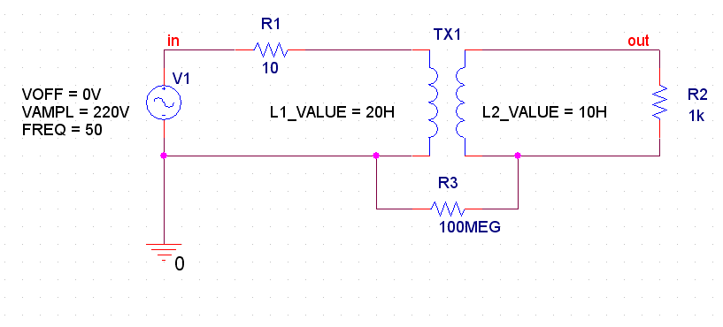For this exercise refer to section 3.1 of the primer. Using the tutorial provided as a guide, perform transient analysis on the following circuit and save the results. Print or sketch the results on a separate sheet and attach it to the lab handout for submission   
  
  
 **Figure 1**

1. Reverse the primary and secondary of transformer and comment on the result.

1. Change the transformation ratio of transformer via the formula given and print

Print graphs for input and output voltages.

**EXERCISE 2**

1. This part will allow the students to use parametric sweep for dynamic simulations.
   1. **Rectifier Circuit (peak detector).**

A peak detector circuit, like the name suggests, is used to clamp voltage at a certain peak value. For this exercise refer to section 3.4 and 3.4.2 of the primer.

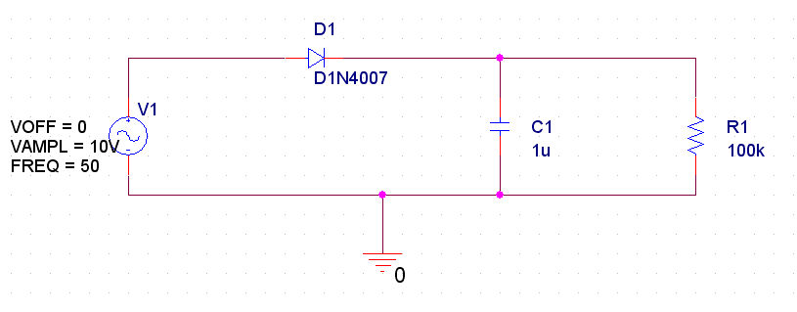

**Figure 2**

1. Change the amplitude of input voltage and find out the peak to peak value of ripple voltage along with graph.

Note: The ripple voltage obtained should be visible on graph as indicated by cursor.

* 1. **Use of Parametric Sweep**

It is interesting to see the effect of the load resistance on the output voltage and its ripple voltage. This can be done using PARAM part.

For this exercise refer to 3.4.2 of primer

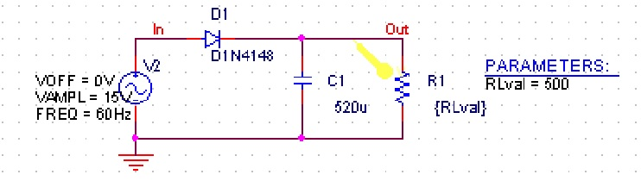

1. Change the value of load resistance from 250 to 1000 ohm in steps of 250 ohm and Print the graph obtained as result of parametric sweep of load

Resistor.

1. Comment on the effect of ripple voltage as result of changing load resistance.