**Department of Electrical Engineering and   
Computer Science**

**Faculty Member:** Dr. Shakeel Alvi  **Dated:** 29/11/2022

**Semester:** 5th **Section:** BEE 12C

**EE-313:** **Electronic Circuit Design**

Lab 10: Differential Pair  
(Mismatches and Offset Adjustment)

Group Members

|  |  |  |  |  |
| --- | --- | --- | --- | --- |
| **Name** | **Reg. No** | **Report**  **Marks** | **Viva**  **Marks** | **Total**  **Marks** |
|  |  | **10 Marks** | **5 Marks** | **15 Marks** |
| Danial Ahmad | 331388 |  |  |  |
| Muhammad Ahmed Mohsin | 333060 |  |  |  |
| Muhammad Umer | 345834 |  |  |  |
| Tariq Umar | 334943 |  |  |  |
|  |  |  |  |  |

**Table of Contents**

3 Differential Amplifier 3

3.1 Objectives 3

3.2 Equipment 3

3.3 Introduction 3

3.4 Lab Instructions 3

4 Lab Tasks 4

4.1 Calculation 4

4.2 Simulation 5

5 Conclusion 7

**Table of Figures**

Figure 1 4

Figure 2 4

# Differential Amplifier

## Objectives

The input offset voltage of operational amplifiers (op amps) arises from unavoidable mismatches in the differential input stage of the op-amp circuit caused by mismatched transistor pairs, collector currents, current- gain betas (β), collector or emitter resistors, etc. This experiment deals with voltage offset due to collector resistance mismatch.

## Equipment

Hardware

* Discrete elements
* Breadboard
* BJTs

Software

* PSpice

## Introduction

Consider the simplified input-stage circuit of the operational amplifier the following figure. The input offset voltage of the op amp results from mismatches in collector/emitter resistors and the transistor pair of the differential input.

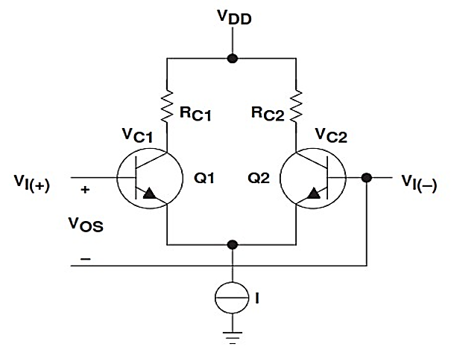

## Lab Instructions

All questions should be answered precisely to get maximum credit. Lab report must ensure following items:

* Lab objectives
* Results (Graphs/Tables) duly commented and discussed
* Conclusion

# Lab Tasks

## Calculation

1. Consider the circuit shown in Figure 1 using 2N2222 transistors for the NPN BJTs.

*Use R3 = 10 kΩ, R1 = R2 = 5.6 kΩ, VCC = 9 V and VEE= -9 V*

1. Calculate the DC bias currents IC1 and IC2 and Voltages VC1 and VC2.

|  |  |
| --- | --- |
| IC1: 0.918 mA | IC2: 0.918 mA |
| VC1: 3.85 V | **VC2:** 3.85 V |

1. Calculate the differential gain Ad for the given circuit.

**Ad =** 205.6 V/V

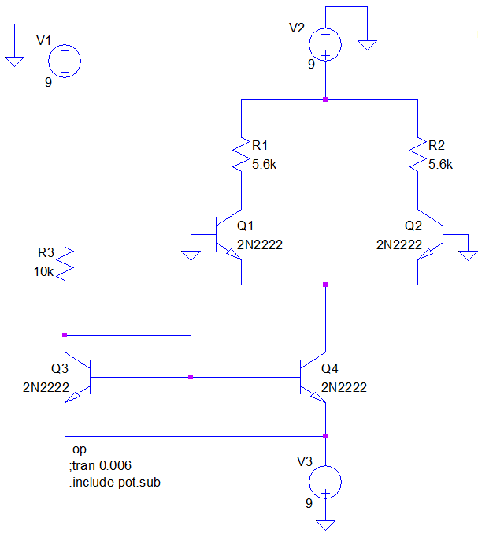

Figure

1. Use a multimeter to measure the exact resistance of the 5.6 k $Ω$ resistances.

**R1(measured):** 5.568 k $Ω$**R2(measured):** 5.610 k $Ω$

1. Using the values measured above calculate the mismatch.
$$\frac{ΔR_{C}}{R_{C}}=0.75\%$$

2. Using the measured values of resistance calculate the new collector voltages and hence the difference between the collector voltages

**VC1:** 3.885 V **VC2:** 3.848 V

**VC2 - VC1:** 0.037 V

1. Calculate the offset voltage using the formula given in the introduction section.

**VOS =** 1.8 e-4 V

## Implementation

1. On the breadboard construct the circuit shown in Figure 1 using 2N2222 transistors for the NPN BJTs. Use R3 = 10 k Ω, R1 = R2 = 5.6 k Ω, VCC = 9 V and VEE= - 9V

Note: Use the higher value resistance of the two 5.6 k $Ω$ resistances as R1.

1. Measure the DC bias currents IC1 and IC2 and Voltages VC1 and VC2.

|  |  |
| --- | --- |
| IC1: 1.011 mA | IC2: 1.106 mA |
| VC1: 3.07 V | **VC2:** 3.17 V |
| VC1 - VC2 = 0.1 V | |

1. Calculate the differential gain Ad for the given circuit.

**Ad =** 226.46 V/V

1. Using the measured values for VC2- VC1 and Ad, Determine the offset voltage VOS. Does it compare with the values calculated for PART 1?

**VOS** = 4.414 e-4 V

Now add a variable resistor as shown in Figure 2. Make sure that the resistance is equal on both sides.

1. Adjust the potentiometer so that VC2 - VC1 becomes 0. Measure the resistances labeled x and 1 - x.

**x**: 677.3 $Ω$**1 - x**: 422.3 $Ω$

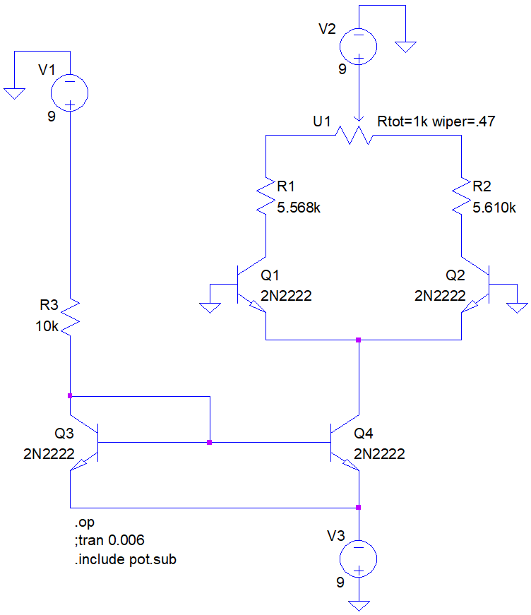

Figure

## Simulation

1. Simulate in PSpice the circuit shown in Figure 2 using 2N2222 transistors for the NPN BJTs. Use potentiometer (POT) from the breakout library in PSPICE

*Use R3 = 10 kΩ, R1 = R2 = 5.6 kΩ, VCC = 9 V and VEE= -9 V*

1. Use bias point analysis for DC bias currents IC1 and IC2 and Voltages VC1 and VC2. When potentiometer is set at 0.5.

|  |  |
| --- | --- |
| IC1: 0.9185 mA | IC2: 0.9182 mA |
| VC1: 3.885 V | **VC2:** 3.848 V |
| VC1 - VC2 = 0.034 V | |

1. Use the same values for X and 1-X measured for PART 2 and calculate the set point of potentiometer. Write down the

|  |  |
| --- | --- |
| Set: 0.47 | |
| VC1: 3.408 V | **VC2:** 3.407 V |
| VC1 - VC2 = 0.001 V | |

# Conclusion

In this lab we performed on differential amplifier we observed the mismatches in resistances RC and the offset adjustment through potentiometer. First, we calculated the mismatch in resistances and then using the potentiometer we adjusted the offset so that there was no mismatch and then observed the gain values respectively. We correlated our theoretical concepts to our practical knowledge for better understanding of the concepts.