|  |  |
| --- | --- |
| **Faculty Member:** | **Dated:** |
| **Semester:** | **Section:** |

EE313: ELECTRONIC CIRCUIT DESIGN

Lab10: Differential pair (Mismatches and Offset Null adjustment)

|  |  |  |  |
| --- | --- | --- | --- |
| **S.no** | **Name** | **Reg. no.** | **Total/25** |
| **1** |  |  |  |
| **2** |  |  |  |
| **3** |  |  |  |
| **4** |  |  |  |

# Objective

The input offset voltage of operational amplifiers (op amps) arises from unavoidable mismatches in the differential input stage of the op-amp circuit caused by mismatched transistor pairs, collector currents, current- gain betas (β), collector or emitter resistors, etc. This experiment deals with voltage offset due to collector resistance mismatch.

# Materials

The items listed in table 1 will be needed. For this lab, assume all NPN transistors are identical 2N2222 BJTs.

**CAUTION:** Please DO NOT leave the circuit on for long periods since there is a risk of heating up of transistors.

|  |  |
| --- | --- |
| **Components** | **Quantity** |
| Transistors: | 2N2222 NPN x2 |
| Resistors: | 10k x 1 ,5.6k x 2, 1k variable resistor |

# Introduction

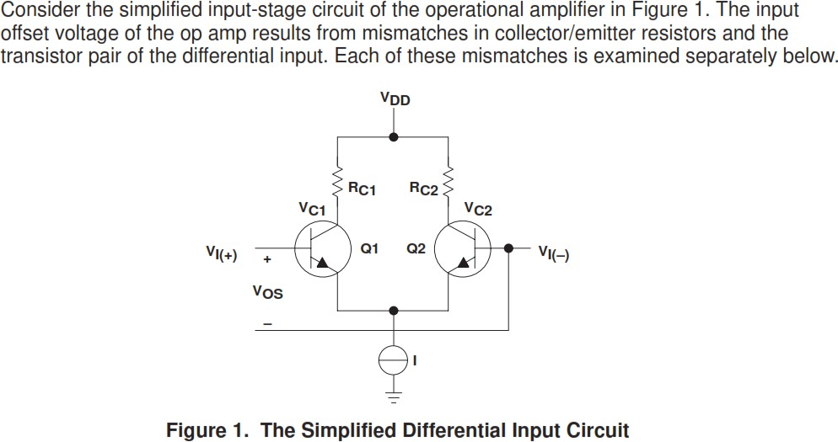

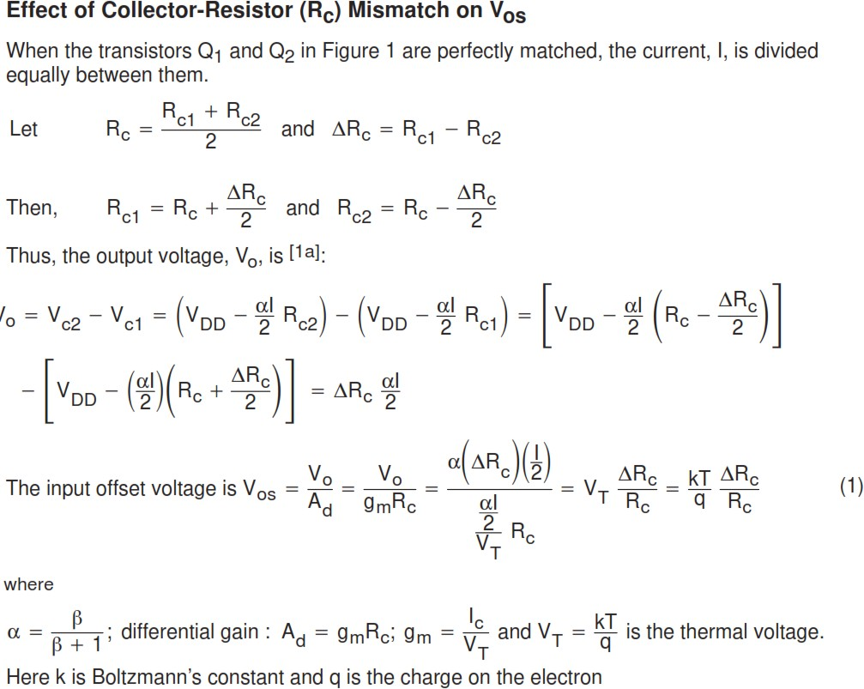

**Procedure**

## PART 1- CALCULATION

1. Consider the circuit shown in Figure 2 using 2N2222 transistors for the NPN BJTs.

Use R3 = 10 k Ω, R1 = R2 = 5.6 k Ω, VCC = 9 V and VEE= - 9V

1. Calculate the DC bias currents IC1 and IC2 and Voltages VC1 and VC2.

IC1: 0.918 mA, IC2: 0.918 mA

VC1: 3.85 V VC2: 3.85 V

1. Hence calculate the differential gain Ad for the give circuit.

**Ad= 205.6 V/V**

0

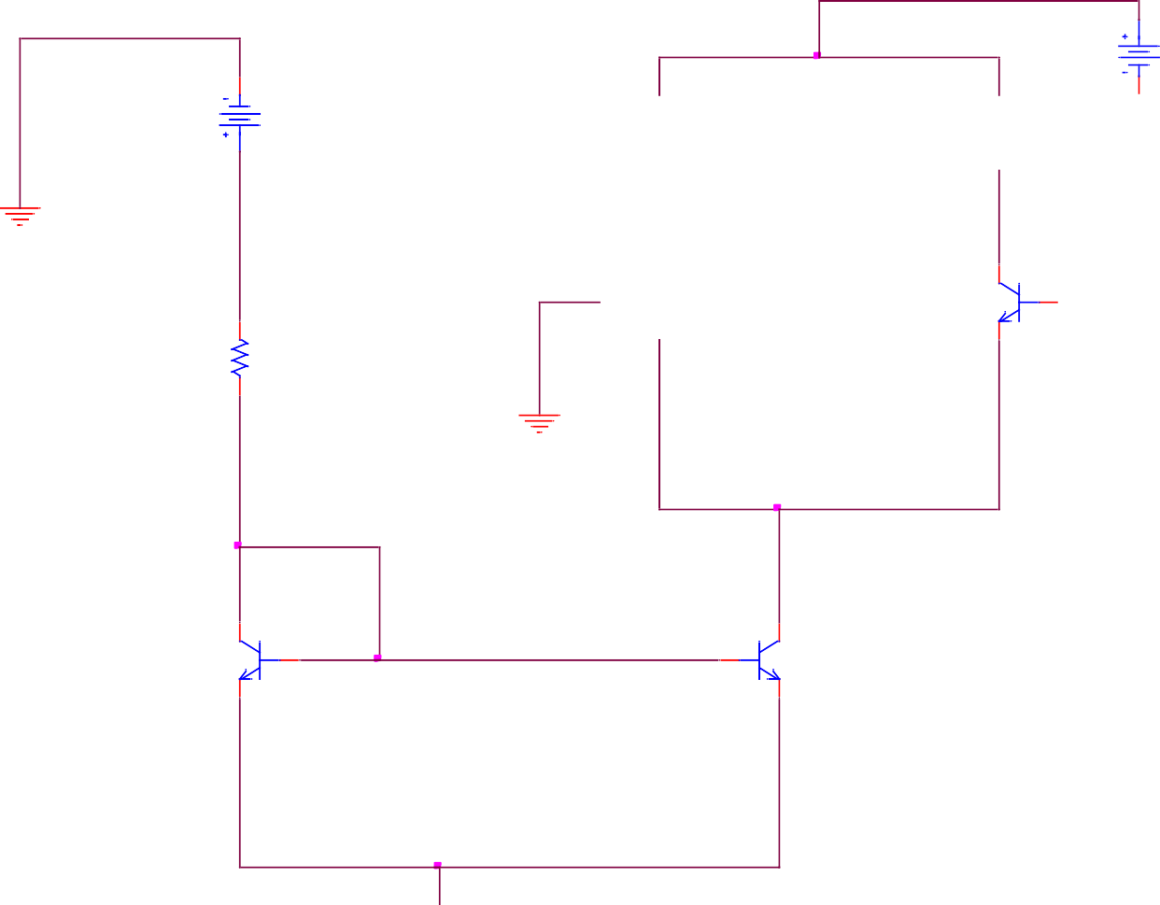

V2

9Vdc

9Vdc

V1

R1 5.6k

R2 5.6k

0

0

Q1

Q2

2N2222

2N2222

R3

10k

0

0

Q3

Q4

2N2222

2N2222

V6

9Vdc

Figure 2. Differential Amplifier

1. Use a multimeter to measure the exact resistance of the 5.6k Ohms resistances. (Note: We shall use the higher resistance as R1 as shown in figure1.)

R1 (measured): 5.568 k $Ω$ R2 (measured): 5.610 k $Ω$

1. Using the values measured above calculate the mismatch.

∆𝑹**c = 0.75 %**

𝑹𝒄

1. Using the measured values of resistance calculate the new collector voltages and hence the difference between the collector voltages

VC1: 3.885 V VC2: 3.848 V

VC2- VC1: 0.037 V

1. Calculate the offset voltage using the formula given in introduction section.

VOS= 1.8 e-4 V

## PART 2- IMPLEMENTATION

* 1. On breadboard construct the circuit shown in Figure 2 using 2N2222 transistors for the NPN BJTs. Use R3 = 10 k Ω, R1 = R2 = 5.6 k Ω, VCC = 9 V and VEE= - 9V

*Note: Use the higher value resistance of the two 5.6kohm resistances as R1*

* 1. Measure the DC bias currents IC1 and IC2 and Voltages VC1 and VC2.

IC1: 1.011 mA, IC2: 0.106 mA

VC1: 3.07 V

VC2: 3.17 V

VC2- VC1: 0.1 V

* 1. Hence using the measured current, calculate the differential gain Ad for the give circuit.

**Ad= 226.46 V/V**

* 1. Using the measured values for VC2- VC1 and Ad, Determine the offset voltage VOS. Does it compare with the values calculated for PART 1?

VOS= 4.414 e-4 V

* 1. Now add a variable resistor as shown in figure 3. Make sure that the resistance is equal on both sides.

0

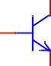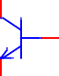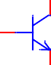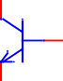

V2

x

1-x

9Vdc

9Vdc

V1

R1

5.6k

R4 1K

SET = 0.5

R2

5.6k

0

0

Q1

Q2

2N2222

2N2222

R3

10k

0

0

Q3

Q4

2N2222

2N2222

V6

9Vdc

Figure 3. Differential Amplifier with potentiometer.

* 1. Adjust the potentiometer so that VC2- VC1 becomes 0. Measure the resistances labeled **x** and **1-x** on figure3.

# X: 677.3 $Ω$ 1-X: 422.3 $Ω$

## PART 3- SIMULATION

* + 1. Simulate in PSpice the circuit shown in Figure 3 using 2N2222 transistors for the NPN BJTs. Use potentiometer(POT) from the breakout library in PSPICE

Use R3 = 10 k Ω, R1 = R2 = 5.6 k Ω, VCC = 9 V and VEE= - 9V

*Note: Use the measured values for R1 and R2 and the higher value resistance of the two as R1*

* + 1. Use bias point analysis for DC bias currents IC1 and IC2 and Voltages VC1 and VC2. When potentiometer is set at 0.5.

IC1: 0.9185 mA, IC2: 0.9182 mA

VC1: 3.885 V

VC2: 3.848 V

VC2- VC1: 0.037 V

* + 1. Use the same values for X and 1-X measured for PART 2 and calculate the set point of potentiometer. Write down the

Set = 0.47

*Note: Set: 0 means 1-x: 1kohms and set: 1 means x=1k ohms for the potentiometer*

VC1: 3.408

VC2: 3.407 V

VC2- VC1: 0.001 V