**Department of Electrical Engineering and   
Computer Science**

**Faculty Member:** Dr. Shakeel Alvi  **Dated:** 6/12/2022

**Semester:** 5th **Section:** BEE 12C

**EE-313:** **Electronic Circuit Design**

Lab 11: Operational Amplifier with Negative Feedback

Group Members

|  |  |  |  |  |
| --- | --- | --- | --- | --- |
| **Name** | **Reg. No** | **Report**  **Marks** | **Viva**  **Marks** | **Total**  **Marks** |
|  |  | **10 Marks** | **5 Marks** | **15 Marks** |
| Danial Ahmad | 331388 |  |  |  |
| Muhammad Ahmed Mohsin | 333060 |  |  |  |
| Muhammad Umer | 345834 |  |  |  |
| Tariq Umar | 334943 |  |  |  |
|  |  |  |  |  |

**Table of Contents**

3 Differential Amplifier 3

3.1 Objectives 3

3.2 Equipment 3

3.3 Introduction 3

3.4 Lab Instructions 3

4 Lab Tasks 4

4.1 Implementation 4

4.2 Simulation 5

5 Conclusion 6

**Table of Figures**

Figure 1 Circuit 4

Figure 2 Oscilloscope Display for R2=10k, R1=10k 5

Figure 3 LTSpice Schematic 5

# Differential Amplifier

## Objectives

In this experiment you will:

* Demonstrate the operation of non-inverting amplifier
* Verify voltage gain control by feedback resistors

## Equipment

Hardware

* 741 Operational amplifier
* Breadboard
* BJTs

Software

* PSpice

## Introduction

The non-inverting voltage amplifier has the characteristics of an ideal voltage amplifier: exceptionally high input impedance and very low output impedance. Additionally, this amplifier, like any other based on a high-gain op-amp, has a voltage gain and stability that are dependent upon the external circuit resistors and independent of amplifier variations.

## Lab Instructions

All questions should be answered precisely to get maximum credit. Lab report must ensure following items:

* Lab objectives
* Results (Graphs/Tables) duly commented and discussed
* Conclusion

# Lab Tasks

## Implementation

1. Construct the circuit as shown in the following figure without the feedback network and measure the open loop. Set the generator to supply a 1-kHz sine wave at 200 mV peak-to-peak.

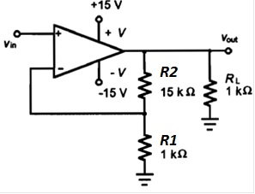

Figure Circuit

1. Apply DC power. Connect the function generator to vin. Set the generator to supply a 1-kHz sine wave at 200 mV peak-to-peak.

Phase shift = 0.031

1. With an oscilloscope measure the peak-to-peak of VIN and VOUT and record their values.
2. Select a new value of R2 to set the amplifier gain in the range of 6 to 25. Record the new value of R2 in the given table with your predicted gain.
3. With both DC and AC sources off, install a 10 kΩ resistor for R2. Reapply the DC power and input signal. Measure and record the peak-to-peak input and output voltage signal levels.

|  |  |  |  |  |
| --- | --- | --- | --- | --- |
| Measured Values (Peak-to-peak) | | | | |
| R2 = (10+5) kΩ | | R2 = 4.7 kΩ | R2=10 kΩ, RL=1 kΩ | R2=10 kΩ, RL=75 Ω |
| VIN = 400 mV | | VIN = 400 mV | VIN = 400 mV | VIN = 400 mV |
| VOUT = 6.33 V | | VOUT = 2.26 V | VOUT = 4.23 V | VOUT = 4.29 V |
| AV = 15.83 V | | **AV = 5.66 V** | **AV = 10.74 V** | **AV = 10.73 V** |
| Calculated | | | | |
| AV = 16 V | **AV = 5.7 V** | | **AV = 11 V** | **AV = 11 V** |

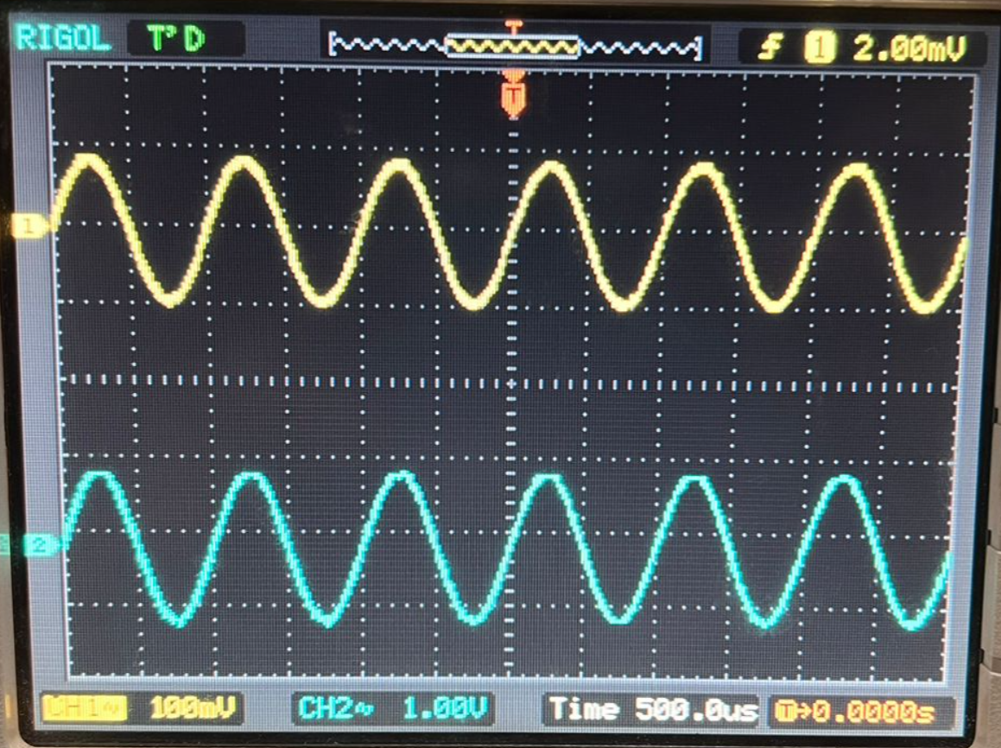

Figure Oscilloscope Display for R2=10k, R1=10k

## Simulation

Create the circuit given in the following on any SPICE software.

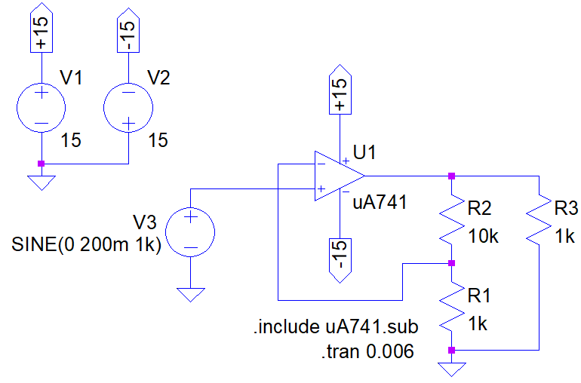

Figure LTSpice Schematic

Repeat the steps from implementation and record your results below.

Phase shift =

|  |  |  |  |
| --- | --- | --- | --- |
| Simulated Values (Peak-to-peak) | | | |
| R2 = 15 kΩ | R2 = 4.7 kΩ | R2=10 kΩ, RL=1 kΩ | R2=10 kΩ, RL=75 Ω |
| VIN = 400 mV | VIN = 400 mV | VIN = 400 mV | VIN = 400 mV |
| VOUT = 6.4 V | VOUT = 2.26 V | VOUT = 4.4 V | VOUT = 4.4 V |
| AV = 16 V | **AV = 5.65 V** | **AV = 11 V** | **AV = 11 V** |

# Conclusion

In this lab we learnt about non-inverting amplifier and further discussed their function. We performed hardware on amplifiers with feedback resistors. And we got to know about the voltage gain due to the efffects of feedbacks. Furthermore, we simulated the circuit that we build in the lab. We did this using LTSpice.