**Department of Electrical Engineering and   
Computer Science**

**Faculty Member:** Dr. Shakeel Alvi  **Dated:** 18/12/2022

**Semester:** 5th **Section:** BEE 12C

**EE-313:** **Electronic Circuit Design**

Lab 12: Operational Amplifier Feedback Topologies

Group Members

|  |  |  |  |  |
| --- | --- | --- | --- | --- |
| **Name** | **Reg. No** | **Report**  **Marks** | **Viva**  **Marks** | **Total**  **Marks** |
|  |  | **10 Marks** | **5 Marks** | **15 Marks** |
| Danial Ahmad | 331388 |  |  |  |
| Muhammad Ahmed Mohsin | 333060 |  |  |  |
| Muhammad Umer | 345834 |  |  |  |
| Tariq Umar | 334943 |  |  |  |
|  |  |  |  |  |

**Table of Contents**

3 Operational Amplifier Feedback Topologies 3

3.1 Objectives 3

3.2 Equipment 3

3.3 Introduction 3

3.4 Lab Instructions 3

4 Lab Tasks 4

4.1 Voltage Series Feedback Amplifier (VCVS) 4

4.2 Voltage Shunt Feedback Amplifier (CCVS) 4

4.3 Current Series Feedback Amplifiers (VCCS) 4

4.4 Current Shunt Feedback Amplifiers (CCCS) 5

5 Conclusion 5

# Operational Amplifier Feedback Topologies

## Objectives

* To study the various feedback amplifiers using op-amps

## Equipment

Hardware

* 741 Operational amplifiers
* Breadboard
* BJTs

Software

* PSpice

## Introduction

A practical amplifier has a gain of nearly one million, i.e., its output in one million times the input. Consequently, even a casual disturbance at the input will appear in the amplified form in the output. There is a strong tendency in amplifiers to introduce hum due to sudden temperature changes or stray electric and magnetic fields. Therefore, every high gain amplifier tends to give noise along with signal in its output. The noise in the output of an amplifier is undesirable and must be kept to as small as possible. The noise level in amplifiers can be reduced considerably by the use of a negative feedback, i.e., by injecting a fraction of output in phase opposition to the input signal.

## Lab Instructions

All questions should be answered precisely to get maximum credit. Lab report must ensure following items:

* Lab objectives
* Results (Graphs/Tables) duly commented and discussed
* Conclusion

# Lab Tasks

Use μA741 op-amp with +15 V and -15V power supply.

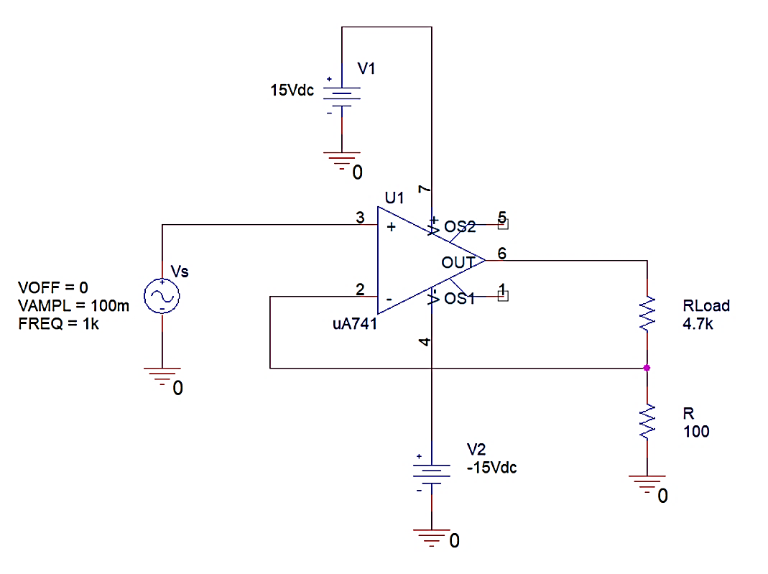

## Voltage Series Feedback Amplifier (VCVS)

Construct the circuit in PSpice. Connect a load RL across the output terminals. Choose each resistance value to be equal to 10 kΩ. Apply 1 V, 1 KHz ac input signal, Vs. Measure the voltage gain **Vo/Vi**.

$$Av = Vo/Vi = 1.99 V/V$$

Repeat the measurements for three different values of Vi keeping RL constant.

|  |  |  |  |
| --- | --- | --- | --- |
| Vi | β (calculated) | Gain (Calculated) | Gain (Simulated) |
| 2 V | 0.5 | 2 | 1.9979 V/V |
| 4 V | 0.5 | 2 | 1.9989 V/V |
| 6 V | 0.5 | 2 | 1.9989 V/V |

Repeat the measurements for three different values of RL keeping Vi constant.

|  |  |  |  |
| --- | --- | --- | --- |
| Vi | β (calculated) | Gain (Calculated) | Gain (Simulated) |
| 20 K | 0.5 | 2 | 2.003 V/V |
| 25 K | 0.5 | 2 | 2.003 V/V |
| 30 K | 0.5 | 2 | 2.003 V/V |

## Voltage Shunt Feedback Amplifier (CCVS)

Construct the circuit in PSpice. Choose Rs=47 kΩ, RL=4.7 kΩ and R=47kΩ.. Measure the transresistance **Vo/Ii.**

$$Rm = Vo/Ii = 47001 V/A$$

Repeat the measurements for three different values of Rs keeping RL constant.

|  |  |  |  |
| --- | --- | --- | --- |
| Vi | β (calculated) | Gain (Calculated) | Gain (Simulated) |
| 47 K | 0.5 | 47000 | 47019.011 |
| 60 K | 0.56074 | 47000 | 47022.188 |
| 100 K | 0.6802 | 47000 | 47037.121 |

## Current Series Feedback Amplifiers (VCCS)

Construct the circuit in PSpice. Choose RL = 4.7 kΩ and R = 100 Ω. Apply 100mV, 1 kHZ ac input signal. Measure the transconductance **Io/Vi**.

$$Gm = Io/Vi = 9.981 mA/V$$

Repeat the measurements for three different values of Vi keeping RL constant.

|  |  |  |  |
| --- | --- | --- | --- |
| Vi | β (calculated) | Gain (Calculated) | Gain (Simulated) |
| 100 m | 0.02083 | 0.01 | 9.988 x 10-3 |
| 25 m | 0.02083 | 0.01 | 9.983 x 10-3 |
| 50 m | 0.02083 | 0.01 | 0.0100 |

Repeat the measurements for three different values of RL keeping Vi constant.

|  |  |  |  |
| --- | --- | --- | --- |
| Vi | β (calculated) | Gain (Calculated) | Gain (Simulated) |
| 500 | 0.1667 | 0.01 | 0.01000 |
| 1K | 0.0909 | 0.01 | 9.987 x 10-3 |
| 4.7 K | 0.02083 | 0.01 | 9.988 x 10-3 |

## Current Shunt Feedback Amplifiers (CCCS)

Construct the circuit in PSpice. Choose Rs = 47 kΩ, R1 = 4.7 kΩ, RL= 1kΩ and R2 = 100Ω. Apply 10 V, 1 kHZ ac input signal. Measure the current gain **Io/Ii**.

$$Ai= Io/Ii = 48.005 A/A$$

Repeat the measurements for three different values of Vs keeping RL constant.

|  |  |  |  |
| --- | --- | --- | --- |
| Vi | β (calculated) | Gain (Calculated) | Gain (Simulated) |
| 5 | 0.0208 | 48 | 48.027 |
| 10 | 0.0208 | 48 | 48.011 |
| 15 | 0.0208 | 48 | 42.226 |

Repeat the measurements for three different values of RL keeping Vs constant.

|  |  |  |  |
| --- | --- | --- | --- |
| Vi | β (calculated) | Gain (Calculated) | Gain (Simulated) |
| 100 | 0.0208 | 48 | 47.982 |
| 500 | 0.0208 | 48 | 48.015 |
| 1 K | 0.0208 | 48 | 48.011 |

# Conclusion

In this lab, we studied the gains and configurations of various feedback topologies featuring the 741 op-amp. We also verified the simulated gain values with that of calculated values and observed that they remained in near vicinity to each other in all feedback topologies.