| **Faculty Member:____________________** | **Dated: ________________** |
| --- | --- |
| **Semester:_____________** | **Section: ________________** |

**EE313: ELECTRONIC CiRCUIT DESIGN**

**Lab 12: OPERATIONAL AMPLIFIER FEEDBACK TOPOLOGIES**

| **S.no** | **Name** | **Reg. no.** | **Total/25** |
| --- | --- | --- | --- |
| **1** |  |  |  |
| **2** |  |  |  |
| **3** |  |  |  |
| **4** |  |  |  |

**Experiment 12**

**Operational Amplifiers (Feedback)**

**INTRODUCTION**

A practical amplifier has a gain of nearly one million, i.e., its output in one million times the input. Consequently, even a casual disturbance at the input will appear in the amplified form in the output. There is a strong tendency in amplifiers to introduce hum due to sudden temperature changes or stray electric and magnetic fields. Therefore, every high gain amplifier tends to give noise along with signal in its output. The noise in the output of an amplifier is undesirable and must be kept to as small as possible. The noise level in amplifiers can be reduced considerably by the use of a negative feedback, i.e., by injecting a fraction of output in phase opposition to the input signal.

**Feedback**

The process of injecting a fraction of output energy of some device back to the input of the same device is known as feedback. Depending on the relative polarity of the signal being feedback into a circuit, there are two basic types of feedback in amplifiers, namely

a. Positive feedback

b. Negative feedback.

**Positive feedback**

When the feedback signal (voltage or current) is in phase with the input signal and thus aids it, it is called positive feedback. Positive feedback increases the gain of the amplifier. However, it has the disadvantage of increased distortion and instability. Therefore, positive feedback is seldom used for amplification. One important use of positive feedback is in oscillators.

**Negative feedback**

When the feedback signal (voltage or current) is out of phase with the input signal and thus opposes it, it is called negative feedback. Negative feedback reduces gain of the amplifier. However, it has a number of advantages, among them being

a. Higher input impedance

b. Lower output impedance

c. Better stabilized voltage gain

d. Improved frequency response

e. Reduced noise

f. Increased bandwidth

g. More linear operation

It is due to these advantages, negative feedback is frequently employed in amplifiers.

**Block diagram**

In the feedback amplifiers, a part of the output is returned to the input. If this feedback reduces the net input, it is called negative feedback. If the feedback increases the net input, it is called positive feedback. The schematic representation of a generalized feedback amplifier is shown in Figure 3-2-1.

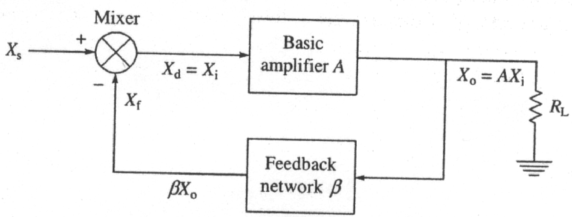

**Fig.3-2-1** Basic schematic of feedback amplifier

The signal XS can be a voltage or a current. The gain with feedback, Af, is given by

Af=(3-2-1)

where A is the gain without feedback and β is the feedback factor defined as

β= Xf/X0.

**Feedback connection types**

There are four basic ways of connecting the feedback signal. Both voltage and current can be feedback to the input in series or parallel. Specifically, there can be

a. Voltage-series feedback

b. Current-series feedback

c. Voltage-shunt feedback

d. Current-shunt feedback

In the list above, voltage refers to connecting the output voltage as input to the feedback network; current refers to tapping off some output current through the feedback network. Series refers to connecting the feedback signal in series with the input signal voltage; shunt refers to connecting the feedback signal in shunt with an input current source. Series feedback connections tend to increase the input resistance, while shunt feedback connections tend to decrease the input resistance. Voltage feedback tends to decrease the output resistance while current feedback tends to increase the output resistance. Typically, higher input resistance and lower output resistance are desired for most cascade amplifiers. Both of these provided using the voltage-series feedback connection. Figure 3-2-2 shows these configurations.

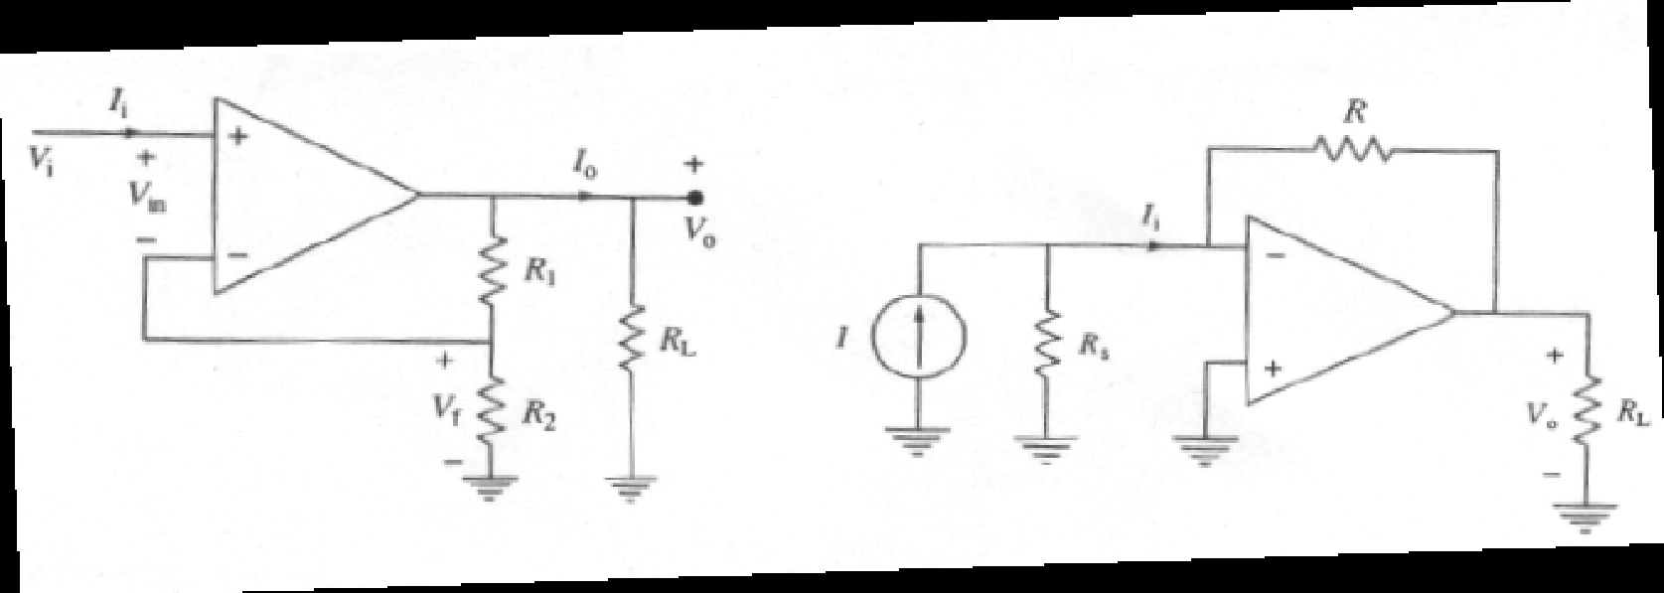

1. **(b)**

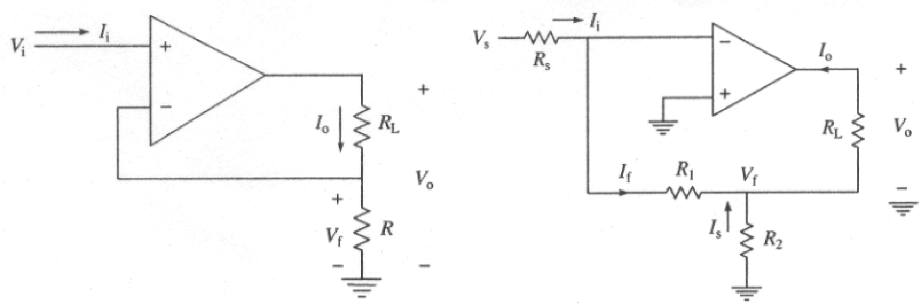

**(c) (d)**

***Fig. 3-2-2 Feedback Amplifier circuits:*** *(a) Voltage-Series circuit, (b) Voltage-Shunt circuit,*

*(c) Current-Series circuit, and (d) Current-Shunt circuit*

The expressions for the performance parameters of these four controlled source are tabulated in Table 3-2-1.

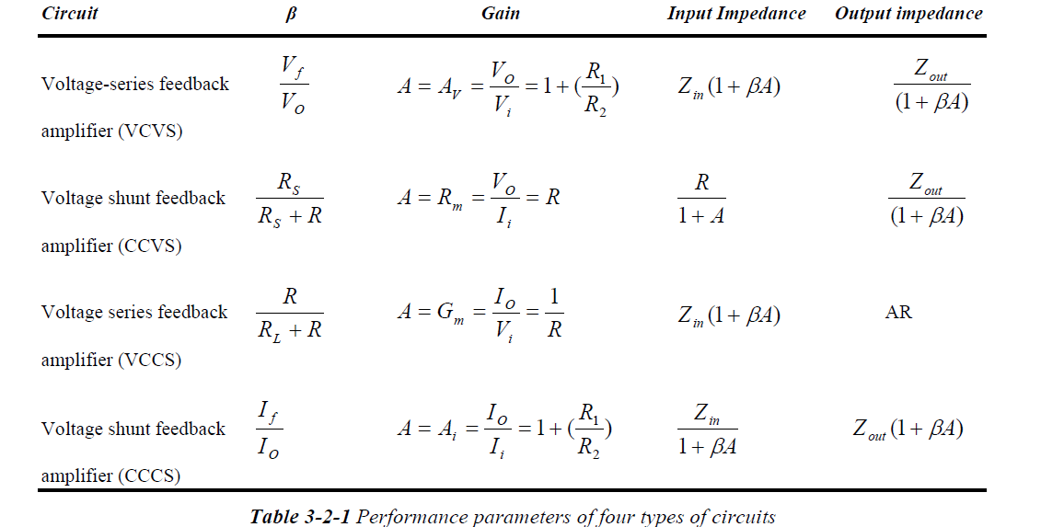

**OBJECTIVES**

To study the various feedback amplifiers using op-amps.

**EQUIPMENT AND MATERIALS**

* DC power supply
* Function generator
* Digital multimeter
* Oscilloscope
* Breadboardu
* Operational amplifier 741
* Resistors 4.7kΩ, 10 kΩ, 47 kΩ

**PART 1. Simulation**

Use μA741 op-amp with +15 V and -15V power supply.

**1. Voltage series feedback amplifier (VCVS)**

1.1 Construct the circuit shown in Figure 3-2-2(a) in PSpice. Connect a load RL across the output terminals. Choose each resistance value to be equal to 10 kΩ. Apply 1 V, 1 KHz ac input signal, Vs. Measure the voltage gain **Vo/Vi**.

AV= Vo/Vi=____________________

1.2 Repeat the measurements for three different values of Vi keeping RL constant.

| Vi | β(calculated) | Gain (Calculated) | Gain (Simulated) |
| --- | --- | --- | --- |
|  |  |  |  |
|  |  |  |  |
|  |  |  |  |

1.3 Repeat the measurements for three different values of RL keeping Vi constant.

| RL | β(calculated) | Gain (Calculated) | Gain (Simulated) |
| --- | --- | --- | --- |
|  |  |  |  |
|  |  |  |  |
|  |  |  |  |

1.4 Compare the measured values with the calculated values.

**Voltage shunt feedback amplifier (CCVS)**

2.1 Construct the circuit shown in Figure 3-2-3(b) in PSpice. Choose Rs=47 kΩ, RL=4.7 kΩ and R=47kΩ. Note that the current source, I, in parallel with resistor, Rs, can be replaced by a voltage source, *S S V* = *I* × *R* in series with Rs. In this case Ii = Vs/Rs. Apply 10V, 1 kHz ac input signal. Measure the transresistance **Vo/Ii.**

Rm= Vo/Ii=____________________

2.2 Repeat the measurements for three different values of Rs keeping RL constant.

| Rs | β(calculated) | Gain (Calculated) | Gain (Simulated) |
| --- | --- | --- | --- |
|  |  |  |  |
|  |  |  |  |
|  |  |  |  |

2.3 Compare the measured values with the calculated values.

**3. Current series feedback amplifiers (VCCS)**

3.1 Construct the circuit shown in Figure 3-2-3(c) in PSpice. Choose RL = 4.7 kΩ and R = 100 Ω. Apply 100mV, 1 kHZ ac input signal. Measure the transconductance **Io/Vi**.

Gm= Io/Vi=____________________

3.2 Repeat the measurements for three different values of Vi keeping RL constant.

| Vi | β(calculated) | Gain (Calculated) | Gain (Simulated) |
| --- | --- | --- | --- |
|  |  |  |  |
|  |  |  |  |
|  |  |  |  |

3.3 Repeat the measurements for three different values of RL keeping Vi constant.

| RL | β(calculated) | Gain (Calculated) | Gain (Simulated) |
| --- | --- | --- | --- |
|  |  |  |  |
|  |  |  |  |
|  |  |  |  |

3.4 Compare the measured values with the calculated values.

**4. Current shunt feedback amplifiers (CCCS)**

4.1 Construct the circuit shown in Figure 3-2-3(d) in PSpice. Choose Rs = 47 kΩ, R1 = 4.7 kΩ, RL= 1kΩ and R2 = 100Ω. Apply 10 V, 1 kHZ ac input signal. Measure the current gain **Io/Ii**.

Ai= Io/Ii=____________________

4.2 Repeat the measurements for three different values of Vs keeping RL constant.

| Vs | β(calculated) | Gain (Calculated) | Gain (Simulated) |
| --- | --- | --- | --- |
|  |  |  |  |
|  |  |  |  |
|  |  |  |  |

4.3 Repeat the measurements for three different values of RL keeping Vs constant.

| RL | β(calculated) | Gain (Calculated) | Gain (Simulated) |
| --- | --- | --- | --- |
|  |  |  |  |
|  |  |  |  |
|  |  |  |  |

4.4 Compare the measured values with the calculated values.

**PART 2. Implementation**

Use LM741 op-amp with +15 V and -15V power supply. Make sure you use 0.1uF decoupling capacitors in parallel to these sources.

**1. Voltage series feedback amplifier (VCVS)**

1.1 Construct the circuit shown in Figure 3-2-2(a) on Breadboard. Connect a load RL across the output terminals. Choose each resistance value to be equal to 10 kΩ. Apply 1 V, 1 KHz ac input signal, Vs. Measure the voltage gain **Vo/Vi**.

AV= Vo/Vi=____________________

1.2 Repeat the measurements for three different values of Vi keeping RL constant.

| Vi | Gain (Measured) |
| --- | --- |
|  |  |
|  |  |
|  |  |

1.3 Repeat the measurements for three different values of RL keeping Vi constant.

| RL | Gain (Measured) |
| --- | --- |
|  |  |
|  |  |
|  |  |

1.4 Compare the measured values with the calculated values.

**Voltage shunt feedback amplifier (CCVS)**

2.1 Construct the circuit shown in Figure 3-2-3(b) on Breadboard. Choose Rs=47 kΩ, RL=4.7 kΩ and R=47kΩ. Note that the current source, I, in parallel with resistor, Rs, can be replaced by a voltage source, *S S V* = *I* × *R* in series with Rs. In this case Ii = Vs/Rs. Apply 10V, 1 kHz ac input signal. Measure the transresistance **Vo/Ii.**

Rm= Vo/Ii=____________________

2.2 Repeat the measurements for three different values of Rs keeping RL constant.

| Rs | Gain (Measured) |
| --- | --- |
|  |  |
|  |  |
|  |  |

2.3 Compare the measured values with the calculated values.

**3. Current series feedback amplifiers (VCCS)**

3.1 Construct the circuit shown in Figure 3-2-3(c) on Breadboard. Choose RL = 4.7 kΩ and R = 100 Ω. Apply 100mV, 1 kHZ ac input signal. Measure the transconductance **Io/Vi**.

Gm= Io/Vi=____________________

3.2 Repeat the measurements for three different values of Vi keeping RL constant.

| Vi | Gain (Measured) |
| --- | --- |
|  |  |
|  |  |
|  |  |

3.3 Repeat the measurements for three different values of RL keeping Vi constant.

| RL | Gain (Measured) |
| --- | --- |
|  |  |
|  |  |
|  |  |

3.4 Compare the measured values with the calculated values.

**4. Current shunt feedback amplifiers (CCCS)**

4.1 Construct the circuit shown in Figure 3-2-3(d) on Breadboard. Choose Rs = 47 kΩ, R1 = 4.7 kΩ, RL= 1kΩ and R2 = 100Ω. Apply 10 V, 1 kHZ ac input signal. Measure the current gain **Io/Ii**.

Ai= Io/Ii=____________________

4.2 Repeat the measurements for three different values of Vs keeping RL constant.

| Vs | Gain (Measured) |
| --- | --- |
|  |  |
|  |  |
|  |  |

4.3 Repeat the measurements for three different values of RL keeping Vs constant.

| RL | Gain (Measured) |
| --- | --- |
|  |  |
|  |  |
|  |  |

4.4 Compare the measured values with the calculated values.

**END**