**Department of Electrical Engineering and   
Computer Science**

**Faculty Member:** Dr. Shakeel Alvi  **Dated:** 13/09/2022

**Semester:** 5th **Section:** BEE 12C

**EE-313:** **Electronic Circuit Design**

Lab 2: Common Emitter Amplifier

Group Members

|  |  |  |  |  |
| --- | --- | --- | --- | --- |
| **Name** | **Reg. No** | **Report**  **Marks** | **Viva**  **Marks** | **Total**  **Marks** |
|  |  | **10 Marks** | **5 Marks** | **15 Marks** |
| Danial Ahmad | 331388 |  |  |  |
| Muhammad Ahmed Mohsin | 333060 |  |  |  |
| Muhammad Umer | 345834 |  |  |  |
| Tariq Umar | 334943 |  |  |  |
|  |  |  |  |  |

**Table of Contents**

3 Common Emitter Amplifier 3

3.1 Objectives 3

3.2 Equipment 3

3.3 Introduction 3

3.4 Lab Instructions 4

4 Lab Tasks 5

4.1 Theoretical Calculations 5

4.1.1 Circuit 5

4.1.2 Results 5

4.2 Simulation 6

4.2.1 Circuit 6

4.2.2 Results 6

4.2.3 Transient Analysis 6

4.3 Hardware Implementation 7

5 Conclusion 8

**Table of Figures**

Figure 4.1.1‑a: Circuit 5

Figure 4.2.1‑a Schematic 6

Figure 4.2.3‑a Transient Settings 6

Figure 4.2.3‑b Waveform 7

Figure 4.2.3‑a Oscilloscope 8

# Common Emitter Amplifier

## Objectives

* To perform DC analysis and calculate gain
* Implement it on hardware and verify calculations

## Equipment

Software

* *PSpice*



## Introduction

The common-emitter transistor amplifier configuration is widely used. It provides large voltage gain (typically tens to hundreds) and provides moderate input and output impedance. The AC signal voltage gain is defined as $A_{V}=\frac{V_{OUTPUT}}{V_{INPUT}}$.

For the voltage-divider DC bias configuration, all DC bias voltages can be approximately determined without knowing the exact value of transistor beta. The transistors AC dynamic resistance re can be calculated using $r_{e}=\frac{26mV}{I_{EQ}}mA$

The AC voltage gain of a CE amplifier under no load can be calculated using $A_{v}=-\frac{R_{c}}{R_{E}+r_{e}}$.

## Lab Instructions

All questions should be answered precisely to get maximum credit. Lab report must ensure following items:

* Lab objectives
* Results (Graphs/Tables) duly commented and discussed
* Conclusion

# Lab Tasks

Theoretical Calculations

### Circuit

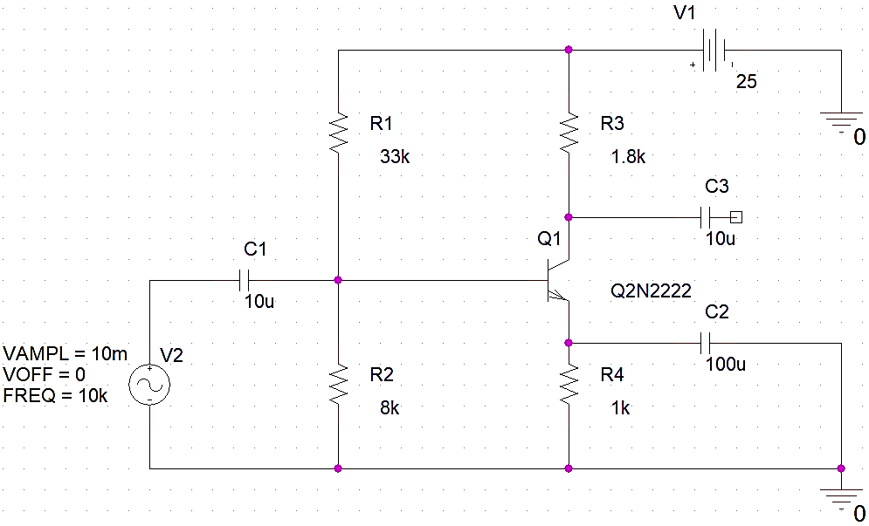

Figure 4.1.1‑a: Circuit

### Results

1. **DC bias values**

VB (Calculated) = 4.872 V

VE (Calculated) = 4.170 V

VC (Calculated) = 17.722 V

IE (Calculated) = 4.170 mA

1. **Intrinsic re**

re (Calculated) = 6.232 $Ω$

1. **Amplifier voltage gain**

Av (Calculated) = -288.831 V/V

## Simulation

### Circuit

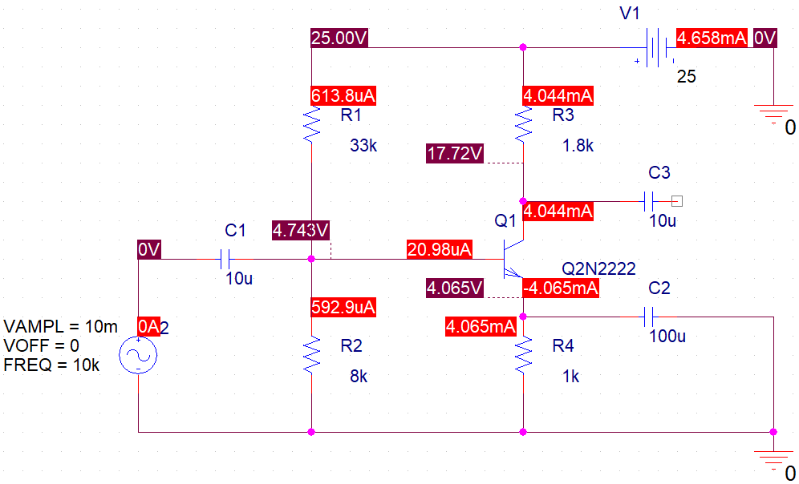

Figure 4.2.1‑a Schematic

### Results

1. **DC bias values**

VB (Simulated) = 4.743 V

VE (Simulated) = 4.065 V

VC (Simulated) = 17.720 V

IE (Simulated) = 4.065 mA

### Transient Analysis

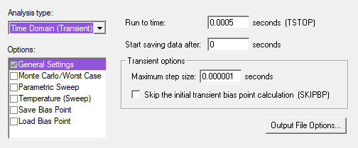

Figure 4.2.3‑a Transient Settings

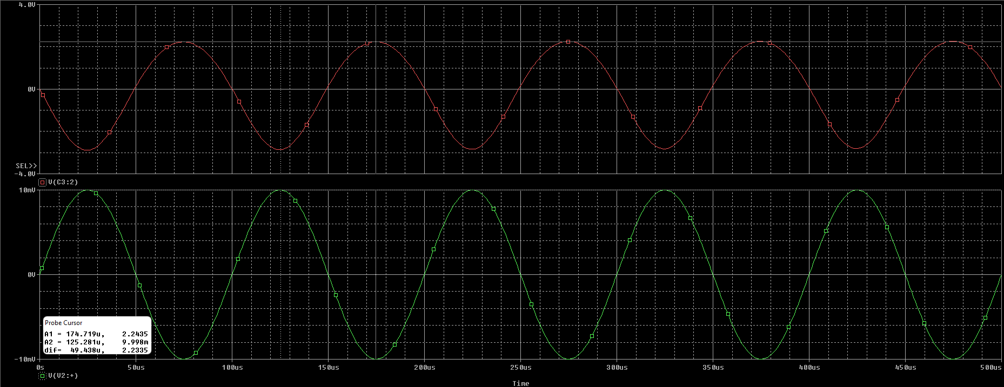

Figure 4.2.3‑b Waveform

1. **AC voltage gain**

Av (Simulated) = 281.4 V/V

1. **Proximity of values**

**Comments:** We can observe that simulated and calculated voltage gain are in near proximity of each other; the difference arises as simulation approximates to be as close to real life implementation as possible by considering the tolerances of each individual component. In PSpice, the end-user can reduce these tolerance values to zero, effectively removing it, to verify that simulated and theoretical values are the same.

## Hardware Implementation

1. **After implementation, record bias values**

VB (Practical) = 4.792 V

VE (Practical) = 4.065 V

VC (Practical) = 17.910 V

1. **Using measured value of VE calculate IE**

IE = VE/RE

IE = 4.032/1k

IE = 4.032 mA

1. **Using results of Part C and equation 2, find out the re**

re (Practical) = 6.448 $Ω$

1. Apply an AC signal Signal=10mV, rams at frequency of 10KHz. Observe the output waveform on an oscilloscope and **sketch it**. Measure the resulting output voltage.

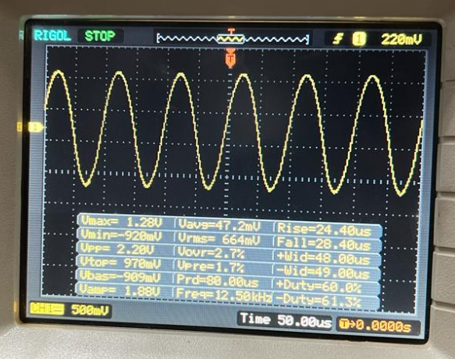

Figure 4.2.3‑a Oscilloscope

VOUT (P-P) = 2.20 V

1. Calculate the gain of the implemented circuit and record the value below.

Av (Practical) = 220.10 V/V

1. Compare all the values especially **re** and **Av** for all the parts (calculated, measured and simulated) and comment on their proximity

**Comments:** Comparing all the values of re and Av, we deduce that although simulated and calculated values are in close proximity of each other, the hardware implementation causes a significant drop in gain. This is due to the fact that practically, getting the right values of components is difficult and that gain being dependent on re, a value which varies with the temperature, gain is hard to replicate in different environments and suffers losses.

# Conclusion

After performing this lab, we have learned how to design a common emitter amplifier and verified the results of circuit analysis through both simulation and implementation. We further expanded on the theory of transistors, more specifically BJTs, and calculated all small signal parameters to deduce the gain. We also realized that practical gain is almost always different than simulated one due to component tolerances and temperature.