**Department of Electrical Engineering and   
Computer Science**

**Faculty Member:** Dr. Shakeel Alvi  **Dated:** 9/10/2022

**Semester:** 5th **Section:** BEE 12C

**EE-313:** **Electronic Circuit Design**

Lab 4: Current Sources

Group Members

|  |  |  |  |  |
| --- | --- | --- | --- | --- |
| **Name** | **Reg. No** | **Report**  **Marks** | **Viva**  **Marks** | **Total**  **Marks** |
|  |  | **10 Marks** | **5 Marks** | **15 Marks** |
| Danial Ahmad | 331388 |  |  |  |
| Muhammad Ahmed Mohsin | 333060 |  |  |  |
| Muhammad Umer | 345834 |  |  |  |
| Tariq Umar | 334943 |  |  |  |
|  |  |  |  |  |

**Table of Contents**

3 Current Sources 3

3.1 Objectives 3

3.2 Equipment 3

3.3 Introduction 3

3.4 Lab Instructions 3

4 Lab Tasks 4

4.1 Simulation 4

4.1.1 Circuit 4

4.1.2 Procedure 4

4.2 Implementation 5

5 Conclusion 6

**Table of Figures**

Figure 3.4.1: Current Mirror 4

Figure 4.2.1 Implementation 5

# Current Sources

## Objectives

* To verify the operation of BJT current mirror
* Observe the limitations of BJT current mirror

## Equipment

Hardware

* Discrete elements
* Breadboard
* BJTs

Software

* PSpice



## Introduction

A current mirror is a circuit designed to copy a current through one active device by controlling the current in another active device of a circuit, keeping the output current constant regardless of loading. The current being "copied" can be, and sometimes is, a varying signal current.

## Lab Instructions

All questions should be answered precisely to get maximum credit. Lab report must ensure following items:

* Lab objectives
* Results (Graphs/Tables) duly commented and discussed
* Conclusion

# Lab Tasks

Simulation

### Circuit

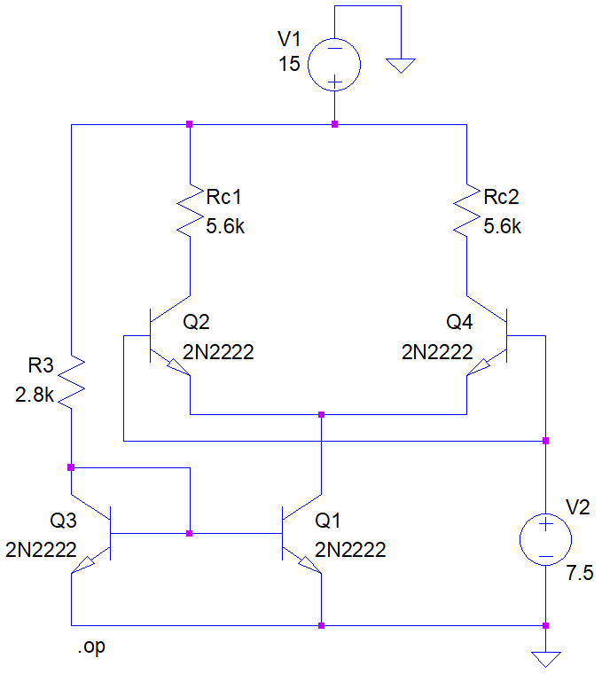

Figure 3.4.1: Current Mirror

### Procedure

1. **According to the formula given, calculate a suitable value for resistance to be used as reference to ensure a 5mA reference current. Formula:**

Resistance: **2.86 kΩ**

1. **Record all the node voltages and branch currents and tabulate the data.**

|  |  |  |  |  |
| --- | --- | --- | --- | --- |
|  | Q1 | Q2 | Q3 | Q4 |
| VB | 687.9 mV | 687.9 mV | 7.5 V | 7.5V |
| VC | 6.8 V | 687.9 mV | 6.793 V | 6.793 V |
| IB | 29.43 A | 29.43 A | 1.211 mA | 1.211 mA |
| IC | 5.353 mA | 4.945 mA | 1.466 mA | 1.466 mA |
| IE | 5.382 mA | 4.976 mA | 2.676 mA | 2.676 mA |

1. **Study the behavior of the current source by changing the precision reference resistor R.**

Resistance: **3.2 kΩ**

1. **Present your findings in an easy to understand manner.**

Increasing the RREF will decrease the sink current that is collector current of transistor Q1.

1. **How is the current being divided among the two branches of the differential amplifier?**

It is being divided equally between the two branches.

## Implementation

1. **Use the same value of resistance used for simulation as your reference resistor. Measure the resistance through multimeter.**

Resistance (Measured): **2.86 kΩ**

1. **Construct the circuit shown in Figure 3.4.1: Current Mirror on breadboard. Make sure that you supply DC voltages to the base terminals of transistors Q1 and Q2. The magnitude of the voltage must be approximately half of the VCC supplied.**

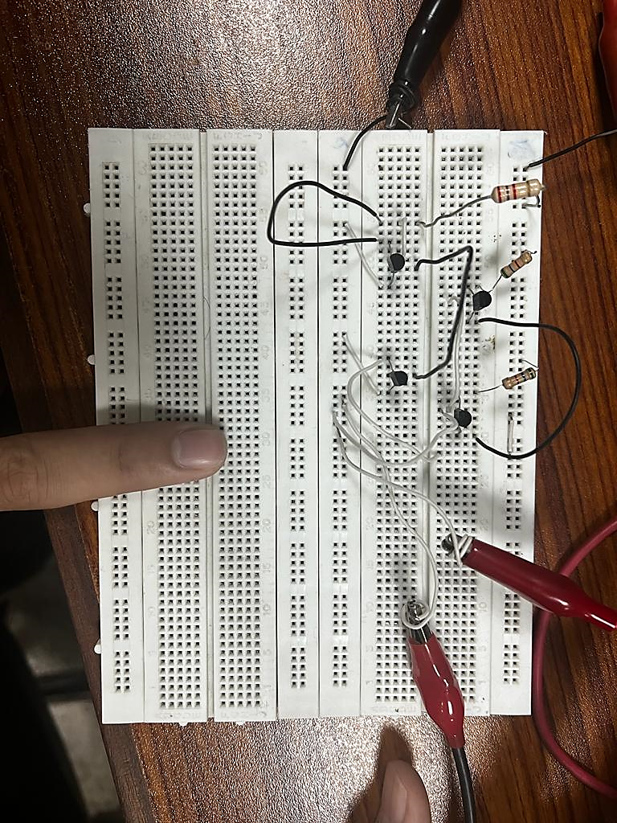

Figure 4.2.1 Implementation

1. **Measure the collector current for Q4 and compare its value to the simulation results.**

IC (Q4): **4.6 mA**

% Age Difference: **3.86%**

1. **Similarly record all the node voltages and branch currents as for the simulation and tabulate the data along with percentage deviation.**

|  |  |  |  |  |
| --- | --- | --- | --- | --- |
|  | Q1 | Q2 | Q3 | Q4 |
| VB | 667 mV (2.6%) | 667 mV (2.61%) | 7.49 V (0.06%) | 7.49 V (0.06%) |
| VC | 6.7 V (1.4%) | 667 mV (3.03%) | 6.75 V (0.73%) | 6.75 V (0.73%) |
| IB | 25.2 A (4.86%) | 25.21 A (4.86%) | 873 A (16%) | 873.2 A (20%) |
| IC | 4.6 mA (3.86%) | 4.23 mA (4.32%) | 1.4 mA (6.32%) | 1.4 mA (5.13%) |
| IE | 4.6 mA (3.99%) | 4.25 mA (4.31%) | 2.2 mA (4.3%) | 2.3 mA (3.46%) |

1. **Study the behavior of the current source by changing the precision reference resistor R. Present your findings in an easy to understand manner.**

Increasing the RREF will decrease the sink current that is collector current of transistor Q1.

1. **Does answer of Q-7 in part 1 satisfy?**

They are almost divided equally between the two branches.

# Conclusion

After performing this lab, we learned about current mirrors, and how their functionality. We understood how to transfer the same current from one part of the circuit to the other without adding multiple current sources. This technique is applied in ICs to keep them small. It can model a real current source since ideal sources do not exist. Furthermore, we found that they had limitations to it. We also find how we set the current, by changing and adjusting the values of RREF resistor. Increasing the resistors value will decrease current that is to be copied. Lastly, we implemented this experiment and found that the current is copied to almost the same value approximately with some current lost as IB.