

**Department of Electrical Engineering**

|  |  |
| --- | --- |
| **Faculty Member: __________** | **Dated: ________________** |
| **Semester:_____________** | **Section: ________________** |

**EE313: ELECTELECTRONIC CIRCUIT DESIGN**

# Lab No 4: Current Sources

|  |  |  |  |  |  |  |
| --- | --- | --- | --- | --- | --- | --- |
| **Name** | **Reg. No** | **Viva** | **Analysis of data in Lab Report** | **Modern Tool Usage** | **Ethics and Safety** | **Individual and Team Work** |
|  |  | **5 Marks** | **5 Marks** | **5 Marks** | **5 Marks** | **5 Marks** |
|  |  |  |  |  |  |  |
|  |  |  |  |  |  |  |
|  |  |  |  |  |  |  |
|  |  |  |  |  |  |  |

**PART 1 Simulation**

**Circuit Diagram:**

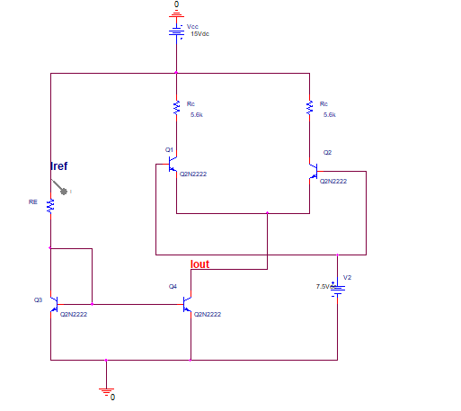

1. According to the formula given below calculate a suitable value for resistance to be used as reference to ensure a 5mA reference current

**RREF= VCC-0.7/ IREF**

Resistance: ____________ Ohms

1. Construct the circuit shown in figure1 in Spice. Make sure that you supply DC voltages to base of transistors Q1 and Q2. The magnitude of the voltage must be approximately half of the Vcc Supplied. (Typical VCC =15V)
2. Perform a bias point Analysis.
3. Record all the node voltages and branch currents and tabulate the data.
4. Study the behavior of the current source by changing the precision reference resistor R.
5. Present your findings in an easy to understand manner.
6. How is the current being divided among the two branches of the differential amplifier?

.

**PART 1 Implementation**

1. Use the same value of resistance used for simulation as your reference resistor. Measure the resistance through multimeter.

Resistance (Measured) :______________ Ohms

1. Construct the circuit shown in figure1 on breadboard. Make sure that you supply DC voltages to the base terminals of transistors Q1 and Q2. The magnitude of the voltage must be approximately half of the Vcc Supplied. (Typical VCC =15V)
2. Measure the collector current for transistor Q4 and compare its value to the simulation results.

IC (Q4): ____________ Amps

%age Difference: ____________

1. Similarly record all the node voltages and branch currents as for the simulation and tabulate the data along with percentage deviation.
2. Study the behavior of the current source by changing the precision reference resistor R.
3. Present your findings in an easy to understand manner.
4. Does answer of Q-7 in part 1 satisfied?

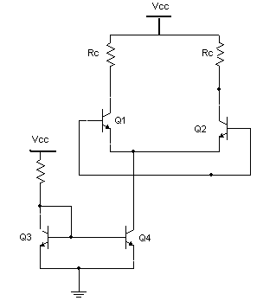

**Figure 1 Basic Current Source**