**Department of Electrical Engineering and   
Computer Science**

**Faculty Member:** Dr. Shakeel Alvi  **Dated:** 11/10/2022

**Semester:** 5th **Section:** BEE 12C

**EE-313:** **Electronic Circuit Design**

Lab 5: BJT Current Mirror Circuits

Group Members

|  |  |  |  |  |
| --- | --- | --- | --- | --- |
| **Name** | **Reg. No** | **Report**  **Marks** | **Viva**  **Marks** | **Total**  **Marks** |
|  |  | **10 Marks** | **5 Marks** | **15 Marks** |
| Danial Ahmad | 331388 |  |  |  |
| Muhammad Ahmed Mohsin | 333060 |  |  |  |
| Muhammad Umer | 345834 |  |  |  |
| Tariq Umar | 334943 |  |  |  |
|  |  |  |  |  |

**Table of Contents**

3 Current Sources 3

3.1 Objectives 3

3.2 Equipment 3

3.3 Introduction 3

3.4 Lab Instructions 3

4 Lab Tasks 4

4.1 Simulation 4

4.1.1 Circuit 4

4.1.2 Procedure 4

4.2 Implementation 5

4.2.1 Circuit 5

5 Conclusion 6

**Table of Figures**

Figure 3.4.1: Current Mirror 4

# Current Sources

## Objectives

* To design a Wilson Current Mirror
* To implement Wilson current mirror circuit on hardware

## Equipment

Hardware

* Discrete elements
* Breadboard
* BJTs

Software

* PSpice



## Introduction

This laboratory exercise is meant to enable the students to design and understand the basic working of current mirrors. For this, current mirrors with different configurations are implemented and the current voltage relationships and output resistance of the circuits are studied thoroughly. In the end, a conclusion is drawn on the basis of comparative study.

## Lab Instructions

All questions should be answered precisely to get maximum credit. Lab report must ensure following items:

* Lab objectives
* Results (Graphs/Tables) duly commented and discussed
* Conclusion

# Lab Tasks

Simulation

### Circuit

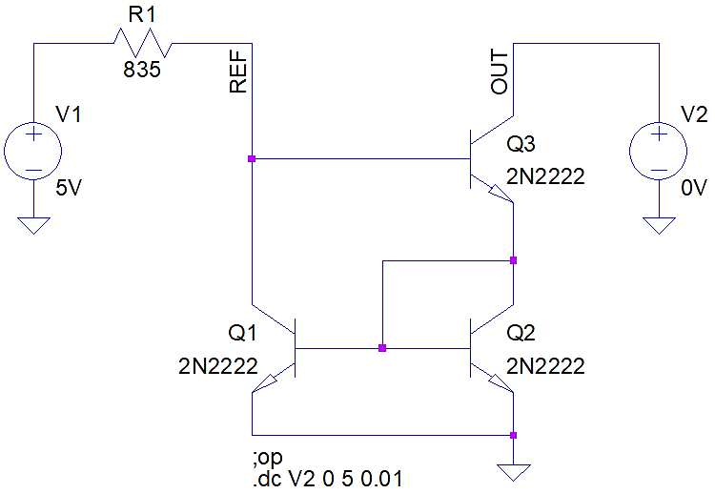

Figure 3.4.1: Current Mirror

### Procedure

1. **Determine the value of resistor R1 to generate IREF of 4.31 mA.**

Resistance R1: **835 Ω**

1. **Calculate the percentage difference between the desired and simulated value of output current.**

Percentage Difference: **0.316 %**

1. **Alter the voltage V2 as shown in following table and record the values of IO at Q2.**

|  |  |  |  |  |  |
| --- | --- | --- | --- | --- | --- |
| V2 DC | 1V | 2V | 3V | 4V | 5V |
| IO at Q3 | 4.295 mA | 4.296 mA | 4.297 mA | 4.298 mA | 4.299 mA |

1. **Keeping V2 at 5 volts, add the following resistances, one by one, to output i.e., collector of Q3 and measure the value of output current for each of the resistance.**

|  |  |
| --- | --- |
| RL = 1 kΩ | RL = 4.7 kΩ |
| Io = 4.21 mA | Io = **0.916 mA** |
| Percentage Difference: 2.32% | Percentage Difference: **78.74%** |

1. **Calculate the output resistance of the circuit using DC sweep.**

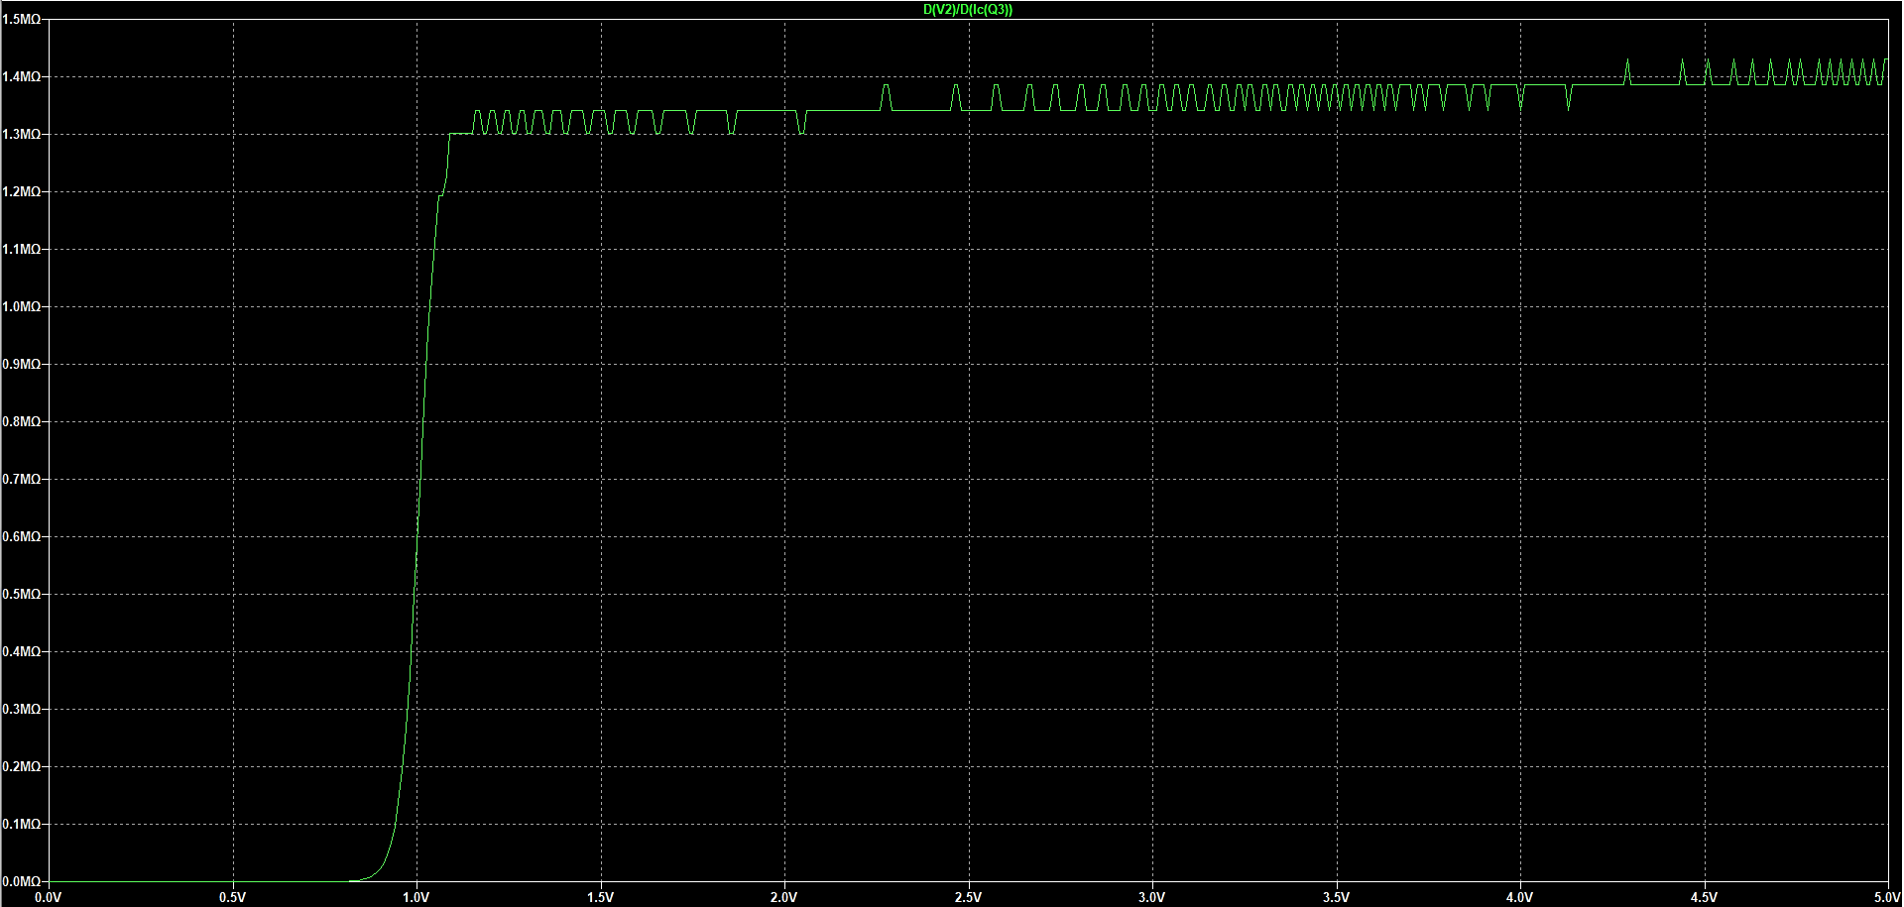

Output Resistance: **1.38 MΩ**

## Implementation

### Circuit

1. **Determine the value of resistor R1 to generate IREF of 4.31 mA.**

Resistance R1 (Nearest to simulation available in lab) **= 800 Ω**

1. **Calculate the percentage difference between the desired and simulated value of output current.**

IREF = **4.17 mA**

IO = **3.62 mA**

Percentage Difference = $\frac{3.62 – 3.82}{3.82}×100\%$ = **13.12 %**

1. **Alter the voltage V2 as shown in following table and record the values of IO at Q2.**

|  |  |  |  |  |  |
| --- | --- | --- | --- | --- | --- |
| V2 DC | 1V | 2V | 3V | 4V | 5V |
| IO at Q3 | 2.85 mA | 3.50 mA | 3.61 mA | 3.52 mA | 3.32 mA |

1. **Keeping V2 at 5 volts, add the following resistances, one by one, to output i.e., collector of Q3 and measure the value of output current for each of the resistance.**

|  |  |
| --- | --- |
| RL = 1 kΩ | RL = 4.7 kΩ |
| Io = 3.328 mA | Io = **380.5 $μ$ A** |
| Percentage Difference: 21.21% | Percentage Difference: **58.64%** |

1. **Calculate the output resistance of the circuit.**

From $R_{out}=\frac{1}{2}βr_{o}$, and with $β=140$

Output Resistance: **2.13 MΩ**

# Conclusion

After performing this lab, we learned about current mirrors, and how their functionality. We understood how to transfer the same current from one part of the circuit to the other without adding multiple current sources. This technique is applied in ICs to keep them small. It can model a real current source since ideal sources do not exist. Furthermore, we found that they had limitations to it. We also find how we set the current, by changing and adjusting the values of RREF resistor. Increasing the resistors value will decrease current that is to be copied. Lastly, we implemented this experiment and found that the current is copied to almost the same value approximately with some current lost as IB.