**Department of Electrical Engineering and   
Computer Science**

**Faculty Member:** Dr. Shakeel Alvi  **Dated:** 16/10/2022

**Semester:** 5th **Section:** BEE 12C

**EE-313:** **Electronic Circuit Design**

Lab 5: BJT Current Mirror Circuits

(Wilson Current Mirror)

Group Members

|  |  |  |  |  |
| --- | --- | --- | --- | --- |
| **Name** | **Reg. No** | **Report**  **Marks** | **Viva**  **Marks** | **Total**  **Marks** |
|  |  | **10 Marks** | **5 Marks** | **15 Marks** |
| Danial Ahmad | 331388 |  |  |  |
| Muhammad Ahmed Mohsin | 333060 |  |  |  |
| Muhammad Umer | 345834 |  |  |  |
| Tariq Umar | 334943 |  |  |  |

**Table of Contents**

3 Current Sources 3

3.1 Objectives 3

3.2 Equipment 3

3.3 Introduction 3

3.4 Lab Instructions 3

3.5 Theory and Background 3

4 Lab Tasks 4

4.1 Part 1: Simulation of Wilson Current Mirror 4

4.1.1 Circuit 4

4.1.2 Procedure 4

4.2 Part 2: Simulation of Wilson Current Mirror 6

5 Conclusion 7

**Table of Figures**

Figure 4.1: Wilson Current Mirror 4

Figure 4.2: IREF and Io (Q3) 5

# Current Sources

## Objectives

* To design a Wilson Current Mirror
* To implement Wilson current mirror circuit on hardware

## Equipment

Hardware

* Discrete elements
* Breadboard
* BJTs

Software

* PSpice



## Introduction

A current mirror is a circuit designed to copy a current through one active device by controlling the current in another active device of a circuit, keeping the output current constant regardless of loading. The current being "copied" can be, and sometimes is, a varying signal current. In this lab, current mirrors with different configurations are implemented and the current voltage relationships and output resistance of the circuits are studied thoroughly. In the end, a conclusion is drawn based on comparative study.

## Lab Instructions

All questions should be answered precisely to get maximum credit. Lab report must ensure following items:

* Lab objectives
* Results (Graphs/Tables) duly commented and discussed
* Conclusion

## Theory and Background

* A current mirror is a circuit which can provide a copy of a current from a single reference current source to one or more circuit elements which require current biasing. This allows for distribution from a single reference by minimizing direct connections to the reference current source. In addition the current steering circuits can be added to allow for the reference current to be distributed to many circuits that require biasing constant currents.
* The basic PSpice models and symbols are given in table-1. These will be used in the exercise.

# Lab Tasks

Part 1: Simulation of Wilson Current Mirror

### Circuit



**Figure 4.1: Wilson Current Mirror**

### Procedure

1. **Determine the value of resistor R1 to generate IREF of 4.31 mA.**

**Formula:**

R1: **835Ω**

1. **Now setup the circuit in PSPICE as shown in (Fig-1) and use the “Bias Point” analysis type to show that the collector current IO in Q3 is nearly the same as IREF. In addition save the graph by using print screen option.**

**Note:** V2 in this part is 3V.

**The Percentage Difference $=\frac{{|I}_{REF}|{- |I}_{c}(Q3)|}{|I_{REF|}}$**

**= 0.65%**

**Graph:**

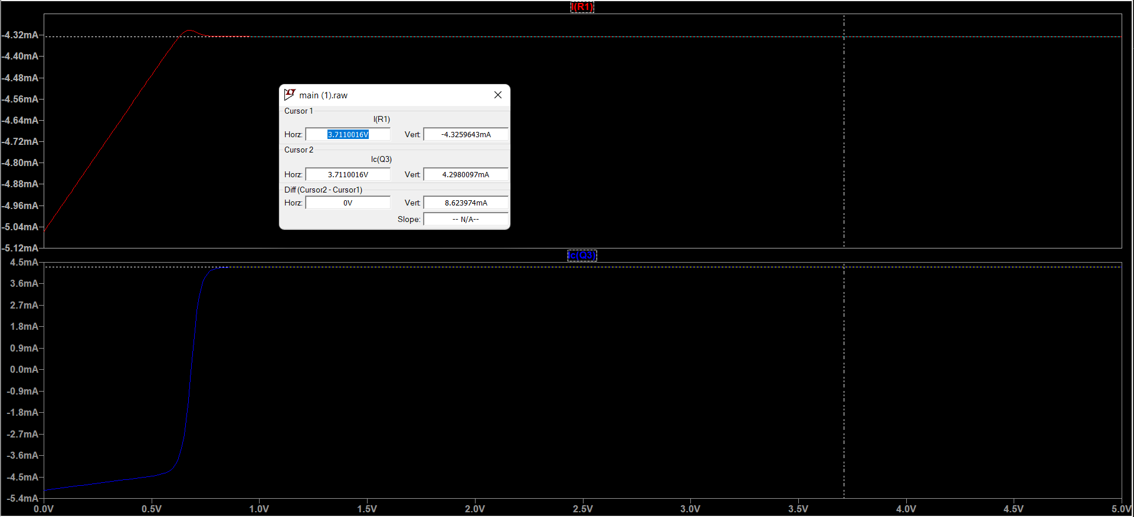

**Figure 4.2: IREF and Io (Q3)**

1. **Now alter the voltage V2 as shown in the following table and record the values of IO at Q3**

|  |  |  |  |  |  |
| --- | --- | --- | --- | --- | --- |
| V2 DC Supply | 1V | 2V | 3V | 4V | 5V |
| IO at Q3 | 4.295 mA | 4.296 mA | 4.297 mA | 4.298 mA | 4.299 mA |

1. **While keeping V2 at 5 Volts add the following resistances, one by one, to output i.e. collector of Q3, and measure the value of output current for each of the resistance.**

**RL=**1kΩ **RL=**4.7kΩ

**Io=** 4.21 mA **Io=** 0.916 mA

**%age difference:** 2.54%  **%age difference:** 78.47%

1. **Now calculate the output resistance of the circuit. This can be done by selecting the “DC Sweep” analysis type and sweeping the voltage V2 with Start Value=0, End Value=5, and Increment=0.01. The output resistance is the slope of the IV-curve generated. In addition, save the graph by using the print screen option.**

**Output Resistance =**

## Part 2: Simulation of Wilson Current Mirror

1. **Determine the value of resistor R1 to generate IREF of 4.31 mA.**

R1 (Nearest to simulation available in lab) **= 800Ω**

1. **Now setup the circuit on Breadboard as shown in (Figure 4.1: Wilson Current Mirror) and use the “Bias Point” analysis type to show that the collector current IO in Q3 is nearly the same as IREF. In addition save the graph by using print screen option.**

**Note:** V2 in this part is 3V.

**The Percentage Difference $=\frac{{|I}_{REF}|{- |I}_{c}(Q3)|}{|I_{REF|}}$**

**= %**

1. **Now alter the voltage V2 as shown in the following table and record the values of IO at Q3**

|  |  |  |  |  |  |
| --- | --- | --- | --- | --- | --- |
| V2 DC Supply | 1V | 2V | 3V | 4V | 5V |
| IO at Q3 | mA | mA | mA | mA | mA |

1. **While keeping V2 at 5 Volts add the following resistances, one by one, to output i.e. collector of Q3, and measure the value of output current for each of the resistance.**

**RL=**1kΩ **RL=**4.7kΩ

**Io=**  mA **Io=**  mA

**%age difference:** %  **%age difference:** %

1. **Using the results for step 4.2.3 find the output resistance of the circuit. This can be done by calculating the slope of the I-V graph and taking the inverse of slope.**

**Output Resistance =**

# Conclusion