**Department of Electrical Engineering and   
Computer Science**

**Faculty Member:** Dr. Shakeel Alvi  **Dated:** 19/10/2022

**Semester:** 5th **Section:** BEE 12C

**EE-313:** **Electronic Circuit Design**

Lab 6: BJT Current Mirror Circuits (Widlar)

Group Members

|  |  |  |  |  |
| --- | --- | --- | --- | --- |
| **Name** | **Reg. No** | **Report**  **Marks** | **Viva**  **Marks** | **Total**  **Marks** |
|  |  | **10 Marks** | **5 Marks** | **15 Marks** |
| Danial Ahmad | 331388 |  |  |  |
| Muhammad Ahmed Mohsin | 333060 |  |  |  |
| Muhammad Umer | 345834 |  |  |  |
| Tariq Umar | 334943 |  |  |  |
|  |  |  |  |  |

**Table of Contents**

3 Current Sources 3

3.1 Objectives 3

3.2 Equipment 3

3.3 Introduction 3

3.4 Lab Instructions 3

4 Lab Tasks 4

4.1 Simulation 4

4.1.1 Circuit 4

4.1.2 Procedure 4

4.2 Implementation 5

4.2.1 Circuit 5

5 Conclusion 6

**Table of Figures**

Figure 3.4.1: Current Mirror 4

# Current Sources

## Objectives

* To design a Widlar current mirror
* To implement Widlar current mirror circuit on hardware

## Equipment

Hardware

* Discrete elements
* Breadboard
* BJTs

Software

* PSpice



## Introduction

This laboratory exercise is meant to enable the students to design and understand the basic working of current mirrors. For this, current mirrors with different configurations are implemented and the current voltage relationships and output resistance of the circuits are studied thoroughly. In the end, a conclusion is drawn on the basis of comparative study.

## Lab Instructions

All questions should be answered precisely to get maximum credit. Lab report must ensure following items:

* Lab objectives
* Results (Graphs/Tables) duly commented and discussed
* Conclusion

# Lab Tasks

Simple Current Mirror

### Circuit

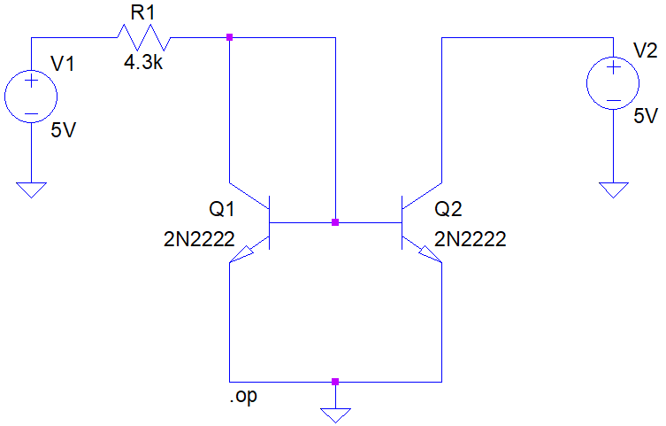

Figure 4.1.1.1: Simple Current Mirror

### Procedure

1. **Determine the value of resistor R1 to generate IREF of 1 mA.**

Resistance R1: **4.3 kΩ**

1. **Calculate the percentage difference between the desired & simulated value of output current.**

Percentage Difference: **0.4 %**

1. **Alter the voltage V2 as shown in following table and record the values of IO at Q2.**

|  |  |  |  |  |  |
| --- | --- | --- | --- | --- | --- |
| V2 DC | 1V | 2V | 3V | 4V | 5V |
| IO at Q3 | 1 mA | 1.01 mA | 1.02 mA | 1.03 mA | 1.04 mA |

1. **What would be the value of R1 if IO at Q2 is required to be 10 µA?**

Resistance R1: **430 kΩ**

## Widlar Current Mirror (Simulation)

### Circuit

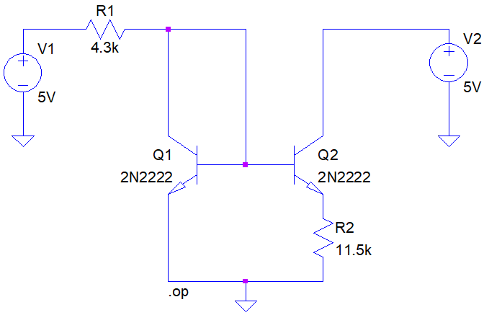

Figure . Widlar Current Mirror

1. **Determine the value of resistor R1 to generate IREF of 1 mA.**

Resistance R1: **4.3 kΩ**

1. **What would be the value of R2 if IO at Q2 is required to be 10 µA?**

Resistance R1: **11.5 kΩ**

1. **Calculate the percentage difference between the desired & simulated value of output current.**

Percentage Difference: **0.36 %**

1. **Comparing the value of resistances in simple and Widlar current mirror, which approach is better to be implemented from integrated circuit design point of view?**

The circuit with an emitter resistance is better i.e., Widlar current source. This is because large resistances (430 k $Ω$) are not feasible to fit in an IC without making it significantly bigger.

1. **Calculate the output resistance of the circuit.**

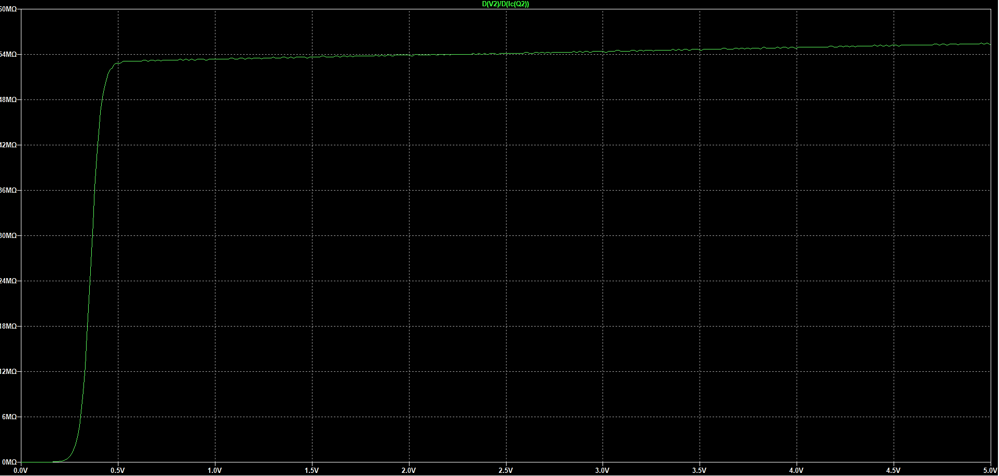

Output Resistance: **54.1 MΩ**

## Widlar Current Mirror (Implementation)

1. **Determine the value of resistor R1 to generate IREF of 1 mA.**

Resistance R1: **4.7 kΩ (Available)**

1. **Calculate the percentage difference between the desired & simulated value of output current.**

$$I_{O}=10.07 μA$$

Percentage Difference: **0.7 %**

1. **Alter the voltage V2 as shown in following table and record the values of IO at Q2.**

|  |  |  |  |  |  |
| --- | --- | --- | --- | --- | --- |
| V2 DC | 1V | 2V | 3V | 4V | 5V |
| IO at Q3 | 10.23 $μ$ A | 10.28 $μ$ A | 10.07 $μ$ A | 10.38 $μ$ A | 10.41 $μ$ A |

1. **Calculate the output resistance of the circuit.**

Output Resistance: **53.2 MΩ**

# Conclusion

In this lab, we implemented a type of BJT current mirror known as Widlar current mirror configuration. We simulated the Widlar configuration on PSpice and implemented it on hardware as well. Different conclusions were drawn by comparisons of the results, and we noted its advantages over a simple current mirror in context of IC design.