**Department of Electrical Engineering and   
Computer Science**

**Faculty Member:** Dr. Shakeel Alvi  **Dated:** 25/10/2022

**Semester:** 5th **Section:** BEE 12C

**EE-313:** **Electronic Circuit Design**

Lab 7: Differential Pair with Resistive Load

Group Members

|  |  |  |  |  |
| --- | --- | --- | --- | --- |
| **Name** | **Reg. No** | **Report**  **Marks** | **Viva**  **Marks** | **Total**  **Marks** |
|  |  | **10 Marks** | **5 Marks** | **15 Marks** |
| Danial Ahmad | 331388 |  |  |  |
| Muhammad Ahmed Mohsin | 333060 |  |  |  |
| Muhammad Umer | 345834 |  |  |  |
| Tariq Umar | 334943 |  |  |  |
|  |  |  |  |  |

**Table of Contents**

3 Current Sources 3

3.1 Objectives 3

3.2 Equipment 3

3.3 Introduction 3

3.4 Lab Instructions 3

4 Lab Tasks 4

4.1 Simulation 4

4.1.1 Circuit 4

4.1.2 Procedure 4

4.2 Implementation 5

4.2.1 Circuit 5

5 Conclusion 6

**Table of Figures**

Figure 3.4.1: Current Mirror 4

# Current Sources

## Objectives

* To design a BJT differential amplifier

## Equipment

Hardware

* Discrete elements
* Breadboard
* BJTs

Software

* PSpice



## Introduction

Differential amplifiers are designed to amplify the difference between two signals; thus, such amplifiers are capable of reducing noise that is common to both inputs. We can quantify the differential-mode versus common-mode gain in a quantity called the common-mode rejection ratio (CMRR). Differential amplifiers also lend themselves to use in feedback, though we will not explore that usage in this lab. A typical differential amplifier with a single-ended output is the op-amp.

## Lab Instructions

All questions should be answered precisely to get maximum credit. Lab report must ensure following items:

* Lab objectives
* Results (Graphs/Tables) duly commented and discussed
* Conclusion

# Lab Tasks

## Circuit

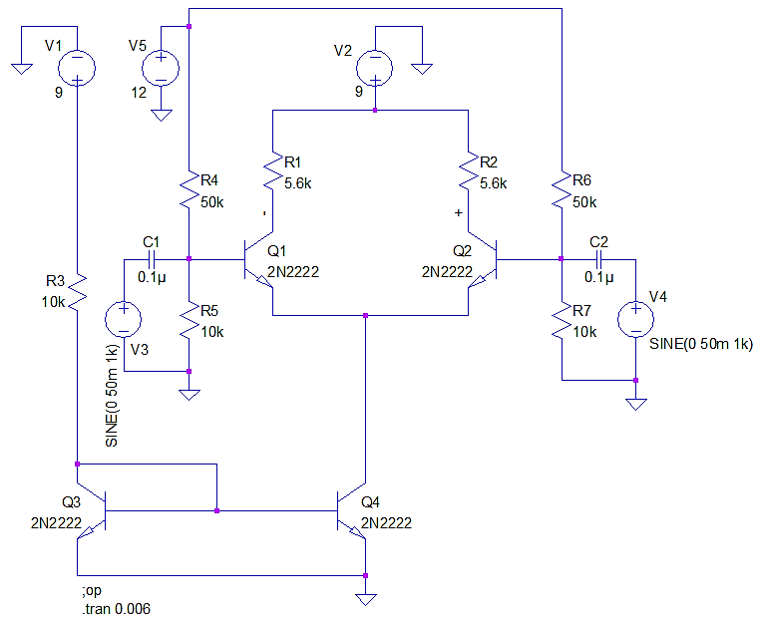

Calculation

1. Perform step by step, DC Analysis of the circuit and mention equations used for the same. Calculate the DC bias currents IC1, IC2, IC3, and Voltages VC1 and VC2.

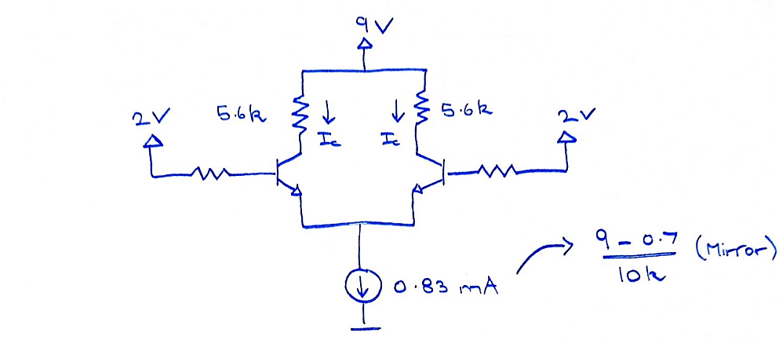

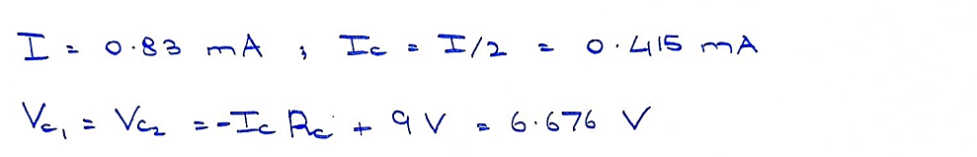

|  |  |  |  |
| --- | --- | --- | --- |
| IC1: 0.415 mA | IC:0.415 mA | | IC3: 0.830 mA |
| VC1: 6.676 V | | **VC2:** 6.676 V | |

## Simulation

1. Simulate the circuit using SPICE software. Perform a Bias point Analysis and compare with your calculated values.

|  |  |  |  |
| --- | --- | --- | --- |
| IC1: 0.414 mA | IC:0.414 mA | | IC3: 0.832 mA |
| VC1: 6.68 V | | **VC2:** 6.68 V | |

1. Using differential Markers, obtain the waveform for VOUT. Also, by “Add plot to window” option, obtain output waveforms on Vo1 and Vo2 using voltage level marker. Compare the waveforms obtained and comment on results.

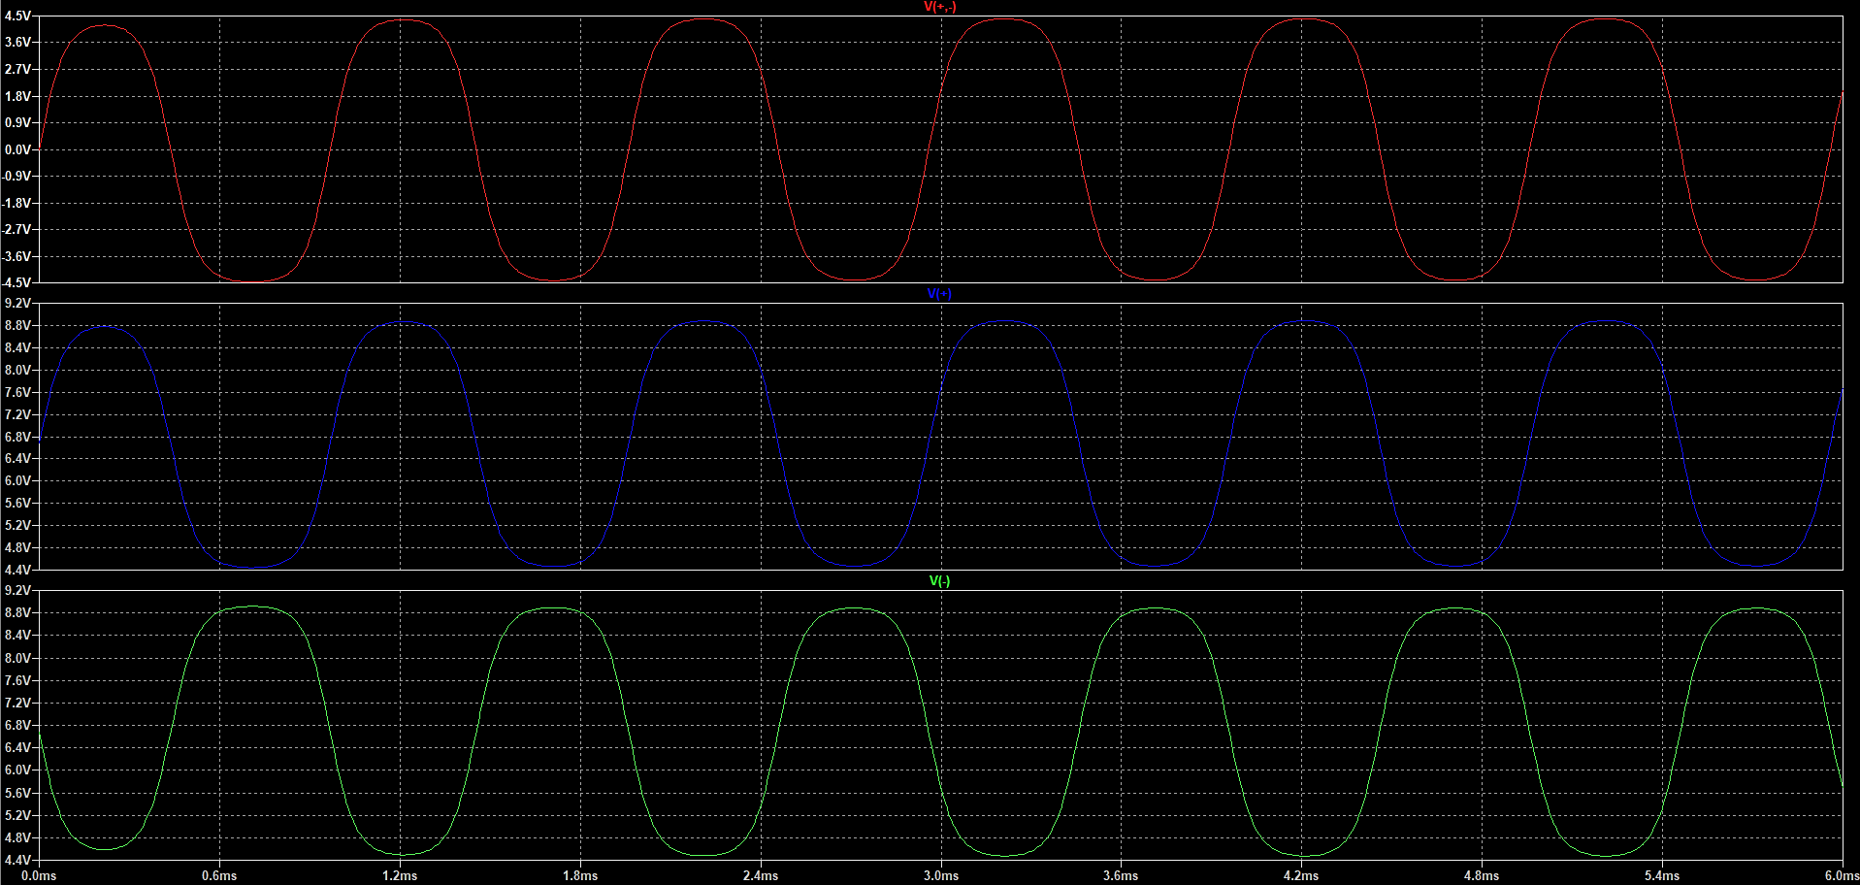

**Comments:** From the three observed waveforms, we can deduce that if the input signals to a differential amplifier are 180 $°$ out of phase, our amplifier will only amplify the “difference”, filtering out all noise and other disturbances.

1. Change the amplitude of V3 to 100 mV first and then change amplitude of V4 to 100 mV and observe and comment on results both cases.

**Case 1:** V3 = 100 mV; V4 = 50 mV

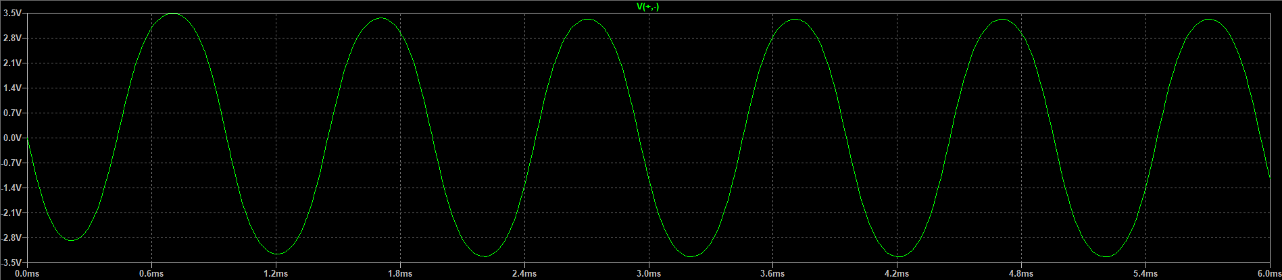

**Case 2:** V3 = 100 mV; V4 = 100 mV

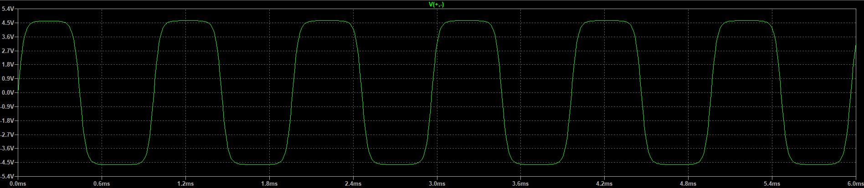

**Comments:** Case 1 results in a more sinusoidal waveform due to the amplitude of the +ive terminal of the differential output being lower than the -ive terminal, whereas in Case 2, differential symmetry causes the output to seem like a square-sine wave hybrid.

1. Change the value of resistor R3 i.e., reference resistor for current mirror and discuss the impact on output and results.

**Answer:** With an increase in R3, the reference current of the mirror decreases, thereby causing a decrease in the current flowing through each transistor of the differential amplifier. As a result, the transconductance $g_{m}=\frac{I_{c}}{V_{t}}$ decreases and so does the gain of our design, and vice versa.

1. Change the value of resistors R1 and R2 and observe your output.

**Answer:** No apparent effect appears on the gain if both R1 and R2 are increased/decreases by the same factor.

# Conclusion

In this lab we learnt about the basics of differential amplifier. The differential amplifier has a common made gain of zero and is used to amplify differential inputs. We learnt through different simulations about the resistance mismatch that takes place in the amplifier and correlated it with our theoretical knowledge. This lab helped us build practical knowledge and proper applications of differential amplifiers.