**Department of Electrical Engineering and   
Computer Science**

**Faculty Member:** Dr. Shakeel Alvi  **Dated:** 01/11/2022

**Semester:** 5th **Section:** BEE 12C

**EE-313:** **Electronic Circuit Design**

Lab 8: Differential Amplifier  
(Common Mode Gain and Common Mode Rejection Ratio)

Group Members

|  |  |  |  |  |
| --- | --- | --- | --- | --- |
| **Name** | **Reg. No** | **Report**  **Marks** | **Viva**  **Marks** | **Total**  **Marks** |
|  |  | **10 Marks** | **5 Marks** | **15 Marks** |
| Danial Ahmad | 331388 |  |  |  |
| Muhammad Ahmed Mohsin | 333060 |  |  |  |
| Muhammad Umer | 345834 |  |  |  |
| Tariq Umar | 334943 |  |  |  |
|  |  |  |  |  |

**Table of Contents**

3 Differential Amplifier 3

3.1 Objectives 3

3.2 Equipment 3

3.3 Introduction 3

3.4 Lab Instructions 3

4 Lab Tasks 4

4.1 Circuit 4

4.2 Calculation 4

4.3 Simulation 5

4.4 Implementation 6

4.5 Common Mode Rejection Ratio 6

5 Conclusion 6

**Table of Figures**

Figure 4.1.1 Schematic 4

# Differential Amplifier

## Objectives

* To design a BJT differential amplifier

## Equipment

Hardware

* Discrete elements
* Breadboard
* BJTs

Software

* PSpice



## Introduction

A differential amplifier is a circuit with plus (+) or minus (-) inputs. In typical operation inputs which are opposite in-phase are amplified greatly, while inputs which are in-phase are cancelled at the output. Typically, no capacitor is needed, the input signals being DC coupled, and positive (VCC) and negative (VEE) supplies providing DC bias.

## Lab Instructions

All questions should be answered precisely to get maximum credit. Lab report must ensure following items:

* Lab objectives
* Results (Graphs/Tables) duly commented and discussed
* Conclusion

# Lab Tasks

## Circuit

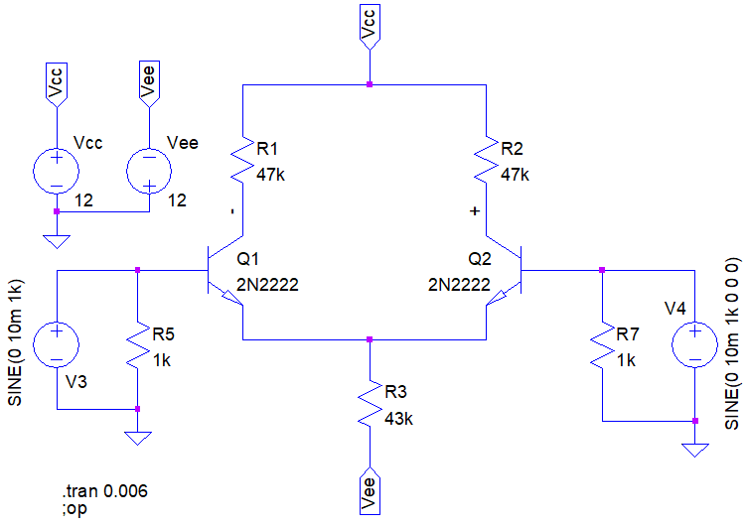

Figure . Schematic

Calculation

1. Calculate the following DC values for the given circuit.

|  |  |
| --- | --- |
| Q1 | Q2 |
| VE1 = -0.7 V | VE2 = -0.7 V |
| VB1 = 0 V | VB2 = 0 V |
| VC1 = 5.82 V | VC2 = 5.82 V |
| IE1 = 131.4 $μ$ A | IE2 = 131.4 $μ$ A |
| re1 = 190.3 $Ω$ | re2 = 190.3 $Ω$ |

1. Calculate the differential gain (differential gain) of the amplifier.

**AD (calculated)** = 246.97 V/V

1. Calculate the common-mode gain of the amplifier shown.

**AC (calculated)** = 0 V/V

## Simulation

1. Simulate the circuit given using PSpice and record the following DC values.

|  |  |
| --- | --- |
| Q1 | Q2 |
| VE1 = -0.69 V | VE2 = -0.69 V |
| VB1 = 0 V | VB2 = 0 V |
| VC1 = 5.799 V | VC2 = 5.799 V |
| IE1 = 132.5 $μ$ A | IE2 = 132.5 $μ$ A |
| re1 = 188.67 $Ω$ | re2 = 188.67 $Ω$ |

1. Using transient analysis, obtain the differential gain for given amplifier. Sketch the output waveform below.

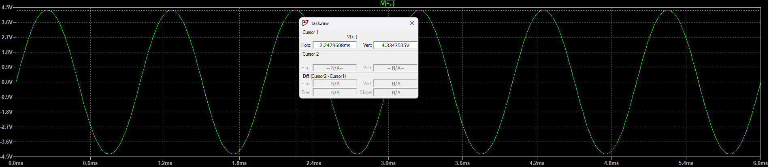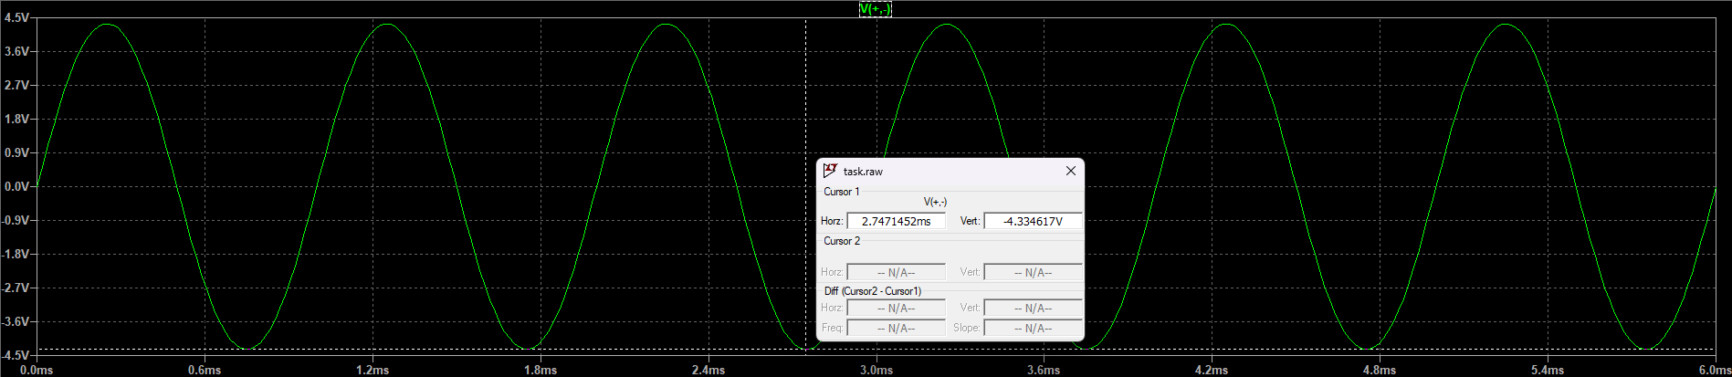

**AD (simulated)** = 216.7 V/V

1. Simulate the circuit using PSpice and using transient analysis observe the output Sketch the waveform below.

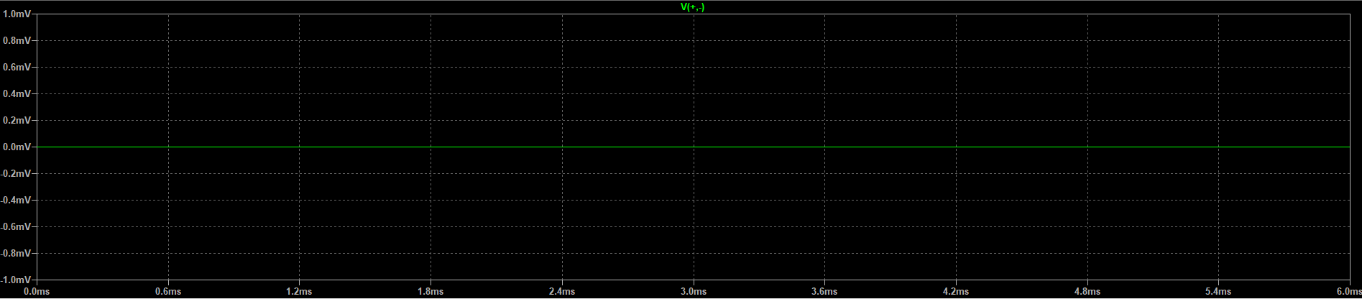

**AC (simulated)** = 0 V/V

## Implementation

1. Patch the circuit using PSpice and measure the following dc values using multimeter.

|  |  |
| --- | --- |
| Q1 | Q2 |
| VE1 = -0.69 V | VE2 = -0.69 V |
| VB1 = 0 V | VB2 = 0 V |
| VC1 = 5.764 V | VC2 = 5.761 V |
| IE1 = 131.5 $μ$ A | IE2 = 130.7 $μ$ A |
| re1 = 190.03 $Ω$ | re2 = 191.20 $Ω$ |

1. Using oscilloscope, obtain the waveform and hence differential gain for amplifier in figure 1. Sketch the output waveform below. Note that you may have to use both the probes and MATH function for the differential output.

**AD (Measured)** = 207.3 V/V

1. Adjust the circuit according to figure 2 and using oscilloscope, observe the output. Sketch the waveform below. Make sure that the oscilloscope channel you use is AC coupled or you may use a suitable Capacitor.

**AC (Measured)** = 2.4 mV/V

## Common Mode Rejection Ratio

1. Calculate the Common Mode Rejection Ratio using the values calculated, simulated and measured.

**CMRR (Calculated)** = $∞$

**CMRR (Simulated)** = $∞$

**CMRR (Measured)** = 86375

1. Comment on the proximity of the values for CMRR.

**Answer:** CMRR is significantly lower when implemented physically than when calculated and/or simulated as real life resistance mismatch is always present (due to tolerance and other factors).

# Conclusion

In this lab, we further familiarized ourselves with differential amplifiers. We learnt through different simulations about the resistance mismatch that takes place in the amplifier and correlated it with our theoretical knowledge. We observe that real-life implementation of a differential amplifier does not have $∞$ CMRR, due to the current source being non-ideal and due to the presence of resistance mismatches. This lab helped us build practical knowledge and proper applications of differential amplifiers.