|  |  |
| --- | --- |
| **Faculty Member:_________________** | **Dated: _________________** |
| **Semester:_____________** | **Section: ________________** |

**EE313: ELECTRONIC CIRCUIT DESIGN**

**Lab08: Differential amplifier**

**(Common Mode Gain and Common Mode Rejection Ratio)**

|  |  |  |  |  |  |  |
| --- | --- | --- | --- | --- | --- | --- |
| **Name** | **Reg. No** | **Viva** | **Analysis of data in Lab Report** | **Modern Tool Usage** | **Ethics and Safety** | **Individual and Team Work** |
|  |  | **5 Marks** | **5 Marks** | **5 Marks** | **5 Marks** | **5 Marks** |
|  |  |  |  |  |  |  |
|  |  |  |  |  |  |  |
|  |  |  |  |  |  |  |
|  |  |  |  |  |  |  |

Lab-08: Differential amplifier

(Common Mode Gain and Common Mode Rejection Ratio)

**Objective:**

To measure and observe common mode gain and common mode rejection ratio of differential amplifier.

**Equipment Required:**

Instruments: Oscilloscope, DMM, Function Generator & DC Supply.

Components: Resistors: 2 x 47 KΩ 1 x 43 KΩ, Transistors: 2 x 2N3904 BJT Transistor

**Differential Amplifier:**

A differential amplifier is a circuit with plus (+) or minus (-) inputs. In typical operation inputs which are opposite in-phase are amplified greatly, while inputs which are in-phase are cancelled at the output. **Figure 1** is the circuit of a simple BJT differential amplifier with plus (Vin+) input and minus (Vin-) input, and outputs, **Vo1** and **Vo2**. Typically no capacitor is needed, the input signals being DC coupled, and positive (VCC) and negative (VEE) supplies providing DC bias.

**Modes of Operation:**

1. If two opposite-polarity input signals are applied, the operation is referred to as “differential mode.”
2. If the same input is applied to both inputs, the operation is called “common-mode.”

* In differential operation, two input signals are applied, the difference of the inputs resulting in different outputs from both collectors.
* In common-mode operation, the common input signal results in same output at each collector, these signals cancel each other if differential output is taken so the resulting output signal is zero. Due to mismatches, the output signals do not completely cancel, and a small differential output signal results.
* The ratio of this differential gain to common gain is called common-mode rejection ratio.

**Calculations of Gains:**

*Note: we are assuming ${r_{e}}_{1}$* ***= $r_{e2}$ = $r_{e}$***

The Differential voltage Gain can be calculated as

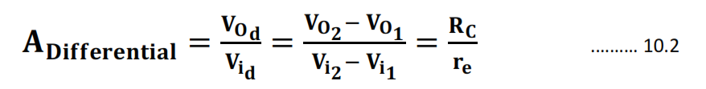

If input signal is common to both the inputs then

$A_{cm}$**= $\frac{V_{od}}{V_{icm}}$ = $\frac{-α ∆R_{c}}{2R_{EE}}$** …….10.3

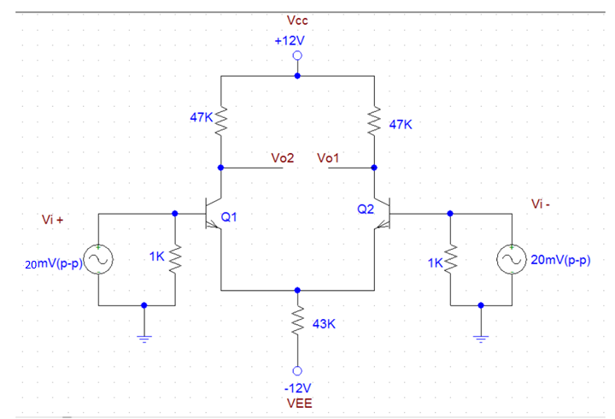

**Figure 1: Differential mode operation**

**PART 1- CALCULATION**

* For the circuits given in figure 1. Calculate the following DC values.

|  |  |
| --- | --- |
| Q 1 | Q2 |
| VE1 (Calc.)=___________________________ | VE2 (Calc.)=___________________________ |
|  |  |
| VB1 (Calc.)=___________________________ | VB2 (Calc.)=___________________________ |
|  |  |
| VC1 (Calc.)=___________________________ | VC2 (Calc.)=___________________________ |
|  |  |
| IE1 (Calc.)=___________________________ | IE2 (Calc.)=___________________________ |
|  |  |
| re1 (Calc.)=___________________________ | re2 (Calc.)=___________________________ |

* Calculate the differential gain(differential gain) of the amplifier using equation 10.2

**AD (calculated) =________________**

* Calculate the common-mode gain of the amplifier shown in figure 2. using equation 10.3

**AC (calculated) =________________**

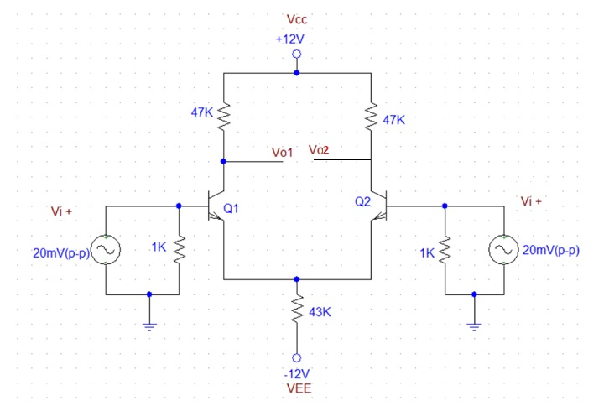

**Figure 2: Common mode operation**

**PART 2- SIMULATION**

* Simulate the circuit given in figure 1 using PSpice and record the following dc values using Bias point analysis.

|  |  |
| --- | --- |
| Q1 | Q2 |
| VE1 = -0.7 V | VE2 = -0.7 V |
| VB1= 0 V | VB2 = 0 V |
| VC1 = 5.82 V | VC2 = 5.82 V |
| IE1 = 131.4 $μ$ A | IE2 = 131.4 $μ$ A |
| re1 = 190.3 $Ω$ | re2 = 190.3 $Ω$ |

* Using transient analysis, obtain the differential gain for amplifier in figure 1. Sketch the output waveform below.

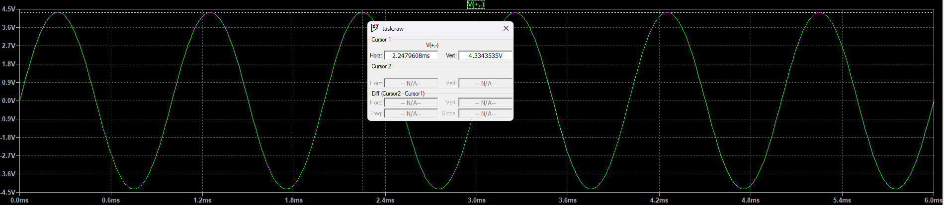

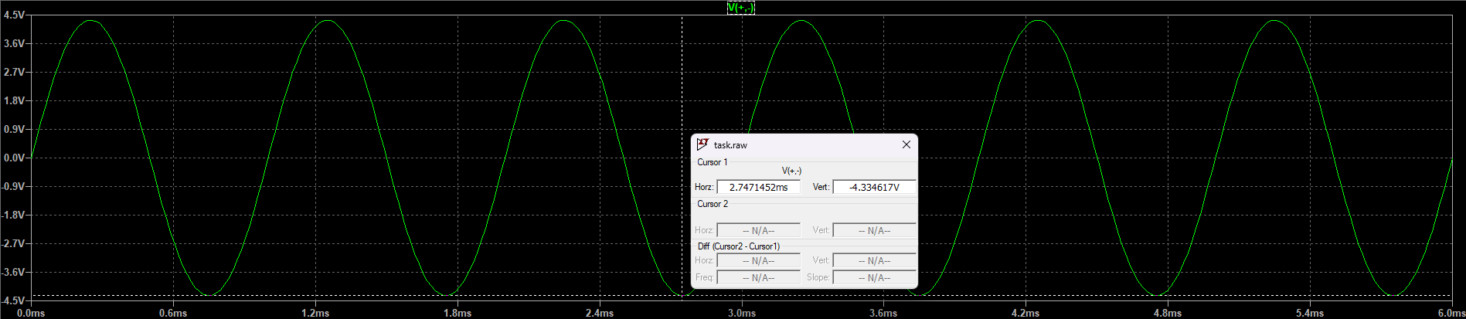

**AD (simulated) = 216.7 V/V**

* Simulate the circuit given in figure 2 using PSpice and using transient analysis observe the output Sketch the waveform below.

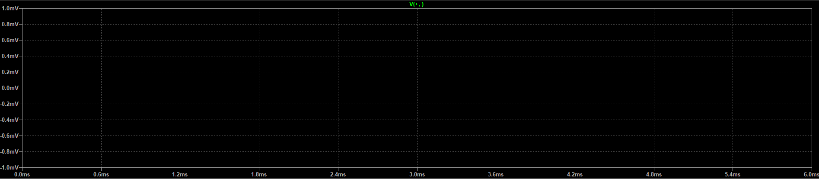

**AC (simulated) = 0 V/V**

**PART 3- IMPLEMENTATION**

* Patch the circuit given in figure 1 using PSpice and measure the following dc values using multimeter.

|  |  |
| --- | --- |
| Q 1 | Q2 |
| VE1 (Meas.)=___________________________ | VE2 (Meas.)=___________________________ |
|  |  |
| VB1 (Meas.)=___________________________ | VB2 (Meas.)=___________________________ |
|  |  |
| VC1 (Meas.)=___________________________ | VC2 (Meas.)=___________________________ |
|  |  |
| IE1 (Meas.)=___________________________ | IE2 (Meas.)=___________________________ |
|  |  |
| re1 (Meas.)=___________________________ | re2 (Meas.)=___________________________ |

* Using oscilloscope, obtain the waveform and hence differential gain for amplifier in figure 1. Sketch the output waveform below. Note that you may have to use both the probes and MATH function for the differential output.



**AD (measured) =________________**

* Adjust the circuit according to figure 2 and using oscilloscope, observe the output. Sketch the waveform below. Make sure that the oscilloscope channel you use is AC coupled or you may use a suitable Capacitor.



**AC (measured) =________________**

**Common Mode Rejection Ratio:**

* **Calculate the Common Mode Rejection Ratio using the values calculated, simulated and measured.**

**CMRR= $\frac{A_{d} }{A_{cm}}$**

CMRR (Calculated):__________________

CMRR (Simulated):__________________

CMRR (Measured):__________________

* **Comment on the proximity of the values for CMRR.**