**Department of Electrical Engineering**

|  |  |
| --- | --- |
| **Faculty Member: ­­­__________________** | **Dated: ________________** |
| **Semester:_____________** | **Section: ________________** |

**EE313: ELECTRONIC CIRCUIT DESIGN**

# LAB 09: Differential pair with Active Load

|  |  |  |  |
| --- | --- | --- | --- |
| **S.no** | **Name** | **Reg. no.** | **Total/25** |
| **1** |  |  |  |
| **2** |  |  |  |
| **3** |  |  |  |
| **4** |  |  |  |

**Introduction**

The differential amplifier, or differential pair, is an essential building block in all integrated amplifiers. In general, the input stage of any analog integrated circuit with more than one input consists of a differential pair or differential amplifier. The basic differential pair circuit consists of two-matched transistors *Q*3and *Q*4 their emitters are joined together and biased a constant current source

**Materials**

The items listed in table 1 will be needed. For this lab, assume all NPN transistors are identical 2N3904 BJTs.

**CAUTION:** Please DO NOT leave the circuit on for long periods since there is a risk of heating up of transistors.

|  |  |
| --- | --- |
| **Components** | **Quantity** |
| Transistors: | 2N3904 NPN , 2N3906 PNP |
| Resistors: | 20k x 2 ,10k x 3 ,5.6k x 2 |
| Capacitors: | 0.1 µ F |

**Procedure**

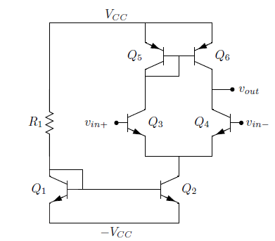

Figure 1. Differential Amplifier with Active Load

**.**

**Differential pair with Active load:**

**PART 1- CALCULATION**

a) Consider the circuit, shown in Figure 1, in PSPICE using 2N3904 transistors for the NPN BJTs and 2N3906 for PNP.

Use R1 = 10 k Ω, R2 = R3 = 5.6 k Ω, and VCC = 9 V.

b) Calculate the Differential mode gain of the amplifier shown in figure 1 with values given above. (Assume Vbe=0.7V)

Gain: _______________

c) Now consider the Circuit given in figure 2. Calculate the differential mode gain of the circuit given in figure 2. Use R1 = 10 kΩ and VCC = 9 V.

Gain:_______________

**PART 2-SIMULATION**

1. Construct the circuit in Figure 2 using 2N3904 transistors for the NPN BJTs and 2N3906 transistors for the PNP BJTs. Use R1 = 10 kΩ and VCC = 9 V.
2. Apply a 30 mV amplitude, 1 kHz sine wave to vin+ and ground vin−. Use the level marker to display the output waveform at Vout and sketch the result.

*Note: Make sure you apply an offset of 2Volts to the signal. For the grounded pin you may use simple DC source or a sine source with 0 frequencies and 0 amplitude.*



1. Why isn’t the output sinusoidal?

1. We’d like to reduce Rout by loading the amplifier with a small resistor. Attach a load to the amplifier as shown in Figure 2. Use CL = 0.1 µF and RL = 5 kΩ.

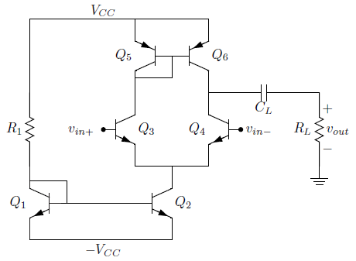

Figure 2.

1. Calculate the differential gain for the amplifier with the new load resistance.

Gain: _________________

1. Apply a 20 mV amplitude, 1 kHz sine wave to vin+ and ground vin−. Use the level marker to display vin+ and Vout. Sketch Vout.



1. What is the measured differential gain of the circuit?

Gain: __________________

1. How does this compare with your calculations?
2. Does the gain match the differential gain you measured for resistive load differential amplifier? Should it?