

**NATIONAL UNIVERSITY OF SCIENCES & TECHNOLOGY**

**Instrumentation and Measurements (EE-383)**

**Assignment # 1**

|  |  |
| --- | --- |
| Submitted to: | Dr. Shahzad Younis |
| Submitted by: | Muhammad Umer |
| Class: | BEE-12C |
| Semester: | 5th |
| Dated: | 13/10/2022 |
| CMS ID: | 345834 |

***Question****: Identify digital (05) and analog (05) sensors which could be interfaced with micro-controller. Write main features of the sensors, along with block diagram/picture and pin configuration for each. Moreover make a table to list all the parameters i.e., range, accuracy, precision, min, max, average values etc. Make use of datasheets to get the information.*

# Digital Sensors

## Compact Absolute Pressure Sensor - MPL3115A2

1. Main Features

* *Programmable interrupts*
* *Autonomous data acquisition*
* *Embedded 32-sample FIFO*
* *Data logging up to 12 days using the FIFO*
* *One-second to nine-hour data acquisition rate*
* *I2C digital output interface*
* *Fully compensated internally*
* *Direct reading*

1. Block Diagram

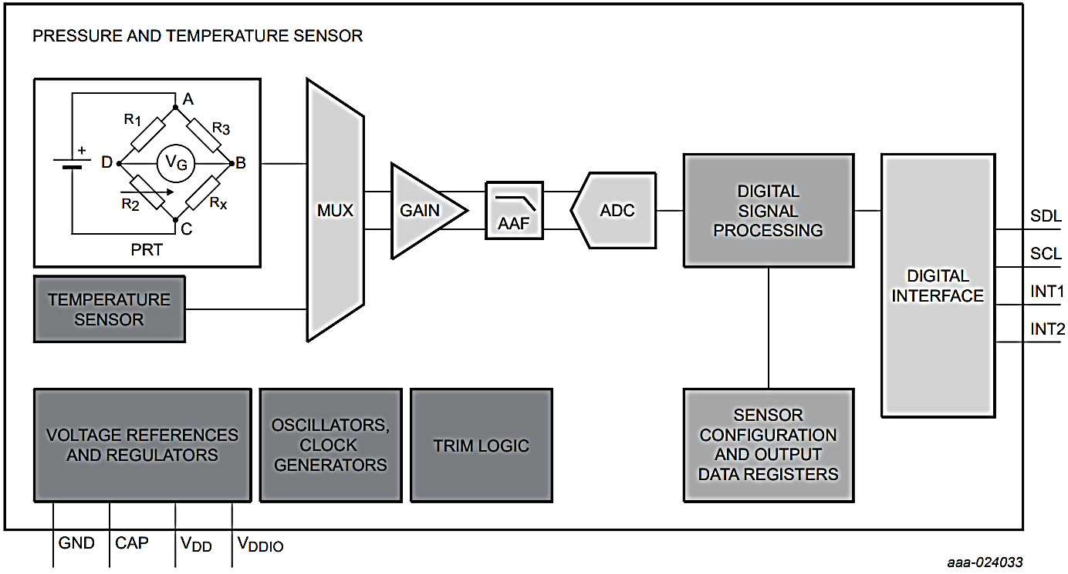

1. Pin Configuration

|  |  |
| --- | --- |
| Pin | Description |
| VDD | Power supply |
| CAP | External capacitor |
| GND | Ground |
| VDDIO | Digital interface supply |
| INT2 | Pressure interrupt 2 |
| INT1 | Pressure interrupt 1 |
| SDL | I2C Serial Data |
| SCL | I2C Serial Clock |

1. Parameter Table

|  |  |
| --- | --- |
| Parameters | Values |
| Calibrated range | 70 - 150 |
| Calibrated temperature output | -40 to 85 |
| Operating range | 50 - 150 |
| Operating temperature | -40 to 85 |
| Max pressure | 500 |
| Absolute accuracy | ± 0.4 |

## Programmable Resolution 1-Wire Digital Thermometer - DS18B20

1. Main Features

* *Unique 1-Wire Interface Requires*
* *Reduce Component Count with Integrated Temperature Sensor and EEPROM*
* *Parasitic Power Mode Requires Only 2 Pins for Operation*
* *Simplifies Distributed Temperature-Sensing Applications with Multidrop Capability*
* *Flexible User-Definable Nonvolatile (NV) Alarm Settings*

1. Block Diagram

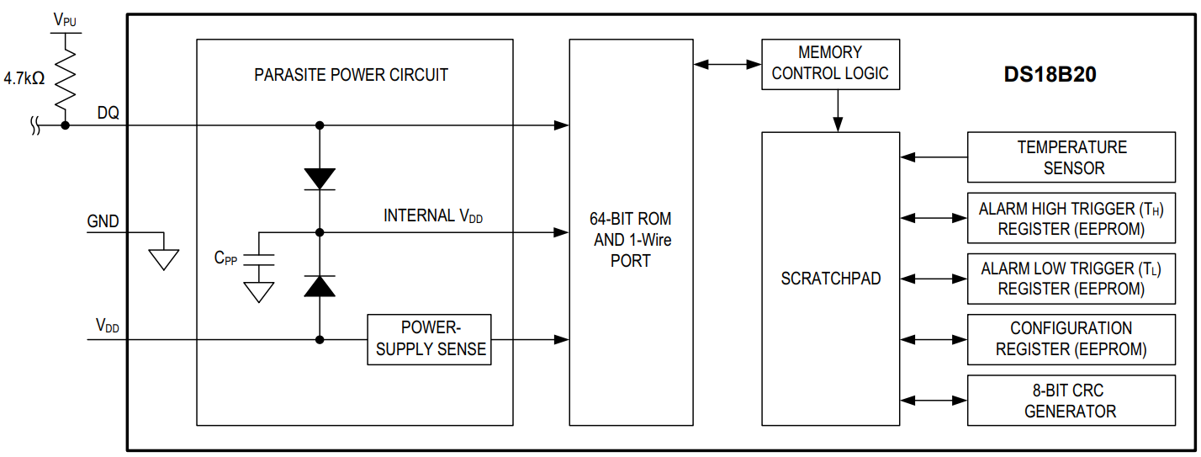

1. Pin Configuration

|  |  |
| --- | --- |
| Pin | Description |
| VDD | Power supply |
| DQ | Data Input/Output |
| GND | Ground |

1. Parameter Table

|  |  |
| --- | --- |
| Parameters | Values |
| Thermometer error | ± 2 |
| Accuracy | ± 0.5 |
| Temperature resolution | 9 to 12 bits |
| Operating temperature | -55 to 125 |
| DQ input current | ± 0.4 |
| Conversion time | < 750 |

## Ambient Light Sensor - BH1750

1. Main Features

* I2C bus interface
* Spectral responsibility is approximately human eye response
* Illuminance to digital converter
* Supports continuous measurement mode
* Supports one-time measurement mode
* Low current by power down function

1. Block Diagram

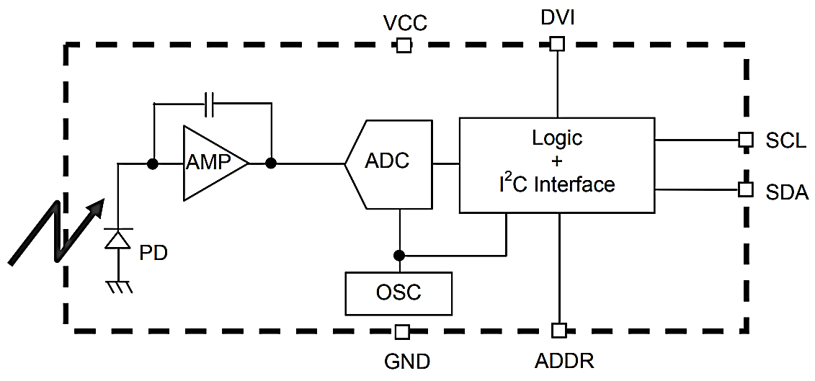

1. Pin Configuration

|  |  |
| --- | --- |
| Pin | Description |
| **VCC** | Power supply |
| **GND** | Ground |
| **SCL** | SCL pin for I2C communication |
| **SDA** (Data) | SDA pin for I2C communication |
| **ADD**\* | Selects address |

1. Parameter Table

|  |  |
| --- | --- |
| Parameters | Values |
| Resolution modes | High, H-2, Low |
| Accuracy | ± 1.4% |
| Operating temperature | -40 to 85 |
| Peak wave length | 560 |
| Powerdown current | 1 |
| Conversion Time | < 750 |

## Distance Measuring Sensor Unit - GP2Y0D810Z0F

1. Main Features

* Short distance type
* Sunlight tolerance
* Battery drive possible
* Low profile; weight without header pins: 1.3 g
* Add VIN terminal, and an external transistor of VCC line is unnecessary at operation

1. Block Diagram

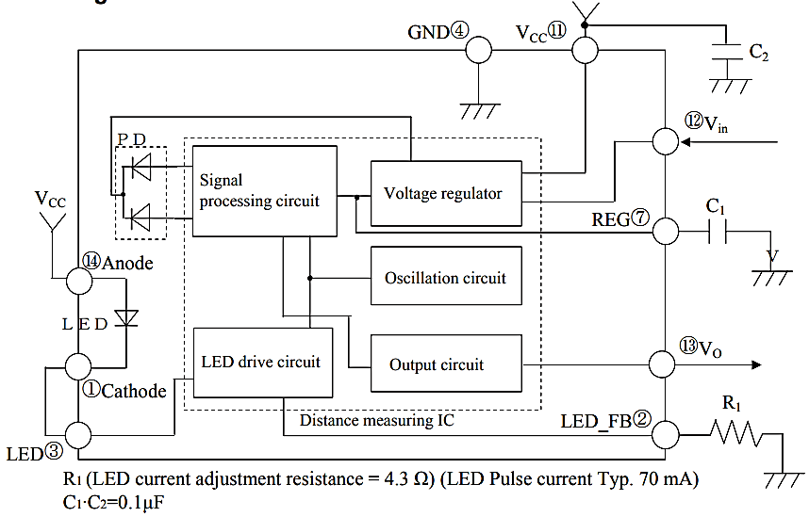

1. Pin Configuration

|  |  |
| --- | --- |
| Pin | Description |
| **VCC** | Power supply |
| **GND** | Ground |
| **DO** | Digital output |

1. Parameter Table

|  |  |
| --- | --- |
| Parameters | Values |
| Operating temperature | -10 to 60 |
| Measuring duration | 2.56 |
| Supply current | 5 |
| Detecting distance | 20 - 100 |

## Digital IR Sensor - TSOP38238

1. Main Features

* Adjustable Sensing range
* Built-in Ambient Light Sensor
* Mounting hole

1. Block Diagram

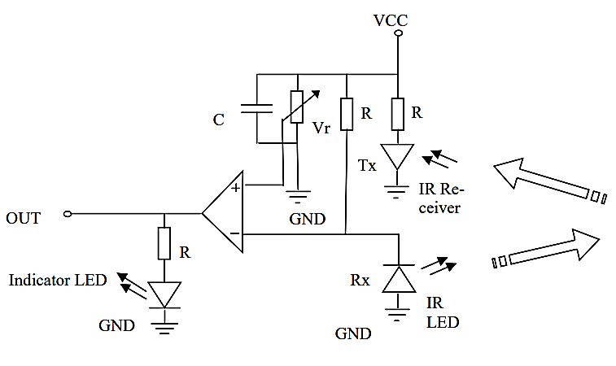

1. Pin Configuration

|  |  |
| --- | --- |
| Pin | Description |
| **VCC** | Power supply |
| **GND** | Ground |
| **DO** | Digital output |

1. Parameter Table

|  |  |
| --- | --- |
| Parameters | Values |
| Operating temperature | -20 to 50 |
| Supply current | 20 |
| Obstacle detection range | upto 20 |

# Analog Sensors

## Analog Temperature Sensor - HX710A

1. Main Features

* On-chip temperature measurement
* On-chip power-on-reset
* On-chip oscillator requiring no external component
* DVDD and AVDD supply voltage difference measurement
* Simultaneous 50 and 60Hz supply rejection

1. Block Diagram

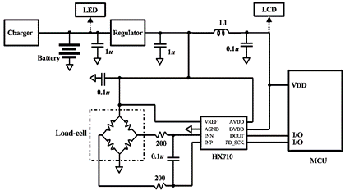

1. Pin Configuration

|  |  |
| --- | --- |
| Pin | Description |
| **VCC** | Power supply |
| **GND** | Ground |
| **DOUT** | Analog output |
| **SCK** | Clock |

1. Parameter Table

|  |  |
| --- | --- |
| Parameters | Values |
| Operating temperature | -40 to 85 |
| Supply current | 1100 |
| Temperature drift | ± 15 |
| Output data rate | 10/40 |
| Power supply rejection | 100 dB |
| Output settling time | 400 |

## Analog Water Pressure Sensor – DFRobot Gravity

1. Main Features

* Support liquid level detection in special situation
* Support water pressure detection of tanks
* Support water pressure detection of outdoor environment

1. Block Diagram

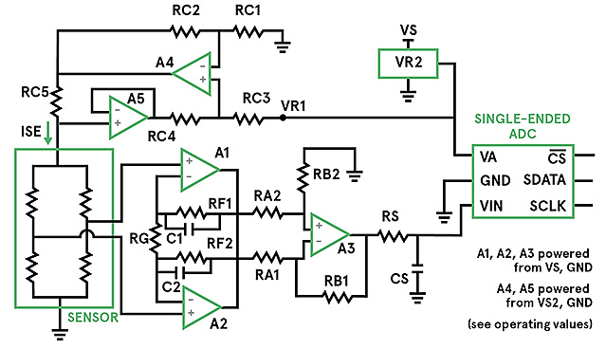

1. Pin Configuration

|  |  |
| --- | --- |
| Pin | Description |
| **VS** | Power supply |
| **GND** | Ground |
| **CS** | Chip select |
| **SDATA** | Serial analog data |
| **SCLK** | Clock |

1. Parameter Table

|  |  |
| --- | --- |
| Parameters | Values |
| Operating temperature | -20 to 85 |
| Quiescent current | 2.8 |
| Temperature drift | ± 15 |
| Response time | <2 |
| Accuracy | 0.5 % |
| Operating pressure | < 2 |

## Pressure Transducer - MS4515

1. Main Features

* Inches H2O Pressure Ranges
* PCB Mountable
* High Level Analog Output
* Barbed Pressure Ports
* Hosts 1/8” barbed pressure ports

1. Block Diagram

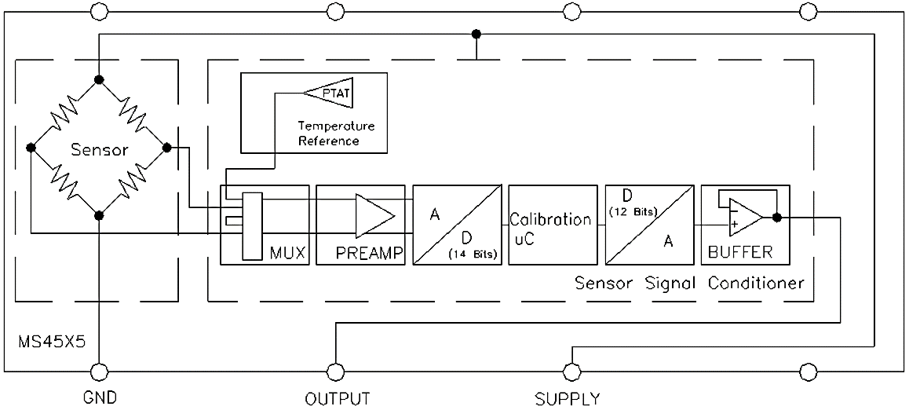

1. Pin Configuration

|  |  |
| --- | --- |
| Pin | Description |
| SUPPLY | Power supply |
| **GND** | Ground |
| **OUTPUT** | Analog output |

1. Parameter Table

|  |  |
| --- | --- |
| Parameters | Values |
| Operating temperature | -10 to 85 |
| Supply current | 3 |
| Creep time | 6 |
| Response time | 1 |
| Accuracy | 0.5 % |
| Output voltagemax | 4.75 |

## Precision Centigrade Temperature Sensor - LM35

1. Main Features

* Calibrated Directly in Celsius
* Low-Cost Due to Wafer-Level Trimming
* Low-Impedance Output
* Low Self-Heating

1. Block Diagram

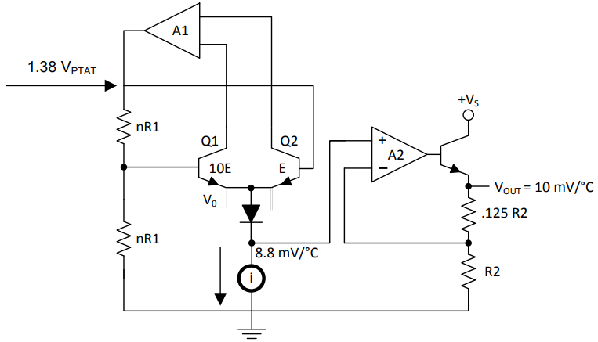

1. Pin Configuration

|  |  |
| --- | --- |
| Pin | Description |
| **VS** | Power supply |
| **GND** | Ground |
| **OUTPUT** | Analog output |

1. Parameter Table

|  |  |
| --- | --- |
| Parameters | Values |
| Operating temperature | -55 to 150 |
| Quiescent current | 60 |
| Temperature rating | -55 to 150 |
| Nonlinearity | ± 0.18 |
| Accuracy | ± 0.4 |

## Transformer Drive Ultrasonic Sensor - TUSS4440

1. Main Features

* Integrated driver for transformer driven transducers and receiver stage with analog output
* Configurable drive stage
* Serial Peripheral Interface (SPI) for configuration by microcontroller
* 86-dB input dynamic range analog front-end

1. Block Diagram

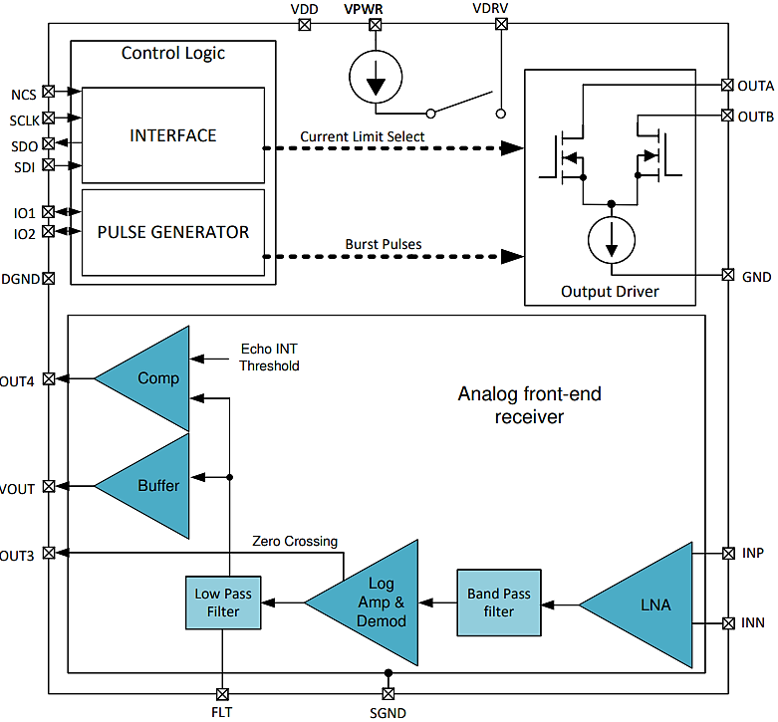

1. Pin Configuration

|  |  |
| --- | --- |
| Pin | Description |
| **VPWR/VDD** | Power supply |
| **GND** | Ground |
| **INN** | Negative transducer receive |
| **INP** | Positive transducer receive |
| **SDI** | SPI data input |
| **SDO** | SPI data output |
| **OUT A/B** | Transducer driver output |

1. Parameter Table

|  |  |
| --- | --- |
| Parameters | Values |
| Operating temperature | -40 to 105 |
| Maximum current rating | 25 |
| Maximum output load capacitance | 10 |
| Input hysteresis | 100 |
| Supported transducer frequencies | 40 - 400 |
| Dynamic input range | 86 |



