

**NATIONAL UNIVERSITY OF SCIENCES & TECHNOLOGY**

**Instrumentation and Measurements (EE-383)**

**Assignment # 3**

|  |  |
| --- | --- |
| Submitted to: | Dr. Shahzad Younis |
| Submitted by: | Muhammad Umer |
| Class: | BEE-12C |
| Semester: | 5th |
| Dated: | 7/12/2022 |
| CMS ID: | 345834 |

**Table of Contents**

2 Table of Figures 2

3 Introduction 3

4 Flowchart 3

5 Altium Schematics 3

6 Hardware Implementation 5

7 Sensor Working 5

8 Conclusion 5

# Table of Figures

Figure 1 Flowchart 3

Figure 2 Schematic 3

Figure 3 PCB Schematic 4

Figure 4 PCB Design 4

Figure 5 Hardware Implementation 5

# Introduction

The DHT11 is a simple digital temperature and humidity sensor. This sensor includes a resistive-type humidity measurement component and an NTC temperature measurement component and connects to a high-performance 8-bit microcontroller, offering excellent quality, fast response, anti-interference ability and cost-effectiveness. The sensor measures relative humidity, which is the amount of water vapor in air versus the saturation point of water vapor in air. Due to its low cost, it’s suitable for applications where temperature and humidity monitoring is required to automate systems.

# Flowchart

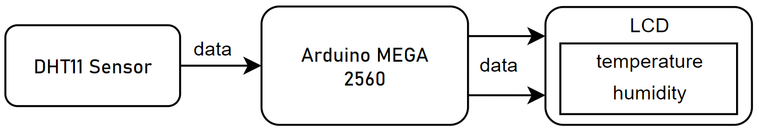

Figure Flowchart

# Altium Schematics

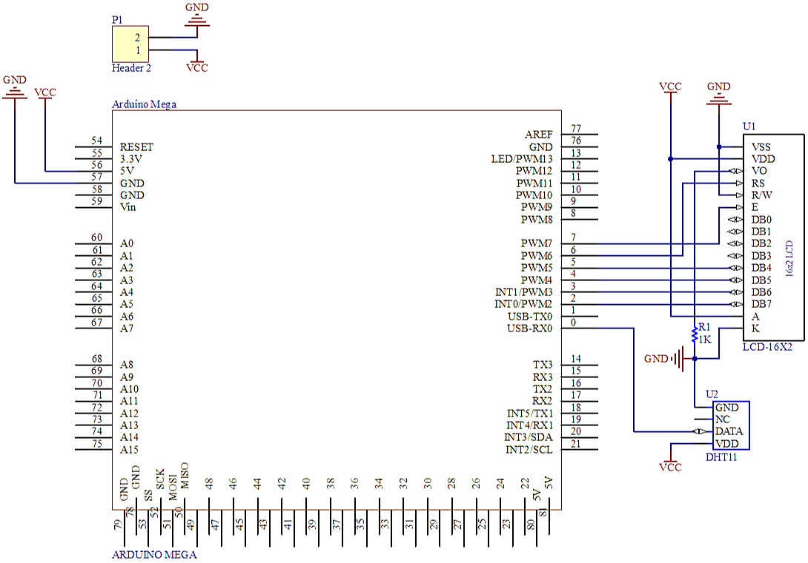

Figure Schematic

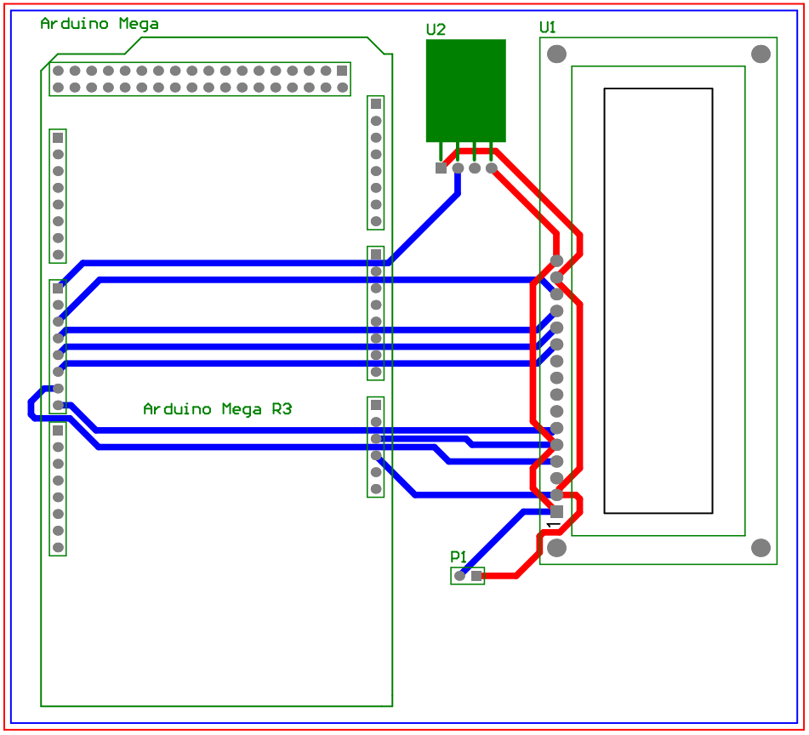

Figure PCB Schematic

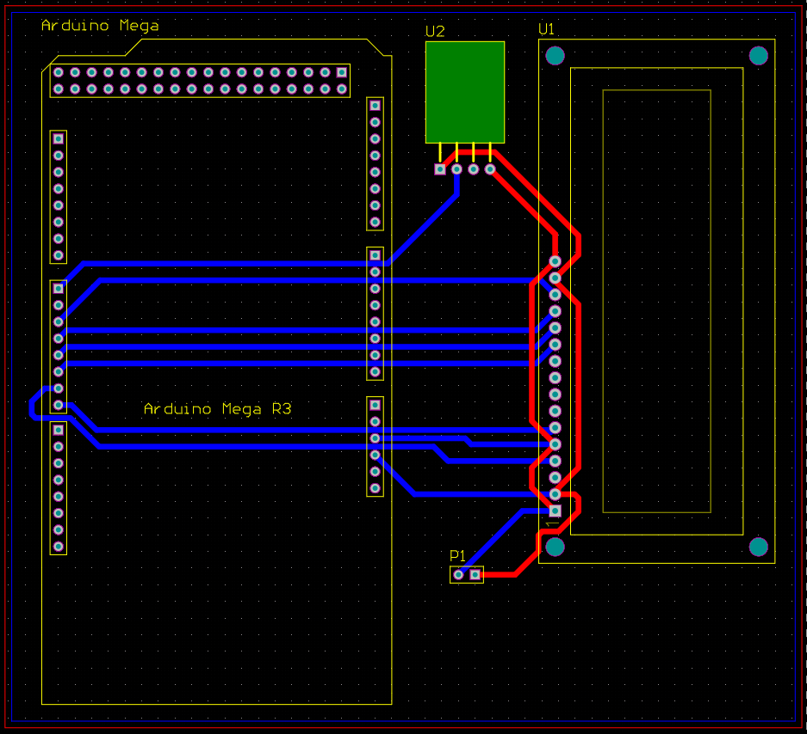

Figure PCB Design

# Hardware Implementation

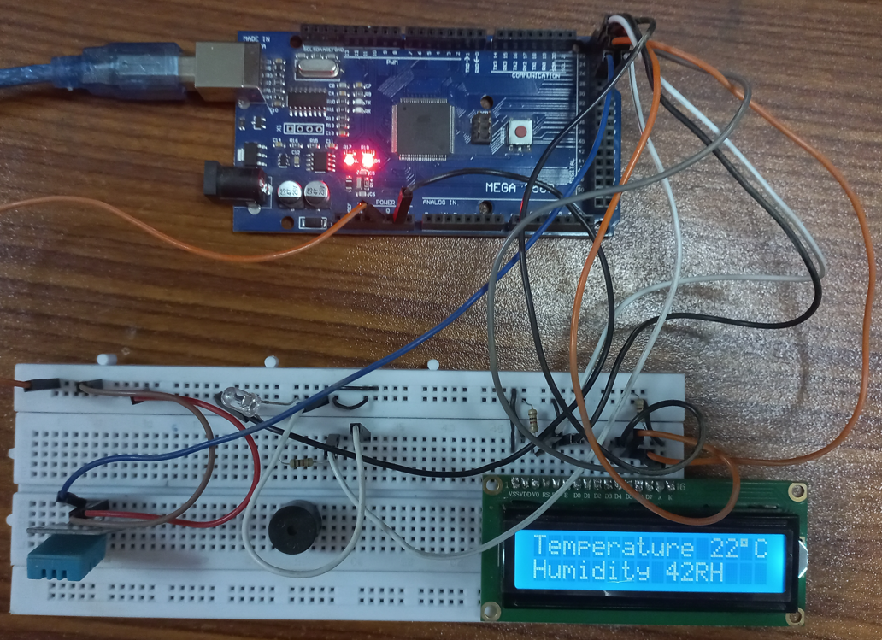

Figure Hardware Implementation

# Sensor Working

The DHT11 sensor consists of a thermistor for measuring temperature and a capacitive humidity sensing element. The humidity sensing capacitor consists of two electrodes separated by a substrate that can hold moisture as a dielectric. The capacitance value changes as the humidity levels change. The IC calculates, interprets, and converts the modified resistance values into digital form.

This sensor uses a negative temperature coefficient thermistor to measure temperature, which results in a decrease in the value of resistance as temperature rises. It is typically made of semiconductor ceramics or polymers in order to obtain higher resistance values even for the smallest change in temperature.

# Conclusion

In this assignment, DHT11 sensor was interfaced with ARDUINO Mega 2560 microcontroller and displayed the readings of the sensor onto a Liquid Crystal Display (LCD). The DHT11 sensor was observed to take around 2 seconds to process and output a reading; subsequent readings are delayed by 2 seconds. PCB of the circuit was also designed using Altium Designer and the relevant photos are attached in the report.