

**NATIONAL UNIVERSITY OF SCIENCES & TECHNOLOGY**

**Instrumentation and Measurements (EE-383)**

**Assignment # 4**

|  |  |
| --- | --- |
| Submitted to: | Dr. Shahzad Younis |
| Submitted by: | Muhammad Umer |
| Class: | BEE-12C |
| Semester: | 5th |
| Dated: | 21/12/2022 |
| CMS ID: | 345834 |

# Assume a scenario of resistance ($R_{T}$) measurement

* Apply two-wire method
* Apply four-wire method
* Compare both

## Resistance Measurement

In order to measure resistance, digital multimeters (DMMs) commonly use the constant-current method, in which a constant current is sourced to the test object while sensing the voltage. Resistance $R_{T}$ is then calculated and displayed using the known current $I_{x}$ and measured voltage $V_{o}$ using the following formula:

$$R=\frac{V_{o}}{I_{ex}}$$

## Two-Wire Method

In the two-wire resistance measurement method, the excitation current flows through the leads and the unknown resistance $R_{T}$. The DMM measures the voltage drop across this branch through the same set of leads and computes the resistance, using the formula introduced in Section 1.1.

The main issue with this approach is that for small resistances (less than 100 $Ω$), the lead resistances A and B contribute to the voltage drop $V_{o}$ significantly enough that the measured resistance is no longer accurate. Mathematically, the measured resistance has an added factor of $A+B$ and can be expressed as:

$$R=R_{T}+A+B=\frac{V_{o}}{I_{ex}}$$

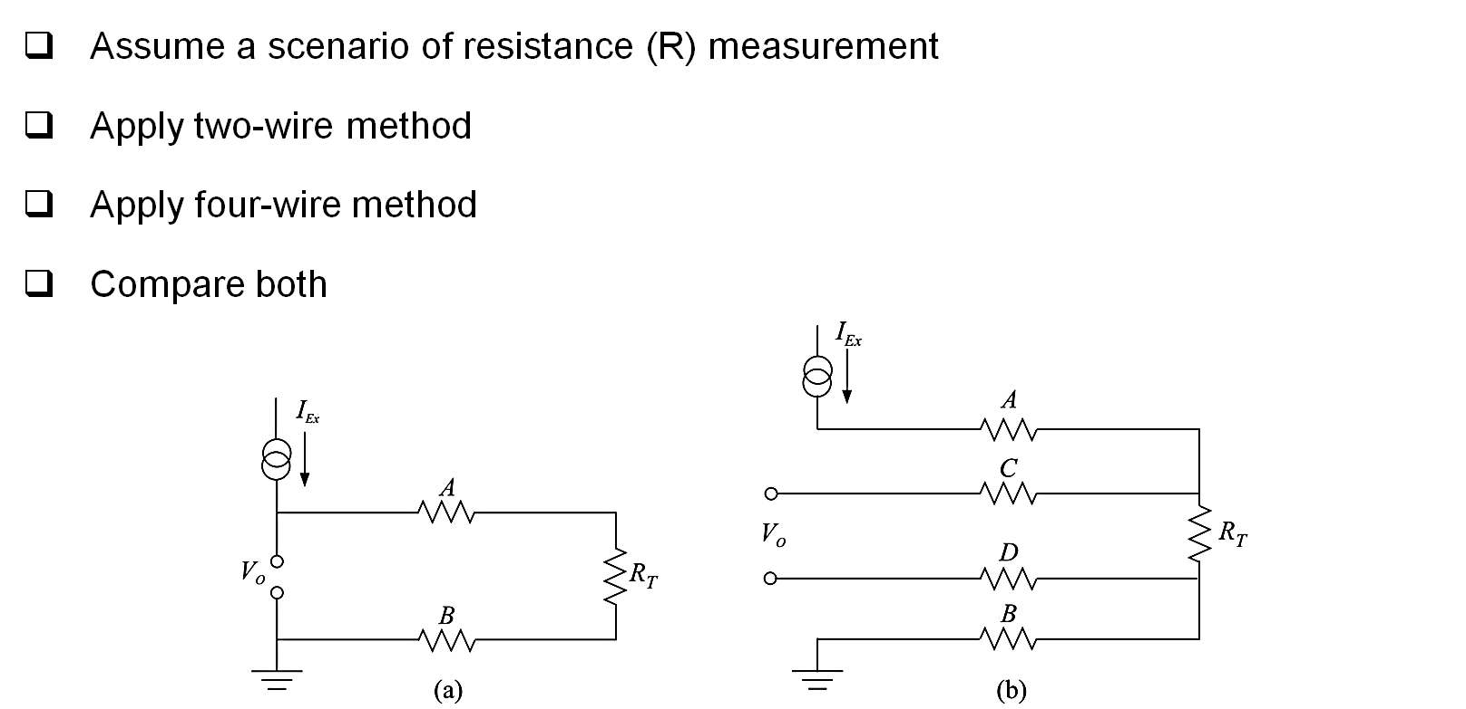

## Four-Wire Method

The four-wire method uses four test leads, one pair (test lead) for the injected current $I_{ex}$ and the other pair (sense lead) for sensing the voltage across the resistor $R_{T}$. As negligible amounts of current flows in the sense lead, the device measures only the voltage developed across the resistance. Thus, in this way, the errors introduced by the test lead and contact resistances are mitigated.

However, a drawback is that the sense leads must be placed as close as possible to the resistance under measurement; the lead resistance increases with an increase in distance between the measurement unit and the measurand. Mathematically,

$$R_{T}≈\frac{V_{o}}{I_{ex}}$$

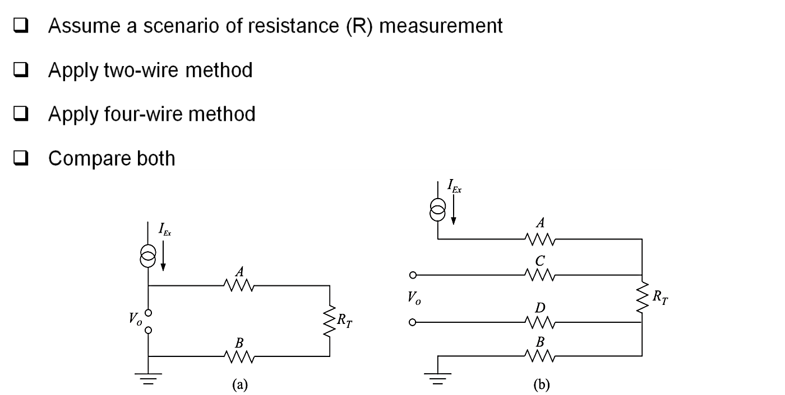

## Comparison

The main drawback of two-wire resistance measurement test is when measuring small resistances (less than 100 $Ω$), the contribution of lead resistance becomes apparent enough to not be negligible. However, it offers a simpler solution, comprising of less read resistors and only two wires. Whereas, the four-wire resistance measurement test offers better accuracy, at the expense of added complexity. Another drawback is that the test leads must be connected as close to the resistance under test, otherwise, resistance from test leads become apparent enough to cause a significant voltage to drop, distorting the measured value.

Collectively, we can deduce that the four-wire method should be used extensively when measuring small resistances, and the two-wire method can be used for larger values of resistances.