**Department of Electrical Engineering and   
Computer Science**

**Faculty Member:** Dr. Shahzad Younis  **Dated:** 13/12/2022

**Semester:** 5th **Section:** BEE 12C

**EE-383:** **Instrumentation and Measurements**

Lab 10: Switch Debouncing / Strain Gauge / Thermistor

Lab Instructor: Mr. Ali

Group Members

|  |  |  |  |  |  |  |
| --- | --- | --- | --- | --- | --- | --- |
| **Name** | **Reg. No** | **Viva + Lab Performance (Individual)** | | **Analysis of data in Lab Report** | **Teamwork** | **Total** |
|  |  | **5+5 Marks** | | **5 Marks** | **5 Marks** | **20 Marks** |
| Danial Ahmad | 331388 |  |  |  |  |  |
| Muhammad Umer | 345834 |  |  |  |  |  |
| Tariq Umar | 334943 |  |  |  |  |  |
|  |  |  |  |  |  |  |

**Table of Contents**

2 Switch Debouncing / Strain Gauge / Thermistor 3

2.1 Objectives 3

2.2 Equipment 3

2.3 Introduction 3

2.4 Lab Instructions 3

3 Lab Procedure 4

3.1 Switch Debouncing 4

3.1.1 Collect Data 4

3.1.2 Switch Debounce 5

3.2 Strain Gauge 6

3.2.1 Calibrate the Strain Gage 7

3.2.2 Determine Natural Frequency 8

3.3 Thermistor 9

3.3.1 Collect Data 9

3.3.2 Calibrate the Thermistor 10

3.3.3 Determine the Thermal Time Constant 11

4 Conclusion 12

# Switch Debouncing / Strain Gauge / Thermistor

## Objectives

In this lab, you will be introduced to QNET mechatronics sensor board; and you will learn:

* QNET mechatronic sensor Board and its salient features
* Switch debouncing, working principle, uses and application
* Thermistor, working principle, uses and application
* Strain gauge, working principle, uses and application

## Equipment

Hardware

* LabVolt Proprietary Sensor Training System



## Introduction

* All switches suffer from a phenomenon called “switch bouncing”, which refers to the back and forth bouncing between ON and OFF states prior to settling on a final state. Bouncing in mechanical switches occurs because of the flexible components used inside the switch which physically bounce until a secure mechanical contact is made.
* Strain gage is a sensor used for measuring strain in solid bodies. It is constructed from a fine metallic foil element formed into a grid pattern and mounted on a thin backing called a carrier.
* Thermistors are a type of semiconductor that react like a resistor sensitive to temperature - meaning they have greater resistance than conducting materials, but lower resistance than insulating materials. To establish a temperature measurement, the measured value of a thermistor's electrical resistance can be correlated to the temperature of the environment in which that thermistor has been situated.

## Lab Instructions

All questions should be answered precisely to get maximum credit. Lab report must ensure following items:

* Lab objectives
* Results (Graphs/Tables/Pictures) duly commented and discussed
* Conclusion

# Lab Procedure

## Switch Debouncing

### Collect Data

1. Open QNET Mechatronic Sensors.lvproj.
2. From the Project Explorer window, open QNET Sensors Switch Debounce.vi.
3. From the Device drop-down menu, select the device name.
4. Run the VI.
5. Click the snap action switch once. By default, the debounce period is set to 0 microseconds, which means the output of the switch will not be debounced. Therefore, the graph will display the same results for the Raw Signal and Debounced Signal.
6. Export a copy of the graph.

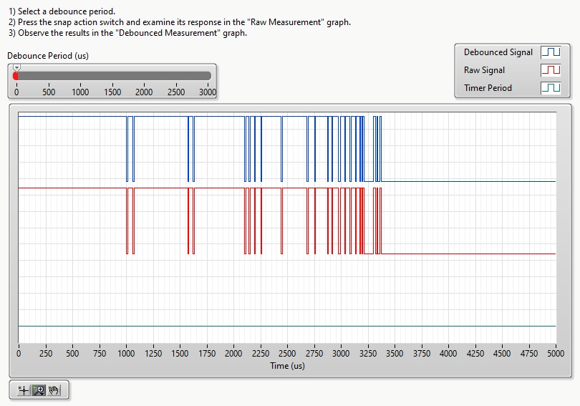

Figure 1 Debounce Period: 0 us

1. With the debounce period still set to 0 microseconds, press the snap action switch several times and observe switch bouncing. Is switch bouncing different each time you press the switch?

Yes, the switch bouncing is different each time as the mechanical reverberation is not calibrated to occur as precisely as possible, rather, a software interface is used to debounce it.

### Switch Debounce

1. Set the Debounce Period (us) slider to 1000, 500, and 100. Examine the response of the timer, raw signal, and the debounced signal.
2. How do different debounce period values affect the debounced signal?

The longer the debounce period is, the longer it takes for a stable signal (debounced signal) to be generated.

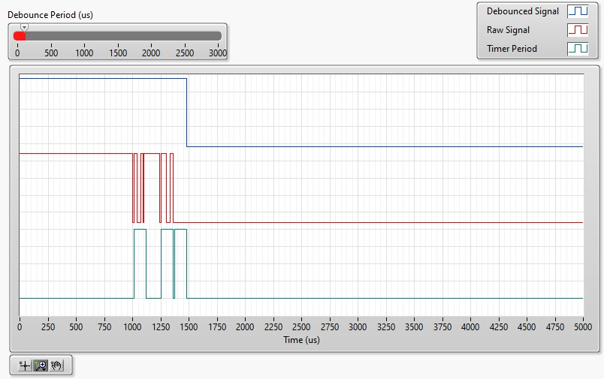

Figure 2 Debounce Period: 100 us

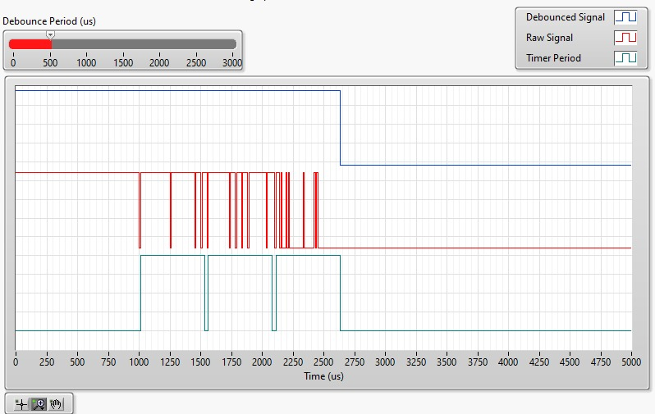

Figure 3 Debounce Period: 500 us

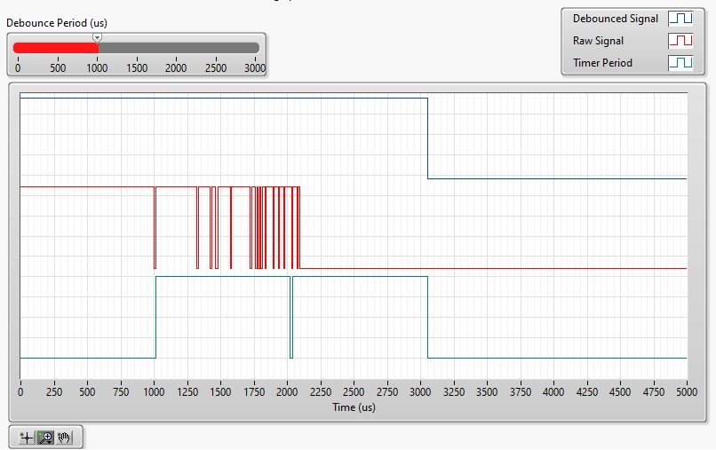

Figure 4 Debounce Period: 1000 us

## Strain Gauge

1. Open QNET Mechatronic Sensors.lvproj .
2. From the *Project Explorer* window, open QNET Sensors Strain Gage.vi .
3. Click on the *Collect Data* tab.
4. From the *Device* drop-down menu, select the device name.
5. Run the VI.
6. Using the *Uncalibrated Output* waveform chart, read the initial strain gage bridge output.
7. Balance the strain gage bridge by adjusting the *Zero Offset (V)* knob such that the uncalibrated output of the bridge circuit is as close as possible to 0.00 V
8. Enter -1 in the *Beam Position (cm)* array.
9. Flex the tip of the cantilever beam to the -1 cm mark.
10. Read the corresponding strain gage output and enter the value in the *Sensor Output (V)* array.
11. Repeat the process by moving the tip of the beam to the following positions: -0.5 cm, 0 cm, +0.5 cm, and +1 cm. Enter the beam position and measured sensor outputs in the *Beam Position (cm)* and *Sensor Output (V)* arrays respectively.
12. As the measured readings are entered, a linear curve is automatically generated to fit the data. The curve is shown in the *Sensor Readings* waveform graph. This curve represents the calibration curve of the sensor.
13. The slope and offset of the calibration curve are automatically calculated by the VI and displayed in the *Slope (cm/V)* and *Offset (cm)* indicators. Make a note of these values.
14. Record the collected data in Table 1.

|  |  |
| --- | --- |
| Beam Position (cm) | Sensor Output (V) |
| -1.0 | +4.01 |
| -0.5 | +2.13 |
| 0 | 0.4 |
| +0.5 | -0.78 |
| +1.0 | -2.16 |

Figure 5 Recorded Output

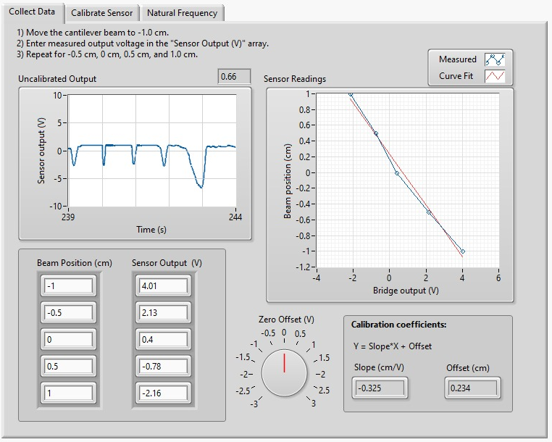

### Calibrate the Strain Gage

1. Click on the Calibrate Sensor tab to calibrate the output of the strain gage bridge circuit in terms of linear displacement of the tip of the cantilever beam (in cm).
2. Use the Slope (cm/V) and Offset (cm) numeric controls to enter the slope and offset values you obtained during the data collection step.
3. Test the accuracy of your calibration. To do this, flex the cantilever beam to different positions and verify that the correct position is displayed in the Calibrated Output waveform chart as well as the Beam Position (cm) slider indicator.

|  |  |  |
| --- | --- | --- |
| Beam Position (cm) | Sensor Output | Measured Beam Position |
| -1.0 | +4.01 | -1.00 |
| -0.5 | +2.13 | -0.52 |
| 0 | 0.4 | -0.02 |
| +0.5 | -0.78 | +0.53 |
| +1.0 | -2.16 | +1.03 |

Figure 6 Testing accuracy

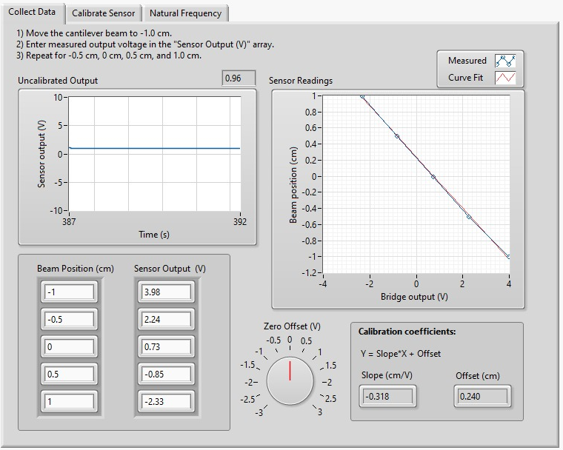

### Determine Natural Frequency

1. To determine the natural frequency of the cantilever beam, click on the Natural Frequency tab.
2. Ensure the Beam is at rest (i.e., not vibrating).
3. With one finger manually perturb its tip of the beam.
4. Wait for a couple of seconds for the beam to stop vibrating and immediately press the Plot button.
5. The VI captures the resulting response in the Power Spectrum waveform graph. The response should look like the following figure.

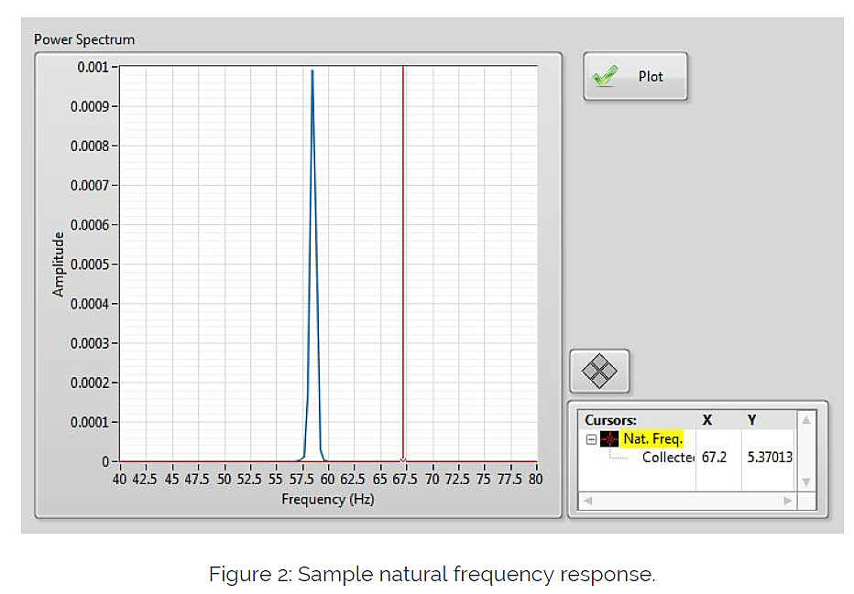

1. Using the Cursor tool, measure the peak frequency and record it in the following table.

|  |  |
| --- | --- |
| Trial | Natural Frequency (Hz) |
| 1 | 51.4 |
| 2 | 53.0 |
| 3 | 48.2 |
| 4 | 52.1 |
| 5 | 54.1 |

1. Repeat the measurement several times to determine the average natural frequency of the beam. Record your measurements in Table 2.

Average value of the natural frequency =

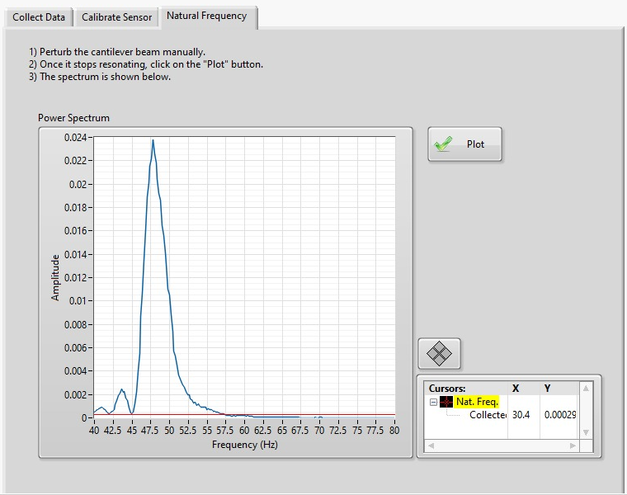

## Thermistor

### Collect Data

1. For best results, your NI ELVIS II and the QNET Mechatronic Sensors board should be at room temperature before starting this experiment.
2. Determine the temperature of your fingertip with a thermometer.
3. Power on the NI ELVIS II using the power switch on the back of the unit. The READY and ACTIVE
4. LEDs on the NI ELVIS II panel should briefly light, and the READY LED should stay on.
5. Power on the QNET Mechatronic Sensors board by switching on the NI ELVIS II prototyping board power switch. The POWER LED next to the switch should light up.
6. Open QNET Mechatronic Sensors.lvproj.
7. From the Project Explorer window, open QNET Sensors Thermistor.vi.
8. Click on the Collect Data tab.
9. From the device drop-down menu, select the device name.
10. Run the VI.
11. Gently place your fingertip on the thermistor and examine the response.
12. Using the Uncalibrated Output waveform chart, read the corresponding sensor output when it reaches steady state (after approximately 15 s).

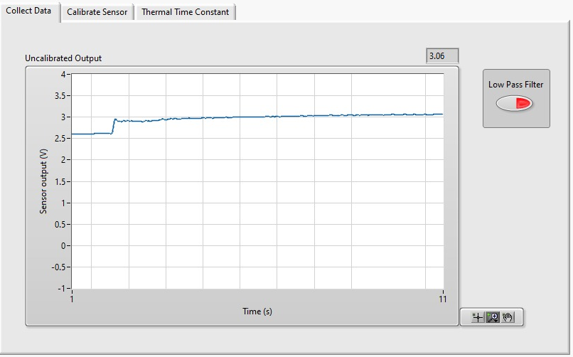

### Calibrate the Thermistor

1. Using the steady-state output of the sensor from the data collection step and Equation 3 in the Concept Review, determine the resistance of the thermistor.
2. Using the temperature of your fingertip which you determined in the data collection step and Equation 1 in the Concept Review, determine the  [-](https://www.codecogs.com/eqnedit.php?latex=%20%5Cbeta%20)parameter of the thermistor. The nominal resistance of the sensor is R0 = 47000 ohms at 25 °C.
3. For best results, your NI ELVIS II and the QNET Mechatronic Sensors board should be at room temperature before continuing with this experiment.
4. Power on the NI ELVIS II using the power switch on the back of the unit. The *READY* and *ACTIVE*
5. LEDs on the NI ELVIS II panel should briefly light, and the *READY* LED should stay on.
6. Power on the QNET Mechatronic Sensors board by switching on the NI ELVIS II prototyping board power switch. The *POWER* LED next to the switch should light up.
7. In VI, click on the *Calibrate Sensor* tab to calibrate the output of the thermistor in terms of temperature (in °C).
8. From the *Device* drop-down menu, select the device name.
9. Re-run the VI.
10. Enter the -parameter you calculated for the thermistor using the numeric control.
11. Test the accuracy of your calibration. To do this, gently place your fingertip on the sensor and verify that the correct fingertip temperature is displayed in the *Calibrated Output* waveform chart as well as the *Temperature (C)* thermometer indicator.
12. Stop the VI.
13. Switch OFF the QNET Mechatronic Sensors board as well as the NI ELVIS II.
14. Continue to the next section.

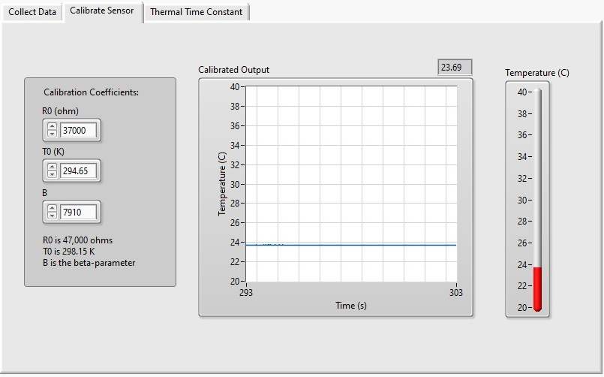

### Determine the Thermal Time Constant

1. For the best results, your NI ELVIS II and the QNET Mechatronic Sensors board should be at room temperature before continuing with the experiment.
2. Power on the NI ELVIS II using the power switch on the back of the unit. The *READY* and *ACTIVE*
3. LEDs on the NI ELVIS II panel should briefly light, and the *READY* LED should stay on.
4. Power on the QNET Mechatronic Sensors board by switching on the NI ELVIS II prototyping board power switch. The *POWER* LED next to the switch should light up.
5. In VI, click on the *Thermal Time Constant* tab.
6. From the *Device* drop-down menu, select the device name.
7. Re-run the VI.
8. Gently place your fingertip on the thermistor and examine the response using the *Calibrated Output* waveform chart.
9. After approximately 15 seconds, click the *Plot* button. The response of the sensor will be captured in the *Thermal Time Constant* waveform graph as shown in Figure 2.
10. Using the *Cursor* tool and referring to the Concept Review, determine the thermal time constant of the thermistor.
11. If no further experiments are required, press the *Stop* button and power down the experiment.

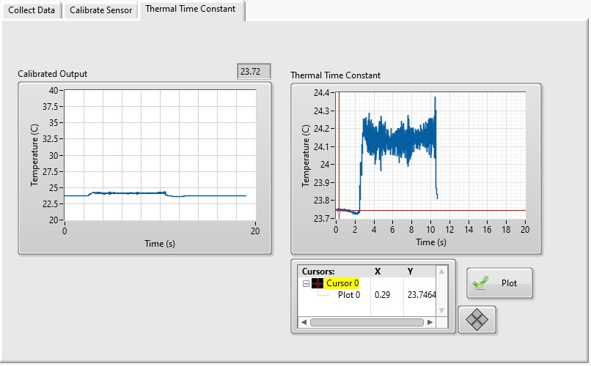

Thermal time constant (time it takes to reach 63.2% of the steady state value) = 2.74s

# Conclusion

In this lab, we further familiarized ourselves with the various sensors on the QNET mechatronic sensor board; namely, switch debouncer, strain gauge, and thermistor. We used our pre-existing knowledge and the newly reviewed concepts to calculate the parameter and characteristics of these sensors. We also calibrated the sensors to their linearity by readjusting the slope and offset.