**Department of Electrical Engineering and   
Computer Science**

**Faculty Member:** Dr. Shahzad Younis  **Dated:** 14/12/2022

**Semester:** 5th **Section:** BEE 12C

**EE-383:** **Instrumentation and Measurements**

Lab 11: Ultrasonic Distance Sensor / Reflective Optical Sensor

Lab Instructor: Mr. Ali

Group Members

|  |  |  |  |  |  |  |
| --- | --- | --- | --- | --- | --- | --- |
| **Name** | **Reg. No** | **Viva + Lab Performance (Individual)** | | **Analysis of data in Lab Report** | **Teamwork** | **Total** |
|  |  | **5+5 Marks** | | **5 Marks** | **5 Marks** | **20 Marks** |
| Danial Ahmad | 331388 |  |  |  |  |  |
| Muhammad Umer | 345834 |  |  |  |  |  |
| Tariq Umar | 334943 |  |  |  |  |  |
|  |  |  |  |  |  |  |

**Table of Contents**

2 Ultrasonic Distance Sensor / Reflective Optical Sensor 3

2.1 Objectives 3

2.2 Equipment 3

2.3 Introduction 3

2.4 Lab Instructions 3

3 Lab Procedure 4

3.1 Ultrasonic Distance Sensor 4

3.1.1 Collect Data 4

3.1.2 Calibrate the Ultrasonic Distance Sensor 5

3.2 Reflective Optical Sensor 6

3.2.1 Collect Data 6

3.2.2 Calibrate the Reflective Optical Sensor 7

4 Conclusion 8

# Ultrasonic Distance Sensor / Reflective Optical Sensor

## Objectives

In this lab, you will be introduced to QNET Mechatronics Sensor board; and you will learn:

* Ultrasonic Distance Sensor, its working principle, uses and application
* Reflective Optical Sensor, its working principle, uses and application

## Equipment

Hardware

* LabVolt Proprietary Sensor Training System



## Introduction

* Ultrasonic distance sensors are popular non-contact distance measurement and object detection sensors. They are used in a variety of applications such as robotics, unmanned aerial vehicles (UAVs), obstacle detection, and liquid level measurement in water tanks. The signal conditioning circuitry integrated into the sensor converts the measured distance into a measurable signal, typically a voltage, which can be processed by a data acquisition system or microcontroller.
* Optical sensors convert light into a measurable electrical signal. They are typically made of semiconductor material and are used in a wide range of applications such as smartphones, assembly lines, machine automation, optical switching, and even edge detection in robots. An important usage of optical sensors is to create electrical isolation in electronic equipment and power transmission lines, where unwanted voltage surges are often caused by switching pulses and electrostatic discharge. The use of such sensors prevents voltage surges from affecting the system receiving the signal.

## Lab Instructions

All questions should be answered precisely to get maximum credit. Lab report must ensure following items:

* Lab objectives
* Results (Graphs/Tables/Pictures) duly commented and discussed
* Conclusion

# Lab Procedure

## Ultrasonic Distance Sensor

### Collect Data

1. Prior to conducting this lab, use the NI ELVIS II prototyping board power switch to cycle the QNET Mechatronic Sensors power. The MaxBotix ultrasonic distance sensor performs a self-calibration on power-up to compensate for ambient temperature and humidity. Ensure that there are no objects close to the sensor while cycling the power. The best sensitivity is obtained when the sensor is clear for 35 cm during power-up.
2. Open QNET Mechatronic Sensors.lvproj.
3. From the Project Explorer window, open QNET Sensors Ultrasonic Distance.vi .
4. Click on the Collect Data tab.
5. From the Device drop-down menu, select the device name.
6. Run the VI.
7. Enter 20 in the Target Distance (cm) array.
8. Hold sturdy cardboard 20 cm away from the sensor. Using the Uncalibrated Output waveform chart, read the corresponding sensor output and enter the value in the Sensor Output (V) array.
9. Continue taking measurements by moving the target in 10 cm intervals away from the sensor. Each time, enter the target distance and measure sensor outputs in the Target Distance (cm) and Sensor Output (V) arrays respectively.
10. The slope and offset of the calibration curve are automatically calculated by the VI and displayed in the Slope (cm/V) and Offset (cm) indicators. Make a note of these values.
11. Record the collected data in Table 1.
12. Export a copy of the Sensor Readings graph. To do this, right-click on the graph and select Export.
13. Continue to the next section.

Table 1

|  |  |
| --- | --- |
| Target Distance  (cm) | Sensor Output  (V) |
| 20 | 0.27 |
| 30 | 0.42 |
| 40 | 0.60 |
| 50 | 0.72 |
| 60 | 0.84 |
| 70 | 1 |

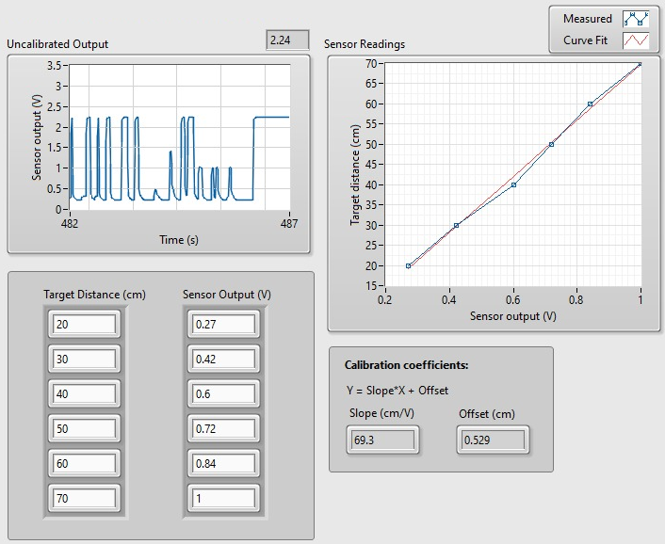

### Calibrate the Ultrasonic Distance Sensor

1. Click on the Calibrate Sensor tab to calibrate the output of the ultrasonic distance sensor in terms of linear displacement of the target (in cm).
2. Use the Slope (cm/V) and Offset (cm) numeric controls to enter the slope and offset values you obtained during the data collection step.
3. Test the accuracy of your calibration. To do this, place the target at different known positions within the calibrated range, and verify that the correct distance is displayed in the Calibrated Output waveform chart as well as the Distance (cm) slider indicator. Record the actual and measured distances in Table 2.

Table 2

|  |  |
| --- | --- |
| Actual Distance  (cm) | Measured Distance  (cm) |
| 20 | 19.3 |
| 30 | 29.18 |
| 40 | 39.2 |
| 50 | 49.1 |
| 60 | 58.5 |
| 70 | 68.3 |

1. Using the Calibrated Output waveform chart, approximate the resolution of the sensor (in cm).

Resolution (V/cm) is the slope of the curve and is computed as:

*Resolution = $\frac{1-0.27}{70-50}=0.0146$ V/cm*

## Reflective Optical Sensor

### Collect Data

1. Open QNET Mechatronic Sensors.lvproj.
2. From the Project Explorer window, open QNET Sensors Reflective Optical.vi.
3. Click on the Collect Data tab.
4. From the Device drop-down menu, select the device name.
5. Run the VI.
6. Gently turn the reflective optical sensor knob clockwise until it reaches its lower limit.
7. Enter 5 in the Target Distance (mm) array.
8. Using the Uncalibrated Output waveform chart, read the corresponding sensor output and enter the value in the Sensor Output (V) array.
9. Continue taking measurements by rotating the knob counterclockwise one rotation at a time. Enter the target distance and measured sensor outputs in the Target Distance (mm) and Sensor Output (V) arrays respectively.
10. As the measured readings are entered, a one-term power series is automatically generated to fit the data. The curve is shown in the Sensor Readings waveform graph. This curve represents the calibration curve of the sensor.
11. The coefficients of the calibration curve are automatically calculated by the VI and displayed in the A and B indicators. Make a note of these values.
12. How well does the curve fit your data?
13. Record the collected data in Table 1.

Table 3

|  |  |
| --- | --- |
| Target Distance  (mm) | Sensor Output  (V) |
| 5.00 | 0.4 |
| 6.25 | 0.28 |
| 7.50 | 0.21 |
| 8.75 | 0.16 |
| 10.00 | 0.12 |
| 11.25 | 0.1 |
| 12.5 | 0.09 |

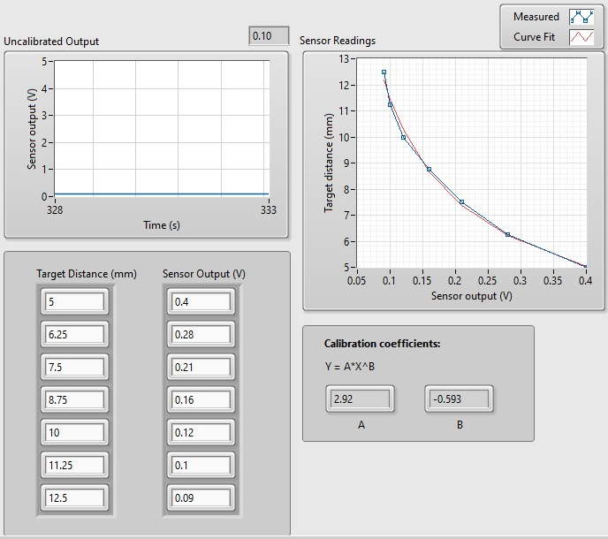

### Calibrate the Reflective Optical Sensor

1. Click on the Calibrate Sensor tab to calibrate the output of the reflective optical sensor in terms of linear displacement of the reflective target (in mm).
2. Use the A and B numeric controls to enter the power series coefficient values you obtained during the data collection step.
3. Test the accuracy of your calibration. To do this, move the target to different known positions within the calibrated range, and verify that the correct distance is displayed in the Calibrated Output waveform chart as well as the Distance (mm) slider indicator. Record the actual and measured distances in Table 2.

Table 4

|  |  |
| --- | --- |
| Actual Target Distance  (mm) | Measured Target Distance  (mm) |
| 5.00 | 5.02 |
| 6.25 | 6.2 |
| 7.50 | 7.41 |
| 8.75 | 8.55 |
| 10.00 | 9.75 |
| 11.25 | 11.12 |
| 12.5 | 12.35 |

1. A common problem with reflective optical sensors that are packaged with an IRED, is that ambient light affects their output. To observe this phenomenon, rotate the sensor’s knob in the counterclockwise direction until it reaches the highest position. Note the sensor value. Now partially obstruct ambient light by holding a notebook or your hand over the sensor assembly. How does blocking the ambient light affect the output of the sensor?

Blockage of ambient light results in more of the light being reflected onto the base of the phototransistor to be from the IRED emitter, ergo, the conduction control of ICC­ is now less than what it was with ambient light, causing lower output voltage to be received at the same target distance and calibration.

# Conclusion

In this lab, we further familiarized ourselves with modules on the QNET mechatronic sensor board. We observed that whenever an object comes close to ultrasonic distance sensor, the sensor produces an output voltage according to its distance from sensor. The closer the object is to the sensor, the higher is the output voltage and vice versa. By using these voltage values, we can find the distance between object and sensor. We also learned about reflective optical sensors and how the conduction of collector current, and therefore the output voltage, is dependent on the light received at the open enclosure at the base of the phototransistor. Effects of the blockage of ambient lights were also studied comprehensively.