**Department of Electrical Engineering and   
Computer Science**

**Faculty Member:** Dr. Shahzad Younis  **Dated:** 21/12/2022

**Semester:** 5th **Section:** BEE 12C

**EE-383:** **Instrumentation and Measurements**

Lab 12: Magnetic Field / Infrared Distance / Piezo Vibration

Lab Instructor: Mr. Ali

Group Members

|  |  |  |  |  |  |  |
| --- | --- | --- | --- | --- | --- | --- |
| **Name** | **Reg. No** | **Viva + Lab Performance (Individual)** | | **Analysis of data in Lab Report** | **Teamwork** | **Total** |
|  |  | **5+5 Marks** | | **5 Marks** | **5 Marks** | **20 Marks** |
| Danial Ahmad | 331388 |  |  |  |  |  |
| Muhammad Umer | 345834 |  |  |  |  |  |
| Tariq Umar | 334943 |  |  |  |  |  |
|  |  |  |  |  |  |  |

**Table of Contents**

2 Magnetic Field / Infrared Distance / Piezo Vibration 3

2.1 Objectives 3

2.2 Equipment 3

2.3 Lab Instructions 3

3 Lab Procedure 4

3.1 Magnetic Field Sensor 4

3.1.1 Collect Data 4

3.1.2 Calibrate Sensor 5

3.2 Infrared Distance Sensor 5

3.2.1 Collect Data 6

3.2.2 Effect of Surface Reflectivity 7

3.3 Piezo Vibration Sensor 8

3.3.1 Collect Data 8

3.3.2 Determine Natural Frequency 8

4 Conclusion 9

# Magnetic Field / Infrared Distance / Piezo Vibration

## Objectives

Using the background information learnt about sensors in theory and labs, their properties, working principles and application; you are required to design and conduct experiment on QNET Mechatronics Sensors; Magnetic Field, Infrared and Piezo Vibration Sensors. Investigate their properties, analyze and verify results.

## Equipment

Hardware

* QNET Mechatronics Sensor Board
* NI LabView

## Lab Instructions

All questions should be answered precisely to get maximum credit. Lab report must ensure following items:

* Lab objectives
* Results (Graphs/Tables/Pictures) duly commented and discussed
* Conclusion

# Lab Procedure

## Magnetic Field Sensor

### Collect Data

Using Magnetic Field Sensor and running VI in LabView, (Uncalibrated) Record Target Distance vs. Output Voltage Reading. Vary distance by rotating knob and recording your readings in table. Obtain the graph, Target Distance vs. Output Voltage.

|  |  |
| --- | --- |
| Target Distance (mm) | Sensor Output (V) |
| 6 | 2.37 |
| 6.25 | 2.41 |
| 7.5 | 2.44 |
| 8.75 | 2.46 |
| 10 | 2.47 |
| 11.25 | 2.48 |
| 12.5 | 2.49 |

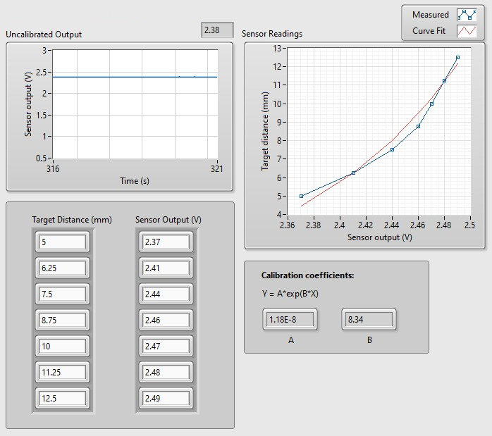

### Calibrate Sensor

Now calibrate your sensor, obtain calibration equation and test the accuracy of calibration. Record Actual Distance (mm) and Measured Distance (mm).

|  |  |
| --- | --- |
| Actual Distance (mm) | Measured Distance (mm) |
| 6 | 5.92 |
| 6.25 | 6.31 |
| 7.5 | 7.44 |
| 8.75 | 8.77 |
| 10 | 9.87 |
| 11.25 | 11.13 |
| 12.5 | 12.45 |

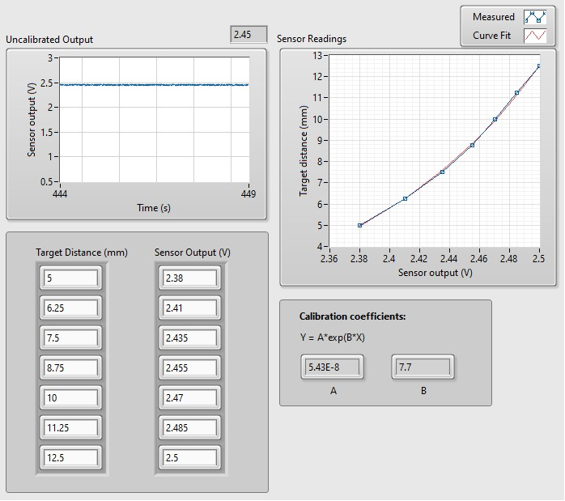

## Infrared Distance Sensor

Using Infrared Sensor and running VI in LabView, (Uncalibrated) Record Target Distance vs. Output Voltage Reading. Use a cardboard (30cm x 30cm) of matte surface and vary distance, record your readings in table. Obtain the graph, Target Distance vs. Output Voltage.

|  |  |
| --- | --- |
| Target Distance (cm) | Sensor Output (V) |
| 10 | 3.06 |
| 15 | 1.83 |
| 20 | 1.54 |
| 25 | 1.31 |
| 30 | 1.17 |
| 35 | 1.03 |
| 40 | 0.82 |

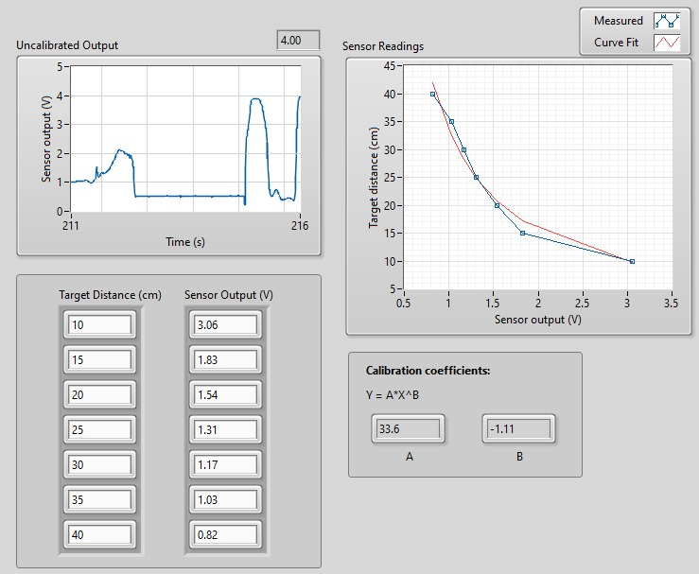

### Collect Data

Now calibrate your sensor, obtain calibration equation and test the accuracy of calibration. Record Actual Distance (cm) and Measured Distance (cm).

|  |  |
| --- | --- |
| Actual Distance (cm) | Measured Distance (cm) |
| 10 | 9.87 |
| 15 | 14.81 |
| 20 | 19.98 |
| 25 | 24.68 |
| 30 | 29.71 |
| 35 | 33.97 |
| 40 | 39.87 |

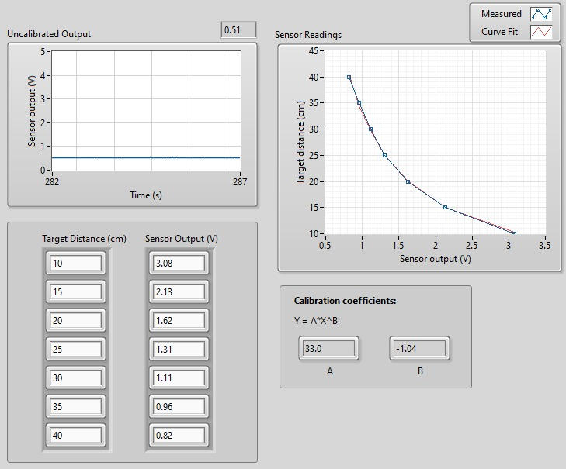

### Effect of Surface Reflectivity

To observe the effect of surface reflectivity, repeat the data collection procedure using a target that has a highly shiny surface finish. Record your measurements in Table. Do you observe a notable difference?

|  |  |
| --- | --- |
| Target Distance (cm) | Sensor Output (V) |
| 10 | 3.62 |
| 15 | 2.21 |
| 20 | 1.26 |
| 25 | 0.78 |
| 30 | 0.57 |
| 35 | 0.43 |
| 40 | 0.31 |

A noticeable difference is indeed observed, as now, more infrared lights are being reflected into the receiver, causing a higher voltage output.

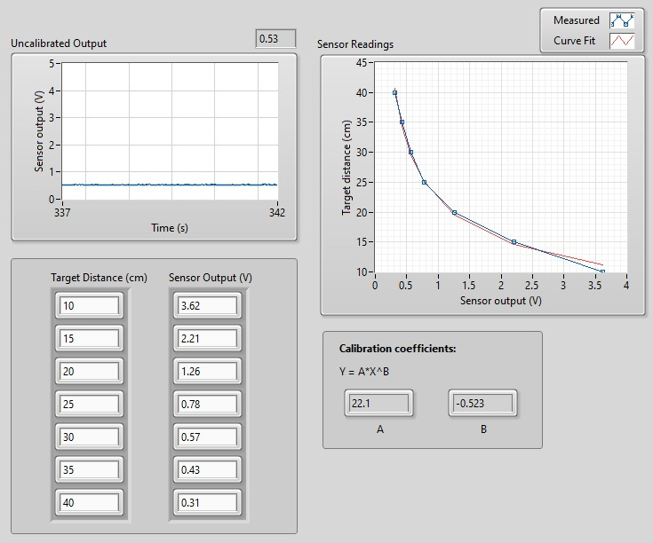

## Piezo Vibration Sensor

### Collect Data

Using Piezo vibration sensor on the sensor board and running VI in LabView, with one finger manually perturb the plastic tab that is attached to the Piezo sensor and examine the response in the Piezo Output waveform chart. Hold the end of the plastic tab and slowly flex it. Examine the response.

The piezo vibration sensor measures the micro strain, and a short-time impulse response is observed for when a quick perturbation is applied to the plastic tab. The response follows an exponential trend when the plastic tab is held and slowly flexed.

Based on these two tests, what does the Piezo vibration sensor measure? How is the measurement different from a strain gage measurement? Capture sample results for both tests using the Piezo Output waveform chart.

The piezo vibration sensor differs from the strain gauge in that the former is used to measure micro strain for quick perturbations as opposed to the prolonged loading case as in that of the latter sensor.

### Determine Natural Frequency

Determine the natural frequency using the natural frequency tab and record your observations.

|  |  |
| --- | --- |
| Trial | Frequency (Hz) |
| 1 | 48.85 |
| 2 | 49.43 |
| 3 | 50.31 |
| 4 | 49.68 |
| 5 | 51.12 |

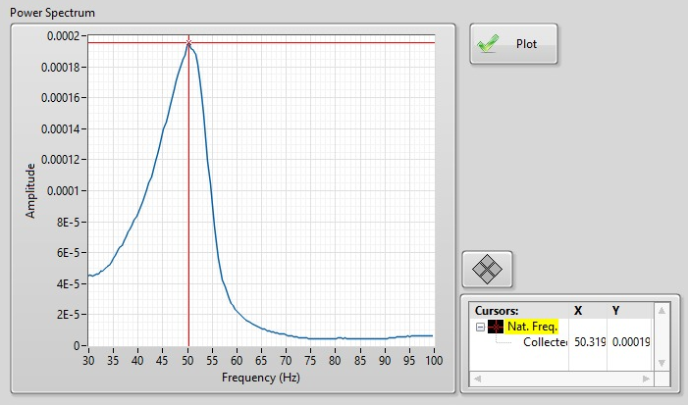

# Conclusion

In this lab, we used three new sensors and their working. These 3 include magnetic field sensor, infrared distance sensor, and Piezo vibration sensor. After seeing that measured values are not plotting the expected graph, we calibrate the sensor to fix that. In addition to that, we also plotted the graphs to see the relationships of each sensor with the respective parameters. This was an open-ended lab, so we did not receive any demonstration from lab instructors.