**Department of Electrical Engineering and   
Computer Science**

**Faculty Member:** Dr. Shahzad Younis  **Dated:** 30/09/2022

**Semester:** 5th **Section:** BEE 12C

**EE-383:** **Instrumentation and Measurements**

Lab 3 Additional Task: Gas Sensor

Lab Instructor: Mr. Ali

Group Members

|  |  |  |  |  |  |  |
| --- | --- | --- | --- | --- | --- | --- |
| **Name** | **Reg. No** | **Conduct of**  **Experiment** | **Analysis of data in Lab Report** | **Modern Tool Usage** | **Ethics**  **and**  **Safety** | **Individual and Teamwork** |
|  |  | **5 Marks** | **5 Marks** | **5 Marks** | **5 Marks** | **5 Marks** |
| Danial Ahmad | 331388 |  |  |  |  |  |
| Muhammad Umer | 345834 |  |  |  |  |  |
| Tariq Umar | 334943 |  |  |  |  |  |
|  |  |  |  |  |  |  |

**Table of Contents**

2 Table of Figures 2

3 Introduction 3

4 Objectives 3

5 Design 3

5.1 Methodology 3

5.2 Proteus Simulation 3

5.3 Hardware 4

6 Conclusion 4

# Table of Figures

# Introduction

Gas sensor is a device that measures the concentration level of the gases present in the atmosphere. One such sensor that is used in safety systems to detect harmful gases is MQ2 gas sensor. This sensor is often used in quality monitoring system, breath checker or early fire detection system. In this additional lab task, we shall be interfacing the smoke sensor with the Arduino Mega.

# Objectives

* Get familiar with Arduino and sensors
* Get familiar with interfacing a sensor in Arduino
* Understand the hardware of the microcontroller
* Revise Proteus for making simulations
* Interface the MQ2 sensor with the Arduino and write its code.

# Design

We used a MQ2 gas sensor because it’s the most used gas sensor and is readily available in the market, furthermore, is used to detect carbon monoxide which is present in smoke and hence can be used as smoke detectors. In addition to that we added an LCD screen to display the output of the sensor.

We initially connected the MQ2 sensor with ground and a VCC source of 5V. We then connected the analogue pin of the sensor with the analogue pin A0 of Arduino Mega. We connected the digital pin of the sensor D0 with digital pin number 8 of Arduino. We also connected the A1 pin of the Arduino with a Resistor and LED in series and connected it with ground.

The LED screen pin connections were made accordingly. RXD pin connected to pin 1, TXD pin connected to pin 0.

## Methodology

Aaaa idkkk man idkkk I wish I knew but idkk

## Proteus Simulation

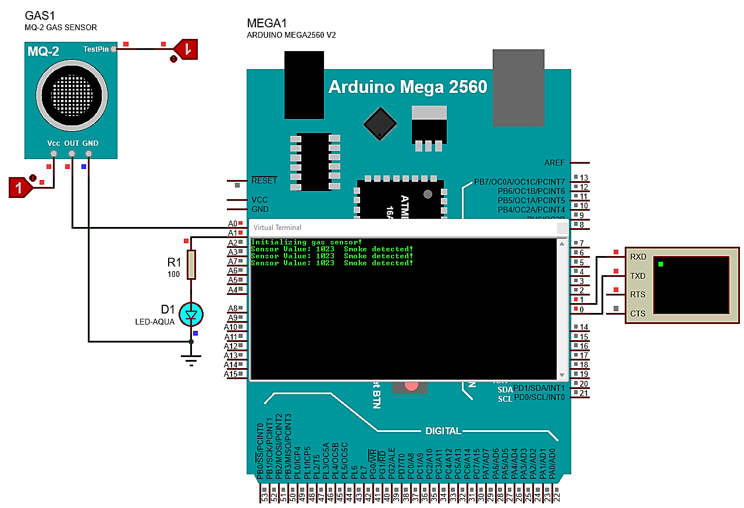

Figure . Proteus Schematic

*Note: This simulation uses LOGICTOGGLE to provide power to the circuit, as well as the test pin of the MQ-2 Gas Sensor. As such, the only possible readings are 0 and 1023 (corresponding to 0V and 4.99V). In the practical implementation, analog output of the gas sensor is used, and the readings are thus mapped between 0 – 1023.*

### Arduino Code

#define sensorPin A0

#define ledPin A1

int gasIntensity; // analog reading (0-5V) from the sensor

int threshold = 470;

void setup()

{

    Serial.begin(9600); // sets the serial port to 9600

    Serial.println("Initializing gas sensor!");

}

void loop()

{

    gasIntensity = analogRead(sensorPin); // read analog input pin 0

    Serial.print("Sensor Value: ");

    Serial.print(gasIntensity);

    if (gasIntensity > threshold)

    {

        Serial.print("  Smoke detected!");

        analogWrite(ledPin, gasIntensity / 4); // maps 0-1023 to 0-255

    }

    Serial.println(""); // print null and move to next line

    delay(200);

    analogWrite(ledPin, 0); // turn LED off

}

## Hardware Functioning

When semiconductor particles are heated in air, oxygen is being absorbed on the surface. In clean air, donor electrons in the semiconductor are attracted towards the oxygen, and hence prevent current flow.

Whereas in the presence of Combustible gases (reducing gases), surface density of absorbed oxygen decreases since it reacts with the reducing gases. Electrons are then released into the semiconductor allowing current to flow through the sensor.



# Conclusion