**Department of Electrical Engineering and   
Computer Science**

**Faculty Member:** Dr. Shahzad Younis  **Dated:** 28/09/2022

**Semester:** 5th **Section:** BEE 12C

**EE-383:** **Instrumentation and Measurements**

Lab 3 Additional Task: Smoke Sensor

Lab Instructor: Mr. Ali

Group Members

|  |  |  |  |  |  |  |
| --- | --- | --- | --- | --- | --- | --- |
| **Name** | **Reg. No** | **Viva + Lab Performance (Individual)** | | **Analysis of data in Lab Report** | **Teamwork** | **Total** |
|  |  | **5+5 Marks** | | **5 Marks** | **5 Marks** | **20 Marks** |
| Danial Ahmad | 331388 |  |  |  |  |  |
| Muhammad Umer | 345834 |  |  |  |  |  |
| Tariq Umar | 334943 |  |  |  |  |  |
|  |  |  |  |  |  |  |

**Table of Contents**

2 Table of Figures 2

3 Introduction 3

4 Objectives 3

5 Design 3

5.1 Implementation 3

5.2 Proteus Simulation 4

5.2.1 Arduino Code 4

5.3 Hardware Functioning 5

6 Conclusion 5

# Table of Figures

Figure 5.1.1 Hardware Implementation 3

Figure 5.2.1 Proteus Schematic 4

# Introduction

Gas sensor is a device that measures the concentration level of the gases present in the atmosphere. One such sensor that is used in safety systems to detect harmful gases is MQ2 gas sensor. This sensor is often used in quality monitoring system, breath checker or early fire detection system. In this additional lab task, we shall be interfacing the smoke sensor with the Arduino Mega.

# Objectives

* Get familiar with Arduino and sensors
* Get familiar with interfacing a sensor in Arduino
* Understand the hardware of the microcontroller
* Revisit Proteus for making simulations
* Interface the MQ2 sensor with the Arduino and write its code

# Design

We used a MQ-2 gas sensor because it is both reliable and readily available in the market. Furthermore, it is used to detect carbon monoxide which is present in smoke and hence can be used as smoke detectors. In addition to that, we added an LCD screen to display the output of the sensor.

After appropriate connections are made to turn the MQ-2 sensor on (VCC to 5 V, GND to 0 V), we drive out its analog output to an analog PIN A0 of the Arduino MEGA. To display smoke detection to an observer, an LED is connected to PIN A1 of the microcontroller. Readings of the sensor are also displayed to the serial monitor in real-time.

## Implementation

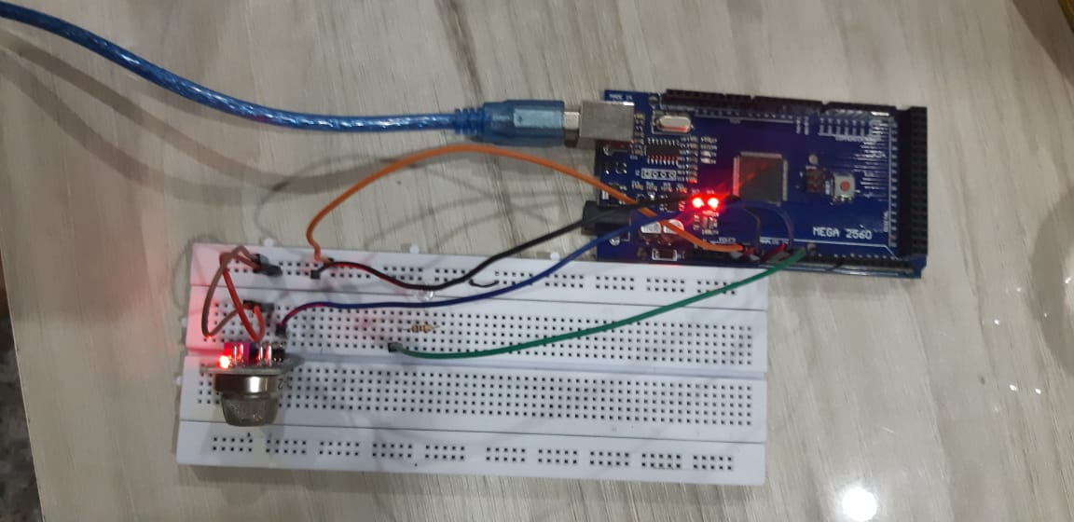

Figure . Hardware Implementation

## Proteus Simulation

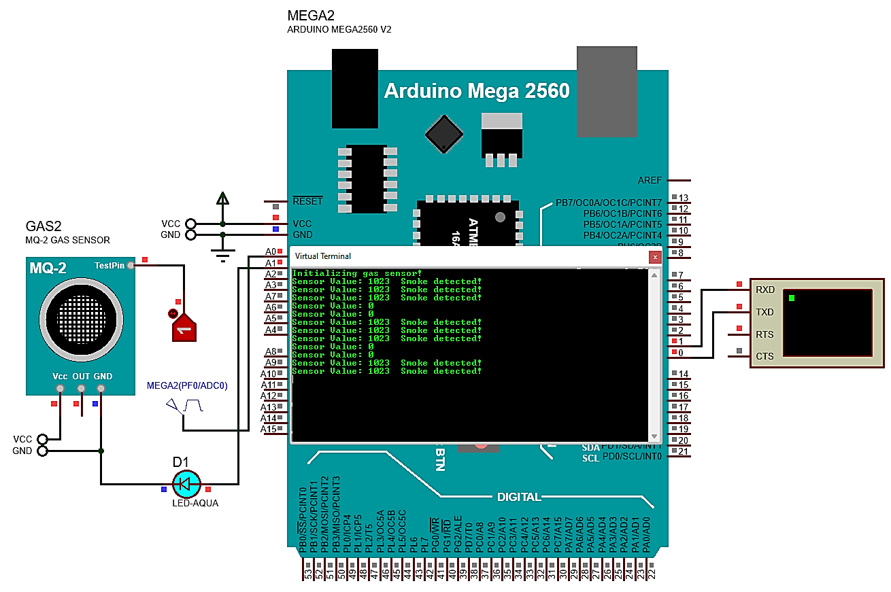

Figure . Proteus Schematic

*Note: This simulation uses a Pulse Generator to emulate an analog output from the OUT pin of the MQ-2 sensor. As such, the only possible readings are 0 and 1023 (corresponding to 0V and 4.99 V). In the real-life implementation, analog output of the gas sensor can take any value between 0 and 1023 (corresponding to any value between 0V and 4.99 V).*

### Arduino Code

#define sensorPin A0

#define ledPin A1

int gasIntensity; // analog reading (0-5V) from the sensor

int threshold = 470;

void setup()

{

    pinMode(sensorPin, INPUT);

    pinMode(ledPin, OUTPUT);

    Serial.begin(9600); // sets the serial port to 9600

    Serial.println("Initializing gas sensor!");

}

void loop()

{

    gasIntensity = analogRead(sensorPin); // read analog input pin 0

    Serial.print("Sensor Value: ");

    Serial.print(gasIntensity);

    if (gasIntensity > threshold)

    {

        Serial.print("  Smoke detected!");

        digitalWrite(ledPin, HIGH); // turns LED on

    }

    Serial.println(""); // print null and move to next line

    delay(200);

    digitalWrite(ledPin, LOW); // turns LED off

}

## Hardware Functioning

When semiconductor particles are heated in air, oxygen is being absorbed on the surface. In clean air, donor electrons in the semiconductor are attracted towards the oxygen, and hence prevent current flow.

Whereas in the presence of combustible gases (reducing gases), surface density of absorbed oxygen decreases since it reacts with the reducing gases. Electrons are then released into the semiconductor allowing current to flow through the sensor.

So, we set our sensor’s sensitivity by tightening or loosening it using a screwdriver. Then depending upon the concentration of smoke, our LED will light up if the value has crossed the set value.

# Conclusion

In this additional lab task, we familiarized ourselves with how to interface a sensor onto Arduino mega, which we will be doing quite frequently for our final project. We got to know the working of a gas sensor and how to connect it on hardware. This task prepared us for future hardware interfacing of various sensors which we will be using.