**Department of Electrical Engineering and   
Computer Science**

**Faculty Member:** Dr. Shahzad Younis  **Dated:** 28/09/2022

**Semester:** 5th **Section:** BEE 12C

**EE-383:** **Instrumentation and Measurements**

Lab 4: Inductive Proximity Switches

Lab Instructor: Mr. Ali

Group Members

|  |  |  |  |  |  |  |
| --- | --- | --- | --- | --- | --- | --- |
| **Name** | **Reg. No** | **Viva + Lab Performance (Individual)** | | **Analysis of data in Lab Report** | **Teamwork** | **Total** |
|  |  | **5+5 Marks** | | **5 Marks** | **5 Marks** | **20 Marks** |
| Danial Ahmad | 331388 |  |  |  |  |  |
| Muhammad Umer | 345834 |  |  |  |  |  |
| Tariq Umar | 334943 |  |  |  |  |  |
|  |  |  |  |  |  |  |

**Table of Contents**

2 Table of Figures 2

3 Inductive Proximity Switches 3

3.1 Objectives 3

3.2 Equipment 3

3.3 Introduction 3

3.4 Lab Instructions 3

4 Lab Procedure 4

4.1 Characteristics 4

4.2 Sensing Distance 5

5 Questions 5

6 Conclusion 6

# Table of Figures

Figure 4.1.1 Apparatus 4

# Inductive Proximity Switches

## Objectives

* In this exercise, you will be introduced to inductive proximity switches
* You will learn how and when they are used
* You will also learn their advantages and disadvantages
* You will experiment with their operation using the Reflective Block

## Equipment

Hardware

* LabVolt Proprietary Sensor Training System



## Introduction

Inductive proximity switches are designed to detect the presence of metallic objects. They detect their presence by generating an electromagnetic field and detecting changes in this field caused by an approaching metallic object.

## Lab Instructions

All questions should be answered precisely to get maximum credit. Lab report must ensure following items:

* Lab objectives
* Results (Graphs/Tables/Pictures) duly commented and discussed
* Conclusion

# Lab Procedure

## Characteristics

Test the ability of the Inductive Proximity Switch to detect the surfaces of the Reflective Block. Position the proximity switch and the Reflective Block as shown in Figure 4.1.1 Apparatus and determine which surfaces are detected by the sensor. Note your observations in Table 4.1‑1 Observations.

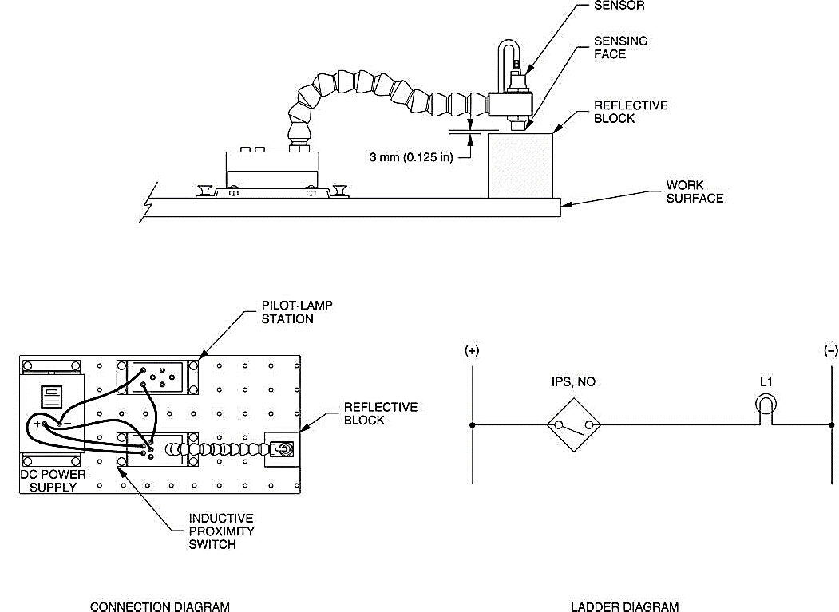

Figure . Apparatus

Table ‑ Observations

|  |  |  |
| --- | --- | --- |
| **Surface** | **Detected** | **Not Detected** |
| Black Plastic Surface |  | ✅ |
| White Plastic Surface |  | ✅ |
| Matte Black Metallic Surface | ✅ |  |
| Shiny Metallic Surface | ✅ |  |
| Retroreflective Surface |  | ✅ |

1. Does the Inductive Proximity Switch detect all surfaces of the Reflective Block whatever the surfaces covering the plastic block?

**Answer:** No, inductive proximity switch relies on the concept of electromagnetic induction, and hence, surfaces containing no trace of metallic elements are undetected by the proximity switch.

1. Which surfaces are detected by the proximity switch?

**Answer:** Only the *Matte Black Metallic Surface* and *Shiny Metallic Surface* of the Reflective Block are detected by the proximity switch.

1. Place some objects of different materials (metallic and non-metallic) against the sensor. Do your observations confirm that only metallic surfaces are detected by the Inductive Proximity Switch?

**Answer:** Yes, our observations align with the theoretical functioning of the Inductive Proximity Switch.

## Sensing Distance

Determine the maximum sensing distance of the Inductive Proximity Switch. To do so, place the shiny metallic surface of the Reflective Block against the sensor. Raise the sensor slowly away from the metallic surface until pilot lamp L1 turns off. Determine the distance.

Maximum sensing distance **= 0.39 in**

# Questions

1. What type of materials do inductive switches detect?

**Answer:** The inductive proximity switches detect only metallic materials/surfaces.

1. What are the four main parts of an inductive proximity switch?

**Answer:**

* Wire coil
* Oscillator
* Rectifier (Detector Circuit)
* Transistor (Output Circuit)

1. What causes the maximum sensing distance of an inductive proximity switch to be relatively short?

**Answer:** The sensing distance of the inductive proximity sensors depends on the size of the coil and the composition of the target object. Because the magnitude of the magnetic field associated with the induced eddy currents is quite small, the maximum sensing distance of an inductive proximity switch is also quite small.

1. Explain why inductive proximity switches must be spaced from surrounding metallic surfaces and/or other sensors.

**Answer:** Because nearby metallic objects affect the operation of inductive proximity switches, they must be spaced from surrounding metallic objects and/or other sensors.

1. Name two parameters that affect the sensing distance of an inductive proximity switch.

**Answer:**

* Size of the coil
* Composition of the target object

# Conclusion

In this exercise, you were introduced to inductive proximity switches. You learned how and when they are used, their advantages and disadvantages. You observed the ability of the Inductive Proximity Switch to detect the presence of various objects. In the last part of the exercise, you observed that the maximum sensing distance of this type of sensor is quite short.