**Department of Electrical Engineering**

|  |  |
| --- | --- |
| **Faculty Member:_____________** | **Dated: ________________** |
| **Semester:___________________** | **Section: ________________** |

**EE-383**-**Instrumentation and Measurements**

**Experiment # 4**

**Inductive Proximity Switches**

|  |  |  |  |  |  |  |
| --- | --- | --- | --- | --- | --- | --- |
|  |  | **PLO4/**  **CLO3** | | **PLO4/ CLO4** | **PLO8/ CLO5** | **PLO9/ CLO6** |
| **Name** | **Reg. No** | **Viva / Quiz / Lab Performance** | **Analysis of data in Lab Report** | **Modern Tool Usage** | **Ethics and Safety** | **Individual and Teamwork** |
|  |  | **5 Marks** | **5 Marks** | **5 Marks** | **5 Marks** | **5 Marks** |
|  |  |  |  |  |  |  |
|  |  |  |  |  |  |  |
|  |  |  |  |  |  |  |
|  |  |  |  |  |  |  |

**Lab no. 4**

**Inductive Proximity Switches**

# OBJECTIVE

* In this exercise, you will be introduced to inductive proximity switches;
* You will learn how and when they are used;
* You will also learn their advantages and disadvantages;
* You will experiment with their operation using the Reflective Block.

# DISCUSSION

Inductive proximity switches are designed to detect the presence of metallic objects. They detect their presence by generating an electromagnetic field and detecting changes in this field caused by an approaching metallic object. Inductive proximity switches consist of a wire coil, oscillator, rectifier (detector circuit), and transistor (output circuit) as shown in Figure 4-1.



Figure 4-1. Inductive proximity sensor.

The oscillator produces a high frequency voltage applied to the wire coil to produce an electromagnetic field. As Figure 4-2 shows, when a metallic object enters the magnetic field, eddy currents are induced in the object. This causes a loss in energy and a reduction in the magnitude of the oscillations. When the energy loss becomes important enough, the oscillator stops functioning.

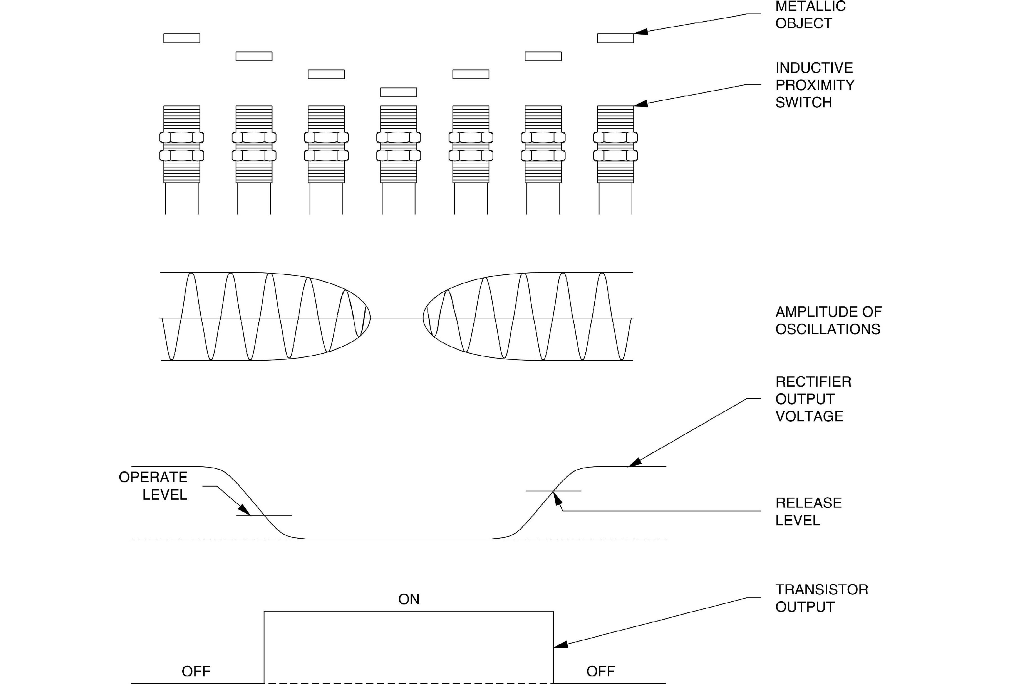

Figure 4-2. Operation of an inductive proximity switch.

The rectifier converts the AC output signal from the oscillator to a DC voltage. When the DC voltage drops below the "operate level", the sensor switches the output transistor to the activated mode. When the DC voltage raises to the "release level", the sensor switches the output transistor to the deactivated mode. Because the magnetic field associated with the induced eddy currents is quite small, the maximum sensing distance of an inductive proximity switch is also quite small. Typical sensing distances are from 1 to 15 mm (0.04 to 0.6 in). These distances are standardized against a mild steel target, typically measuring 50 × 50 × 1 mm (2 × 2 × 0.04 in), the same as for capacitive proximity switches. Objects smaller than the standard target will lessen the maximum sensing distance, and objects larger than the standard target may increase the sensing distance.

Sensing distance, for capacitive proximity sensors, depends on the size of the probe and the target. With inductive proximity sensors, the sensing distance depends on the size of the coil and the composition of the target object. The chart in Table 4-1 shows the effect of target composition on the sensing distance.

**TYPE OF METAL**

**CORRECTION FACTOR**

Mild steel

1

Stainless Steel

0.9

Brass

0.5

Aluminum

0.45

Copper

0.4

Table 4-1. Sensing Distance.

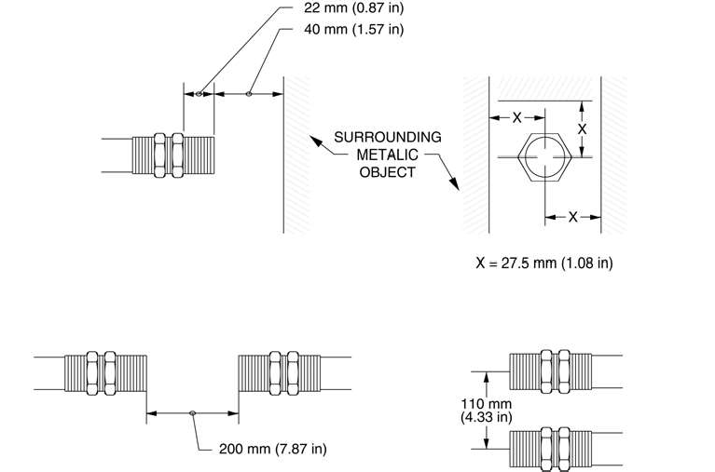For example, an inductive proximity switch detects copper at 40% the standard sensing distance, and stainless steel at 90%. Non-metallic objects are very poor conductors and will not be detected at all. Because nearby metallic objects affect the operation of inductive proximity switches, they must be spaced from surrounding metallic objects and/or other sensors as shown in Figure 4-3. Proximity Switch of your training system.

Inductive proximity sensors can be shielded or unshielded. Shielded sensors are constructed with a metallic band surrounding the coil. This helps to direct the electromagnetic field to the front of the sensor and results in a more concentrated field.

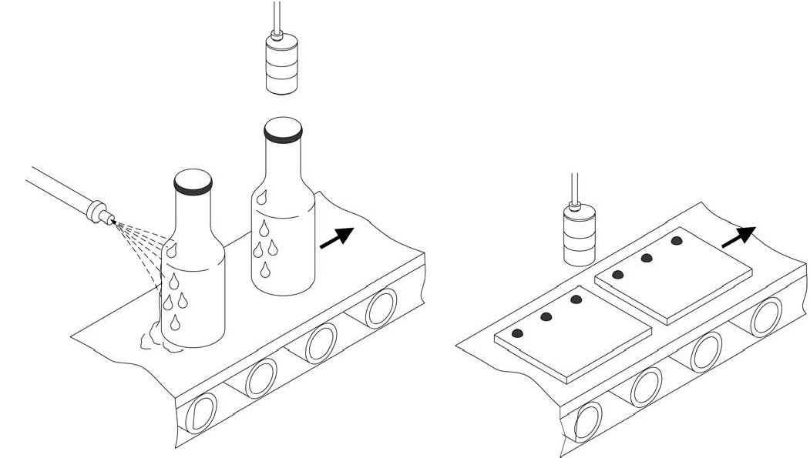Figure 4-4 (a) shows an inductive proximity switch checking bottles for bottle caps. Bottles without caps are rejected. Inductive proximity switches work better than other proximity switches in this application because they are not affected by high humidity. In Figure 4-4 (b) an inductive proximity switch inspects and counts the rivets on a finished work pie

The Inductive Proximity Switch of your training system is shown in Figure 4-5.

As Figure 4-5 shows, the sensor has an output indicator (red LED) that lights when the output is activated. There is no sensitivity adjustment. Other characteristics of the Inductive Proximity Switch are shown in Table 4-2.

**CHARACTERISTICS OF THE INDUCTIVE PROXIMITY SWITCH**

Type

Inductive unshielded

Transistor output type

Sourcing (PNP)

Maximum sensing distance

10 mm (0.4 in)

Response time (sensor only)

40 ms

Table 4-2. Characteristics of the Inductive Proximity Switch.

## Procedure Summary

In the first part of the exercise, *Characteristics*, you will observe the ability of the Inductive Proximity Switch to detect the presence of various objects.

In the second part of the exercise, *Sensing Distance*, you will determine the maximum sensing distance of the Inductive Proximity Switch by using the Reflective Block.

# EQUIPMENT REQUIRED

Refer to the Equipment Utilization Chart, in Appendix A of this manual, to obtain the list of equipment required to perform this exercise.

# PROCEDURE

## Characteristics

1. Connect the circuit shown in Figure 4-6 and turn on the DC Power Supply.
2. Test the ability of the Inductive Proximity Switch to detect the surfaces of the Reflective Block.

Position the proximity switch and the Reflective Block as shown in Figure 4-6 and determine which surfaces are detected by the sensor. Note your observations in Table 4-3.

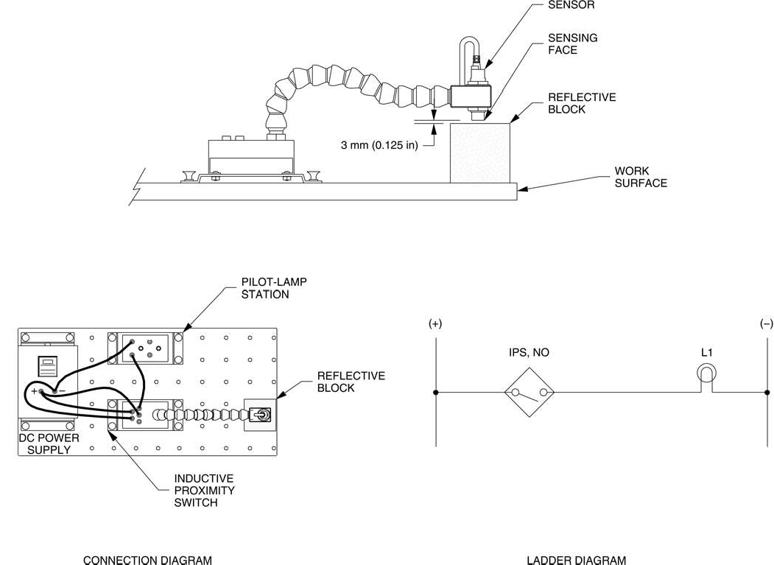

Figure 4-6. Circuit using the Inductive Proximity Switch

**SURFACE**

**DETECTED**

**NOT DETECTED**

Black Plastic Surface White Plastic Surface

Matte Black Metallic Surface Shiny Metallic Surface

Retroreflective Surface

**Table 4-3.**

1. Does the Inductive Proximity Switch detect all surfaces of the Reflective Block whatever the surfaces covering the plastic block?
2. Which surfaces are detected by the proximity switch?
3. Place some objects of different materials (metallic and non-metallic) against the sensor. Do your observations confirm that only metallic surfaces are detected by the Inductive Proximity Switch?

## Sensing Distance

1. Determine the maximum sensing distance of the Inductive Proximity Switch. To do so, place the shiny metallic surface of the Reflective Block against the sensor. Raise the sensor slowly away from the metallic surface until pilot lamp L1 turns off. Determine the distance.

Maximum sensing distance =

1. Turn off the Power DC Supply and remove all leads.

# CONCLUSION

In this exercise, you were introduced to inductive proximity switches. You learned how and when they are used, their advantages and disadvantages. You observed the ability of the Inductive Proximity Switch to detect the presence of various objects. In the last part of the exercise, you observed that the maximum sensing distance of this type of sensor is quite short.

# REVIEW QUESTIONS

1. What type of Materials do inductive switches detect?
2. What are the four main parts of an inductive proximity switch?
3. What causes the maximum sensing distance of an inductive proximity switch to be relatively short?
4. Explain why inductive proximity switches must be spaced from surrounding metallic surfaces and/or other sensors.
5. Name two parameters that affect the sensing distance of an inductive proximity switch.