**Department of Electrical Engineering and   
Computer Science**

**Faculty Member:** Dr. Shahzad Younis  **Dated:** 5/09/2022

**Semester:** 5th **Section:** BEE 12C

**EE-383:** **Instrumentation and Measurements**

Lab 4 Additional Task: Temperature Sensor

Lab Instructor: Mr. Ali

Group Members

|  |  |  |  |  |  |  |
| --- | --- | --- | --- | --- | --- | --- |
| **Name** | **Reg. No** | **Viva + Lab Performance (Individual)** | | **Analysis of data in Lab Report** | **Teamwork** | **Total** |
|  |  | **5+5 Marks** | | **5 Marks** | **5 Marks** | **20 Marks** |
| Danial Ahmad | 331388 |  |  |  |  |  |
| Muhammad Umer | 345834 |  |  |  |  |  |
| Tariq Umar | 334943 |  |  |  |  |  |
|  |  |  |  |  |  |  |

**Table of Contents**

2 Table of Figures 2

3 Introduction 3

4 Objectives 3

5 Design 3

5.1 Flowchart 3

5.2 Proteus Simulation 4

5.2.1 Arduino Code 4

5.3 Implementation 5

5.4 Hardware Functioning 6

6 Conclusion 6

# Table of Figures

Figure 5.2.1 Proteus Schematic 4

Figure 5.3.1 Hardware Implementation 5

# Introduction

A temperature sensor is an electronic device that measures the temperature of its environment and converts the input data into electronic data to record, monitor, or signal temperature changes. There are many different types of temperature sensors. One type is sensor which are in direct contact with the object whose temperature is to be found, other types of sensors are those in which they measure temperature indirectly. Temperature sensors are used in automobiles, medical devices, computers, cooking appliances, and other types of machinery. We shall be interfacing the temperature sensor DHT11 onto Arduino Mega.

# Objectives

* Get familiar with Arduino and sensors
* Get familiar with interfacing a sensor in Arduino
* Understand the hardware of the microcontroller
* Create ideal simulations of real-life sensors
* Interface the DHT11 sensor with the Arduino and write its code

# Design

In this additional lab task, we interfaced the Arduino with a DHT11 sensor, which is a temperature and humidity sensor. It detects water vapor by measuring electrical resistance between two electrodes, and measures temperature using thermistors. This sensor will output the temperature readings through the serial data transfer. We also added an LCD screen to display the temperature output.

We start by connecting the left pin, VCC, to the 5V pin in the Arduino and respectively the right pin, GND, to the ground pin in Arduino. Then connect the middle data signal pin to the pin number 28 of Arduino. The LCD screen pin connections were made accordingly.

## Flowchart

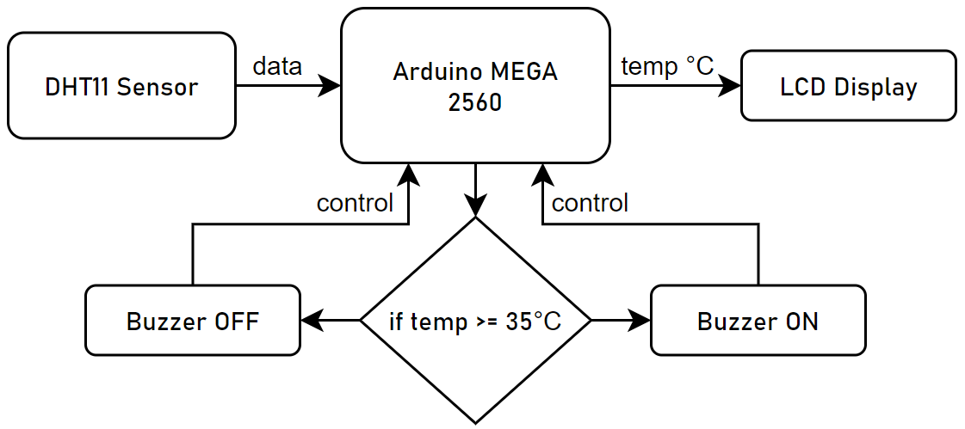

## Proteus Simulation

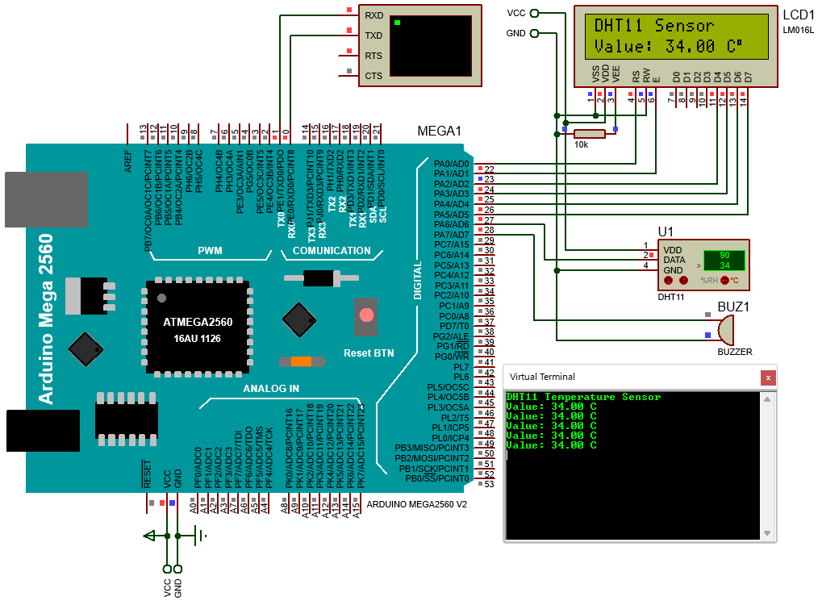

Figure . Proteus Schematic

### Arduino Code

#include "DHT.h"

#include "LiquidCrystal.h"

#define DHTPIN 28     // Pin connected to DHT11

#define DHTTYPE DHT11 // DHT 11

#define BUZZER 29

const int rs = 22, en = 23, d4 = 24, d5 = 25, d6 = 26, d7 = 27;

*LiquidCrystal* lcd(*rs*, *en*, *d4*, *d5*, *d6*, *d7*);

*DHT* dht(*DHTPIN*, *DHTTYPE*);

float temperature = 0;

void clearLCDLine(int *line*)

{

    pinMode(DHTPIN, INPUT);

    pinMode(BUZZER, OUTPUT);

    lcd.setCursor(0, *line*);

    for (int n = 0; n < 16; n++)

    {

        lcd.print(" ");

    }

}

void setup()

{

    Serial.begin(9600);

    Serial.println("DHT11 Temperature Sensor");

    lcd.begin(16, 2);

    lcd.print("DHT11 Sensor");

    dht.begin();

}

void loop()

{

    delay(2000);

    digitalWrite(BUZZER, LOW);

    clearLCDLine(1);

    temperature = dht.readTemperature();

    if (temperature >= 35)

    {

        digitalWrite(BUZZER, HIGH);

    }

    lcd.setCursor(0, 1);

*String* temperature_str = "Value: ";

*String* lcd_str = temperature_str + temperature + " C";

    lcd.print(lcd_str);

    lcd.print((char)223);

    Serial.println(lcd_str);

}

## Implementation

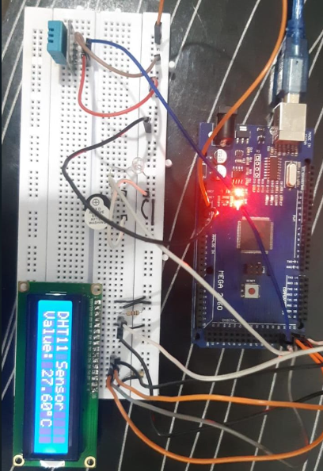

Figure . Hardware Implementation

## Hardware Functioning

Our DHT11 sensor senses water vapor in the environment by measuring the electrical resistance between its two electrodes. The humidity detecting component is a moisture holding substrate with electrodes applied to the surface. When water vapor is absorbed by the substrate, ions are released by the substrate which increases the conductivity between the electrodes. The change in resistance between the two electrodes is proportional to the relative humidity. Higher relative humidity decreases the resistance between the electrodes, while lower relative humidity increases the resistance between the electrodes.

The sensor measures the temperature of the surface with a thermistor. Thermistors change resistance with temperature changes; they are temperature dependent resistors. The sensor measures this change in voltage applied due to the change in the resistance, and hence we can calculate the value of temperature at a particular place or surface.

# Conclusion

In this additional lab task, we familiarized ourselves with how to interface a sensor onto Arduino mega, which we will be doing quite frequently for our final project. We got to know the working of a temperature sensor and how to connect it on hardware. This task prepared us for future hardware interfacing of various sensors which we will be using. It made us practice on how to work on hardware more efficiently and effectively.