**Department of Electrical Engineering and   
Computer Science**

**Faculty Member:** Dr. Shahzad Younis  **Dated:** 12/10/2022

**Semester:** 5th **Section:** BEE 12C

**EE-383:** **Instrumentation and Measurements**

Lab 5: Capacitive Proximity Switches

Lab Instructor: Mr. Ali

Group Members

|  |  |  |  |  |  |  |
| --- | --- | --- | --- | --- | --- | --- |
| **Name** | **Reg. No** | **Viva + Lab Performance (Individual)** | | **Analysis of data in Lab Report** | **Teamwork** | **Total** |
|  |  | **5+5 Marks** | | **5 Marks** | **5 Marks** | **20 Marks** |
| Danial Ahmad | 331388 |  |  |  |  |  |
| Muhammad Umer | 345834 |  |  |  |  |  |
| Tariq Umar | 334943 |  |  |  |  |  |
|  |  |  |  |  |  |  |

**Table of Contents**

2 Table of Figures 2

3 Inductive Proximity Switches 3

3.1 Objectives 3

3.2 Equipment 3

3.3 Introduction 3

3.4 Lab Instructions 3

4 Lab Procedure 4

4.1 Sensitivity Adjustment 4

4.2 Characteristics 4

4.3 Liquid Detection 5

5 Questions 6

6 Conclusion 7

# Table of Figures

Figure 4.1.1 Circuit for Capacitive Proximity Switch 4

Figure 4.3.1 Liquid Detection 5

# Inductive Proximity Switches

## Objectives

* In this exercise, you will be introduced to capacitive proximity switches
* You will learn how and when they are used
* You will also learn their advantages and disadvantages
* You will experiment with their operation using the Reflective Block

## Equipment

Hardware

* LabVolt Proprietary Sensor Training System



## Introduction

Capacitive proximity switches are designed to detect both metallic and non-metallic objects. They detect their presence by generating an electrostatic field and detecting changes in this field caused by a target approaching. Capacitive proximity switches consist of a capacitive probe, oscillator, rectifier (detector circuit), and transistor (output circuit).

## Lab Instructions

All questions should be answered precisely to get maximum credit. Lab report must ensure following items:

* Lab objectives
* Results (Graphs/Tables/Pictures) duly commented and discussed
* Conclusion

# Lab Procedure

## Sensitivity Adjustment

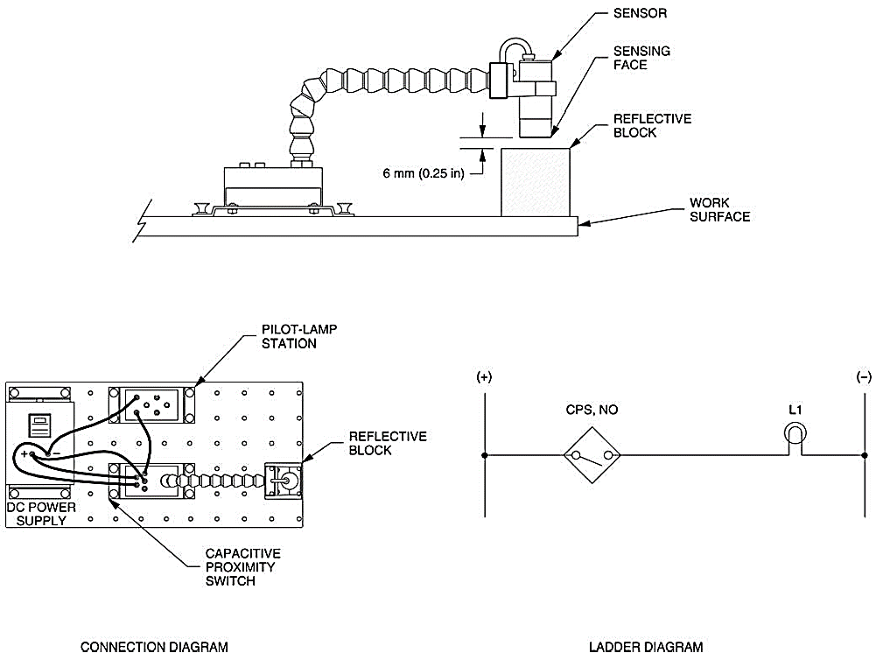

Figure 4.1.1 Circuit for Capacitive Proximity Switch

## Characteristics

Test the ability of the Capacitive Proximity Switch to detect the various surfaces of the Reflective Block. Position the proximity switch and the Reflective Block as shown in Figure 4.1.1 Circuit for Capacitive Proximity Switch and determine which surfaces are detected by the sensor. Note your observations in Table 4.2‑1 Observations.

Table 4.2‑1 Observations

|  |  |  |
| --- | --- | --- |
| **Surface** | **Detected** | **Not Detected** |
| Black Plastic Surface | **🗸** |  |
| White Plastic Surface | **🗸** |  |
| Matte Black Metallic Surface | **🗸** |  |
| Shiny Metallic Surface | **🗸** |  |
| Retroreflective Surface | **🗸** |  |

1. Does the Capacitive Proximity Switch detect all surfaces of the Reflective Block whatever the surfaces covering the plastic block?

**Answer:** Yes, the Capacitive Proximity Switch detects all the surfaces of the Reflective Block.

1. Pass your hand near the proximity switch without touching the sensing face. Does the proximity switch detect the presence of your hand, confirming that the sensor should not be hand-held during sensitivity adjustment?

**Answer:** Yes, the proximity switch detects the presence of hand.

1. Place some objects of different materials like a sheet of paper, plastic, cardboard, Styrofoam, glass and others in front of the sensor sensing face. Note which materials are detected and which are not detected.

|  |  |  |
| --- | --- | --- |
| **Object** | **Detected** | **Not Detected** |
| Piece of Paper | **🗸** |  |
| Plastic Ruler | **🗸** |  |
| Smartphone | **🗸** |  |
| Styrofoam Cup |  | **🗸** |
| Styrofoam Cup (with Water) | **🗸** |  |

## Liquid Detection

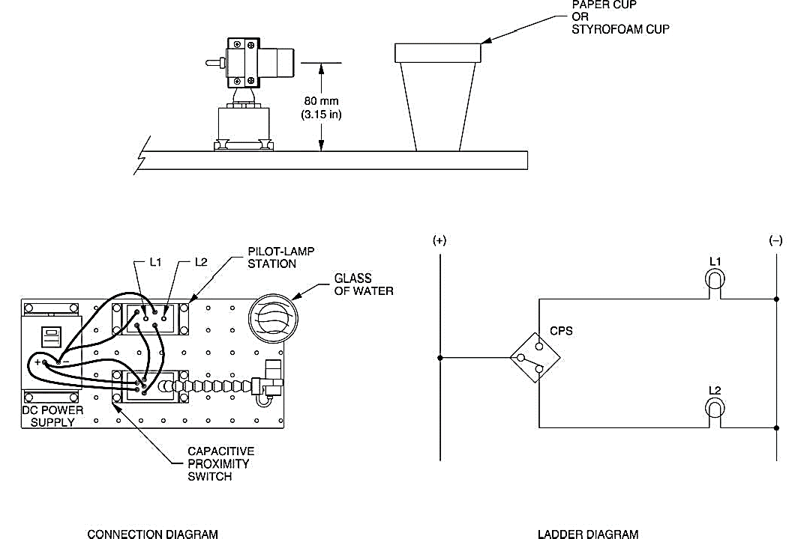

Figure 4.3.1 Liquid Detection

1. Referring to the ladder diagram shown in Figure 4.3.1 Liquid Detection, indicate which of the lamps L1 or L2 will turn off when the proximity switch is activated by the presence of an object.

**Answer:** L2 will turn off when the proximity switch is activated due to the presence of an object.

1. Place an empty paper, or Styrofoam, cup against the sensing face of the proximity switch. Does the switch change status?

**Answer:** When we place the Styrofoam cup against the sensing face of the proximity switch, the switch does not change its status.

1. Fill your cup with water and repeat your observation. Does the switch change status, confirming that the Capacitive Proximity Switch detects the liquid in the cup?

**Answer:** Yes, the switch changes its status, indicating that the sensor detects the liquid in the cup.

1. Is your prediction of step 3 confirmed?

**Answer:** Yes, the prediction is confirmed because as the liquid in the cup is detected.

# Questions

1. What types of material do capacitive proximity switches detect?

**Answer:** It can detect metallic as well as non-metallic surfaces such as paper, glass, liquids, and cloth by generating an electrostatic field and detecting the changes caused by the interfering objects.

1. What are the four main parts of a capacitive proximity switch?

* Capacitive probe (sensor)
* Oscillator circuit
* Rectifier (detector)
* Transistor (output)

1. Name two parameters that affect the sensing distance of a capacitive proximity switch.

* Size of the probe and size of the target object
* Dielectric constant of the target material

1. Explain why capacitive proximity switches must be spaced from surrounding surfaces and/or other sensors.

**Answer:** It is done to avoid any disturbances from the external environment as they operate by generating an electric field.

1. Explain why most capacitive proximity switches are equipped with a sensitivity adjustment.

**Answer:** Most capacitive proximity switches are equipped with a sensitivity adjustment screw to adjust the sensitivity of the switch i.e., control the sensing distance under certain applications as they work by measuring dielectric gaps.

# Conclusion

In this exercise, you were introduced to capacitive proximity switches. You learned how and when they are used, their advantages and disadvantages. You experimented on how to adjust the sensitivity of the Capacitive Proximity Switch to detect a particular material. You observed the ability of the sensor to detect the presence of various objects. You observed that it is not affected by surface reflectivity but by the dielectric of the material. In the last part of the exercise, you observed that the Capacitive Proximity Switch can detect the presence of liquid in a paper or Styrofoam cup.