**Department of Electrical Engineering**

|  |  |
| --- | --- |
| **Faculty Member:_____________** | **Dated: ________________** |
| **Semester:___________________** | **Section: ________________** |

**EE-383**-**Instrumentation and Measurements**

**Experiment # 5**

**Capacitive Proximity Switches**

|  |  |  |  |  |  |  |
| --- | --- | --- | --- | --- | --- | --- |
|  |  | **PLO4/**  **CLO3** | | **PLO4/ CLO4** | **PLO8/ CLO5** | **PLO9/ CLO6** |
| **Name** | **Reg. No** | **Viva / Quiz / Lab Performance** | **Analysis of data in Lab Report** | **Modern Tool Usage** | **Ethics and Safety** | **Individual and Teamwork** |
|  |  | **5 Marks** | **5 Marks** | **5 Marks** | **5 Marks** | **5 Marks** |
|  |  |  |  |  |  |  |
|  |  |  |  |  |  |  |
|  |  |  |  |  |  |  |
|  |  |  |  |  |  |  |

# OBJECTIVES

* In this lab, you will be introduced to capacitive proximity switches;
* You will learn how and when they are used;
* You will also learn their advantages and disadvantages;
* You will experiment with their operation using the Reflective Block.

**INTRODUCTION**

Capacitive proximity switches are designed to detect both metallic and non-metallic objects. They detect their presence by generating an electrostatic field and detecting changes in this field caused by a target approaching. Capacitive proximity switches consist of a capacitive probe, oscillator, rectifier (detector circuit), and transistor (output circuit).

A capacitor is formed when two electrical conductors (plates), separated by an insulating material (dielectric), are connected to opposite poles of a voltage source as shown in Figure 5-1. One plate becomes positively charged while the second plate becomes negatively charged. The amount of electrical charge a capacitor can store is referred to as the capacitance.

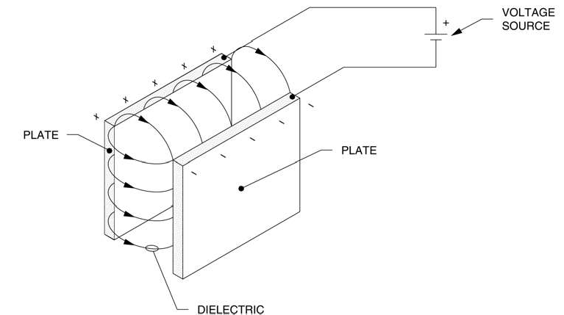

Figure 5-1. Charged capacitor.

Capacitive proximity switches operate on the same principle as a capacitor. The capacitive probe of the sensor acts as the positive pole, and the ground acts as the negative pole. As Figure 5-2 shows, without a detectable object, the oscillator is inactive. As an object approaches the sensor, the dielectric constant (the ratio between the capacitance of a capacitor using an insulant and the capacitance that the same capacitor would have if it used air as an insulant) of the capacitor changes. When the capacitance of the probe system reaches a specified threshold, the oscillator is activated.

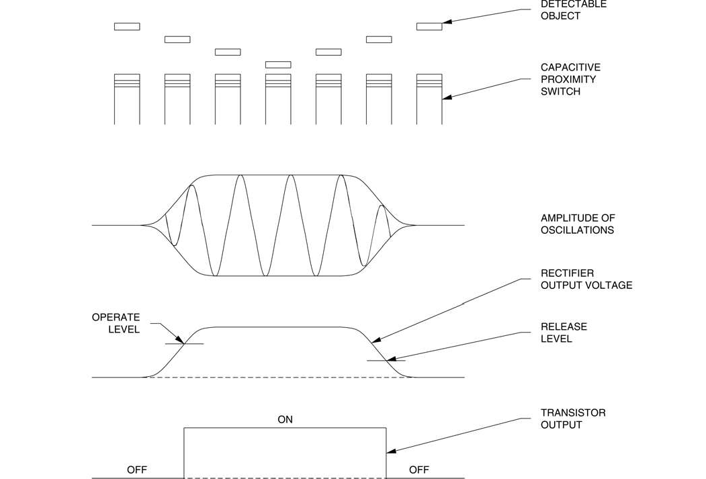

**Figure 5-2. Operation of a capacitive proximity sensor.**

The rectifier converts the AC oscillations to a DC voltage. When the DC voltage reaches the "operate level", the sensor switches the state of the output transistor to the activated mode. When the DC voltage decreases to the "release level", the sensor switches the state of the output transistor to the deactivated mode. Because the sensor is activated by a change in electrical energy rather than magnetic energy, it will detect both metallic and non-metallic materials.

The sensing distance of capacitive proximity switches depends on the size of both the probe and the target object. Large probes have a higher capacitance than small ones, so an object will influence the electrostatic field of a large probe from a greater distance. The sensing distance of capacitive proximity switches is standardized against a mild steel target, typically measuring 50 × 50 × 1 mm (2 × 2 × 0.04 in). Objects smaller than the standard target will lessen the sensing distance, and objects larger than the standard target do not affect sensing distance.

The dielectric constant of the target material also affects the sensing distance. For example, a capacitive proximity switch will detect glass at only 40% of the standard distance, and paper at 10%. Materials having a low dielectric constant are difficult to detect. Temperature and humidity may also affect the sensing distance. For best results, capacitive proximity switches should be used in an environment with constant temperature and humidity. Even when used in perfect conditions, capacitive proximity switches should not be located at more than 80% of the maximum sensing distance for that particular target material.

Because nearby objects may affect the operation of capacitive proximity switches, they must be spaced from surrounding conductive objects and/or other sensors as shown in Figure 6-3. The distances shown in Figure 6-3 apply to the Capacitive Proximity Switch of your training system.

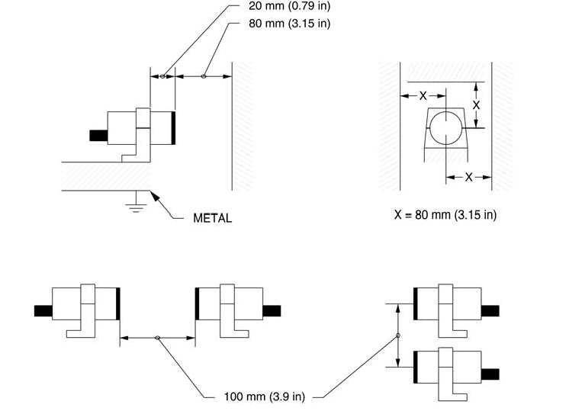

**Figure 5-3. Minimum mounting distances.**

Capacitive proximity sensors can be shielded or unshielded. Shielded sensors are constructed with a metallic band surrounding the capacitive probe. This helps to direct the electrostatic field to the front of the sensor and results in a more concentrated field. Shielded sensors are best suited for sensing low dielectric (difficult to sense) materials due to their highly concentrated electrostatic fields.Most capacitive proximity switches are equipped with a sensitivity adjustment screw. Because they measure a dielectric gap, it is important to compensate for target and application conditions. The sensitivity of capacitive proximity switches can be adjusted so they will be activated by the presence of a full container, but not by the presence of an empty container. They are ideally suited for liquid level control as shown in Figure 5-4.

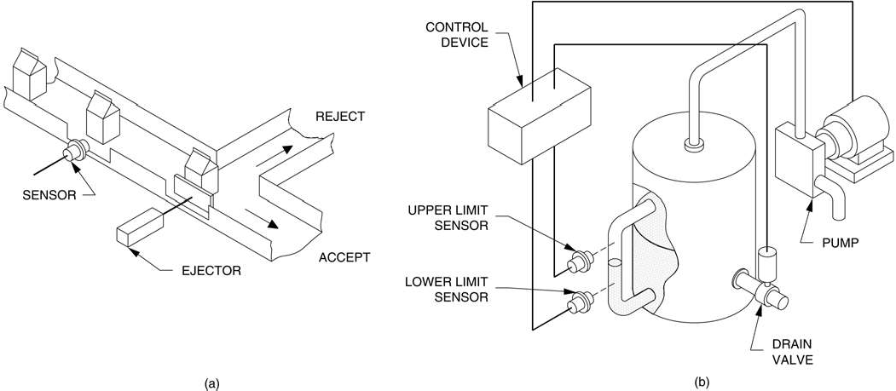

**Figure 5-4. Sensing liquid level.**

Figure 5-4 (a) shows a capacitive proximity switch detecting the fill level of milk cartons. Cartons that are not filled at the proper level are rejected. Figure 5-4 (b) shows two capacitive proximity switches maintaining a particular fill level. If the fluid level in the tank gets too high, the top switch will signal the controller to lower the fluid level. If the fluid level gets too low, the bottom switch will signal the controller to raise the fluid level.

he Capacitive Proximity Switch of your training system is shown in Figure 5-5.

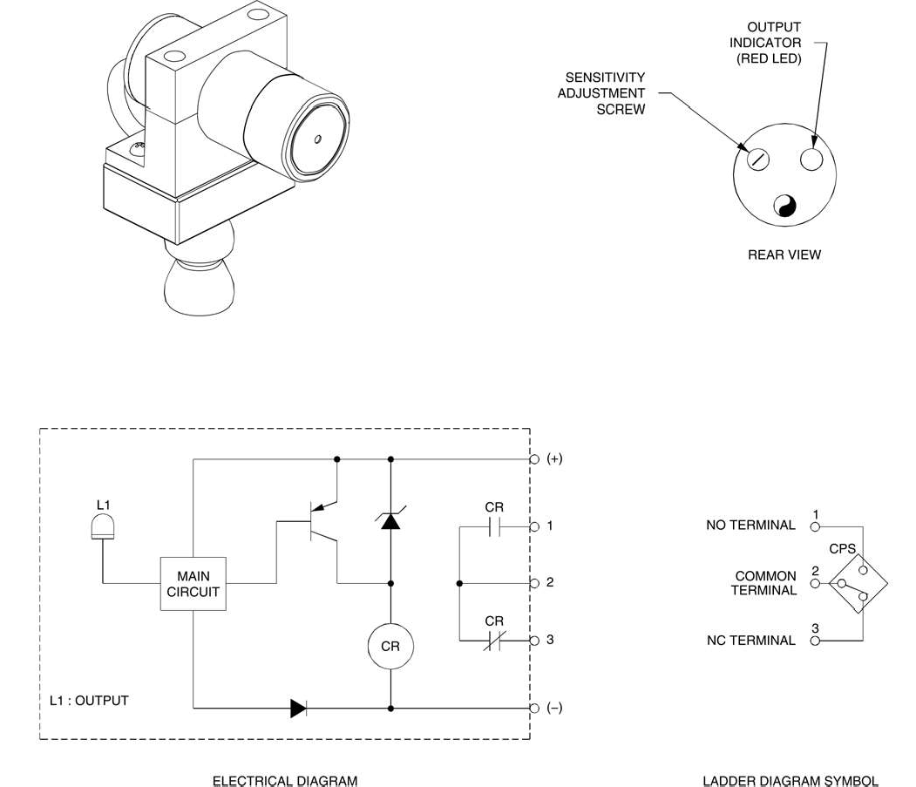

**Figure 5-5. Capacitive Proximity Switch.**

As Figure 5-5 shows, the sensor has a sensitivity adjustment screw, and an output indicator (red LED) that lights when the output is activated. Other characteristics of the Capacitive Proximity Switch are shown in Table 6-1.

**CHARACTERISTICS OF THE CAPACITIVE PROXIMITY SWITCH**

Type

Capacitive unshielded

Transistor output type

Sourcing (PNP)

Sensing distance

3 to 25 mm (0.12 to 0.98 in) adjustable

Response time (sensor only)

14 MS

**Table 5-1. Characteristics of the Capacitive Proximity Switch.**

## Procedure Summary

In the first part of the exercise, *Sensitivity Adjustment*, you will adjust the sensitivity of the Capacitive Proximity Switch to detect the presence of the shiny metallic surface of the Reflective Block.

In the second part of the exercise, *Characteristics*, you will observe the ability of the Capacitive Proximity Switch to detect the presence of various objects.

In the third part of the exercise, *Liquid Detection*, you will observe that the Capacitive Proximity Switch can detect the presence of liquid in a styrofoam or paper cup.

# EQUIPMENT REQUIRED

Refer to the Equipment Utilization Chart, in Appendix A of this manual, to obtain the list of equipment required to perform this exercise.

# PROCEDURE

## Sensitivity Adjustment

Connect the circuit shown in Figure 6-6, and turn on the DC Power Supply.

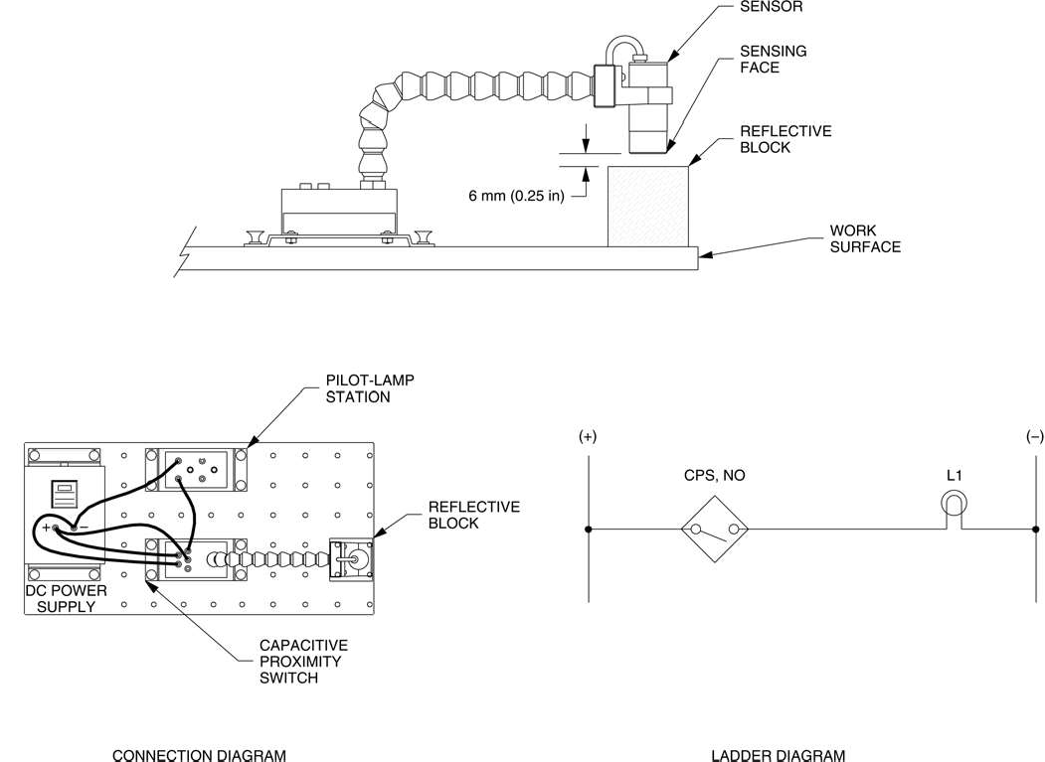

**Figure 5-6. Circuit using the Capacitive Proximity Switch.**

**Note:** *A capacitive sensor should not be hand-held during setup. Because your hand has a dielectric constant greater than air, the sensor may detect your hand rather than the intended target.*

Adjust the sensitivity of the Capacitive Proximity Switch as follows:

* Remove the Reflective Block from in front of the sensor for this part of the setting.
* On the Capacitive Proximity Switch, remove the protective cap to gain access to the sensitivity adjustment screw.
* Using a screw driver, turn carefully the sensitivity adjustment screw clockwise until the sensor turns on and the output indicator lights.
* Replace the Reflective Block in front of the sensor by positioning the shiny metallic surface on top, at a distance of 6 mm (0.25 in) of the sensor, as shown in Figure 6-6.
* Turn carefully the sensitivity adjustment screw counterclockwise until the sensor turns off and the output indicator goes out. Note the number of revolutions between the "on" and "off" positions.
* If the number of revolutions is greater than one and a half, the sensor will provide stable output. If the number is less than one and a half, increase or decrease the distance between the target surface and the sensor as necessary to allow at least one and a half revolutions between the "on" and "off" positions.
* Turn the sensitivity adjustment screw clockwise to the midpoint between the "on" and "off" points. Replace the protective cap.

## Characteristics

1. Test the ability of the Capacitive Proximity Switch to detect the various surfaces of the Reflective Block.

Position the proximity switch and the Reflective Block as shown in Figure 6-6 and determine which surfaces are detected by the sensor. Note your observations in Table 6-2.

**SURFACE**

**DETECTED**

**NOT DETECTED**

Black Plastic Surface White Plastic Surface

Matte Black Metallic Surface

Shiny Metallic Surface Retroreflective Surface

**Table 5-2.**

1. Does the Capacitive Proximity Switch detect all surfaces of the Reflective Block whatever the surfaces covering the plastic block?

Yes No

1. Remove the Reflective Block from the detection area of the proximity switch.

Pass your hand near the proximity switch without touching the sensing face. Does the proximity switch detect the presence of your hand, confirming that the sensor should not be hand-held during sensitivity adjustment?

Yes No

1. Place some objects of different materials like a sheet of paper, plastic, cardboard, Styrofoam, glass and others in front of the sensor sensing face. Note which materials are detected and which are not detected.

**MATERIAL**

**DETECTED**

**NOT DETECTED**

The dielectric constant of certain materials, like the paper, plastic, cardboard, Styrofoam and glass, is very low. These materials are difficult to detect by the capacitive proximity switches.

1. Turn off the DC Power Supply, and remove all leads.

## Liquid Detection

1. Connect the circuit shown in Figure 6-7, and turn on the DC Power Supply.
2. Referring to the ladder diagram shown in Figure 6-7, indicate which of the lamps L1 or L2 will turn off when the proximity switch is activated by the presence of an object.
3. Place an empty paper, or Styrofoam, cup against the sensing face of the proximity switch. Does the switch change status?

Yes No

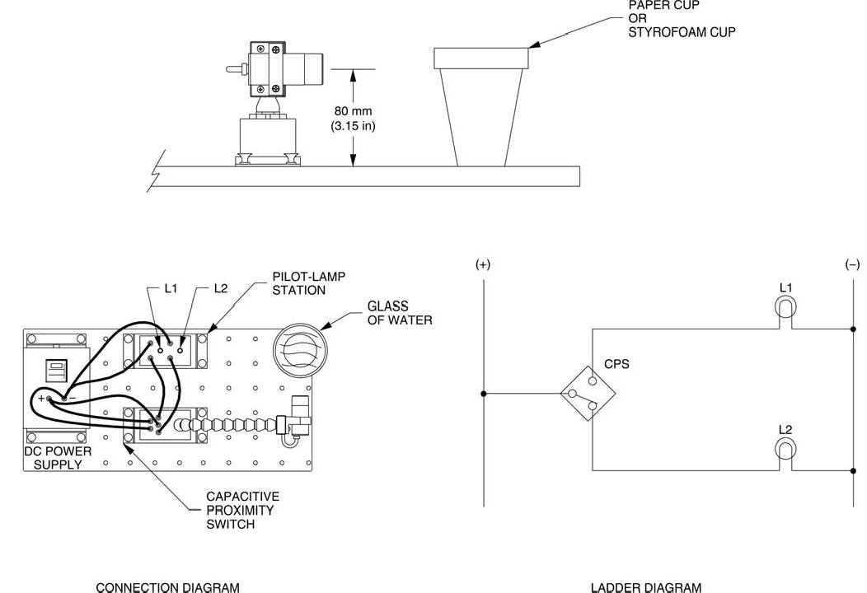

**Figure 6-7. Liquid detection using the Capacitive Proximity Switch.**

1. Fill your cup with water and repeat your observation. Does the switch change status, confirming that the Capacitive Proximity Switch detects the liquid in the cup?

Yes No

1. Is your prediction of step 9 confirmed?

Yes No

1. Repeat your observation using various containers like a plastic bottle, a metallic container and others. Note your observations
2. Turn off the DC Power Supply, and remove all leads.

# CONCLUSION

In this exercise, you were introduced to capacitive proximity switches. You learned how and when they are used, their advantages and disadvantages. You experimented on how to adjust the sensitivity of the Capacitive Proximity Switch to detect a particular material. You observed the ability of the sensor to detect the presence of various objects. You observed that it is not affected by surface reflectivity but by the dielectric of the material. In the last part of the exercise, you observed that the Capacitive Proximity Switch can detect the presence of liquid in a paper or Styrofoam cup.

# REVIEW QUESTIONS

1. What types of material do capacitive proximity switches detect?
2. What are the four main parts of a capacitive proximity switch?
3. Name two parameters that affect the sensing distance of a capacitive proximity switch.
4. Explain why capacitive proximity switches must be spaced from surrounding surfaces and/or other sensors?
5. Explain why most capacitive proximity switches are equipped with a sensitivity adjustment