**Department of Electrical Engineering and   
Computer Science**

**Faculty Member:** Dr. Shahzad Younis  **Dated:** 19/10/2022

**Semester:** 5th **Section:** BEE 12C

**EE-383:** **Instrumentation and Measurements**

Lab 6: Background Suppression Photoelectric Switches

Lab Instructor: Mr. Ali

Group Members

|  |  |  |  |  |  |  |
| --- | --- | --- | --- | --- | --- | --- |
| **Name** | **Reg. No** | **Viva + Lab Performance (Individual)** | | **Analysis of data in Lab Report** | **Teamwork** | **Total** |
|  |  | **5+5 Marks** | | **5 Marks** | **5 Marks** | **20 Marks** |
| Danial Ahmad | 331388 |  |  |  |  |  |
| Muhammad Umer | 345834 |  |  |  |  |  |
| Tariq Umar | 334943 |  |  |  |  |  |
|  |  |  |  |  |  |  |

**Table of Contents**

2 Table of Figures 2

3 Background Suppression Photoelectric Switches 3

3.1 Objectives 3

3.2 Equipment 3

3.3 Introduction 3

3.4 Lab Instructions 3

4 Lab Procedure 4

4.1 Sensitivity Adjustment 4

4.2 Characteristics 4

5 Questions 5

6 Conclusion 6

# Table of Figures

Figure 4.1.1 Circuit for Background Suppression Photoelectric Switches 4

# Background Suppression Photoelectric Switches

## Objectives

* In this exercise, you will be introduced to background suppression photoelectric switches
* You will learn how and when they are used
* You will also learn their advantages and disadvantages
* You will experiment with their operation using the reflective block

## Equipment

Hardware

* LabVolt Proprietary Sensor Training System



## Introduction

Background suppression sensors are designed for short range applications [less than 100 mm (4 in)] where the background behind the target is very close and very reflective. Background suppression sensing is one of the many types of the diffuse sensing mode. Instead of attempting to ignore the background behind the target, background suppression sensors use sophisticated electronics actively to detect the presence of both the target and the background

## Lab Instructions

All questions should be answered precisely to get maximum credit. Lab report must ensure following items:

* Lab objectives
* Results (Graphs/Tables/Pictures) duly commented and discussed
* Conclusion

# Lab Procedure

## Sensitivity Adjustment

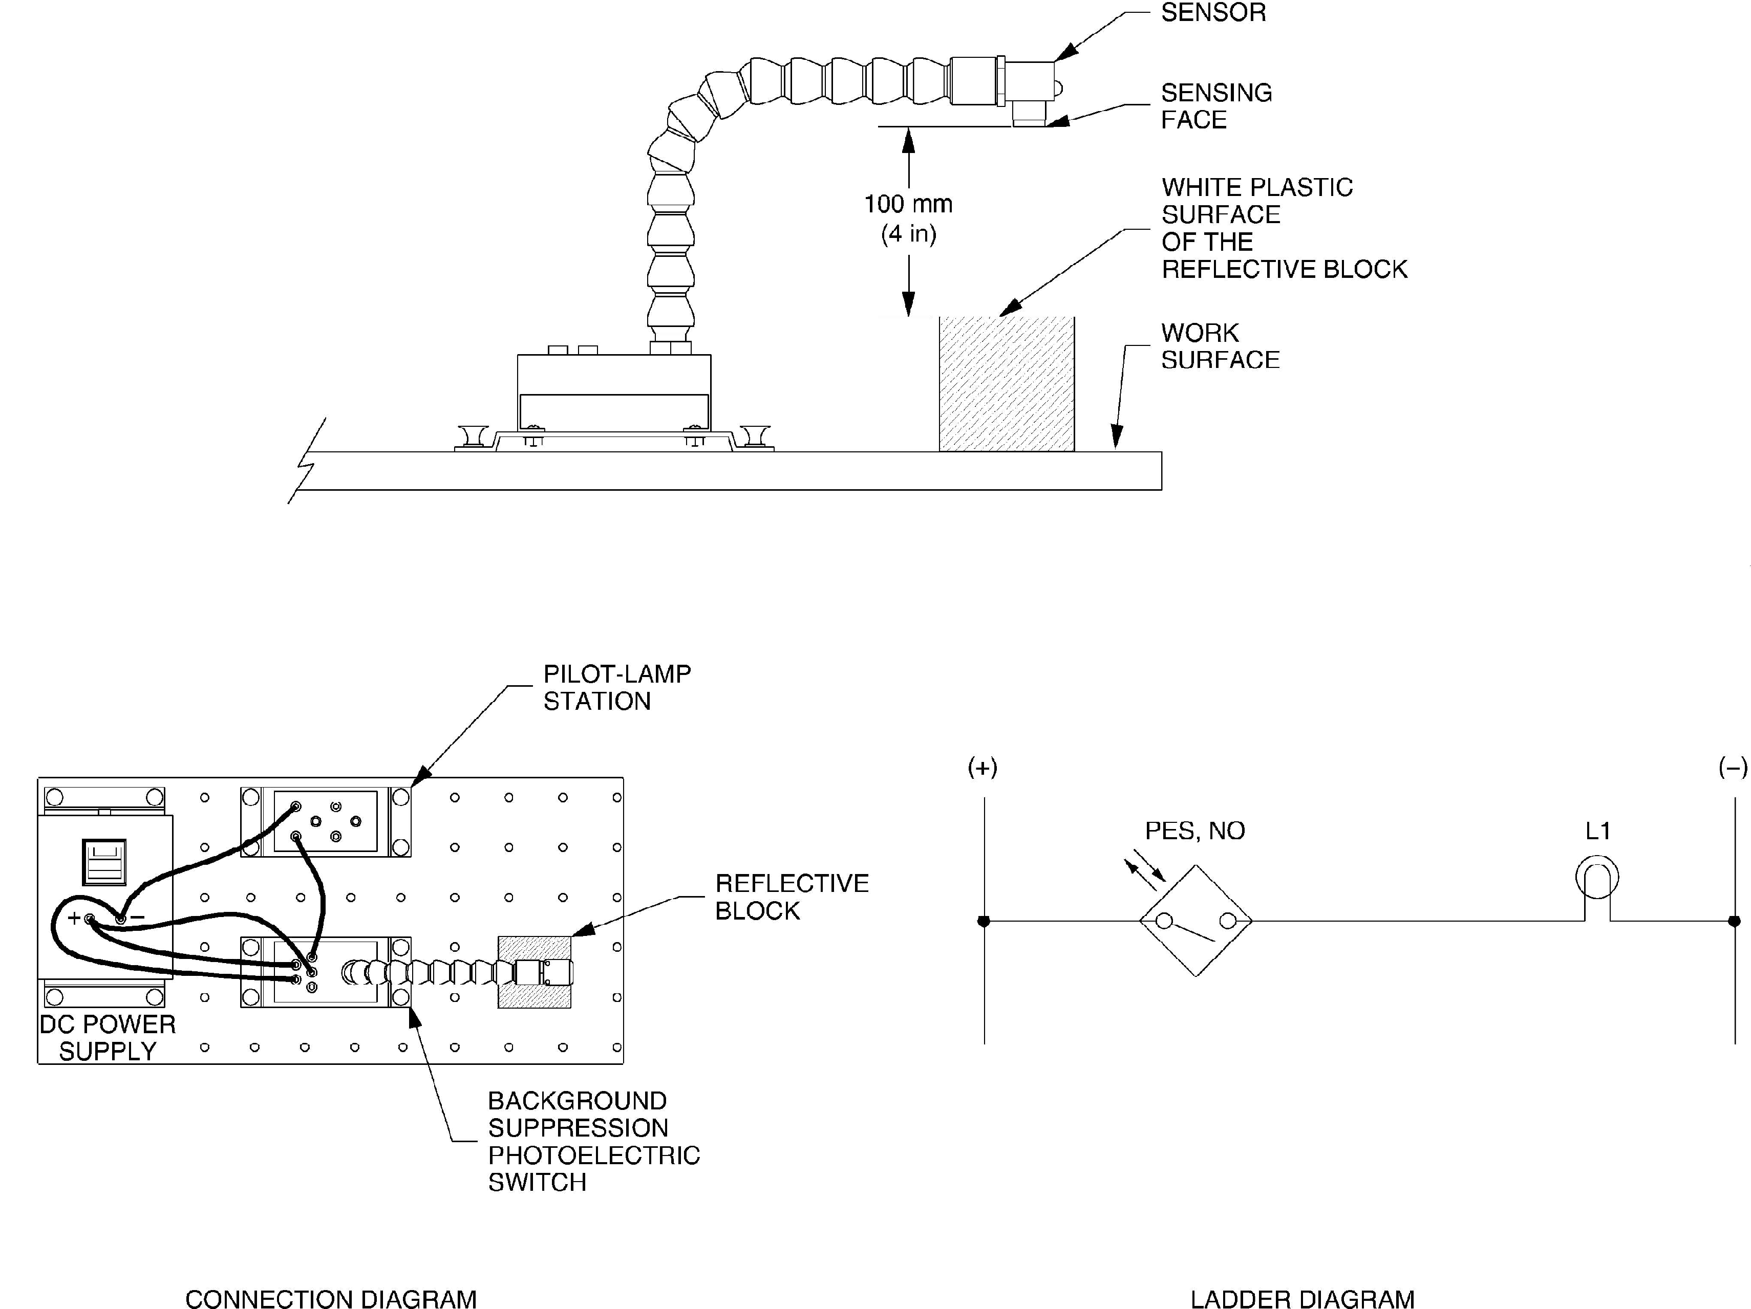

Figure 4.1.1 Circuit for Background Suppression Photoelectric Switches

## Characteristics

Test the ability of the Background Suppression Photoelectric Switch to detect some objects moving over each surface of the Reflective Block at distance of 12 mm (0.5 in). To do so, pass a finger over each surface and note in Table 4.2‑1 Observations if the sensor detects the presence of your finger.

Table 4.2‑1 Observations

|  |  |  |
| --- | --- | --- |
| **Surface** | **Detected** | **Not Detected** |
| Black Plastic Surface | **🗸** |  |
| White Plastic Surface | **🗸** |  |
| Matte Black Metallic Surface | **🗸** |  |
| Shiny Metallic Surface | **🗸** |  |
| Retroreflective Surface | **🗸** |  |

1. Repeat your observations with other objects whose reflectivity differs (matte, shiny, bright, dark). What can you conclude from your observations? Which surfaces are detected by the proximity switch?

**Answer:** We can deduce that our switch is capable enough to ignore the background. We see that the even if the object is not much reflective (or dull), the switch detects the object regardless of the reflective surfaces in the background.

1. Compare the operation of the power indicator (green LED) to that of the output indicator (yellow LED). Note your observations.

**Answer:** Whenever the object is detected, power indicator (green LED) gets turned off.

# Questions

1. What are background suppression photoelectric switches designed for?

**Answer:** Background suppression sensors are designed for short range applications [less than 100 mm (4 in)] where the background behind the target is very close and very reflective. Background suppression sensing is one of the many types of the diffuse sensing mode.

1. How do the background suppression photoelectric switches ignore the background behind the target?

**Answer:** Instead of attempting to ignore the background behind the target, background Suppression sensors use sophisticated electronics actively to detect the presence of both the target and the background. By comparing the two signals, the sensor can ignore the presence of a very reflective background almost directly behind a dark, less-reflective target. The sensor output will change state on active detection of the target, or on active detection of the background.

1. Name two advantages of Background Suppression Photoelectric Switches.

* With the addition of background suppression, these sensors offer more precise detection, depending on your application design. By using a reflective target and a position-sensitive device (PSD) to receive the return signal, the photoelectric sensor can be calibrated to distinguish between the signal returned from the target at a preset distance and interference from background objects, allowing for a more precise detection.
* It can detect the dark objects if they are placed in front of the shiny surfaces even if they are not much reflective.

1. Explain how background suppression photoelectric switches can detect objects in front and behind the nominal sensing distance of the switch.

**Answer:** Background suppression sensors contain two active photoelectric sensing elements calibrated to detect objects in front and behind the nominal sensing distance. One of the sensing elements detects reflections from behind the nominal sensing distance while the other detects reflections in front of the nominal sensing distance.

1. At what distance should the target be distanced from the background for reliable operation?

**Answer:** For reliable background suppression, a minimum separation distance of 10% (i.e., 0.4 inches) the maximum sensing distance is recommended between the target object and the background.

# Conclusion

In this lab, we learned about the Background Suppression Photoelectric Switches. We learned how and when they are used. We saw its advantages and disadvantages. We experimented on how they detect the presence of various objects moving over the surfaces of the Reflective Block.