**Department of Electrical Engineering and   
Computer Science**

**Faculty Member:** Dr. Shahzad Younis  **Dated:** 26/10/2022

**Semester:** 5th **Section:** BEE 12C

**EE-383:** **Instrumentation and Measurements**

Lab 7: Polarized Retroflective Photoelectric Switches

Lab Instructor: Mr. Ali

Group Members

|  |  |  |  |  |  |  |
| --- | --- | --- | --- | --- | --- | --- |
| **Name** | **Reg. No** | **Viva + Lab Performance (Individual)** | | **Analysis of data in Lab Report** | **Teamwork** | **Total** |
|  |  | **5+5 Marks** | | **5 Marks** | **5 Marks** | **20 Marks** |
| Danial Ahmad | 331388 |  |  |  |  |  |
| Muhammad Umer | 345834 |  |  |  |  |  |
| Tariq Umar | 334943 |  |  |  |  |  |
|  |  |  |  |  |  |  |

**Table of Contents**

2 Table of Figures 2

3 Polarized Retroflective Photoelectric Switches 3

3.1 Objectives 3

3.2 Equipment 3

3.3 Introduction 3

3.4 Lab Instructions 3

4 Lab Procedure 4

4.1 Connections 4

4.2 Characteristics 4

4.3 Detection of various objects 5

5 Questions 6

6 Conclusion 6

# Table of Figures

Figure 4.1.1 Circuit for Polarized Retroflective Photoelectric Switches 4

# Polarized Retroflective Photoelectric Switches

## Objectives

* In this exercise, you will be introduced to polarized retroreflective photoelectric switches
* You will learn how and when they are used
* You will also learn their advantages and disadvantages
* You will experiment with their operation using the Reflective Block

## Equipment

Hardware

* LabVolt Proprietary Sensor Training System



## Introduction

Retroreflective, or retroflective, sensing is the most popular sensing mode. Retroreflective sensors can be used to detect most objects, including shiny objects. They contain both the emitter and receiver in the same housing. The light beam emitted by the light source is reflected by a special reflective surface and detected by the receiver. They are intended primarily for use in applications where an opaque target will completely block the light beam between the sensor and the reflective surface. Therefore, retroreflective sensors are not well suited to detect small objects.

## Lab Instructions

All questions should be answered precisely to get maximum credit. Lab report must ensure following items:

* Lab objectives
* Results (Graphs/Tables/Pictures) duly commented and discussed
* Conclusion

# Lab Procedure

## Connections

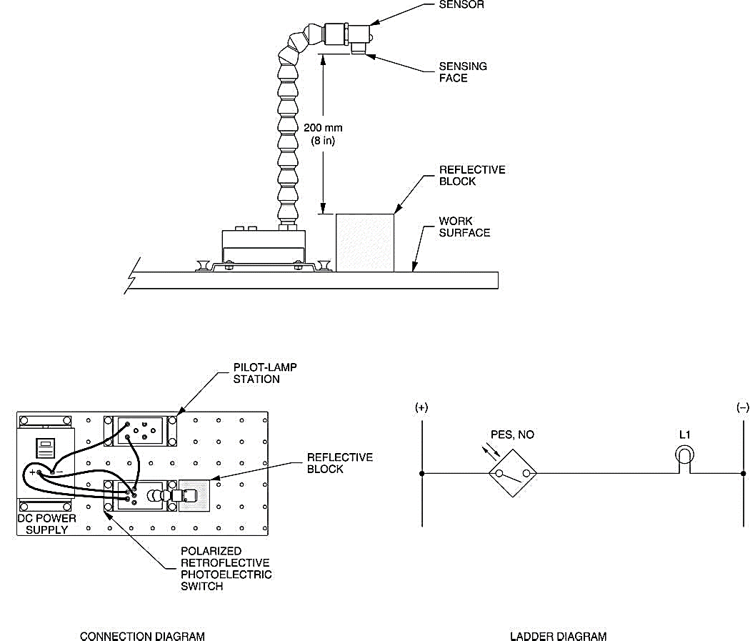

Figure 4.1.1 Circuit for Polarized Retroflective Photoelectric Switches

## Characteristics

Test the ability of the Polarized Retroflective Photoelectric Switch to detect the various surfaces of the Reflective Block. Position the photoelectric switch and the Reflective Block as shown in Figure 4.1.1 and determine which surfaces are detected by the sensor. Note your observations in Table 4.2‑1 Observations.

Table 4.2‑1 Observations

|  |  |  |
| --- | --- | --- |
| **Surface** | **Detected** | **Not Detected** |
| Black Plastic Surface |  | **🗸** |
| White Plastic Surface |  | **🗸** |
| Matte Black Metallic Surface |  | **🗸** |
| Shiny Metallic Surface |  | **🗸** |
| Retroreflective Surface | **🗸** |  |

1. **What can you conclude from your observations?**

**Answers:** Polarized Retroflective Photoelectric Switches can only detect retroreflective surfaces as all other surfaces do not depolarize the light and hence reflect light with the same polarization and are rejected by the polaroid filter.

## Detection of various objects

1. **Position the Reflective Block so that the retro-reflective surface is on top. Pass your fingers between the photoelectric switch and the Reflective Block. Does the photoelectric switch detect their presence? What does this mean?**

**Answers:** It detects the finger as the surface area of the object (finger) is greater than that of size of the light beam, and hence no light gets reflected.

1. **Is lamp L1 lit when the photoelectric switch detects the presence of an object between the sensing face and the retro-reflective surface? Explain why.**

**Answers:** No, the lamp L1 turned OFF as soon as we placed an object between the sensing face and the retroreflective surface because the size of the object was greater than that of the light beam and caused no light to be reflected back to the receiver.

1. **Pass a transparent object between the sensor and the Reflective Block. Does the photoelectric switch detect its presence? What does this mean?**

**Answers:** No, it did not detect the transparent object’s presence. It signifies that this sensor is only intended for opaque objects or objects that completely absorb the light beam and prevent it from passing through.

1. **Pass a small object like an electrical lead between the sensor and the Reflective Block. Does the photoelectric switch detect its presence? What does this mean?**

**Answers:** No, the photoelectric switch was unable to detect it because the wire didn't completely block the light beam; some of the light rays passed through and were reflected back.

1. **Without modifying the sensor position, take the Reflective Block in your hand and hold the retro-reflective surface in front of the sensing face with an angle of approximately 45. Does the photoelectric switch detect its presence in this position? What does this indicate?**

**Answers:** Yes, the photoelectric switch detects its presence in this new position as the retroreflector depolarizes the light and adjusts it in multiple orientations in order to facilitate easy reflection of light.

# Questions

1. **For which applications are the retro-reflective photoelectric sensors designed for?**

**Answers:** Retroreflective materials have been widely used in traffic control and safety signs on highways and in airports. It also suffices as an excellent foundation for emergency gear due to its high reflectivity of both light and radar signals, earning it the recommendation International Convention for the Safety of Life at Sea.

1. **Name two reasons why polarized retro-reflective sensors offer a shorter distance than standard retro-reflective sensors?**

**Answers:** The main reason is that instead of infrared LEDs, they use a less efficient visible red LED. Secondly, there are also additional light losses caused by the polarizing filters therefore they offer a shorter sensing range.

1. **What is the purpose of the filters in a polarized retro-reflective sensor?**

**Answers:** Polarized Retroreflective Sensors consists of two filters; one placed horizontally in front of the emitter and the other vertically in front of the receiver. This is done in order to have the transmitted light oscillate horizontally until it hits the reflector, then observe a 90-degree rotation by the corner cubes of the reflector and in turn, enables the returning light to pass through the vertical polarized filter.

1. **Name the type of retroreflector that provides the highest signal return.**

**Answers:** Corner cube reflector provides the highest signal return. Corner cube reflectors consist of three adjoining sides arranged at right angles. When light rays hit one of the adjoining sides, it is reflected to the second side, then to the third, and then back to its source in a direction parallel to its original course.

1. **Explain why retro-reflective sensors are not well suited to detect small objects.**

**Answers:** Retroreflective Sensors are made predominantly for use in applications that involve the obstruction of light between a sensor and the surface completely. Thus, when dealing with objects that are either translucent or relatively small, they lose much of their purpose and are henceforth, not well suited.

# Conclusion

In this exercise, you were introduced to polarized retroreflective photoelectric switches. You learned how and when they are used, their advantages and disadvantages. You observed how the Polarized Retroflective Photoelectric Switch detects the presence of various objects placed between the sensor and the retroreflective surface of the Reflective Block. You saw that this photoelectric switch does not detect transparent objects. You also observed that it does not detect objects smaller than the light beam.