**Department of Electrical Engineering**

| **Faculty Member:_____________** | **Dated: ________________** |
| --- | --- |
| **Semester:___________________** | **Section: ________________** |

**EE-383**-**Instrumentation and Measurements**

**Experiment # 7**

**Polarized Retroflective Photoelectric Switches**

|  |  | **PLO4/**  **CLO3** | | **PLO4/ CLO4** | **PLO8/ CLO5** | **PLO9/ CLO6** |
| --- | --- | --- | --- | --- | --- | --- |
| **Name** | **Reg. No** | **Viva / Quiz / Lab Performance** | **Analysis of data in Lab Report** | **Modern Tool Usage** | **Ethics and Safety** | **Individual and Teamwork** |
|  |  | **5 Marks** | **5 Marks** | **5 Marks** | **5 Marks** | **5 Marks** |
|  |  |  |  |  |  |  |
|  |  |  |  |  |  |  |
|  |  |  |  |  |  |  |
|  |  |  |  |  |  |  |



# EXERCISE OBJECTIVE

* In this exercise, you will be introduced to polarized retroreflective photoelectric switches;
* You will learn how and when they are used;
* You will also learn their advantages and disadvantages;
* You will experiment with their operation using the Reflective Block.

# DISCUSSION

Retroreflective, or retroflective, sensing is the most popular sensing mode. Retroreflective sensors can be used to detect most objects, including shiny objects. They contain both the emitter and receiver in the same housing. The light beam emitted by the light source is reflected by a special reflective surface and detected by the receiver as shown in Figure 5-1. They are intended primarily for use in applications where an opaque target will completely block the light beam between the sensor and the reflective surface. Therefore, retroreflective sensors are not well suited to detect small objects.

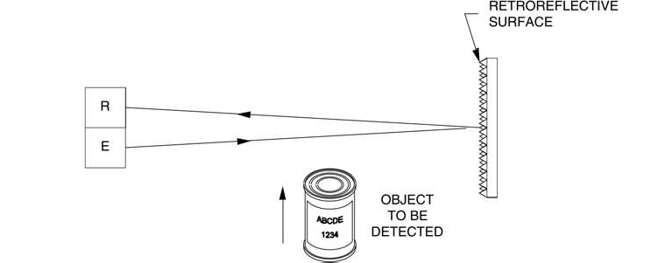

**Figure 5-1. Retroreflective sensing.**

Special reflectors, or reflective tapes, are used for retroreflective sensing. Unlike mirrors, or other flat reflective surfaces, these reflective objects do not require to be aligned perfectly. Misalignment of a reflector, or reflective tape, of up to 15 will typically not reduce significantly the operating margin of the sensing system. A wide selection of reflectors and reflective tapes are available, some of them are shown in Figure 5-2.

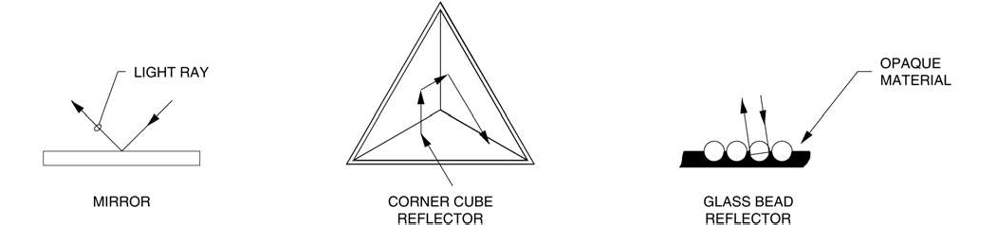

**Figure 5-2. Retroreflective materials.**

Occasionally, standard retroreflective sensors can be falsely triggered by reflections from shiny or highly reflective targets. To avoid this, polarized retroreflective sensing offers a better solution. Polarized retroreflective sensors contain polarizing filters in front of the emitter and receiver. These filters are perpendicular, or 90 out of phase with each other, as shown in Figure 5-3. Retroreflectors depolarize the light. Some of the reflected light passes through the polarizing filter in front of the receiver and is detected by the sensor as shown in Figure 5-3 (a). However, the light reflected by most targets is returned to the sensor with the same polarity, and cannot pass through the polarizing filter in front of the receiver as shown in Figure 5-3 (b).

Polarized retroreflective sensors offer shorter sensing range than standard retroreflective sensors. Instead of infrared LEDs, they must use a less efficient visible red LED. There are also additional light losses caused by the polarizing filters. Many standard reflectors depolarize light and are suitable for polarized retroreflective sensing. However, corner cube retroreflectors provide the highest signal return to the sensor. They have 2000 to 3000 times the reflectivity of white paper. Therefore, they are used to make safety reflectors for bicycles, cars, and signs.

As Figure 5-2 shows, corner cube reflectors consist of three adjoining sides arranged at right angles. When a light ray hits one of the adjoining sides, it is reflected to the second side, then to the third, and then back to its source in a direction parallel to its original course. You can experiment with the corner cube reflection by throwing a tennis ball into the corner of a room. The ball will return to you after bouncing off the three surfaces. Because of their high level of reflectivity, corner cube reflectors were placed on the moon by the Apollo astronauts and are still used today to measure the distance to the moon by timing laser light pulses reflected from earth.

Polarized retroreflective sensors are often used to detect shiny objects. However, because the light may be depolarized as it passes through plastic film or stretch wrap, shiny objects may create detectable reflections (depolarized light) by the receiver if they are wrapped in clear plastic film.

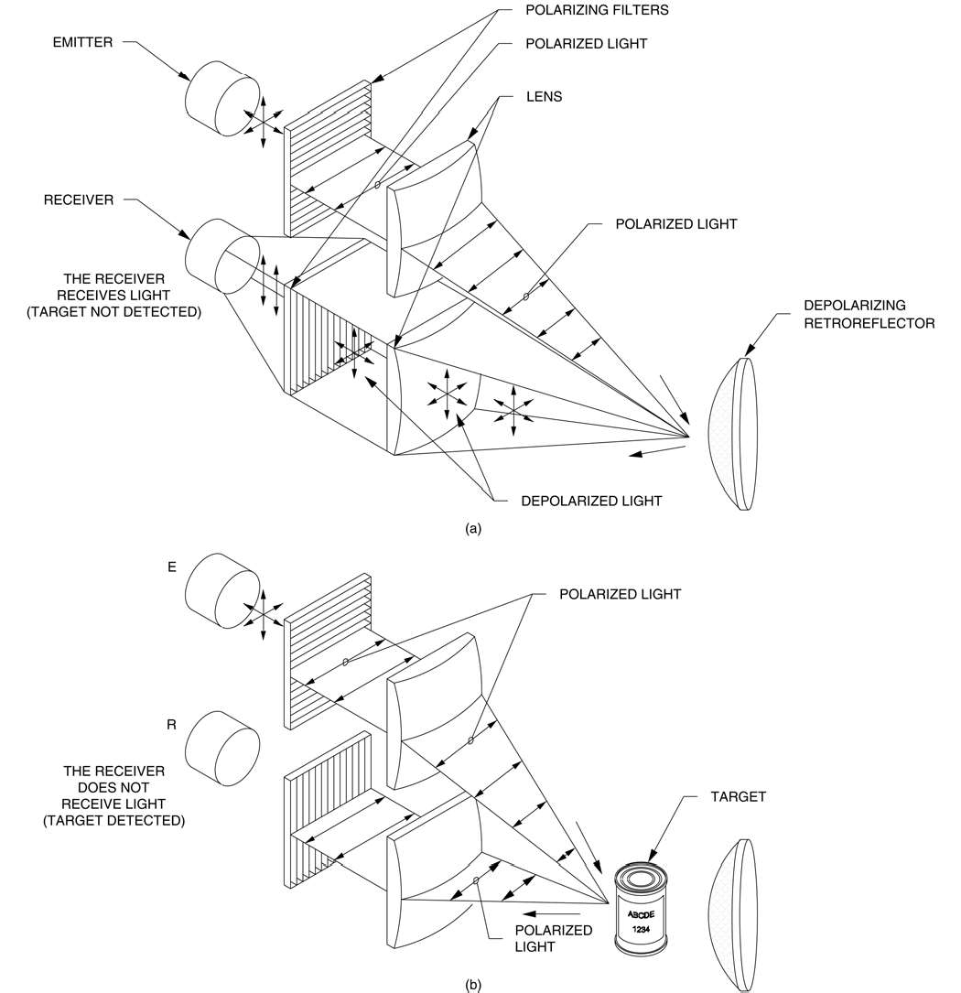

**Figure 5-3. Polarized retroreflective sensing.**

Most reflective tapes, like glass bead retroreflectors, do not depolarize light and are suitable only for use with standard retroreflective sensors.

The Polarized Retroflective Photoelectric Switch of your training system is shown in Figure 5-4.

As Figure 5-4 shows, the sensor has a power indicator (green LED), an output indicator (yellow LED) that lights when the output is activated, and a stability indicator (orange LED) that lights when the excess gain exceeds 2.5. There is no sensitivity adjustment on this sensor. Other characteristics of the Polarized Retroflective Photoelectric Switch are shown in Table 5-1.

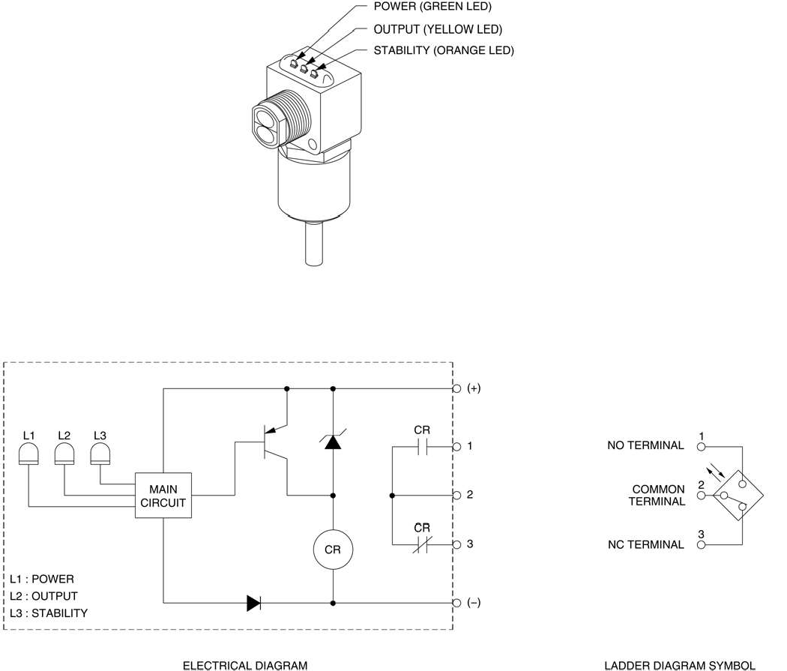

**Figure 5-4. Polarized Retroflective Photoelectric Switch.**

| **CHARACTERISTICS OF THE**  **POLARIZED RETROFLECTIVE PHOTOELECTRIC SWITCH** | |
| --- | --- |
| Type | Polarized retroreflective |
| Transistor output type | Sourcing (PNP) |
| Sensing distance Maximum | 3 m (9.8 ft) |
| Light source Type Wavelength | Visible red  660 nm (26.0 micro-inch) |
| Response time (sensor only) | 1 ms |
| Light beam detection modes | Light operate/Dark operate* |
| Sensor output type | Relay output |

* The sensor has light operate and dark operate outputs. The output relay coil is connected to the light operate output. The dark operate output is not used.

**Table 5-1. Characteristics of the Polarized Retroflective Photoelectric Switch.**

# Procedure Summary

In the first part of the exercise, *Characteristics*, you will observe the ability of the Polarized Retroflective Photoelectric Switch to detect each surface of the Reflective Block.

In the second part of the exercise, *Detection of various objects*, you will observe the ability of the Polarized Retroflective Photoelectric Switch to detect the presence of opaque, transparent and small objects.

# EQUIPMENT REQUIRED

Refer to the Equipment Utilization Chart, in Appendix A of this manual, to obtain the list of equipment required to perform this exercise.

# PROCEDURE

**Characteristics**

1. Connect the circuit shown in Figure 5-5, and turn on the DC Power Supply.

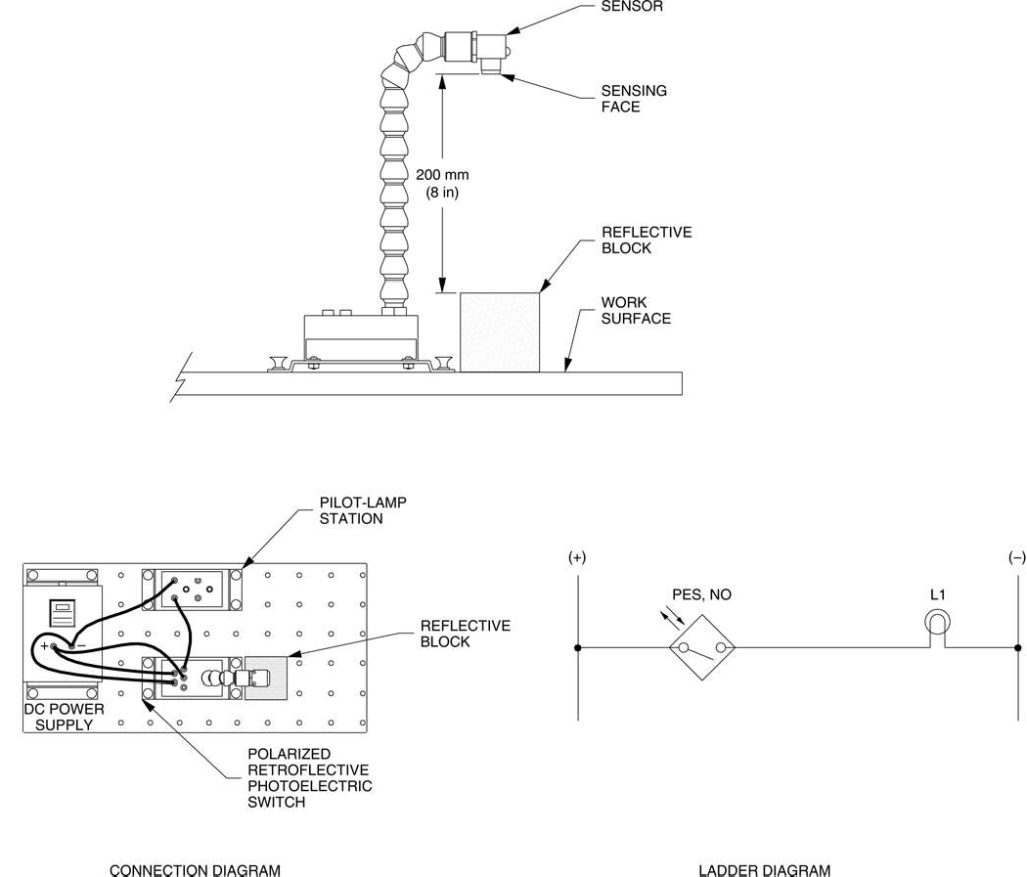

**Figure 5-5. Circuit using the Polarized Retroflective Photoelectric Switch.**

1. Test the ability of the Polarized Retroflective Photoelectric Switch to detect the various surfaces of the Reflective Block.

Position the photoelectric switch and the Reflective Block as shown in Figure 5-5 and determine which surfaces are detected by the sensor. Note your observations in Table 5-2.

| **SURFACE** | **DETECTED** | **NOT DETECTED** |
| --- | --- | --- |
| Black Plastic Surface |  |  |
| White Plastic Surface |  |  |
| Matte Black Metallic Surface |  |  |
| Shiny Metallic Surface |  |  |
| Retroreflective Surface |  |  |

**Table 5-2.**

1. What can you conclude from your observations?

# Detection of various objects

1. Position the Reflective Block so that the retroreflective surface is on top.

Pass your fingers between the photoelectric switch and the Reflective Block. Does the photoelectric switch detect their presence? What does this mean?

1. Is lamp L1 lit when the photoelectric switch detects the presence of an object between the sensing face and the retroreflective surface? Explain why.
2. Pass a transparent object between the sensor and the Reflective Block. Does the photoelectric switch detect its presence? What does this mean?
3. Pass a small object like an electrical lead between the sensor and the Reflective Block. Does the photoelectric switch detect its presence? What does this mean?
4. Without modifying the sensor position, take the Reflective Block in your hand and hold the retroreflective surface in front of the sensing face with an angle of approximately 45 . Does the photoelectric switch detect its presence in this position? What does this indicate?
5. Turn off the DC Power Supply, and remove all leads.

# CONCLUSION

In this exercise, you were introduced to polarized retroreflective photoelectric switches. You learned how and when they are used, their advantages and disadvantages.

You observed how the Polarized Retroflective Photoelectric Switch detects the presence of various objects placed between the sensor and the retroreflective surface of the Reflective Block. You saw that this photoelectric switch does not detect transparent objects. You also observed that it does not detect objects smaller than the light beam.

# REVIEW QUESTIONS

1. For which applications are the retroreflective photoelectric sensors designed for?
2. Name two reasons why polarized retroreflective sensors offer a shorter distance than standard retroreflective sensors.
3. What is the purpose of the filters in a polarized retroreflective sensor?
4. Name the type of retroreflector that provides the highest signal return.
5. Explain why retroreflective sensors are not well suited to detect small objects.