**Department of Electrical Engineering and   
Computer Science**

**Faculty Member:** Dr. Shahzad Younis  **Dated:** 9/11/2022

**Semester:** 5th **Section:** BEE 12C

**EE-383:** **Instrumentation and Measurements**

Lab 8: Fiber-Optic Photoelectric Switches

Lab Instructor: Mr. Ali

Group Members

|  |  |  |  |  |  |  |
| --- | --- | --- | --- | --- | --- | --- |
| **Name** | **Reg. No** | **Viva + Lab Performance (Individual)** | | **Analysis of data in Lab Report** | **Teamwork** | **Total** |
|  |  | **5+5 Marks** | | **5 Marks** | **5 Marks** | **20 Marks** |
| Danial Ahmad | 331388 |  |  |  |  |  |
| Muhammad Umer | 345834 |  |  |  |  |  |
| Tariq Umar | 334943 |  |  |  |  |  |
|  |  |  |  |  |  |  |

**Table of Contents**

2 Table of Figures 2

3 Fiber-Optic Photoelectric Switches 3

3.1 Objectives 3

3.2 Equipment 3

3.3 Introduction 3

3.4 Lab Instructions 3

4 Lab Procedure 4

4.1 Connections 4

4.2 Characteristics 4

4.3 Sensitivity Adjustment Using the Retroreflective Surface of the Reflective Block 5

5 Questions 6

6 Conclusion 6

# Table of Figures

Figure 4.1.1 Circuit for Fiber-Optic Photoelectric Switches 4

# Fiber-Optic Photoelectric Switches

## Objectives

In this lab, you will be introduced to Fiber-Optic photoelectric switches; and you will learn:

* Uses of Fiber-optic photoelectric switches
* Advantages and Disadvantages of Fiber-optic switches
* Their operations using reflective block

## Equipment

Hardware

* LabVolt Proprietary Sensor Training System



## Introduction

Fiber-optic sensors are designed for applications where the sensor cannot be placed at the actual sensing position. Fiber-optics is not a sensing technique but a method of transmitting light energy. Fiber-optic cables use transparent fibers of glass, or plastic, to conduct and guide light energy. They are used in photoelectric controls as light "pipes".

## Lab Instructions

All questions should be answered precisely to get maximum credit. Lab report must ensure following items:

* Lab objectives
* Results (Graphs/Tables/Pictures) duly commented and discussed
* Conclusion

# Lab Procedure

## Connections

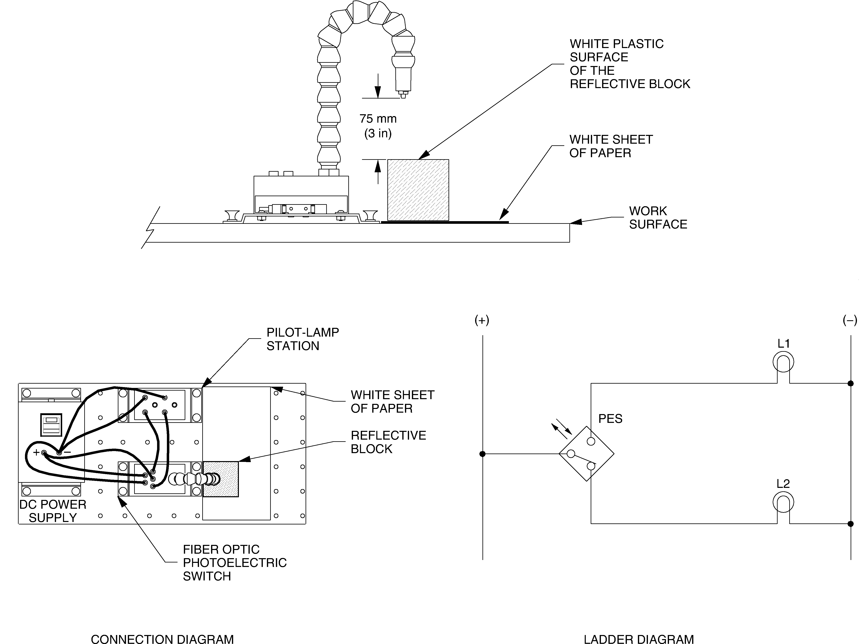

Figure 4.1.1 Circuit for Fiber-Optic Photoelectric Switches

## Characteristics

Test the ability of the Fiber-Optic Photoelectric Switch to detect the various surfaces of the Reflective Block. Leave the photoelectric switch detection mode set to Light operate. Position the photoelectric switch and the Reflective Block as shown in Figure 4.1.1 and determine which surfaces are detected by the sensor. Note your observations in Table 4.2‑1.

Table 4.2‑1 Observations

|  |  |  |  |  |
| --- | --- | --- | --- | --- |
| **Surface** | **Light Operate** | | **Dark Operate** | |
| **Detected** | **Not Detected** | **Detected** | **Not Detected** |
| Black Plastic Surface |  | **✓** |  | **✓** |
| White Plastic Surface |  | **✓** |  | **✓** |
| Matte Black Metallic Surface |  | **✓** |  | **✓** |
| Shiny Metallic Surface | **✓** |  | **✓** |  |
| Retroreflective Surface | **✓** |  | **✓** |  |

1. **What can you conclude from your observations?**

**Answer:** Fiber-optic sensors rely on the reflection of light back into the receiver in order to detect a surface. The only reflective surfaces on the Reflective Block are Shiny Metallic Surface and Retroreflective Surface, and hence are the only ones to get detected.

1. **Set the Photoelectric switch to the Dark operate mode: if you are using the photoelectric switch model with LED indicators, set its L.ON/D.ON selector to the D.ON position; if you are using the photoelectric switch model with digital display, press the L/D button so that the D (Dark) indicator is lit.**
2. **Compare results obtained in light operate, dark operate mode. What can you conclude from these results?**

**Answer:** Both light and dark operate modes detect the same surfaces, albeit through different methodologies.

## Sensitivity Adjustment Using the Retroreflective Surface of the Reflective Block

1. **Set the Photoelectric switch to the Light operating mode. Repeat the sensitivity adjustment procedure, with/without object teaching, using the retroreflective surface of the Reflective Block instead of the white plastic surface. Determine which surfaces are detected by the sensor. Note your observations in Table 4.3‑1.**

Table ‑ Observations

|  |  |  |
| --- | --- | --- |
| **Surface** | **Detected** | **Not Detected** |
| Black Plastic Surface |  | **✓** |
| White Plastic Surface |  | **✓** |
| Matte Black Metallic Surface |  | **✓** |
| Shiny Metallic Surface |  | **✓** |
| Retroreflective Surface | **✓** |  |

1. **Compare the results obtained for each sensitivity setting indicated in Table 4.2‑1 and Table 4.3‑1. Are the results similar? Explain why.**

**Answer:** When the sensitivity of the Fiber-optic sensor is altered, Shiny Metallic Surface does not reflect back enough light into the receiver to trigger the output, however, the Retroreflective Surface continues to function as before.

# Questions

1. **For which applications are the fiber-optic photoelectric switches designed?**

**Answer:** Fiber-optic sensors are designed for applications where the sensor cannot be placed at the actual sensing position.

1. **Explain why fiber-optic photoelectric switches can be easily obstructed by dirt or other opaque substances.**

**Answer:** Due to their small sensing area, fiber-optic photoelectric sensors, when not placed in a location with no proper insulation/air purifying techniques, the head of the fiber-optic sensor is highly susceptible to getting clogged up with dirt particles.

1. **Which teaching method should be used to adjust the sensitivity of the Fiber-Optic Photoelectric Switch to detect the presence of objects with no background?**

**Answer:** To detect the presence of objects that completely block the sensor light beam and to detect the presence of objects with no background, the maximum sensitivity setting should be used.

1. **Explain why the signal transmitted by fiber-optic cables is unaffected by electromagnetic interference and vibration.**

**Answer:** Fiber-optic sensors are dependent on **light**, rather than current, for detection of objects, which are agnostic to electromagnetic interference and vibrations.

1. **What causes the losses in light intensity in fiber-optic cables?**

**Answer:** Between one end of the cable and the other end, optical fiber imperfections result in a loss of light intensity. Light will be refracted or absorbed to some extent by impurities, bubbles, and irregularities in fiber construction and density. Inadequate cutting will result in uneven fiber ends, which will increase light losses.

# Conclusion

In this lab, you were introduced to fiber-optic photoelectric switches. You learned how and when they are used, their advantages and disadvantages. You adjusted the sensitivity of the Fiber-Optic Photoelectric Switch using the with/without object teaching method. You observed its ability to detect the presence of various reflective surfaces in the light operating and dark operate modes of operation. By adjusting the sensitivity using the retroreflective surface of the Reflective Block instead of the white plastic surface, you observed that this photoelectric switch is capable of discrimination.