**Department of Electrical Engineering and   
Computer Science**

**Faculty Member:** Dr. Shahzad Younis  **Dated:** 9/11/2022

**Semester:** 5th **Section:** BEE 12C

**EE-383:** **Instrumentation and Measurements**

Lab 9: QNET Mechatronic Sensors

Lab Instructor: Mr. Ali

Group Members

|  |  |  |  |  |  |  |
| --- | --- | --- | --- | --- | --- | --- |
| **Name** | **Reg. No** | **Viva + Lab Performance (Individual)** | | **Analysis of data in Lab Report** | **Teamwork** | **Total** |
|  |  | **5+5 Marks** | | **5 Marks** | **5 Marks** | **20 Marks** |
| Danial Ahmad | 331388 |  |  |  |  |  |
| Muhammad Umer | 345834 |  |  |  |  |  |
| Tariq Umar | 334943 |  |  |  |  |  |
|  |  |  |  |  |  |  |

**Table of Contents**

2 Table of Figures 2

3 QNET Mechatronic Sensors 3

3.1 Objectives 3

3.2 Equipment 3

3.3 Introduction 3

3.4 Lab Instructions 3

4 Lab Procedure 4

4.1 Encoder 4

4.2 Analysis of Non-quadrature Decoding 4

4.2.1 Calibrate the Encoder 5

4.2.2 Analysis of X2 Decoding 6

4.2.3 Analysis of X4 Decoding 8

4.2.4 Analysis of the Index Pulse 9

4.3 Potentiometer 10

4.3.1 Collect Data 10

4.3.2 Calibrate the Potentiometer 11

5 Conclusion 11

# QNET Mechatronic Sensors

## Objectives

In this lab, you will be introduced to QNET Mechatronics Sensor board; and you will learn:

* QNET Mechatronic Sensor Board and its salient features
* Encoder, working principle, uses and application
* Potentiometer, its working principle, uses and application

## Equipment

Hardware

* LabVolt Proprietary Sensor Training System



## Introduction

The QNET Mechatronic Sensors, pictured in Figure 1, is an engineering trainer board designed for teaching and demonstrating the fundamentals of common sensors used in mechatronic applications. It provides students with hands-on experience measuring calibrating and analyzing the following physical properties/phenomenon: temperature, angular position, short and long distances, vibration, pressure, strain, switch debouncing, and natural frequency. The system is operated using a PC running LabVIEW, and the NI ELVIS II.

## Lab Instructions

All questions should be answered precisely to get maximum credit. Lab report must ensure following items:

* Lab objectives
* Results (Graphs/Tables/Pictures) duly commented and discussed
* Conclusion

# Lab Procedure

## Encoder

## Analysis of Non-quadrature Decoding

1. Open QNET Mechatronic “Sensors.lvproj”.
2. From the Project Explorer window, open QNET Sensors Encoder.vi.
3. In non-quadrature decoding only A signal is used. Rotate the encoder knob in the clockwise direction. How does the Edge (counts) numeric display change?
4. Rotate the knob in the counterclockwise direction. How does the Edge (counts) numeric display change?

The edge count increases positively in the CCW direction.

1. Using the Edge (counts) numeric display, measure the number of pulses the encoder generates per each full revolution (PPR).

In a full revolution, the number of edge counts is 9; implying that there are 9 pulses in a single revolution and hence, PPR = 9.

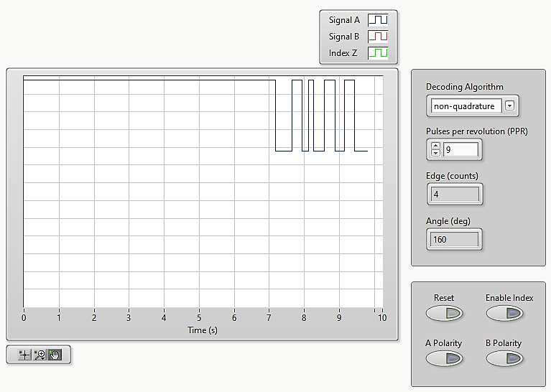

### Calibrate the Encoder

1. Calibrate the pulses of the encoder in terms of angular displacement. To do this, enter the PPR value which was calculated in the previous section in the Pulses per revolution (PPR) numeric control and press the Enter key.
2. Verify the accuracy of your calibration. To do this, rotate the encoder knob and verify that the correct angular position is displayed in the Angle (deg) numeric indicator.
3. Calculate the expected angular resolution using Equation in the Concept Review. Rotate the encoder knob and verify if you measure the same resolution.

|  |  |
| --- | --- |
| Angle = | Angle = |
| Angle = | Angle = |
| Angle =  Resolution = | |

### Analysis of X2 Decoding

1. From the Decoding Algorithm drop-down menu, select X2.
2. In X2 decoding both A and B signals are used. Rotate the encoder knob in the clockwise direction. How do the Edge (counts) and Angle (deg) numeric displays change?

The edge counts increase negatively, and the angle increases inversely with a higher resolution; of 4.5 per step.

1. Rotate the knob in the counterclockwise direction. How do the Edge (counts) and Angle (deg) numeric displays change?

The edge counts increase positively, and the angle increases directly with a higher resolution; of 4.5 per step.

1. What is the resolution of the measured angular displacement?

|  |  |
| --- | --- |
| Angle = | Angle = |
| Angle = | Angle = |
| Angle =  Resolution = | |

### Analysis of X4 Decoding

1. From the Decoding Algorithm drop-down menu, select X4.
2. Press the Reset button.
3. Rotate the knob in the clockwise and counterclockwise directions. How do the Edge (counts) and Angle (deg) numeric displays change?

The edge counts increase negatively in the clockwise direction, and positively in the counterclockwise direction, and accordingly the angles with an even higher resolution of 2.25 per step.

1. What is the resolution of the measured angular displacement?

|  |  |
| --- | --- |
| Angle = | Angle = |
| Angle = | Angle = |
| Angle =  Resolution = | |

## Potentiometer

### Collect Data

1. Open QNET Mechatronic “Sensors.lvproj”.
2. From the Project Explorer window, open QNET Sensors Potentiometer.vi.
3. Click on the Collect Data tab.
4. From the Device drop-down menu, select the device name.
5. Run the VI.
6. Set the potentiometer knob to the 0° mark.
7. Enter 0 in the Pot Angle (deg) array.
8. Using the Uncalibrated Output waveform chart, read the corresponding sensor output and enter the value in the Sensor Output (V) array.
9. Continue taking measurements by rotating the potentiometer at 30° intervals. Enter the angular position and measured sensor outputs in the Pot Angle (deg) and Sensor Output (V) arrays respectively.
10. The slope and offset of the calibration curve are automatically calculated by the VI and displayed in the Slope (deg/V) and Offset (deg) indicators. Make a note of these values.
11. Record the collected data in Table 1.

Table Recorded Potentiometer Measurements

|  |  |
| --- | --- |
| Angle (deg) | Output (V) |
| 0° | 0.72 |
| 30° | 1.32 |
| 60° | 1.85 |
| 90° | 2.46 |
| 120° | 3.11 |
| 150° | 3.77 |
| 180° | 4.51 |

1. Export a copy of the Sensor Readings graph. To do this, right-click on the graph and select Export.

**Results**

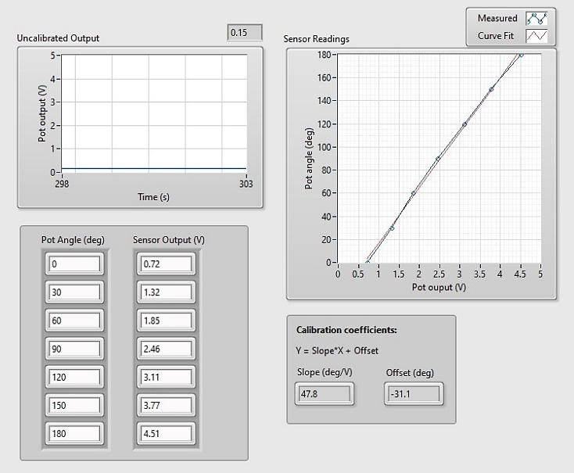 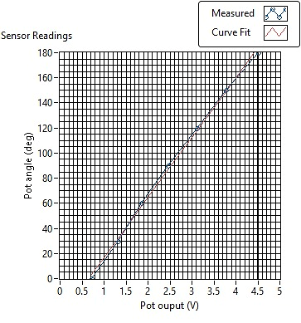

### Calibrate the Potentiometer

1. Click on the Calibrate Sensor tab to calibrate the output of the potentiometer in terms of angular position (in degrees).
2. Use the Slope (deg/V) and Offset (deg) numeric controls to enter the slope and offset values you obtained during the data collection step.
3. Test the accuracy of your calibration. To do this, set the potentiometer knob to different angles and verify that the correct angular position is displayed in the Calibrated Output waveform chart as well as the Pot Angle (deg) meter indicator.

**Results**

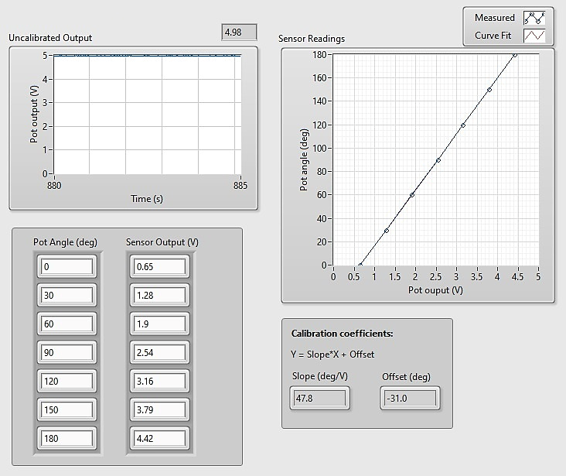 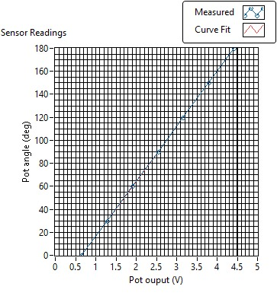

# Conclusion

In this lab we were introduced to QNET Mechatronics Sensor board, and we used it while running the LabVIEW software on pc. Firstly, we learned about the encoder and the number of pulses it generates in a complete revolution. Furthermore, we learnt a formula which we used to calculate the angular displacement, we used number of pulses and Pulse per revolution to calculate it. We also analyzed the X2 and X4 decoders. We found that they had different pulses per revolution because they detected also detected falling edges and rising edges both. Finally, we learned about the potentiometer and calibrated it. We saw, through the help of a graph, that the results were very accurate after our calibration.