**Department of Electrical Engineering and   
Computer Science**

**Faculty Member:** Dr. Salman Ghafoor  **Dated:** 4/12/2022

**Semester:** 5th **Section:** BEE 12C

**EE-232: Signals and Systems**

Lab 10: Linearity in Simulink MATLAB

Group Members

|  |  |  |  |  |  |
| --- | --- | --- | --- | --- | --- |
|  |  | **PLO4 – CLO3** | **PLO5 - CLO3** | **PLO8 -CLO4** | **PLO9 -CLO4** |
| **Name** | **Reg. No** | **Viva / Quiz / Lab Performance** | **Analysis of data in Lab Report** | **Modern Tool Usage** | **Ethics and Safety** |
|  |  | **5 Marks** | **5 Marks** | **5 Marks** | **5 Marks** |
| Danial Ahmad | 331388 |  |  |  |  |
| Muhammad Umer | 345834 |  |  |  |  |
| Syeda Fatima Zahra | 334379 |  |  |  |  |
|  |  |  |  |  |  |

**Table of Contents**

2 MATLAB Simulink 3

2.1 Objectives 3

2.2 Equipment 3

2.3 Lab Instructions 3

3 Lab Tasks 4

3.1 Testing Linearity 4

3.2 Exercise 5

3.2.1 Task 1 5

3.2.2 Task 2 6

4 Conclusion 7

# MATLAB Simulink

## Objectives

This Lab experiment has been designed to familiarize students with MATLAB Simulink; students are required to prove linearity of a system using Simulink.

## Equipment

Software

* *MATLAB*

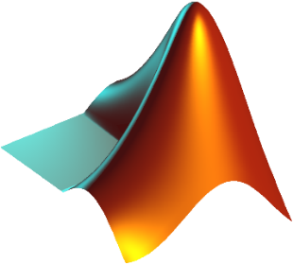

## Lab Instructions

All questions should be answered precisely to get maximum credit. Lab report must ensure following items:

* Lab objectives
* MATLAB codes
* Results (Graphs/Tables) duly commented and discussed
* Conclusion

# Lab Tasks

## Testing Linearity

To test the linearity of the gain block, build the system in the following Figure 1.

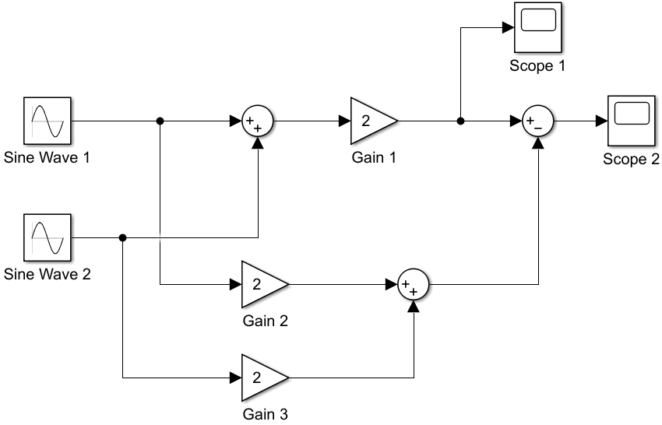

Figure

|  |  |
| --- | --- |
|  |  |
| Scope 1: (Sine Wave 1 + Sine Wave 2) $×$ 2 | Scope 2: ((Sine Wave 1 + Sine Wave 2) $×$ 2) $-$ (2 $×$ Sine Wave 1) + (2 $×$ Sine Wave 2) |

As scope 2 displays: $((Sine Wave 1 + Sine Wave 2) × 2) - (2 × Sine Wave 1) + (2 × Sine Wave 2)$, we can deduce that the system is indeed linear, due to a constant zero output.

## Exercise

### Task 1

Use Simulink to design a non-linear system and show that the system is non-linear by showing that the principle of superposition does not hold.

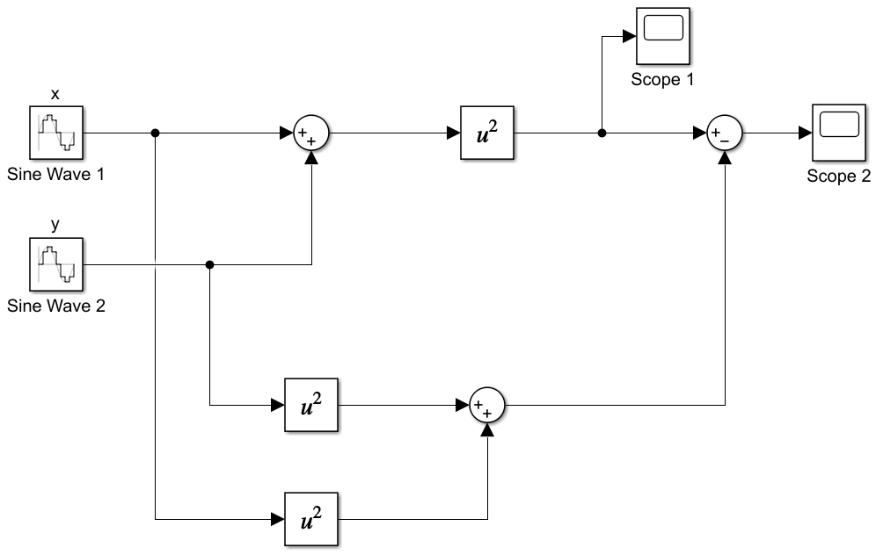

Figure

|  |  |
| --- | --- |
|  |  |
| Scope 1: (x + y) ^ 2 | Scope 2: (x + y) ^ 2 $-$ ((x) ^ 2 + (y) ^ 2) |

As scope 2 displays: ${\left(x + y\right)}^{2} - ({\left(x\right)}^{2} + {\left(y\right)}^{2}),$ we can deduce that the system is not linear, due to a non-zero constant output.

### Task 2

Use the symbolic toolbox to show that the squaring operation is not linear. That is, use the symbolic toolbox to show that:

$${\left(αx+βy\right)}^{2}≠αx^{2}+βy^{2}$$

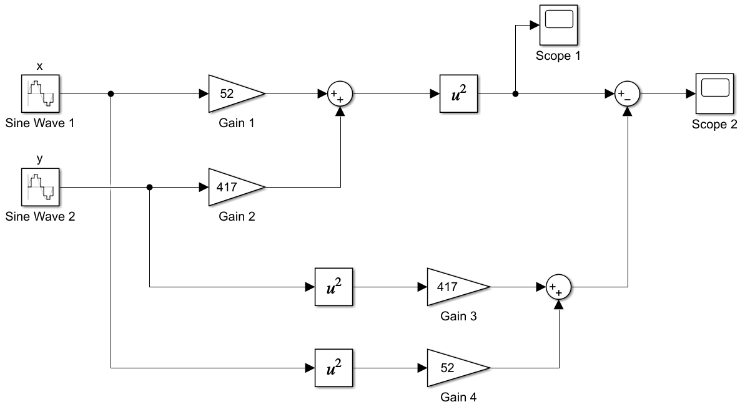

Figure

In Figure 3, x and y are sine waves of different frequencies. $α$ is a gain of 52 and $β$ is a gain of 417.

|  |  |
| --- | --- |
|  |  |
| Scope 1: (52x + 417y) ^ 2 | Scope 2: (52x + 417y) ^ 2 $-$ ((52x) ^ 2 + (417y) ^ 2) |

As scope 2 displays: ${\left(52x + 417y\right)}^{2} - ({\left(52x\right)}^{2} + {\left(417y\right)}^{2}),$ we can deduce that the system is not linear, due to a non-zero constant output.

# Conclusion

In this lab, MATLAB® Simulink was used to show the linearity and non-linearity of different systems, mainly the squaring operation. We deduce that Simulink is a useful and versatile MATLAB “add-on” used as a graphical programming environment for modelling systems.