**Department of Electrical Engineering**

|  |  |
| --- | --- |
| **Faculty Member:____________________** | **Dated: ____________________** |
|  |  |
| **Section:____________________________** | **Semester: __________________** |
|  |  |

**EE-232 : Signals and Systems**

**Lab 11 : Sampling & Reconstruction**

|  |  |  |  |  |  |  |
| --- | --- | --- | --- | --- | --- | --- |
|  |  | **PLO4 –CLO3** | | **PLO5-CLO3** | **PLO8-CLO4** | **PLO9-CLO4** |
| **Name** | **Reg. No** | **Viva / Quiz / Lab Performance** | **Analysis of data in Lab Report** | **Modern Tool Usage** | **Ethics and Safety** | **Individual and Team Work** |
|  |  | **5 Marks** | **5 Marks** | **5 Marks** | **5 Marks** | **5 Marks** |
|  |  |  |  |  |  |  |
|  |  |  |  |  |  |  |
|  |  |  |  |  |  |  |
|  |  |  |  |  |  |  |

**Lab 11: Sampling & Reconstruction**

**Objectives**

To introduce the students to the concepts of Sampling and Reconstruction of Continuous Time Signals.

* Introduction to Sampling and Reconstruction Theory
* Sampling of Continuous Time Signals in Matlab
* Reconstruction of Continuous Time Signals from Sampled Signals
* Demo of sampling and aliasing

**Lab Instructions**

* This lab activity comprises of three parts: Pre-lab, Lab Exercises, and Post-Lab Viva session.
* The Pre-lab tasks should be completed before coming to the lab. The reports are to be submitted on LMS.
* The students should perform and demonstrate each lab task separately for step-wise evaluation
* Only those tasks that completed during the allocated lab time will be credited to the students. Students are however encouraged to practice on their own in spare time for enhancing their skills.

**Lab Report Instructions**

All questions should be answered precisely to get maximum credit. Lab report must ensure following items:

* Lab objectives
* MATLAB codes
* Results (graphs/tables) duly commented and discussed
* Conclusion

# Sampling and Reconstruction

## Pre-Lab

### Introduction

For a signal ***x(t)*** with highest radial frequency **ω*max*** the **Nyquist Criterion** states that the signal should be sampled (**ω*s***) at more than two times the highest frequency so that no spectral distortion takes place.

**ω*s* > 2 ω*max*** (1)

Sampling thus states that a continuous signal containing only one frequency component should be sampled at more than 2 times that frequency. Thus, a signal of 1 Hz should be sampled at more than 2 times per period. The resultant sampled signal can be expressed as ***xp(t). Where Ts is the sampling period associated with the sampling frequency* ω*s***

**x*p(t)* = x*(nTs)*** (2)

The sampling process in both time and frequency domain based upon the use of an impulse train is shown below. This is the same description that was discussed in the class.





Such a sampled signal ***xp(t)*** when passed through an ideal low pass filter will result in the original signal ***x(t)***.



**Demo of con2dis:**

This lab part involves on the use of MATLAB GUI con2dis for sampling and aliasing.

**con2dis:** GUI for sampling and aliasing. An input sinusoid and its spectrum is tracked through A/D and D/A converters.

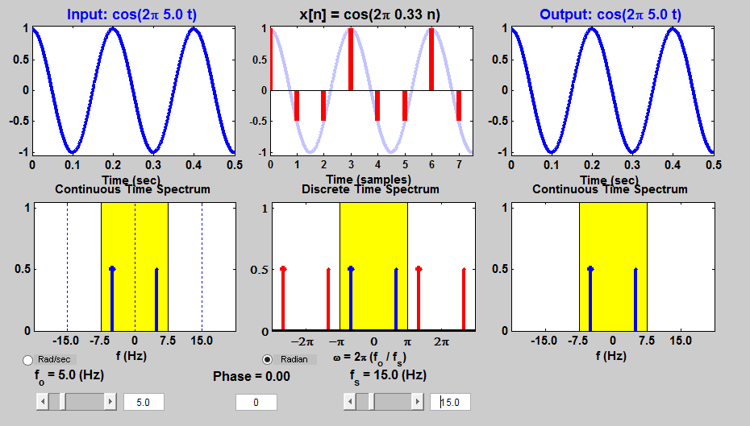

**Run the GUI**

The first objective of this lab is to demonstrate usage of the GUI. First of all, you must download the

ZIP files for each and install them. You can put the GUIs on the matlabpath, or you can run the GUIs from their home directories.

**Sampling and Aliasing Demo**

In this demo, you can change the frequency of an input signal that is a sinusoid, and you can change the sampling frequency. The GUI will show the sampled signal, x[n], it spectrum and also the reconstructed output signal, y(t) with its spectrum. Figure 1 shows the interface for the con2dis GUI. In order to see the entire GUI, you must select Show All Plots under the Plot Options menu.

In the pre-Lab, you should perform the following steps with the con2dis GUI:

1. Set the input to x(t) = cos(20*pi*t)
2. Set the sampling rate to fs = 50 samples/sec.
3. Determine the locations of the spectrum lines for the discrete-time signal, x[n], found in the middle panels. Click the Radian button to change the axis to from f to w.
4. Determine the formula for the output signal, y(t) shown in the rightmost panels. What is the output frequency in Hz?
5. How to find the sampling frequency such that we will not be having an aliased output?
6. Show the aliased output by changing sampling frequency?

(Paste the screenshots)

## Lab Task

#### Assume a continuous time sinusoidal signal with frequency 1 Hz. Since Matlab can only handle discrete sample signals we will assume that the signal having 100 samples per cycle is a continuous time signal.

Generic Information related to the signal and its samples may be declared as follows:

freq=1;

samples_in_one_cycle=100;

division_increment=1/samples_in_one_cycle;

Using the following commands generate the signal for 5 cycles. Next display the signal with respect to time, as a continuous signal in Figure (1).

x(inc)=cos((2*pi*freq*t));

time(inc)=t;

#### Assume that sampling frequency is 4 times the highest frequency in the above generated signal. Only pick appropriate evenly spaced samples, starting from the first sample. The code given below may help you in identifying which samples to pick.

upper_limit=length(x);

increment_value=floor((1/sampling_freq)*(1/division_increment));

Display the sampled signal in Figure(2) along with the time instant from which the signal was picked.

NOTE: Please make sure that you insert zeros between the samples so that the continuous time signal “x(t)” and continuous time sampled signal “xp(t)” have the same number of samples in Matlab.

#### Since filtering with a low pass filter in frequency domain means convolution with a sinc in time domain construct a sinc function using the code given below:

Using the following commands generate the sinc. Next display the signal with respect to time, as a continuous signal in Figure (3).

for t=-2.5:division_increment:2.5

inc=inc+1;

z(inc)=4*sinc(4*t);% In matlab this means sinc(4*pi*t)

end

Comment why set amplitude of Sinc to 4? Is it necessary? Also comment why have sinc(4*pi*t)?

#### Convolve sinc with sampled signal. Plot the resultant continuous time reconstructed signal.

Display the reconstructed signal with respect to time in Figure (4). Is this signal similar to the starting signal?

#### What happens when sampling frequency is set equal to:

#### Signal Frequency

#### 8 times the signal frequency

#### 16 times the signal frequency.

#### Please use the above mentiond steps to show all three outputs (comment on the reconstructed image) and make any changes in the code if necessary.