**Department of Electrical Engineering and   
Computer Science**

**Faculty Member:** Dr. Salman Ghafoor  **Dated:** 5/12/2022

**Semester:** 5th **Section:** BEE 12C

**EE-232: Signals and Systems**

Lab 11: Sampling & Reconstruction

Group Members

|  |  |  |  |  |  |
| --- | --- | --- | --- | --- | --- |
|  |  | **PLO4 – CLO3** | **PLO5 - CLO3** | **PLO8 -CLO4** | **PLO9 -CLO4** |
| **Name** | **Reg. No** | **Viva / Quiz / Lab Performance** | **Analysis of data in Lab Report** | **Modern Tool Usage** | **Ethics and Safety** |
|  |  | **5 Marks** | **5 Marks** | **5 Marks** | **5 Marks** |
| Danial Ahmad | 331388 |  |  |  |  |
| Muhammad Umer | 345834 |  |  |  |  |
| Syeda Fatima Zahra | 334379 |  |  |  |  |
|  |  |  |  |  |  |

**Table of Contents**

2 Sampling & Reconstruction 3

2.1 Objectives 3

2.2 Equipment 3

2.3 Lab Instructions 3

3 Pre-Lab 4

4 Lab Tasks 5

5 Conclusion 9

# Sampling & Reconstruction

## Objectives

To introduce the students to the concepts of Sampling and Reconstruction of Continuous Time Signals.

* Introduction to Sampling and Reconstruction Theory
* Sampling of Continuous Time Signals in MATLAB
* Reconstruction of Continuous Time Signals from Sampled Signals
* Demo of sampling and aliasing

## Equipment

Software

* *MATLAB*

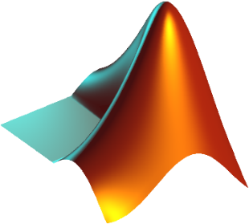

## Lab Instructions

All questions should be answered precisely to get maximum credit. Lab report must ensure following items:

* Lab objectives
* MATLAB codes
* Results (Graphs/Tables) duly commented and discussed
* Conclusion

# Pre-Lab

In the pre-Lab, you should perform the following steps with the **con2dis** GUI:

1. Set the input to x(t) = cos(20*pi*t)
2. Set the sampling rate to fs = 30 samples/sec.
3. Determine the locations of the spectrum lines for the discrete-time signal, x[n], found in the middle panels. Click the Radian button to change the axis to from f to w.

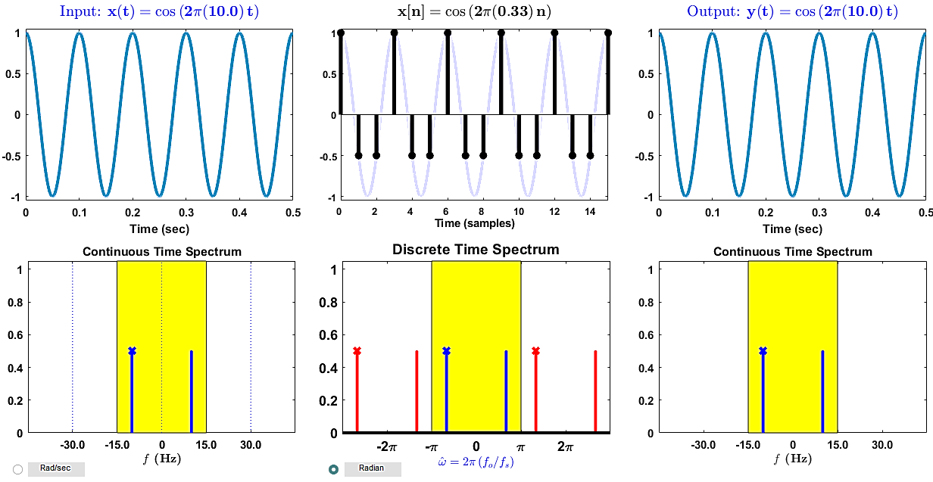

The signal, having $ω=$ 20 $π$, on the discrete time spectrum will have spectrum lines at $ω=20π×\frac{f_{o}}{f_{s}}$, or in other words, at $±\frac{2}{3}π, ±\frac{4}{3}π,$ where $f_{s}$ is 30 Hz and so on.

1. Determine the formula for the output signal, y(t) shown in the rightmost panels. What is the output frequency in Hz?

When sampled above the Nyquist criterion, the output signal frequency will be the same as that of the original signal, i.e., f = 10 Hz.

1. How to find the sampling frequency such that we will not be having an aliased output?

By taking at least 2 samples per period of the original signal, we can recover the original signal after Sampling i.e., $ω_{s}$ > 2 $ω_{m}$ where $ω_{m}$ is the largest frequency component in x(t).

1. Show the aliased output by changing sampling frequency?

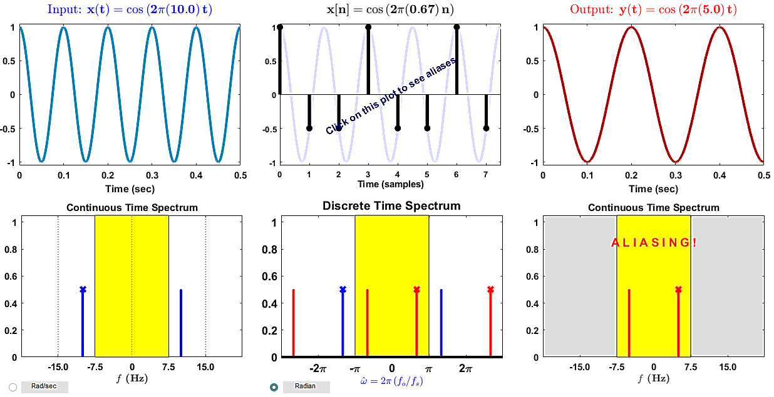

# Lab Tasks

1. **Assume a continuous time sinusoidal signal with frequency 1 Hz. Since MATLAB can only handle discrete sample signals, we will assume that the signal having 100 samples per cycle is a continuous time signal.**

Generic Information related to the signal and its samples may be declared as follows:

freq=1;

samples_in_one_cycle=100;

division_increment=1/samples_in_one_cycle;

x(inc)=cos((2*pi*freq*t));

time(inc)=t;

freq = 1; % frequency

samples_in_one_cycle = 100;

division_increment = 1 / samples_in_one_cycle;

t = 0:division_increment:(1 / freq) * 5; % 5 periods

x = cos(2 * pi * freq * t);

plot(t, x);

title('Original Signal x(t)')

xlabel('Time (s)')

ylabel('x(t) = cos(2*pi*freq*t);')



1. **Assume that sampling frequency is 4 times the highest frequency in the above generated signal. Only pick appropriate evenly spaced samples, starting from the first sample. The code given below may help you in identifying which samples to pick.**

upper_limit=length(x);

increment_value=floor((1/sampling_freq)*(1/division_increment));

upper_limit = length(x);

sampling_freq = 8 * freq; % 4 times the highest frequency

t_p = 0:1 / sampling_freq:1 / freq * 5;

x_p = cos(2 * pi * freq * t_p); % sampled signal

subplot(212)

plot(t, x, ':b', 'MarkerSize', 2); hold on;

stem(t_p, x_p)

grid

title('Sampled Signal')

xlabel('Time (s)')

ylabel('x_p(t) = x(t) * impulse train')



1. **Since filtering with a low pass filter in frequency domain means convolution with a sinc in time domain construct a sinc function using the code given below:**

for t=-2.5:division_increment:2.5

inc=inc+1;

z(inc)=4*sinc(4*t); % In matlab this means sinc(4*pi*t)

end

Comment why set amplitude of Sinc to 1? Is it necessary? Also comment why have sinc(4*pi*t)?

The largest frequency component in x(t), $ω_{m}$, is 2π and the sampling frequenct $ω_{s}$ is 4 times $ω_{m}$, and hence, 8 $π$. $ω_{c}$ is taken to be 4π so that it lies between $ω_{m}$ and $ω_{s}-ω_{m}$, and hence, why we have sinc(4*pi*t). For reconstruction, we must have an amplitude of sinc(4*pi*t) of 1 to have a suitable interpolating filter, with an amplitude the same as that of the reconstructed signal.



t_sinc = -2.5:division_increment:2.5;

z = sinc(4 * t_sinc);

figure

subplot(211)

plot(t_sinc, z);

grid

title('Sinc Signal')

xlabel('Time (s)')

ylabel('sinc(4*pi*t)')

1. **Convolve sinc with sampled signal. Plot the resultant continuous time reconstructed signal.**

Display the reconstructed signal with respect to time.

padded_x_p = *zeros*(1, length(x));   % padding sampled signal to length of

i = 1;                              % original signal

k = 1;

for y = 0:division_increment:(1 / freq) * 5

    if (y == t_p(i))

        padded_x_p(k) = x_p(i);

        i = i + 1;

    end

    k = k + 1;

end

x_r = conv(z, padded_x_p, 'same');

subplot(212)

plot(t, x_r);

grid

title('Reconstructed Signal')

xlabel('Time (s)')

ylabel('x_r(t) = cos(2 * pi * freq * t)')



1. **What happens when sampling frequency is set equal to:**
2. **Signal Frequency**

As the sampling frequency is less than 2 $×$ the maximum frequency in original signal x(t), the Nyquist criterion is not satisfied, and aliasing occurs in the reconstructed signal.



1. **8 times the signal frequency**

As the sampling frequency is 8 × the maximum frequency in original signal x(t), the Nyquist criterion is satisfied, and the reconstructed signal is same as the original signal.



1. **16 times the signal frequency**

As the sampling frequency is 16 × the maximum frequency in original signal x(t), the Nyquist criterion is satisfied, and the reconstructed signal is same as the original signal.



# Conclusion

In this lab we were introduced to sampling and Reconstruction theory. We performed sampling on continuous time signals and saw at what condition does aliasing occurs. Furthermore, we performed reconstruction on those sampled continuous time signals. We also noticed the behavior of the signal when the sampling signal’s frequency was changed to specific values, including signal frequency, 8 times signal frequency etc. We learnt how to perform all this on MATLAB.