**Department of Electrical Engineering and   
Computer Science**

**Faculty Member:** Dr. Salman Ghafoor  **Dated:** 26/09/2022

**Semester:** 5th **Section:** BEE 12C

**EE-232: Signals and Systems**

Lab 3: Signal Transformations

Group Members

|  |  |  |  |  |  |
| --- | --- | --- | --- | --- | --- |
|  |  | **PLO4 – CLO3** | **PLO5 - CLO3** | **PLO8 -CLO4** | **PLO9 -CLO4** |
| **Name** | **Reg. No** | **Viva / Quiz / Lab Performance** | **Analysis of data in Lab Report** | **Modern Tool Usage** | **Ethics and Safety** |
|  |  | **5 Marks** | **5 Marks** | **5 Marks** | **5 Marks** |
| Danial Ahmad | 331388 |  |  |  |  |
| Muhammad Umer | 345834 |  |  |  |  |
| Syeda Fatima Zahra | 334379 |  |  |  |  |
|  |  |  |  |  |  |

**Table of Contents**

2 Signal Transformations 3

2.1 Objectives 3

2.2 Equipment 3

2.3 Lab Instructions 3

3 Pre-Lab 4

4 Exercise 4

4.1 Transformations of the Time Index for Discrete Time Signals 4

4.2 Discrete Unit Step 6

4.3 Even and Odd Part of a Signal 7

4.4 Image Transformation 8

5 Conclusion 9

# Signal Transformations

## Objectives

This lab experiment has been designed to introduce students to signal transformations using MATLAB.

* How to perform time shifting
* How to perform time compression/expansion
* Even and odd Signals

## Equipment

Software

* *MATLAB*

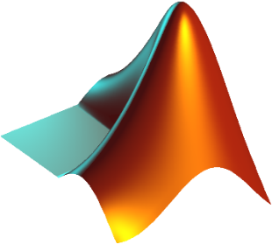

## Lab Instructions

All questions should be answered precisely to get maximum credit. Lab report must ensure following items:

* Lab objectives
* MATLAB codes
* Results (Graphs/Tables) duly commented and discussed
* Conclusion

# Pre-Lab

Using MATLAB to flip, compress and expand an audio sequence in time;

1. Load the audio file titled “song.wav” using MATLAB. Play the audio file.
2. Flip the audio sequence and play it back again.
3. Next perform time compression on the flipped signal by a factor of 2. What does the audio sequence sound like?

**Answer:** As the signal is compressed by a factor of 2, the audio sequence plays twice as fast with duration being reduced from 9.13 s to 4.565 s. As frequency also alters with compression, the pitch also changes and the audio sounds high-pitched.

1. Perform time expansion by a factor of 2. What does the flipped audio sequence sound like?

As the signal is expanded by a factor of 2, the audio sequence plays twice as long with duration being increased from 9.13 s to 18.26 s. As frequency also alters with expansion, the pitch also changes and the audio sounds deeper-pitched.

Following code accomplishes all of the aforementioned pre-lab tasks in a sequential fashion:

[y, Fs] = audioread('test_song.wav');

sound(y, Fs) % Plays the audio

pause(12); % Adds a delay of n seconds

yflip = flipud(y); % Reverses the column vector

sound(yflip, Fs)

pause(12);

sound(yflip, Fs * 2) % Compressed signal

pause(6);

sound(yflip, Fs / 2) % Expanded signal

# Exercise

## Transformations of the Time Index for Discrete Time Signals

1. Define a MATLAB vector *n,* such that -3 ≤ n < 7, representing time/sample indices of a Discrete Time Signal x[n] such that:

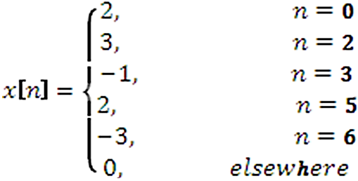

*Enter the MATLAB command(s) through which you defined this vector.*

n = -3:6;

x = *zeros*(1, length(n));

x(4) = 2; x(6) = 3; x(7) = -1; x(9) = 2; x(10) = -3;

stem(n, x)



Figure . DT Signal

1. Make a generalized function that can shift the signal x[n] by delaying or advancing it by a specified amount.

**Function Definition**

function *y* = timeshift(*data*, *shift*)

    x = data(1, :);

    n = data(2, :);

    % Different slicing for negative

    % / positive shifts

    if shift < 0

        y = x((abs(shift) + 1):length(x));

        y = [y, *zeros*(1, abs(shift))];

    else

        for k = 1:length(n)

            y(k + shift) = x(k);

        end

        y = y(1:(length(y) - shift));

    end

end

**Plotting Script**

subplot(211)

stem(n, x)

grid on

xlabel('n')

ylabel('x[n]')

title('Original Signal')

subplot(212)

stem(n, y, 'r')

xlabel('n')

ylabel(['x[n - ' num2str(shift) ']'])

title(['Time shift of ' num2str(shift)])

grid on



## Discrete Unit Step

Implement the following function in MATLAB. Your function should take ***k*** and ***n*** as input from user.

function *u* = unitstep(*k*, *n*)

    u = *zeros*(1, length(n));

    indexer = find(n == k);

    u(indexer:length(u)) = 1;

    stem(n, u);

    grid on

    title('Unit Step u[k - n]')

    xlabel('n')

    ylabel('u[n]')

end

*Attach a screenshot of the figure generated by your function for the input values of* ***k*** *= 4.*



## Even and Odd Part of a Signal

Every signal *x[n]* is sum of its even part and odd part. Given the signal *x[n]* find its even and odd part.



**Even:** **Odd:**

*Write a function that will produce three figures. The first figure shall show the signal x[n] given above. The second figure shall show the signal xe[n]. The third figure shall show the signal xo[n].*

% Signal Definition

n = -3:6;

x = *zeros*(1, length(n));

x(4) = 2; x(6) = 3; x(7) = -1; x(9) = 2; x(10) = -3;

x_e = 1/2 * (x + fliplr(x)); % Even

x_o = 1/2 * (x - fliplr(x)); % Odd

figure

stem(n, x)

title('Original Function')

grid

figure

stem(n, x_e)

title('Even Component')

grid

figure

stem(n, x_o)

title('Odd Component')

grid



## Image Transformation

Load the file ‘image.jpg’ in MATLAB. See the image. You should see a fighter throwing a punch.

img = imread('image.jpg');

[height, width, channels] = size(img);

figure

imagesc(img)

title('Original')

figure

imagesc(fliplr(img))

title('Flipped')

 

Assuming that each row is a separate signal perform time reversal of each row. Now see the image. The fighter is now throwing a punch with which hand?

**Answer:** After time reversal (fliplr), we observe that the fighter is throwing the punch with his left-hand as opposed to the right-hand as in the original image; implying that time reversal is working as expected.

# Conclusion

In this lab, we further familiarized ourselves with MATLAB, and we learned how to perform time shifting. We learned how to plot Discrete time graphs using stem(), and we got to know how to flip vectors and matrices using flipud() and fliplr(). In addition to that, we imported an audio file and performed compression and expansion on it. We also learned how to flip an image using the fliplr() and flipud() functions, and further performed operations which separated odd and even signals from a given function.