**Department of Electrical Engineering and   
Computer Science**

**Faculty Member:** Dr. Salman Ghafoor  **Dated:** 31/10/2022

**Semester:** 5th **Section:** BEE 12C

**EE-232: Signals and Systems**

Lab 8: Discrete Time Fourier Series

Group Members

|  |  |  |  |  |  |
| --- | --- | --- | --- | --- | --- |
|  |  | **PLO4 – CLO3** | **PLO5 - CLO3** | **PLO8 -CLO4** | **PLO9 -CLO4** |
| **Name** | **Reg. No** | **Viva / Quiz / Lab Performance** | **Analysis of data in Lab Report** | **Modern Tool Usage** | **Ethics and Safety** |
|  |  | **5 Marks** | **5 Marks** | **5 Marks** | **5 Marks** |
| Danial Ahmad | 331388 |  |  |  |  |
| Muhammad Umer | 345834 |  |  |  |  |
| Syeda Fatima Zahra | 334379 |  |  |  |  |
|  |  |  |  |  |  |

**Table of Contents**

2 Introduction to Properties of Systems 3

2.1 Objectives 3

2.2 Equipment 3

2.3 Lab Instructions 3

3 Lab Tasks 4

3.1 Lab Task 1 & 2 (Reconstruction done in a single code) 4

3.1.1 Fourier Series of a DT Sinusoid 4

3.1.2 Fourier Series of a DT Rectangular Wave 7

4 Conclusion 11

# Introduction to Properties of Systems

## Objectives

The goal of this laboratory is to be able to calculate the Fourier series of discrete time signals and plot the real part of the spectrum / Fourier series coefficients.

* Fourier Series Calculation of Discrete Time Signals
* Inverse Fourier Series Calculation given Fourier Series Coefficients

## Equipment

Software

* *MATLAB*

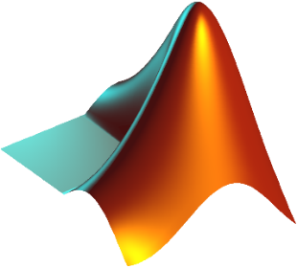

## Lab Instructions

All questions should be answered precisely to get maximum credit. Lab report must ensure following items:

* Lab objectives
* MATLAB codes
* Results (Graphs/Tables) duly commented and discussed
* Conclusion

# Lab Tasks

## Lab Task 1 & 2 (Reconstruction done in a single code)

### Fourier Series of a DT Sinusoid

Write a function that will generate a single Discrete Time (DT) sinusoid $x[n]= A\sin{[wn]}= A\sin\left[2π\frac{f}{F_{s}}n\right]$. $A=3$, $f=500$ Hz and sampling frequency $F_{s} =8000$ Hz.

function [] = discreteSine(*A*, *f*, *Fs*)

    N = Fs / f;

    n_definition = 0:1:N;

    x = A * sin(2 * pi * (f / Fs) * n_definition);

    subplot(2, 2, 1)

    stem(n_definition, x, 'filled')

    title('Original Signal x[n]')

    xlabel('n')

    grid

    n_obv = 0:1:15;

    x_n = A * sin(2 * pi * (f / Fs) * n_obv);

    length(n_obv);

    ak = *zeros*(1, 41);

    length(ak);

    for k = -20:1:20

        for n = 0:1:15

            ak(k + 21) = ak(k + 21) + (x_n(n + 1) ...

                * (exp(-1i * k * (2 * pi * (1 / N)) * n))) / N;

        end

    end

    k_axis = -20:20;

    length(k_axis);

    mag_ak = abs(ak);

    tol = 1e-6;

    for k = -20:1:20

        if abs(ak(k + 21)) < tol

            ak(k + 21) = 0;

        end

    end

    phase_ak = angle(ak);

%     subplot(2, 2, 2)

%     stem(k_axis, mag_ak);

%     title('Magnitude Spectrum');

%     xlabel('k')

%     grid

%

%     subplot(2, 2, 3)

%     stem(k_axis, phase_ak);

%     title('Phase Spectrum');

%     xlabel('k')

%     grid

    frequency_radians = *zeros*(1, 41);

    for k = -20:20

        frequency_radians(k + 21) = 2 * pi * (k / N);

    end

    frequency_Hertz = *zeros*(1, 41);

    for k = -20:20

        frequency_Hertz(k + 21) = (k / N);

    end

    subplot(2,2,2)

    stem(frequency_radians, mag_ak)

    title('Magnitude of a_{k}')

    xlabel('Frequency (in Radians)')

    grid

    subplot(2,2,3)

    stem(frequency_Hertz, mag_ak)

    title('Magnitude of a_{k}')

    xlabel('Frequency (in Hertz)')

    grid

    x_recon = *zeros*(1, N + 1);

    for n = 0:N

        for k = -7:1:8

            x_recon(n + 1) = x_recon(n + 1) + (ak(k + 21) ...

                .* (exp(1i * k * (2 * pi * (1 / N)) * n)));

        end

    end

    n_axis = 0:1:N;

    subplot(2, 2, 4)

    stem(n_axis, x_recon, 'filled')

    title('Reconstructed Signal x[n]')

    xlabel('n')

    grid

1. Determine the period, $N$, of this sinusoid? Determine the DT Fourier series coefficients and plot the magnitude and phase of the DT Fourier series coefficients.

 

 

1. For calculating the DT Fourier series coefficients use . It will return the value of the th DTFS coefficient. For remaining coefficients, you may use a loop to iterate over values of $k$. What will be the range of $k$?
$$Range k= -20:20$$

2. You must make two plots of the coefficients against frequency axis instead of $k$. One plot should be against frequency in radians. Other plot should be against frequency in Hz.

 

1. $k$-th coefficient corresponds to frequency $\frac{2π}{N}k$. Determine the range in radians of the distinct frequency components?
$$Range f \left(in Hertz\right)= 0.3926$$

$$Range f \left(in Radians\right)= 0.0625$$

2. What is relation between frequency in Hz and frequency in radians?

$$Frequency \left(in radians\right)= 2π×Frequency (in hertz)$$

### Fourier Series of a DT Rectangular Wave

Assume a rectangular wave as shown below. Using a similar approach outlined in the previous task, obtain the DTFS representation of the rectangular wave. Plot the magnitude and phase of the Fourier series coefficients with appropriate axes, labels, and titles.

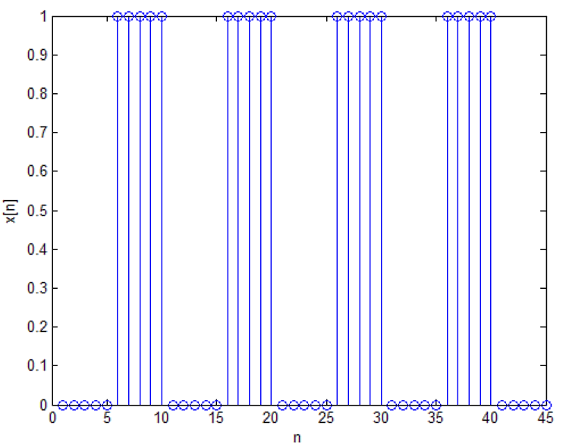

function [] = discreteSquare()

    N = 10; % Period N

    n_definition = 1:1:N;

    x = [0 0 0 0 0 1 1 1 1 1]; % 1 - 10

    subplot(2, 2, 1)

    stem(n_definition, x, 'filled');

    title('Original Function x[n]')

    xlabel('n');

    axis([1 N -0.25 1.25]);

    ak = *zeros*(1, 35);

    length(ak);

    for k = -17:1:17

        for n = 1:1:N

            ak(k + 18) = ak(k + 18) + (x(n) ...

                * (exp(-1i * k * (2 * pi * (1 / N)) * n))) / N;

        end

    end

    k_axis = -17:1:17;

    length(k_axis);

    mag_ak = abs(ak);

    tol = 1e-6;

    for k = -17:1:17

        if abs(ak(k + 18)) < tol

            ak(k + 18) = 0;

        end

    end

    phase_ak = phase(ak);

    subplot(2, 2, 2)

    stem(k_axis, mag_ak);

    title('Magnitude Spectrum');

    xlabel('k')

    grid

    subplot(2, 2, 3)

    stem(k_axis, phase_ak);

    title('Phase Spectrum');

    xlabel('k')

    grid

    x_recon = *zeros*(1, N + 1);

    for n = 1:N

        for k = 1:1:N

            x_recon(n + 1) = x_recon(n + 1) + (ak(k + 18) ...

                .* (exp(1i * k * (2 * pi * (1 / N)) * n)));

        end

    end

    n_axis = 0:1:N;

    subplot(2, 2, 4)

    stem(n_axis, x_recon, 'filled')

    title('Reconstructed Signal x[n]')

    xlabel('n')

    grid

1. Determine the period, $N$, of this sinosoid? Determine the DT Fourier series coefficients and plot the magnitude and phase of the DT Fourier series coefficients.

 

 

1. For calculating the DT Fourier series coefficients use . It will return the value of the th DTFS coefficient. For remaining coefficients, you may use a loop to iterate over values of $k$. What will be the range of $k$?
$$Range k= -17:17$$

2. You must make two plots of the coefficients against frequency axis instead of $k$.

 

1. $k$-th coefficient corresponds to frequency $\frac{2π}{N}k$. Determine the range in radians of the distinct frequency components?
$$Range f \left(in Hertz\right)= 0.3926$$

$$Range f \left(in Radians\right)= 0.0625$$

2. What is relation between frequency in Hz and frequency in radians?

$$Frequency \left(in radians\right)= 2π×Frequency (in hertz)$$

Assume a rectangular wave as shown below. Using a similar approach outlined in the previous task, obtain the DTFS representation of the rectangular wave. Plot the magnitude and phase of the DT Fourier series coefficients with appropriate axes, labels, and titles. What differences can you note from the frequency representation of previous waveform.

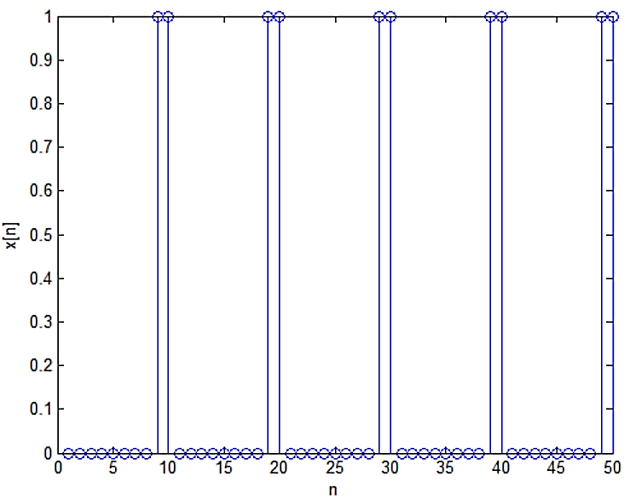

Keeping all the previous code the same, except now, original function is changed to:

x = [0 0 0 0 0 0 0 0 1 1]; % 1 - 10

 

 

**Differences:** Phase spectrum contains more non-zero values for distinct Fourier series coefficients and the magnitude spectrum comprises a greater number of coefficients, but of less magnitude. ($A=0.2$)

# Conclusion

After the conduct of this lab, we have determined that MATLAB can be effectively used for determining Fourier series of Discrete Time signals and any number of coefficients can be obtained. However, a given DTFS only has a finite number of coefficients equal to the period of the signal. Also, we proved the 2π relation between the frequency in Hertz and radians by studying and observing MATLAB output plots.