

**NATIONAL UNIVERSITY OF SCIENCES & TECHNOLOGY**

**Communication Systems (EE-351)**

Assignment 1 (CLO-1)

**Group Members**

|  |  |
| --- | --- |
| **Name** | **CMS ID** |
| Muhammad Ahmed Mohsin | 333060 |
| Muhammad Umer | 345834 |
| Syeda Fatima Zahra | 334379 |
| Danial Ahmad | 331388 |

**Submission Details**

|  |  |
| --- | --- |
| Submitted to: | Dr. Huma Ghafoor |
| Class: | BEE-12C |
| Semester: | 6th |

* **No late submissions will be accepted unless a prior approval from the instructor is obtained with extremely genuine reasons. The assignments submitted after the due date/time will be graded zero.**
* **University has zero tolerance for plagiarism and serious penalties apply.**
* **All assignments found mutually copied will be marked zero.**
* **Five marks are reserved for neat and clean work.**

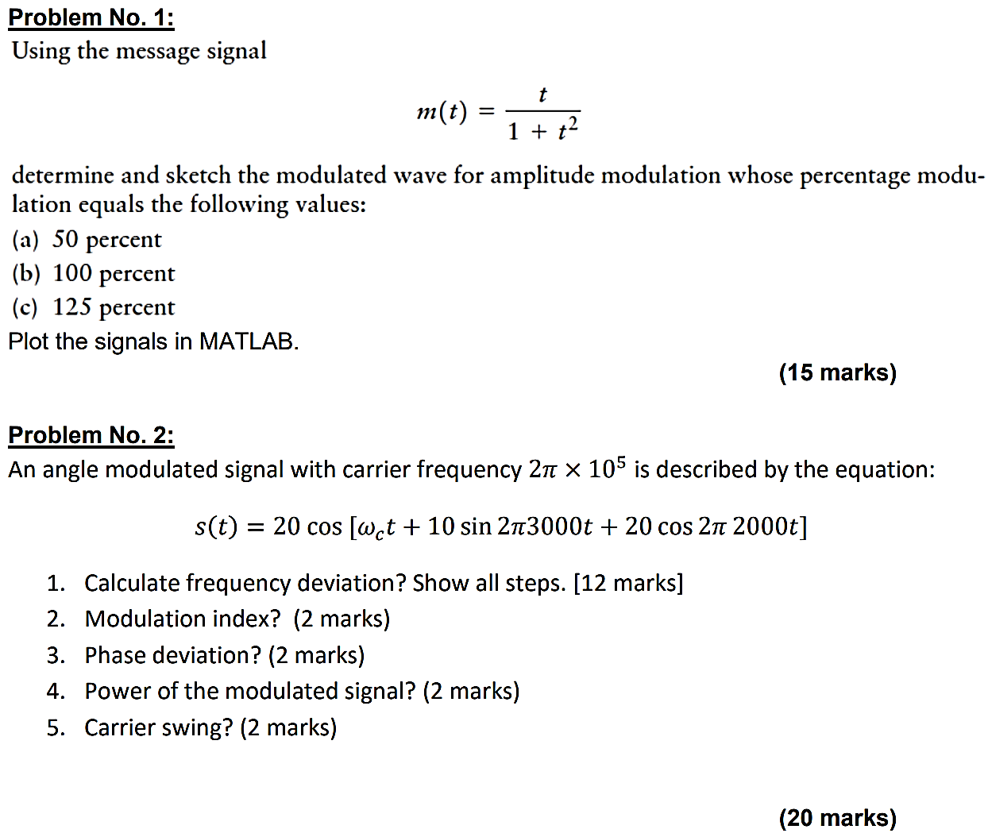

**Problem # 1**



% Define parameters

fc = 20;

fs = 10 * fc;

T = 1 / fs;

t = 0:T:15;

m_t = t ./ (1 + t .^ 2);

c_t = cos(2 * pi * fc * t);

% Define sensitivity list

k_a_50 = 0.5;

k_a_100 = 1.0;

k_a_125 = 1.25;

% Define AM signals

s_t_50 = (1 + k_a_50 * m_t) .* c_t;

s_t_100 = (1 + k_a_100 * m_t) .* c_t;

s_t_125 = (1 + k_a_125 * m_t) .* c_t;

% Plot message signal and AM signals

figure

subplot(2, 1, 1)

plot(t, m_t)

title('Message signal')

xlabel('Time (s)')

ylabel('Amplitude')

subplot(2, 1, 2)

plot(t, s_t_50)

grid

title('AM signal: 50% modulation')

xlabel('Time (s)')

ylabel('Amplitude')

subplot(2, 1, 2)

plot(t, s_t_100)

title('AM signals: 100% modulation')

xlabel('Time (s)')

ylabel('Amplitude')

subplot(2, 1, 2)

plot(t, s_t_125)

grid

title('AM signal: 125% modulation')

xlabel('Time (s)')

ylabel('Amplitude')

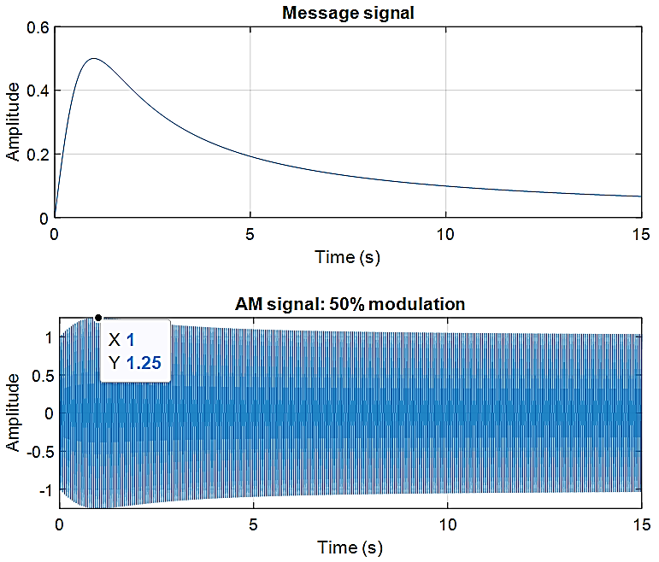

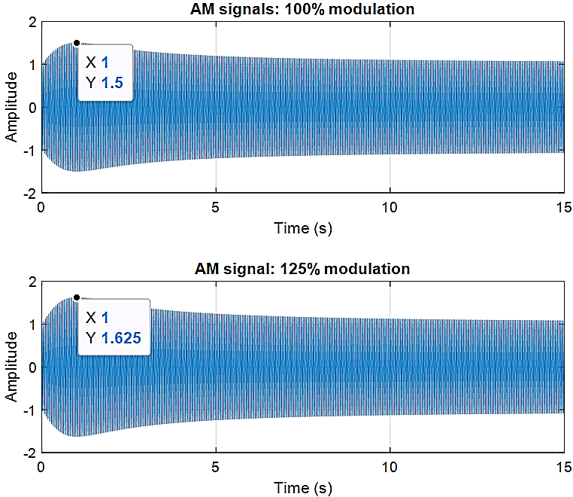

**Problem # 2**

Done by hand on appended pages.