**Department of Electrical Engineering and   
Computer Science**

**Faculty Member:** Dr. Huma Ghafoor  **Dated:** 2/02/2023

**Semester:** 6th **Section:** BEE 12C

**EE-351 Communication Systems**

Lab 1: Introduction to Analog Communications

Group Members

|  |  |  |  |  |  |  |
| --- | --- | --- | --- | --- | --- | --- |
| **Name** | **Reg. No** | **Viva / Quiz / Lab Performance** | **Teamwork** | **Ethics** | **Software Tool Usage** | **Analysis of data in Lab Report** |
|  |  | **5 Marks** | **5 Marks** | **5 Marks** | **5 Marks** | **5 Marks** |
| Muhammad Ali Farooq | 331878 |  |  |  |  |  |
| Danial Ahmad | 331388 |  |  |  |  |  |
| Muhammad Umer | 345834 |  |  |  |  |  |
| Tariq Umar | 334943 |  |  |  |  |  |

**Table of Contents**

3 Introduction to Analog Communications 3

3.1 Objectives 3

3.2 Introduction 3

3.3 Lab Report Instructions 3

4 Lab Procedure 4

5 Conclusion 7

**Table of Figures**

Figure 1: Message Signal 4

Figure 2: Carrier Signal 5

Figure 3: Carrier Signal 6

Figure 4: Amplitude Modulation 6

Figure 5: Recovered Signal 7

# Introduction to Analog Communications

## Objectives

* The main purpose of this lab is to learn the basic principles involved in analog communication and learn some important concepts such as recognition of message signal, carrier signal and modulated signal.
* In addition to that this lab is also hands on experience to the software “Tie Pie Multi Channel”
* We will also learn hardware including Analog Communication Board, F.A.C.E.T Base Unit, Power Supply Multimeter, Virtual Oscilloscope, and generator.

## Introduction

Analog communication is a crucial component of modern technology and plays a vital role in various fields such as telecommunications, signal processing, and control systems. This laboratory experiment aims to provide a comprehensive understanding of the basic principles of analog communication by exploring its key concepts and practical applications.

By the end of this laboratory experiment, students will have acquired a solid understanding of the basic principles of analog communication, as well as practical experience with various hardware and software components. This will provide a foundation for future studies and applications in the field of analog communication.

## Lab Report Instructions

All questions should be answered precisely to get maximum credit. Lab report must ensure following items:

* Lab objective
* Results (screen shots) duly commented and discussed.
* Conclusion

# Lab Procedure

1. Locate an AM/SSB transmitter circuit block on the Analog Communications Circuit and connect the Signal Generator to the M of Modulator. Set Switches S1, S2 and S3 to OFF.

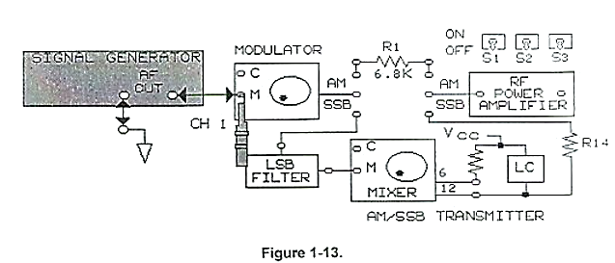

1. Set Oscilloscope Channel 1 to 100mv/DIV, set the sweep to 0.2ms/DIV, then trigger on Channel 1. Set channel 1 to ac. Connect the Oscilloscope channel 1 to M of the modulator.
2. While observing the signal on channel 1 of the oscilloscope, adjust the signal generator for a 200mVpk-pk. 2kHz sin wave signal at M.

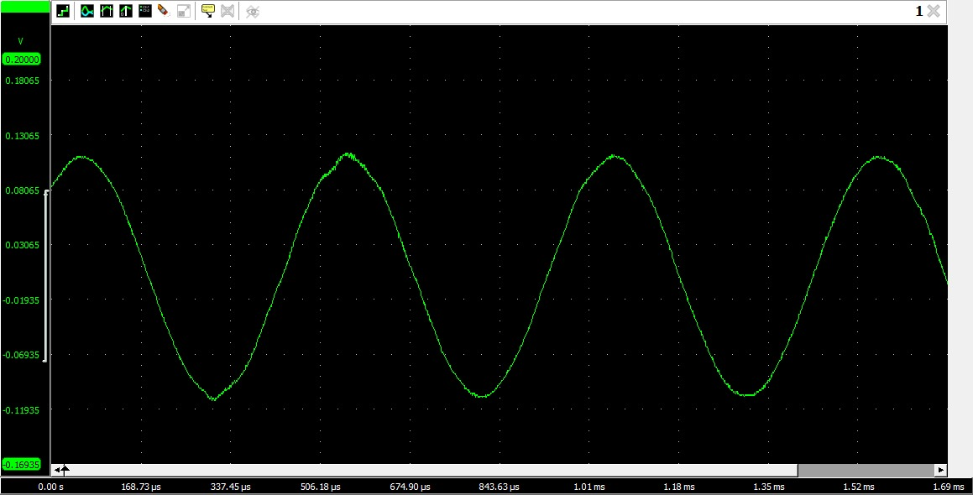

Figure : Message Signal

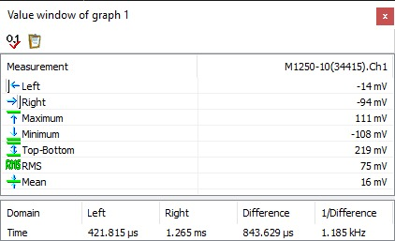

1. What is the Channel 1 signal at M on the modulator, the carrier signal or message signal?

Signal M connected to channel 1 of the oscilloscope is the message signal; to be modulated.

1. Increase the frequency of the message signal to 5kHz, then decrease the frequency to 2khz by varying the AF frequency knob on the signal generator.
2. When increase the frequency on the signal generator, did the signal period decrease?

Yes, the signal period decreased as time period and frequency are inversely related.

1. Increase the amplitude of the message signal to 400mVpk-pk, then decrease the amplitude to 200mVpk-pk by varying the AF level Knob on the signal generator.
2. When you increased the amplitude of the message signal to 400mVpk-pk, did the period increase, decrease, or stay constant?

The period remained constant as time period is invariant of the amplitude of the message signal.

1. Locate the VCO-LO Circuit block on the Analog Communications board. Place a two-port connector in the 1000kHz position on VCO-LO circuit. Connect OUT on the VCO-LO circuit block to C at the modulator.

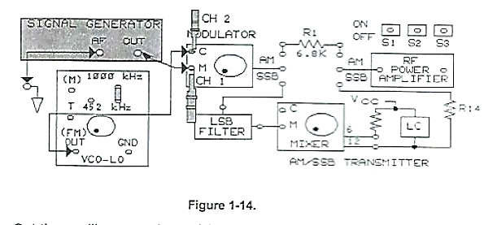

1. Set the Oscilloscope channel 2 to ac and 100mv/DIV.S Set the vertical mode to ALT, then sweep to 0.5us/DIV, Trigger on channel 2, Connect the channel 2 probe to C.

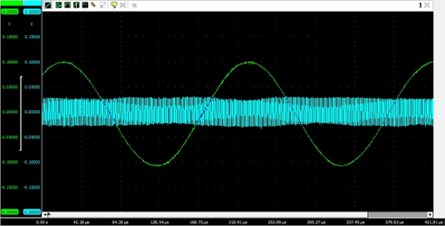

Figure : Carrier Signal

1. Set the frequency of the circuit block to 1000kHz by adjusting the negative supply on the base unit. With the sweep set to 0.5us/DIV, each cycle of 1000kz signal covers two horizontal oscilloscope divisions.

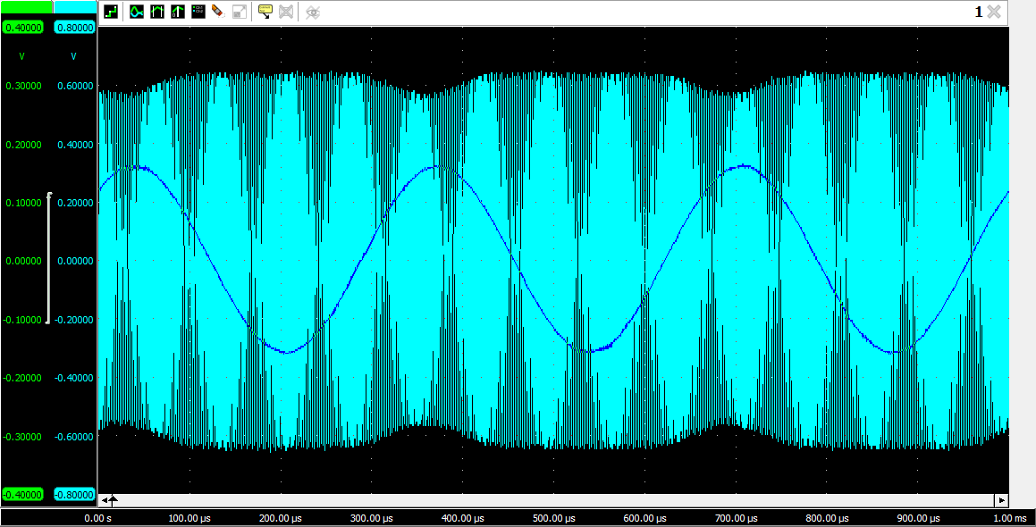

Figure : Carrier Signal

1. What is the signal on channel 2, message signal or carrier signal?

Signal C at channel 2 of the oscilloscope is the high-frequency carrier signal.

1. Adjust the potentiometer knob completely counterclockwise, Trigger the oscilloscope on channel 1. Set the sweep to 0.2ms/DIV. and set the channel to 2 to 1 V/DIV. Connect the channel 2 probe to output of the modulator.
2. Slowly turn the knob of modulator so that AM waveform on oscilloscope channel 2 appears.



Figure : Amplitude Modulation

1. What type of modulation you are observing?

We are observing a DSB (double sideband) modulation, containing two symmetrical sidebands and no carrier band.

1. Connect the modulator to power amplifier, Connect the output of power amplifier the input of Envelope Detector on receiver circuit block.
2. Set the oscilloscope channel 2 to 500mv/DIV. Connect the channel 2 probe to the output of the envelope detector.

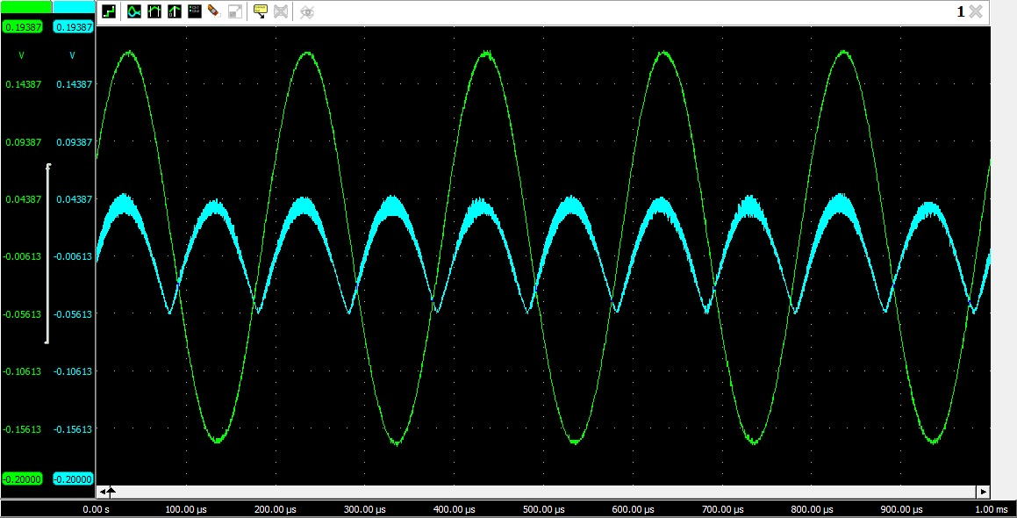

Figure : Recovered Signal

1. Compare the message signal input to the modulator on channel 1 to the output of the envelope detector on channel 2.
2. What is the signal on channel 2, carrier signal or recovered message signal?

The signal at channel 2 is the demodulated output, or in other words, the recovered message signal.

1. Does the amplitude and frequency of the recovered message signal on channel 2 change with the channel 1 message signal?

In an amplitude modulation (AM) system, changes in the amplitude of the message signal on channel 1 directly impact the amplitude of the recovered message signal on channel 2.

# Conclusion

The laboratory experiment on analog communication was a comprehensive and hands-on experience that provided valuable insights into the basic principles and key concepts involved in analog communication. Students were able to understand the recognition of message signal, carrier signal, and modulated signal and gained practical experience with the software "Tie Pie Multi Channel". Overall, this laboratory experiment was a successful and informative experience that helped students understand the basic principles of analog communication and gain practical experience with hardware and software components. The knowledge and skills gained in this laboratory experiment will provide a foundation for future studies and applications in the field of analog communication.