**Department of Electrical Engineering and   
Computer Science**

**Faculty Member:** Dr. Huma Ghafoor  **Dated:** 18/05/2023

**Semester:** 6th **Section:** BEE 12C

**EE-351 Communication Systems**

Lab 12: Amplitude and Frequency Shift Keying Modulation

Group Members

|  |  |  |  |  |  |  |
| --- | --- | --- | --- | --- | --- | --- |
| **Name** | **Reg. No** | **Viva / Quiz / Lab Performance** | **Teamwork** | **Ethics** | **Software Tool Usage** | **Analysis of data in Lab Report** |
|  |  | **5 Marks** | **5 Marks** | **5 Marks** | **5 Marks** | **5 Marks** |
| Muhammad Ali Farooq | 331878 |  |  |  |  |  |
| Danial Ahmad | 331388 |  |  |  |  |  |
| Muhammad Umer | 345834 |  |  |  |  |  |
| Tariq Umar | 334943 |  |  |  |  |  |

**Table of Contents**

2 Amplitude and Frequency Shift Keying Modulation 3

2.1 Objectives 3

2.2 Introduction 3

2.3 Lab Report Instructions 3

3 Lab Tasks 4

3.1 Questions 4

3.2 Tasks 4

4 Conclusion 6

# Amplitude and Frequency Shift Keying Modulation

## Objectives

To understand the concept of Amplitude and Frequency Shift Keying Modulation with the help of **Simulink**

## Introduction

Modulation is the process of encoding information onto a carrier signal so that it can be transmitted over a communication channel. There are many different modulation schemes, each with its own advantages and disadvantages. In this lab, we will explore two of the most common modulation schemes: amplitude shift keying (ASK) and frequency shift keying (FSK).

ASK is a modulation scheme in which the amplitude of the carrier signal is varied to represent the information being transmitted. FSK is a modulation scheme in which the frequency of the carrier signal is varied to represent the information being transmitted. We will use the Simulink software to simulate ASK and FSK modulation. We will then compare the performance of the two modulation schemes under different conditions.

## Lab Report Instructions

All questions should be answered precisely to get maximum credit. Lab report must ensure following items:

* Lab objective
* Results (screen shots) duly commented and discussed.
* Conclusion

# Lab Tasks

## Questions

1. **Define and differentiate the Digital Modulation Techniques & Analog Modulation techniques?**

The main difference between digital and analog modulation techniques is the type of data that they are used to transmit. Digital modulation techniques are used to transmit digital data, while analog modulation techniques are used to transmit analog data.

Another difference between digital and analog modulation techniques is the way that they are used to encode the data. In digital modulation techniques, the data is encoded by varying the amplitude, frequency, or phase of the carrier signal. In analog modulation techniques, the data is encoded by varying the amplitude of the carrier signal.

Finally, digital modulation techniques are generally more efficient than analog modulation techniques. This is because digital modulation techniques can transmit more data in a given amount of time.

1. **What are the main building blocks to generate ASK?**

Amplitude shift keying (ASK) is a modulation technique in which the amplitude of a carrier signal is varied to represent the information being transmitted. The main building blocks of ASK are:

* A carrier signal: A carrier signal is a high-frequency signal that is used to carry the information being transmitted.
* A modulator: A modulator is a device that is used to vary the amplitude of the carrier signal to represent the information being transmitted.
* A demodulator: A demodulator is a device that is used to recover the information being transmitted from the modulated signal.

The modulator and demodulator are the two most important building blocks of ASK. The modulator is responsible for varying the amplitude of the carrier signal to represent the information being transmitted. The demodulator is responsible for recovering the information being transmitted from the modulated signal.

## Tasks

1. Generate ASK wave with message as pulse signal using Bernoulli binary generator and carrier as sin signal with frequency =2*pi*4 and Amplitude =1 using SIMULINK.

sample time = 0.01

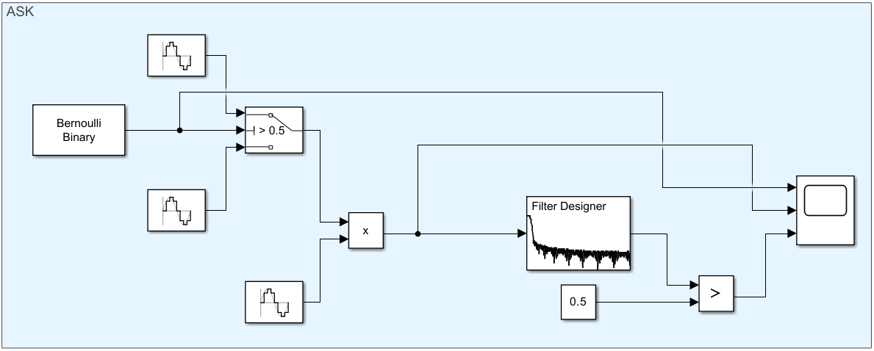

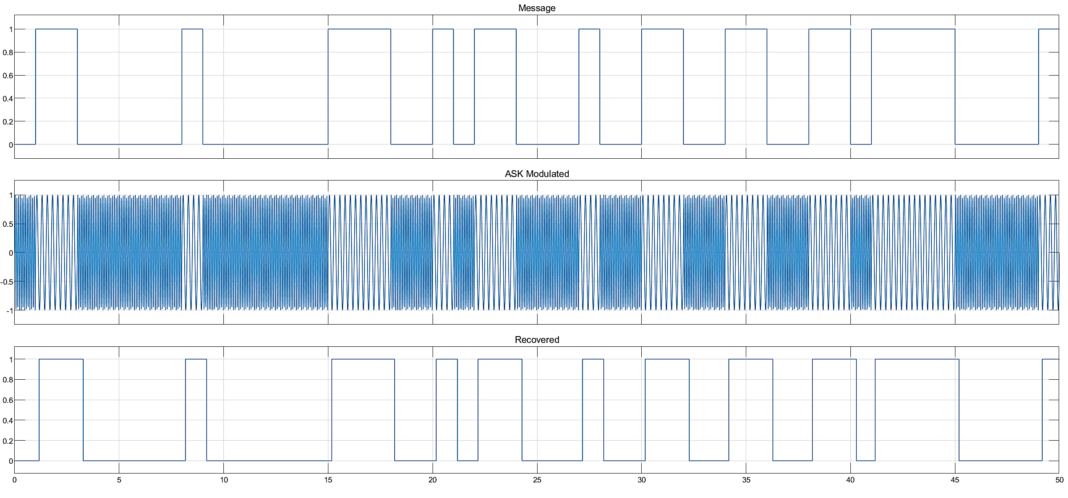

1. Demodulate the above generated ASK signal with sign block using SIMULINK.
2. Generate FSK wave with message as pulse signal using bernouli binary generator and carrier1 as sin signal with frequency =2*pi*4 and Amplitude =1 and carrier2 as sin signal with frequency =2*pi*12 and Amplitude =1 using SIMULINK.

Threshold of switch: 0.5

1. Demodulate the above FSK signal using Simulink
2. Sample time: 0

Numerator: [2*pi*1]

Denominator: [1 2*pi*1]

VCO sensitivity: 4

Frequency: 10

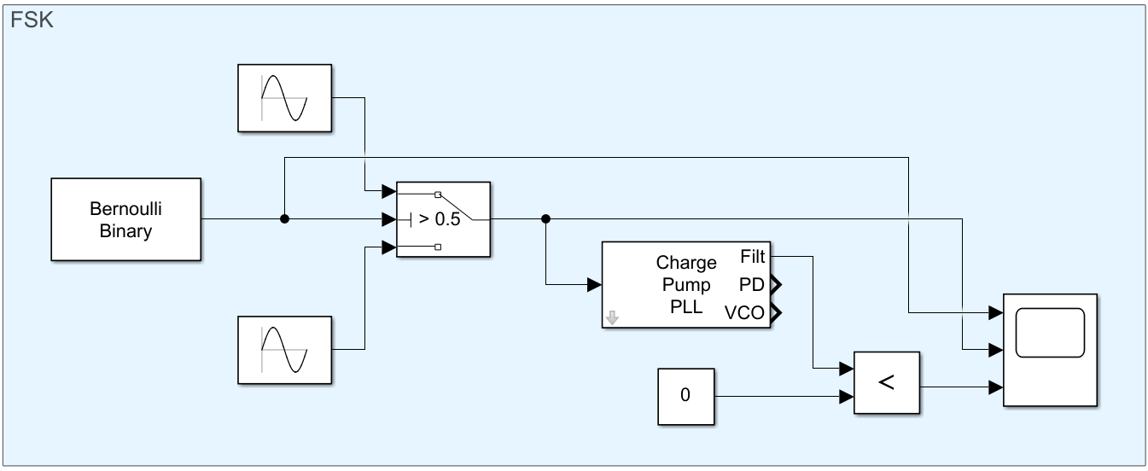

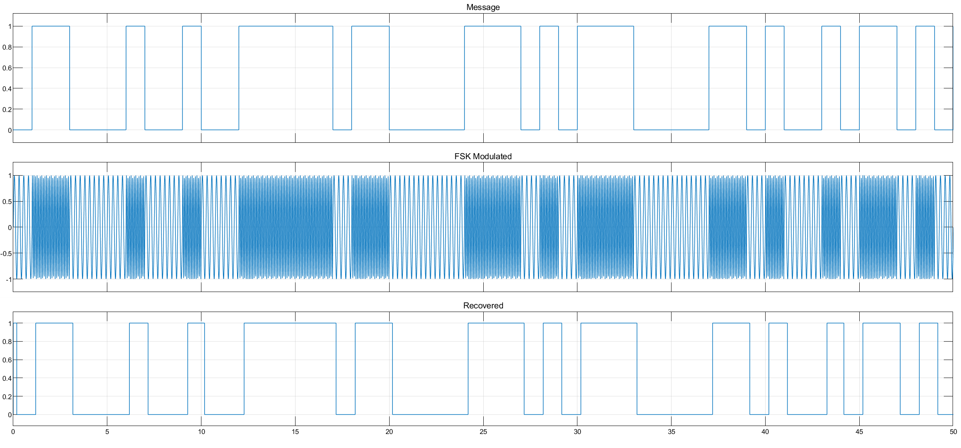

# Conclusion

In conclusion, we have explored two of the most common modulation schemes: amplitude shift keying (ASK) and frequency shift keying (FSK). We have used the Simulink software to simulate ASK and FSK modulation, and we have compared the performance of the two modulation schemes under different conditions. We found that ASK is a simpler modulation scheme than FSK, but it is also less efficient. ASK requires a wider bandwidth than FSK, and it is more susceptible to noise. FSK is a more complex modulation scheme than ASK, but it is also more efficient. FSK requires a narrower bandwidth than ASK, and it is less susceptible to noise. The choice of which modulation scheme to use depends on the specific application. If simplicity is the most important factor, then ASK may be the best choice. If efficiency is the most important factor, then FSK may be the best choice.