**Department of Electrical Engineering and   
Computer Science**

**Faculty Member:** Dr. Huma Ghafoor  **Dated:** 16/02/2023

**Semester:** 6th **Section:** BEE 12C

**EE-351 Communication Systems**

Lab 3: AM Transmission, Amplitude Modulation

Group Members

|  |  |  |  |  |  |  |
| --- | --- | --- | --- | --- | --- | --- |
| **Name** | **Reg. No** | **Viva / Quiz / Lab Performance** | **Teamwork** | **Ethics** | **Software Tool Usage** | **Analysis of data in Lab Report** |
|  |  | **5 Marks** | **5 Marks** | **5 Marks** | **5 Marks** | **5 Marks** |
| Muhammad Ali Farooq | 331878 |  |  |  |  |  |
| Danial Ahmad | 331388 |  |  |  |  |  |
| Muhammad Umer | 345834 |  |  |  |  |  |
| Tariq Umar | 334943 |  |  |  |  |  |

**Table of Contents**

3 AM Transmission, Amplitude Modulation 3

3.1 Objectives 3

3.2 Introduction 3

3.3 Lab Report Instructions 3

4 Lab Procedure 4

4.1 Modulation Index and Modulation Percentage: 7

4.2 100% Modulation - Overmodulation and Transmission Frequency 9

5 Conclusion 10

**Table of Figures**

Figure 1: Frequency Spectra 5

Figure 2: Envelope of a Square Wave 5

Figure 3: Varying AF Changes Modulation % 6

Figure 4: Less than 100% Modulation 8

Figure 5: XY Plot: A = 2V; B = 1V 9

Figure 6: Overmodulated Output 10

# AM Transmission, Amplitude Modulation

## Objectives

* Our learning objective for this lab is to get ourselves familiarized with the process of transmission in the communication system and to go through different circuit parts involved in process. First, we will modulate the signal and go through the calculation of their modulation indexes, waveforms. Then we will learn the RF power amplifier applications and its role in transmission.
* The AM/SSB transmitter part of the circuit board will be thoroughly covered.

## Introduction

The lab experiment primarily focuses on amplitude modulation (AM), which is a method of modulating a signal by varying its amplitude in response to a modulating signal. The lab report will cover the modulation of signals, calculation of modulation indexes and waveforms, as well as the applications of RF power amplifiers. Furthermore, we will also delve into the AM/SSB transmitter part of the circuit board, which plays a significant role in the process of transmission. We will examine the functionalities of different components of the circuit and understand how they work together to transmit the signal.

## Lab Report Instructions

All questions should be answered precisely to get maximum credit. Lab report must ensure following items:

* Lab objective
* Results (screen shots) duly commented and discussed.
* Conclusion

# Lab Procedure

1. Locate the AM/SSB transmitter and VCO-LO circuit block and connect the circuit as shown in Figure 2-6. Be sure to place a two-post connector at the place of 1000kHz on the VCO-LO circuit block. Set switched S1, S2 and S3 to off.

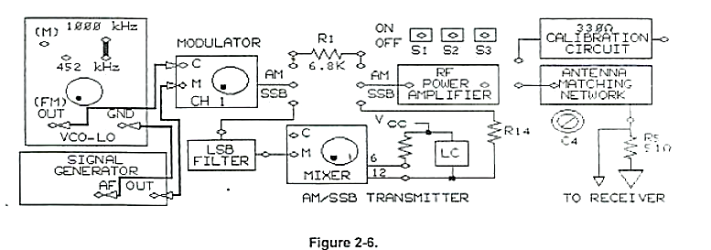

1. Connect the oscilloscope channel 1 to message signal input(M) of the modulator. While observing the signal on channel 1, adjust signal generator to 0.2Vpk-pk, 2kHz sine wave signal at M.
2. Connect the channel 2 probe to carrier signal input(C) of the modulator, while observing the signal on channel 2, adjust VCO-LO for 0.2Vpk-pk, 1000 kHz signal at C. Adjust the carrier frequency with negative supply knob on the base unit and adjust the carrier amplitude with knob on the VCO-LO circuit block.
3. Connect the channel 2 probe to the output of the modulator, trigger on channel 1.
4. Adjust the potentiometer knob so that the AM waveform of oscilloscope channel 2 has 2V between the upper and lower peaks.

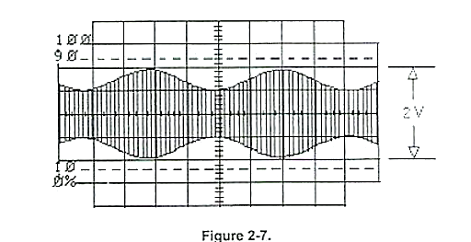

1. Does the AM signal envelope have the same shape and frequency as the message signal?

**Answer:** In AM (amplitude modulation) radio broadcasting, the shape and frequency of the envelope of the AM signal are directly related to the shape and frequency of the message signal. Therefore, while the carrier frequency is typically much higher than the frequency content of the message signal, the envelope of the AM signal will have the same shape and frequency as the message signal, scaled by the amplitude of the carrier frequency.

1. You have set the carrier signal frequency to 1000kHz and the message signal frequency to 2kHz. What frequencies are present in the frequency spectrum of AM signal?

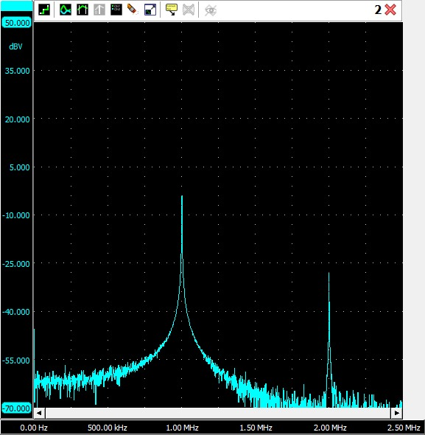

Figure : Frequency Spectra

**Answer:** From the frequency spectra of the AM signal, the major contributing frequencies are that of 1 MHz and 2 MHz.

1. Change the signal generating function from a sin wave to square wave. Did the envelope of the wave change from a sin wave to square wave?

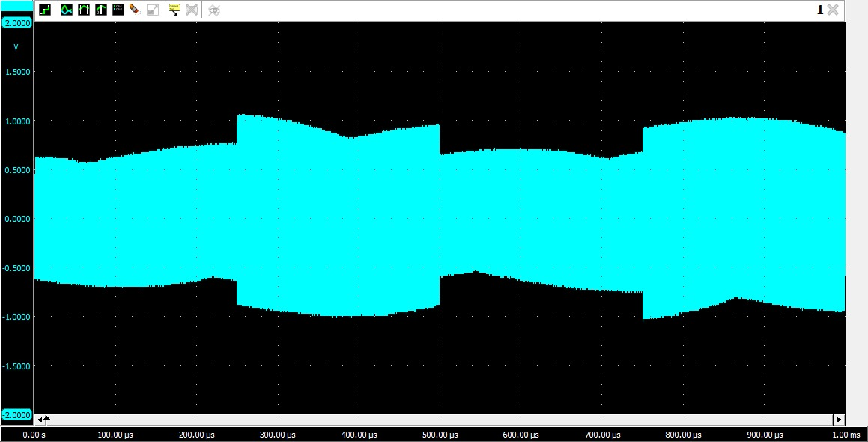

Figure : Envelope of a Square Wave

**Answer:** Yes, the envelope changed from a sine wave to a square wave.

1. Return the signal generator function to sin wave, while observing the AM output signal on channel 2, vary the signal generator AF frequency knob to vert the message signal frequency. Did frequency of the AM signal envelope change to correspond to the frequency of message signal?

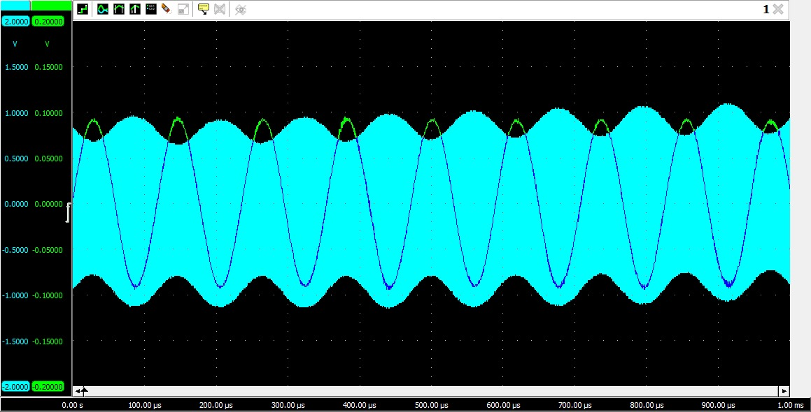

**Answer:** Yes, in amplitude modulation (AM), the frequency of the AM signal envelope changes to correspond to the frequency of the message signal. When the message signal is applied to the carrier wave, it modulates the amplitude of the carrier wave in accordance with the frequency and amplitude of the message signal.

1. Readjust the frequency of message signal to 2kHz, while observing the AM output signal, vary the AF level knob of signal generator to vary the amplitude of message signal. Did the AM signal envelope change to correspond to the amplitude of message signal?

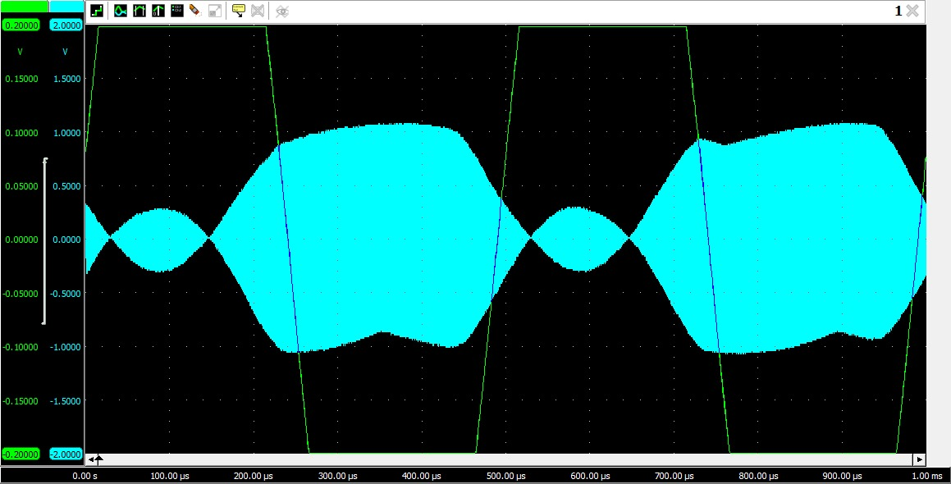

Figure : Varying AF Changes Modulation %

**Answer:** Yes, in amplitude modulation, the envelope changes directly in accordance with the changes made in message signal.

## Modulation Index and Modulation Percentage:

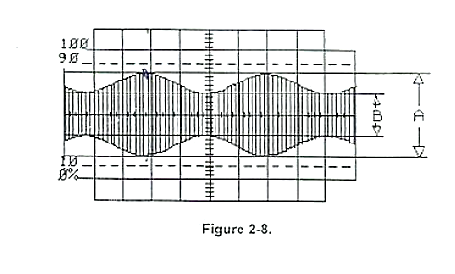

1. Switches S1, S2 and S3 should be off.

1. On oscilloscope channel 1, adjust the peak-to-peak voltage of message signal to 0.2Vpk-pk. If necessary, adjust the modulator’s potentiometer knob so that AM waveform shown on channel 2 has 2V between upper and lower peaks. 2V is measurement A in figure 2-8.
2. On oscilloscope channel 2, measure the vertical height (in volts) between upper and lower valleys (measurement B in figure 2-8 of modulated waveform.

**Answer:** From the oscilloscope cursor, A = 2 V; B = 1 V.

1. Calculate the modulation index m.

**Answer:**

1. Calculate the percentage of modulation.

**Answer:**

1. While observing the AM signal on channel 2, increase the amplitude of the message signal until the AM signal envelope waveform touches the reference line as in figure 2-11 the difference represented by B on the AM signal waveform is now 0.0V.

1. On oscilloscope channel 2, measure the vertical distance (in volts) between upper and lower peaks (measurement A in figure 2-11 of modulated waveform.

**Answer:** From the oscilloscope cursor, A = 2 V; B = 1 V.

1. Calculate the modulation index m.

**Answer:**

1. Calculate the percentage of modulation.

**Answer:**

1. Adjust the amplitude of message signal at channel1 to 0.2Vpk-pk if necessary, adjust the modulator potentiometer knob so that AM on channel 2 is less than 100% modulated and has 2V between upper and lower peaks.

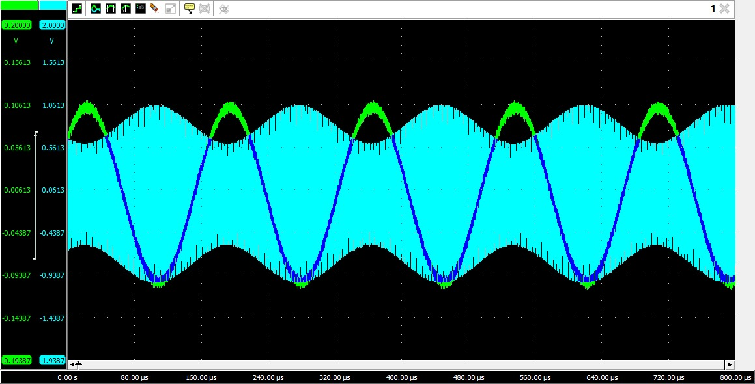

Figure : Less than 100% Modulation

1. Place the oscilloscope in X-Y mode. Adjust the X and Y attenuators to obtain a trapezoidal pattern (figure 2-10). On the oscilloscope measure A in trapezoidal pattern.

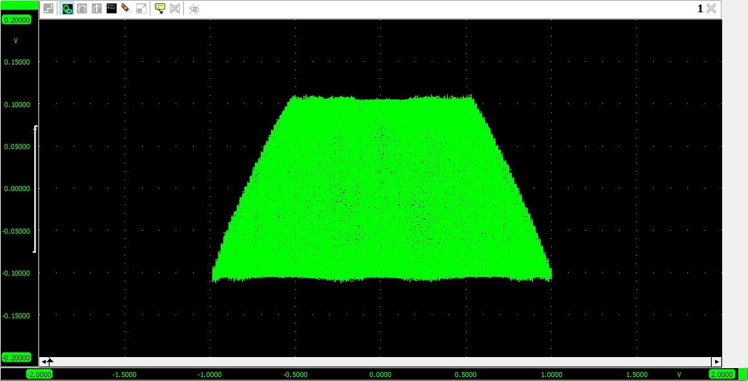

Figure : XY Plot: A = 2V; B = 1V

1. On the oscilloscope pattern, measure B (in volts) in the same pattern.

A and B marked in the Figure 5 caption.

1. Calculate the modulation index m.

**Answer:**

1. Calculate the percentage of modulation.

**Answer:**

1. Are your trapezoidal method measurements of modulation index (m) and percentage modulation like the results you obtained using AM signal.

**Answer:** Yes, as we also obtained a modulation percentage of using the AM signal.

## 100% Modulation - Overmodulation and Transmission Frequency

1. Switches S1, S2. and S3 should be off. Set oscilloscope in the normal mode (out of X and Y). readjust oscilloscope Volt/division and time/division so that signal on channel 2 appears.

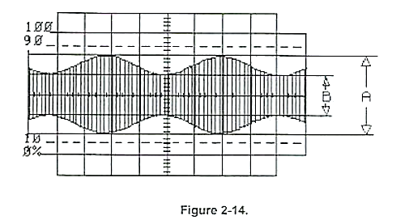

1. Increase the message signal amplitude on channel 1 by adjusting the AF level knob on the signal generator until AM signal as shown appears, it is modulated or over modulated?

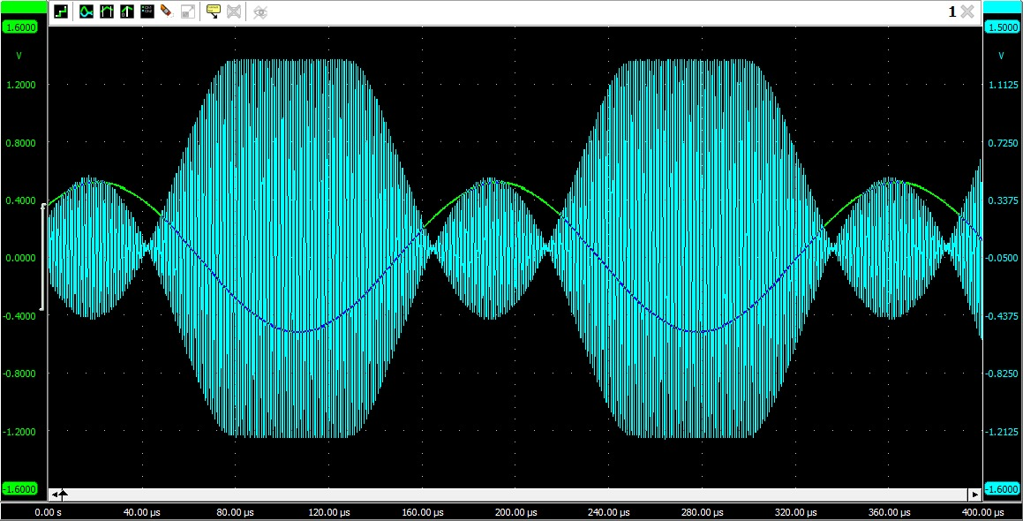

Figure : Overmodulated Output

1. Is the modulation index of AM signal greater or less than 1?

**Answer:** The resulting modulation index obtained is , which is greater than 1.

1. Is the overmodulated signal desirable in AM communications?

**Answer:** Overmodulation in AM communications is generally not desirable because it can lead to distortion and signal interference, which can make the signal difficult to understand. Hence, there should be a certain space allocated to cater for channel impairments.

# Conclusion

In conclusion, this lab report has provided an overview of the process of transmission in communication systems and the different circuit parts involved in the process. The lab experiment focused on amplitude modulation (AM) and its various components. Through the modulation of signals and the calculation of modulation indexes and waveforms, we were able to understand the concepts of AM and how it is used in the transmission process. Additionally, we thoroughly covered the AM/SSB transmitter part of the circuit board, which is essential for transmitting the signal.