**Department of Electrical Engineering**

|  |  |
| --- | --- |
| **Faculty Member: _________________** | **Dated: ____________________** |
|  |  |
| **Course/Section: BEE 12** | **Semester: Spring 2023** |
|  |  |

**EE-351 Communication Systems**

# Lab4: RF Power Amplifier

|  |  |  |  |  |  |  |
| --- | --- | --- | --- | --- | --- | --- |
| **Name** | **Reg. No** | **Viva / Quiz / Lab Performance** | **Teamwork** | **Ethics** | **Software tool Usage** | **Analysis of data in Lab Report** |
|  |  | **5 Marks** | **5 Marks** | **5 Marks** | **5 Marks** | **5 Marks** |
|  |  |  |  |  |  |  |
|  |  |  |  |  |  |  |
|  |  |  |  |  |  |  |

**Lab4: RF Power Amplifier**

**Objectives**

We will learn RF power amplifier applications and its role in transmission.

The AM Transmitter part will be completed with understanding the role of RF power amplifier applications.

**Lab Instructions**

* The students should perform and demonstrate each lab task separately for stepwise evaluation
* Each group shall submit lab report on LMS within 6 days after lab is conducted. Lab report submitted via email will not be graded.
* Students are however encouraged to practice on their own in spare time for enhancing their skills.
* Complete as many problems as you can within the allotted time.
* Talk to your classmates for help

**Lab Report Instructions**

All questions should be answered precisely to get maximum credit. Lab report must ensure following items:

* Lab objective
* Results (screen shots) duly commented and discussed.
* Conclusion

**Introduction:**

Since the message signal is transmitted over long distances, its power should be increased so that it is able to reach the destination. For this purpose we have RF power amplifier in the communication circuit board. It consists of power amplifier and an antenna matching network.

Power amplifier is a common emitter amplifier. The purpose of Antenna matching circuit is to ensure maximum power transfer to low impedance antenna. It works on the principle of maximum power transfer theorem which states “the transfer of power is maximum when the source and load impedances are equal”. Antenna network does match the impedances to maximize power transmission.

The gain of power amplifier was very high in the range of 1000s.

**Lab 3: Lab Tasks**

**Procedure A: Adjust Output Impedance**

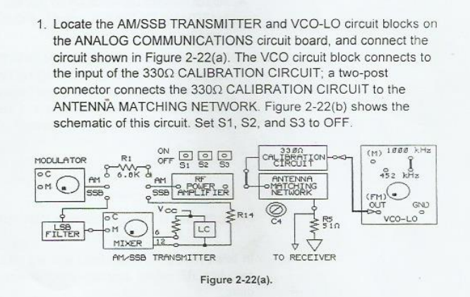

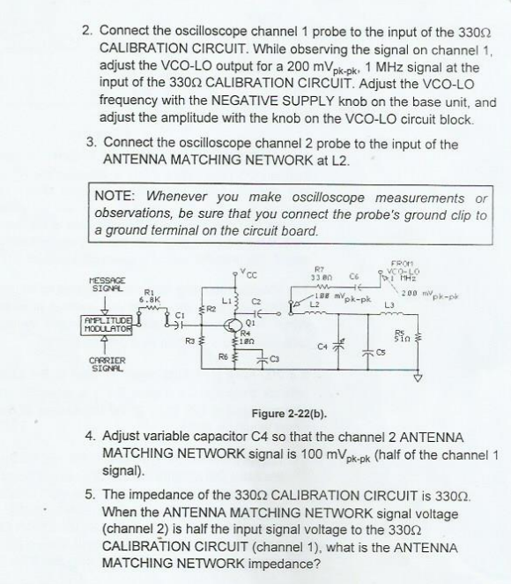

**Procedure B:Input power, Output power and power gain**

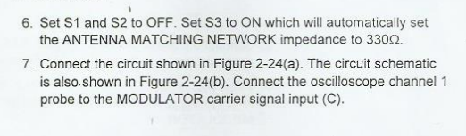

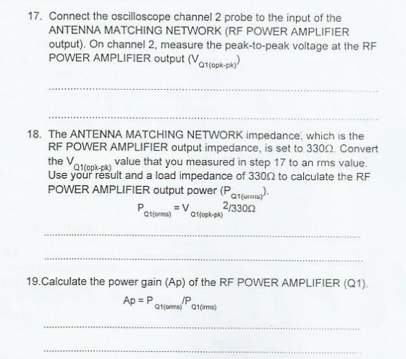

**Procedure C:Antenna Power**

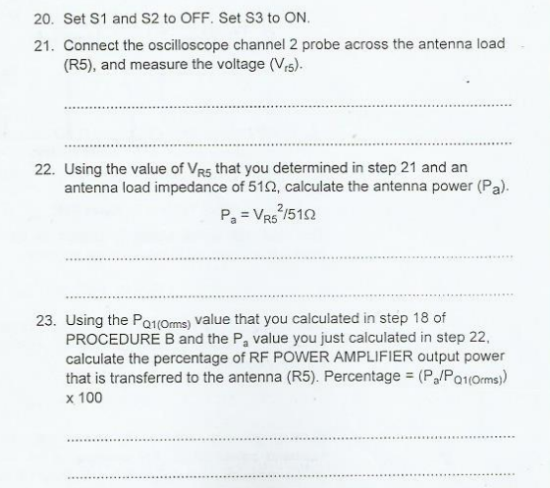

**Procedure D:Total, Carrier and Sideband Power:**



