**Faculty Member: Date:** .

**Semester: Section:** .

**EE-351 Communication Systems**

**Assessment Rubrics for Lab 05: AM Reception and RF Stage**

|  |  |  |  |
| --- | --- | --- | --- |
| **S. No.** | **Student Name** | **Reg. No.** | **Total Marks** |
| **S1** |  |  |  |
| **S2** |  |  |  |
| **S3** |  |  |  |
| **S4** |  |  |  |

**Method:** Lab report and instructor observation during lab session.

**Outcome Assessed:**

1. Ability to conduct experiments, as well as to analyze and interpret data (P).
2. Ability to function in a team (A).
3. Ability to use the techniques, skills and modern engineering tools necessary for engineering practice (P).

|  |  |  |  |  |  |  |
| --- | --- | --- | --- | --- | --- | --- |
| **Performance** | **Meets expectation**  **(3-2)** | **Does not meet expectation (1)** | **Marks** | | | |
| S1 | S2 | S3 | S4 |
| **1.**  MODERN TOOL USAGE | Needs guidance to select relevant equipment to the experiment and to develop equipment connection or wiring diagrams. | lncapable of selecting relevant equipment to conduct the experiment, equipment connection or wiring diagrams are unrecognisable. |  |  |  |  |
| **2.**  INDIVIDUAL AND TEAM WORK | Cooperates with other group members in a reasonable manner . | Distracts or discourages other group members from conducting the experiment. |  |  |  |  |
| **3.**  CONDUCT OF EXPERIMENT | Calibrates equipment , examines equipment and wiring of components and operates the equipment with minor error. | Unable to calibrate appropriate equipmentand wiring, and equipment operation is substantially wrong. |  |  |  |  |
| **4**  ETHICS AND ADHERE TO LABORATORY SAFETY RULES | Observes safety rules and procedures With minor deviation. | Disregards safety rules and procedures. |  |  |  |  |
| **5.**  DATA COLLECTION, ANALYSIS AND INTERPRETATION | Plans data collectionto achieve experimental objectives, and collects complete data with minor error. | Does not know how to Plan data collection to achieve experimental goals; data collected is incomplete and contain errors. |  |  |  |  |

**Lab 5: AM Reception and RF Stage**

**Objectives**

When you have completed this exercise, you will be able to calculate the AM signal power at an RF filter input, describe how an RF filter is tuned to filter an AM signal, and calculate the power gain of an RF amplifier. You will use an oscilloscope to make AM signal measurements.

**Lab Instructions**

* The students should perform and demonstrate each lab task separately for stepwise evaluation
* Each group shall submit lab report on LMS within 6 days after lab is conducted. Lab report submitted via email will not be graded.
* Students are however encouraged to practice on their own in spare time for enhancing their skills.
* Complete as many problems as you can within the allotted time.
* Talk to your classmates for help

**Lab Report Instructions**

All questions should be answered precisely to get maximum credit. Lab report must ensure following items:

* Lab objective
* Results (screen shots) duly commented and discussed.
* Conclusion

**Introduction:**

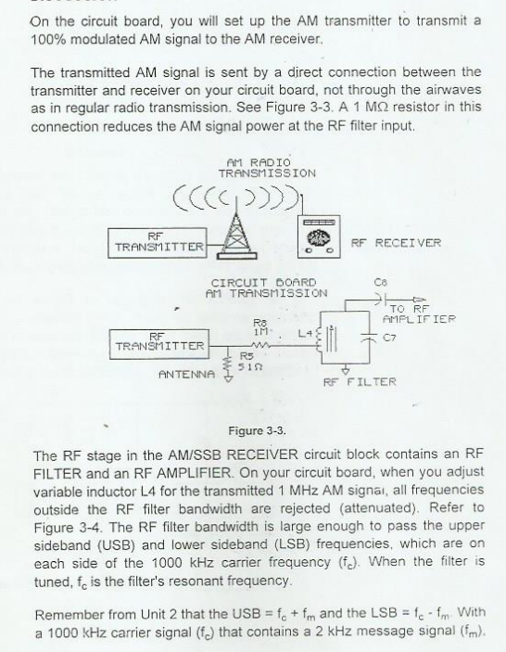

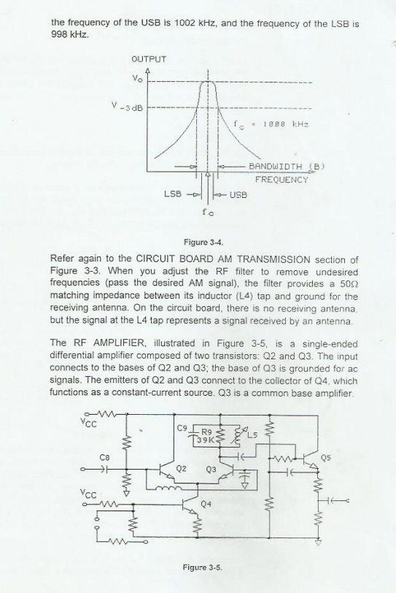

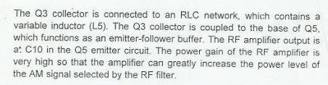

**Tasks:**

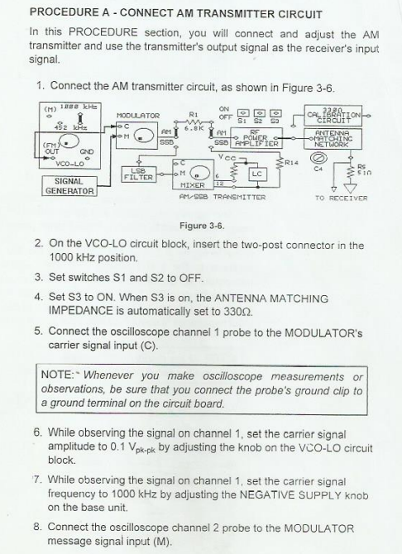

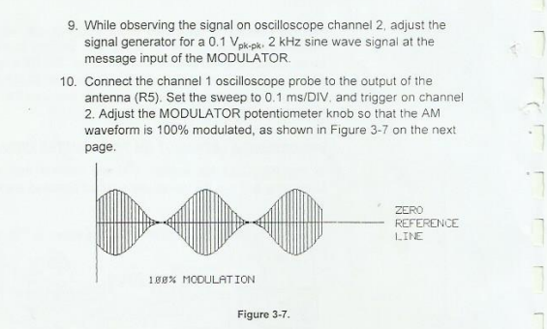

**Procedure B: RF Filter : Input Power**

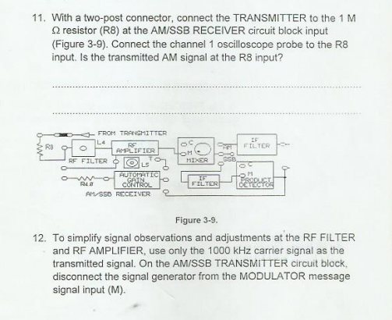

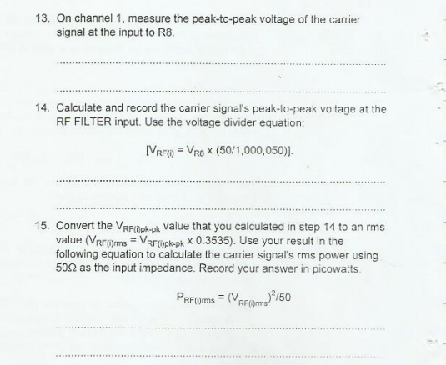

**Procedure C: RF Filter (Adjust for AM signal)**

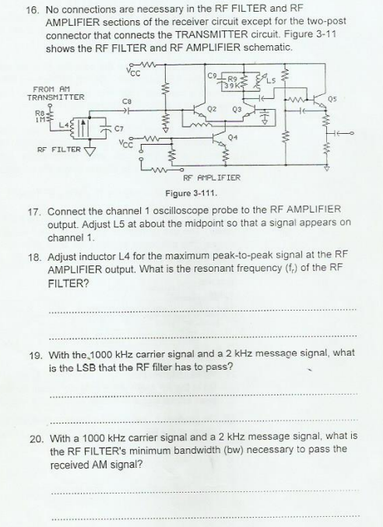

**Procedure D: RF Power Amplifier (Maximize Power Gain)**

