**Department of Electrical Engineering and   
Computer Science**

**Faculty Member:** Dr. Huma Ghafoor  **Dated:** 2/03/2023

**Semester:** 6th **Section:** BEE 12C

**EE-351 Communication Systems**

Lab 5: AM Reception and RF Stage

Group Members

|  |  |  |  |  |  |  |
| --- | --- | --- | --- | --- | --- | --- |
| **Name** | **Reg. No** | **Viva / Quiz / Lab Performance** | **Teamwork** | **Ethics** | **Software Tool Usage** | **Analysis of data in Lab Report** |
|  |  | **5 Marks** | **5 Marks** | **5 Marks** | **5 Marks** | **5 Marks** |
| Muhammad Ali Farooq | 331878 |  |  |  |  |  |
| Danial Ahmad | 331388 |  |  |  |  |  |
| Muhammad Umer | 345834 |  |  |  |  |  |
| Tariq Umar | 334943 |  |  |  |  |  |

**Table of Contents**

3 RF Power Amplifier 3

3.1 Objectives 3

3.2 Introduction 3

3.3 Lab Report Instructions 3

4 Lab Procedure 4

4.1 Introduction 4

4.2 Procedure A: Connect an AM Transmitter Circuit 6

4.3 Procedure B: RF Filter: Input Power 7

4.4 Procedure C: RF Filter (Adjust for AM Signal) 7

4.5 Procedure D: RF Power Amplifier (Maximize Gain) 8

4.6 Deliverables 9

5 Conclusion 12

**Table of Figures**

Figure 1: Message (M) and Carrier Signal (C) at MODULATOR Input 9

Figure 2: 100% Modulation AM Signal 10

Figure 3: Frequency Spectrum to get Resonant Frequency 11

Figure 4: Cursors of the Frequency Spectrum 11

# RF Power Amplifier

## Objectives

* When you have completed this exercise, you will be able to calculate the AM signal power at an RF filter input, describe how an RF filter is tuned to filter an AM signal, and calculate the power gain of an RF amplifier. You will use an oscilloscope to make AM signal measurements.

## Introduction

Radio frequency (RF) amplifiers and amplitude modulation (AM) are critical components in modern communication systems. RF amplifiers are used to amplify low power RF signals, while AM is a widely used technique in broadcasting to carry information through radio waves.

The purpose of this lab report is to explore the properties and characteristics of RF amplifiers, including measurements of amplifier gain, and frequency response characteristics. Overall, the lab report aims to provide a comprehensive understanding of the fundamental concepts and practical applications of RF amplifiers and AM.

## Lab Report Instructions

All questions should be answered precisely to get maximum credit. Lab report must ensure following items:

* Lab objective
* Results (screen shots) duly commented and discussed.
* Conclusion

# Lab Procedure

## Introduction

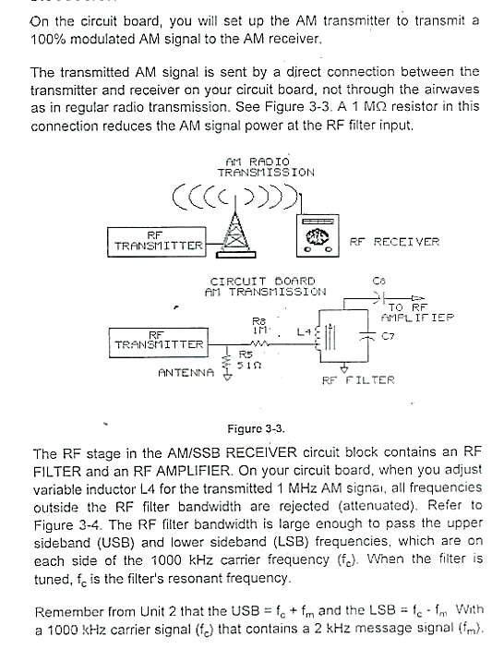

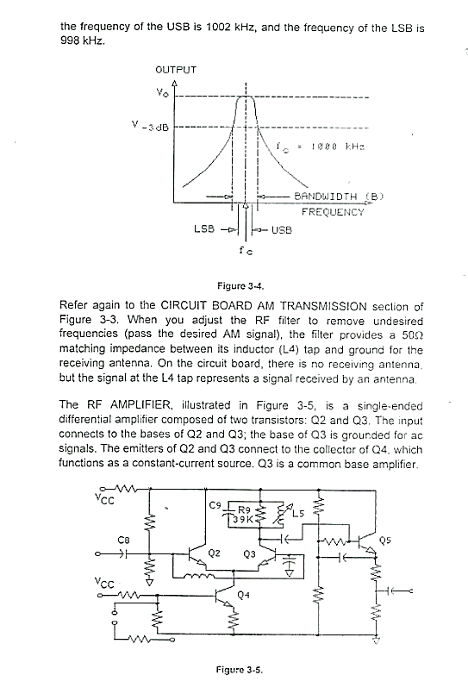



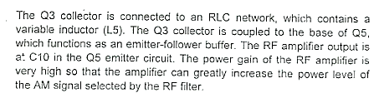

## Procedure A: Connect an AM Transmitter Circuit

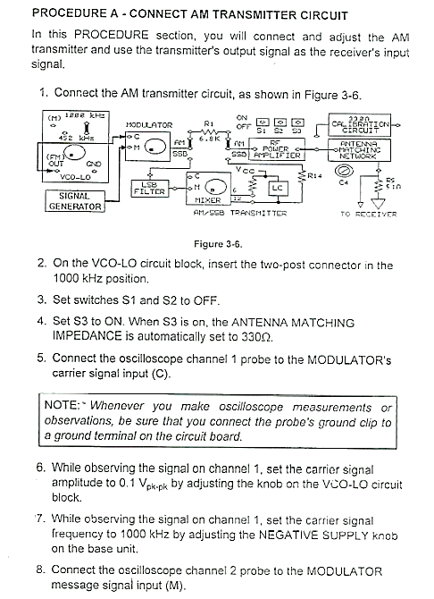

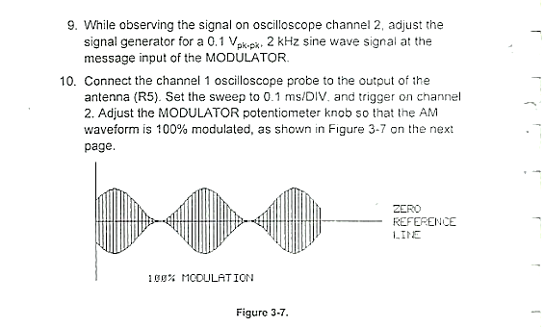

## Procedure B: RF Filter: Input Power

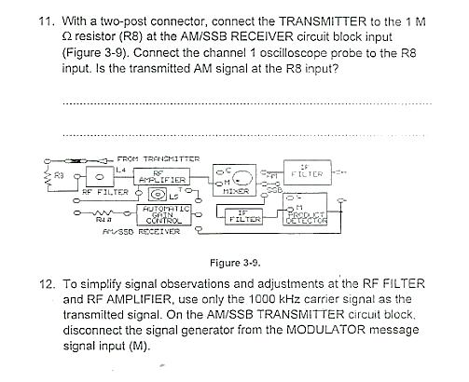

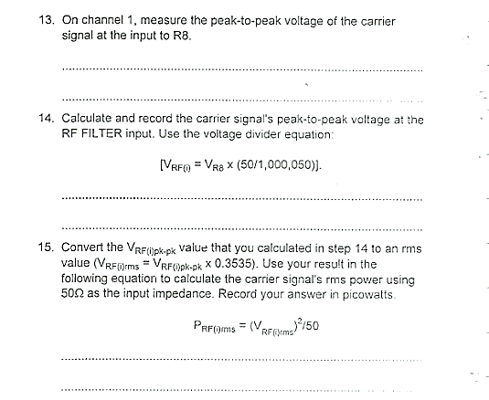

## Procedure C: RF Filter (Adjust for AM Signal)

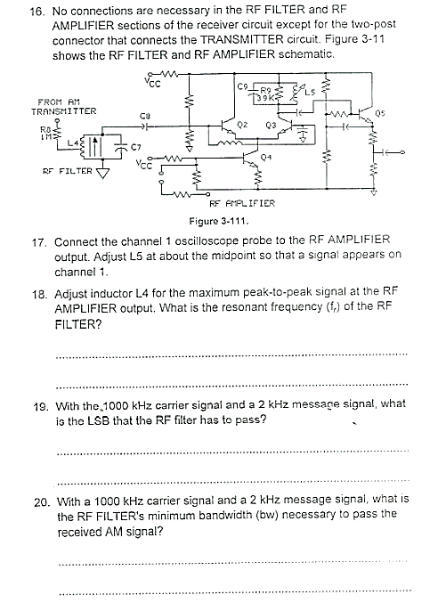



## Procedure D: RF Power Amplifier (Maximize Gain)

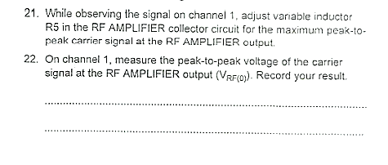

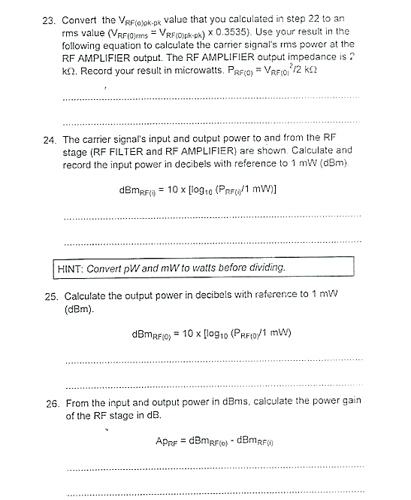



## Deliverables

* **Step 9**

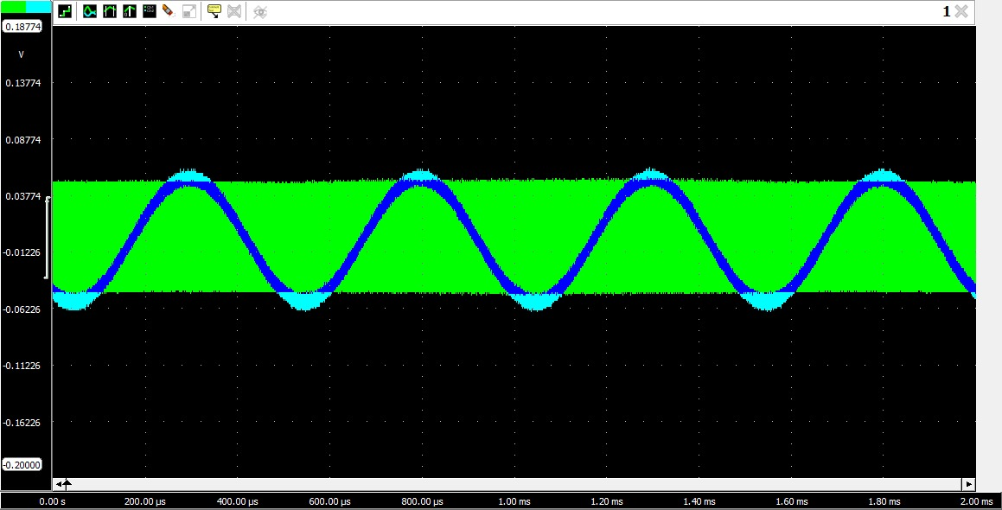

Figure : Message (M) and Carrier Signal (C) at MODULATOR Input

* **Step 10**

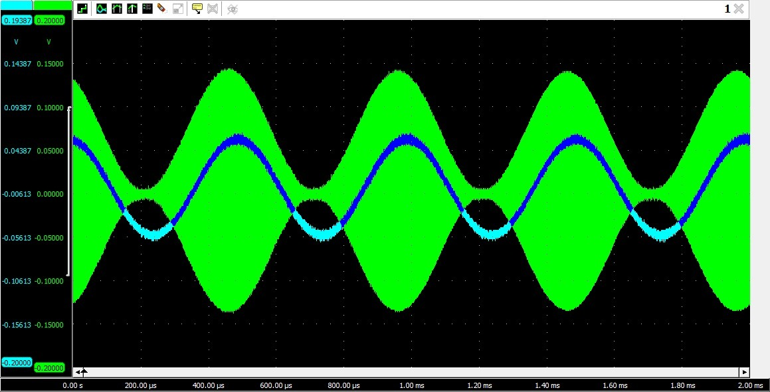

Figure : 100% Modulation AM Signal

* **Step 11**

Yes, the transmitted AM signal is at R8 input.

* **Step 13**

Peak to Peak voltage is 223mV.

* **Step 14**

Using the Voltage divider equation, we get 16mV.

* **Step 15**

**P­RF(i)** = V2RF(i) RMS / 50 = **0.311 pW**

* **Step 18**

The Resonant Frequency of the RF Filter came out to be 1MHz

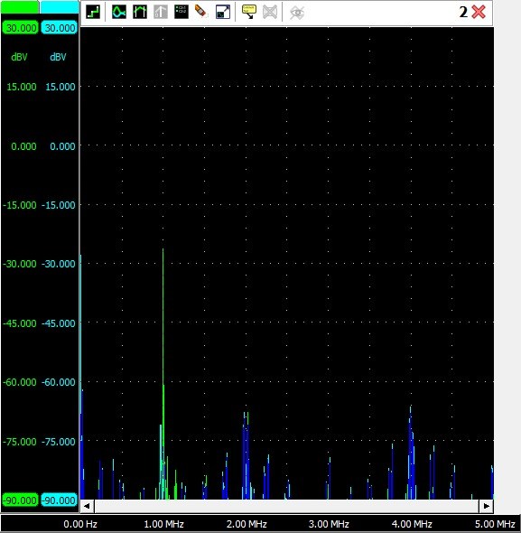

Figure : Frequency Spectrum to get Resonant Frequency

* **Step 19**

In this case, the RF stage will pass the lower sideband, which has a frequency of 998 kHz

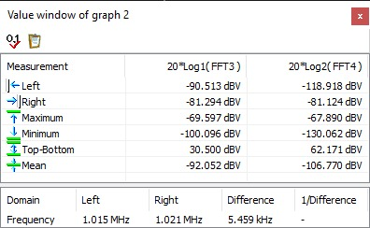

Figure : Cursors of the Frequency Spectrum

* **Step 20**

With a 1000Hz carrier signal and a 2kHz message signal, the minimum band width will be 1002-998Hz. Which comes out to be **4kHz.**

* **Step 22**

**VRF(o) = 230mV**

* **Step 23**

**P­RF(o)** = V2RF(o) RMS / 2000 = **3.3 W**

* **Step 24**

**dBmRF(i)** = 10 x log (PRF(i) / 1mW) = **-95.07 dBm**

* **Step 25**

**dBmRF(O)** = 10 x log (PRF(O) / 1mW) = **-24.8 dBm**

* **Step 26**

**ApRF** = dBm RF(O) – dBm RF(i) = 24.8 – (-95.07) = **70.27 dBm**

# Conclusion

In this lab we learned how to calculate the AM signal power gain using the RF amplifier. We further strengthened our concepts on Amplitude modulation, RF filtering, and amplification. Furthermore, by using the signal generator and oscilloscope we measured and analyzed the effects of signal modulation and amplification.

Through the experimental procedures and data analysis, it was observed that the characteristics of the filters and amplitude modulation were consistent with theoretical expectations. The results demonstrated the effectiveness of the filter circuits in attenuating unwanted signals and the capability of amplitude modulation in carrying information with minimal distortion.