**Department of Electrical Engineering and   
Computer Science**

**Faculty Member:** Dr. Huma Ghafoor  **Dated:** 9/03/2023

**Semester:** 6th **Section:** BEE 12C

**EE-351 Communication Systems**

Lab 6: Mixer, IF Filter and Envelope Detector

Group Members

|  |  |  |  |  |  |  |
| --- | --- | --- | --- | --- | --- | --- |
| **Name** | **Reg. No** | **Viva / Quiz / Lab Performance** | **Teamwork** | **Ethics** | **Software Tool Usage** | **Analysis of data in Lab Report** |
|  |  | **5 Marks** | **5 Marks** | **5 Marks** | **5 Marks** | **5 Marks** |
| Muhammad Ali Farooq | 331878 |  |  |  |  |  |
| Danial Ahmad | 331388 |  |  |  |  |  |
| Muhammad Umer | 345834 |  |  |  |  |  |
| Tariq Umar | 334943 |  |  |  |  |  |

**Table of Contents**

3 RF Power Amplifier 3

3.1 Objectives 3

3.2 Introduction 3

3.3 Lab Report Instructions 3

4 Lab Procedure 4

4.1 Introduction 4

4.2 Procedure A: Connect the AM Transmitter and Set the RF Stage 6

4.3 Procedure B: Mixer 9

4.4 Procedure C: IF Filter 11

4.5 Procedure D: Envelope Detector 12

4.6 Deliverables 12

5 Conclusion 17

**Table of Figures**

Figure 1: Message (M) and Carrier Signal (C) at MODULATOR Input 13

Figure 2: 100% Modulation AM Signal 13

Figure 3: VCO-HI and AM signal 14

Figure 4: Period Calculation 14

Figure 5: Period Calculation 15

Figure 6: Presence of Modulation Envelope 16

Figure 7: IF Filter Output 16

Figure 8: Envelope Detectior Output 17

Figure 9: Frequency Variation 17

# RF Power Amplifier

## Objectives

* When you have completed this exercise, you will be able to explain the operation of the mixer, describe the function of IF filter and describe how the envelope detector converts a 455kHz signal to the message signal. You will use an oscilloscope to make AM signal measurements.

## Introduction

The purpose of this lab report is to explore the properties and characteristics of RF Mixer, IF filter and envelope detector. Overall, the lab report aims to provide a comprehensive understanding of the fundamental concepts and practical applications of RF amplifiers and AM.

## Lab Report Instructions

All questions should be answered precisely to get maximum credit. Lab report must ensure following items:

* Lab objective
* Results (screen shots) duly commented and discussed.
* Conclusion

# Lab Procedure

## Introduction

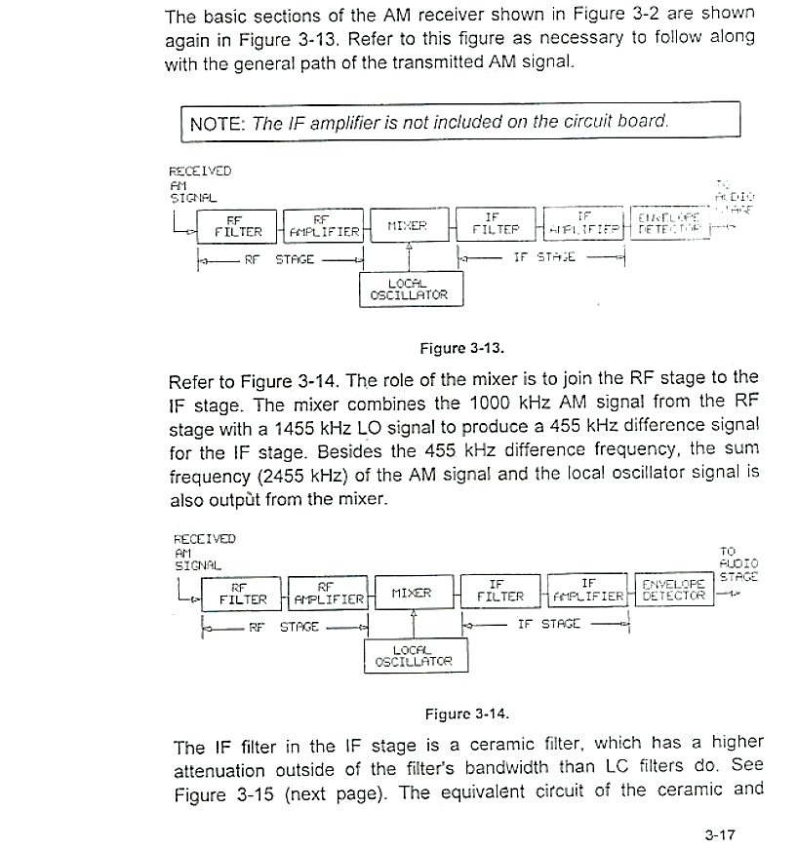

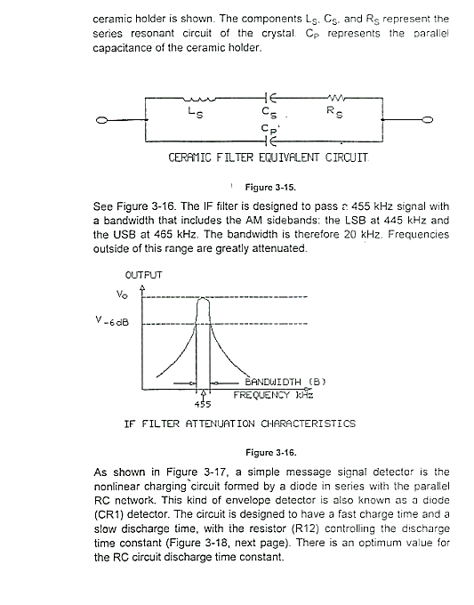



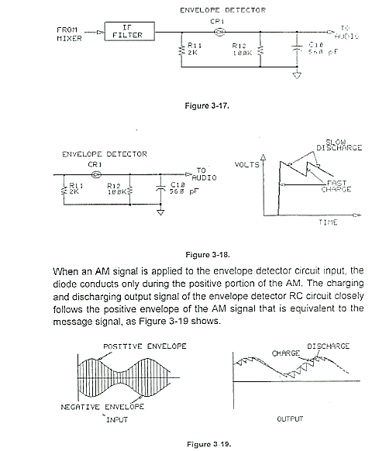

## Procedure A: Connect the AM Transmitter and Set the RF Stage

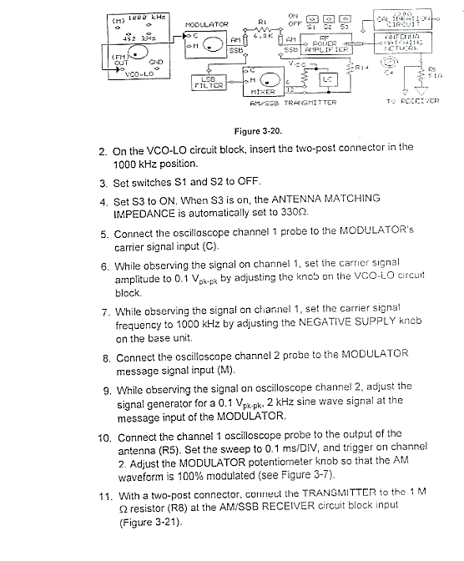

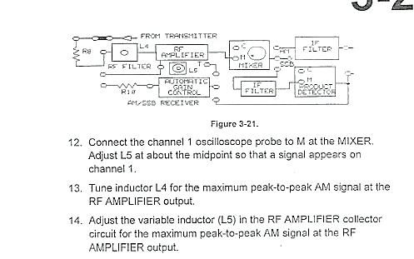

## Procedure B: Mixer

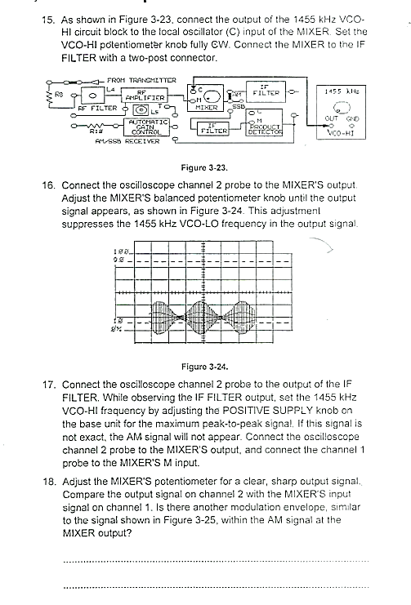

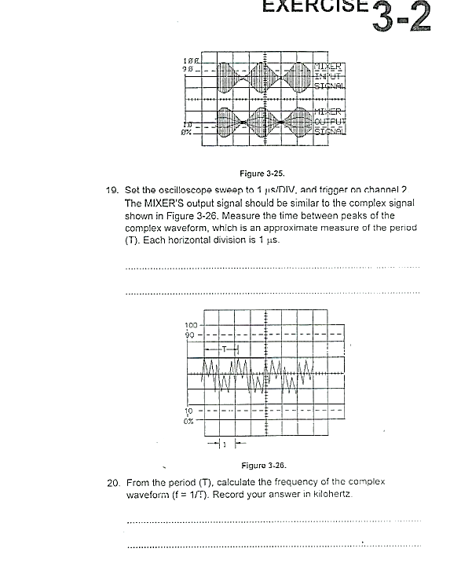

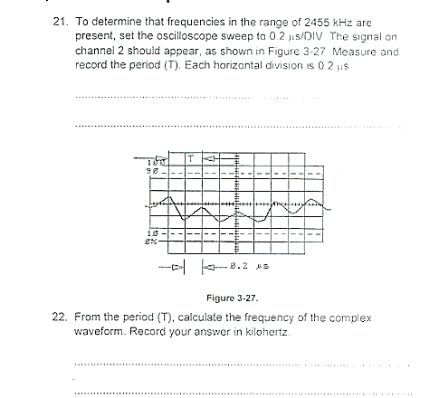

## Procedure C: IF Filter

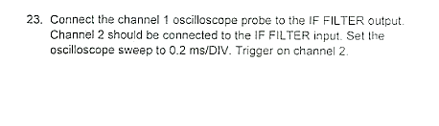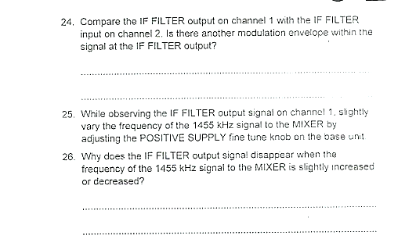

## Procedure D: Envelope Detector

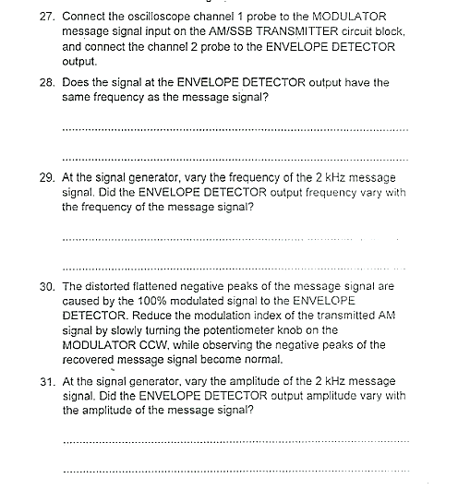

## Deliverables

* **Step 9**

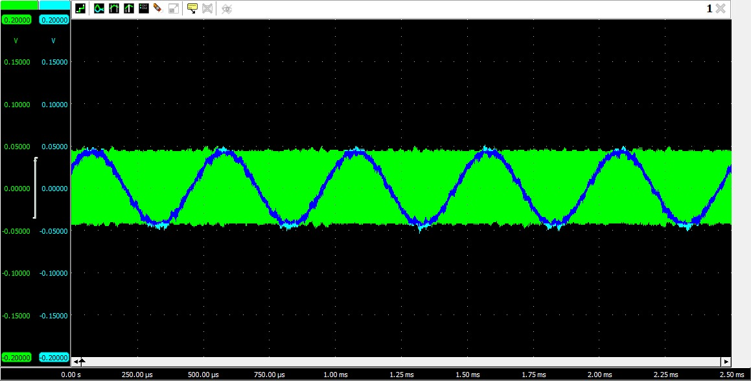

Figure : Message (M) and Carrier Signal (C) at MODULATOR Input

* **Step 11**

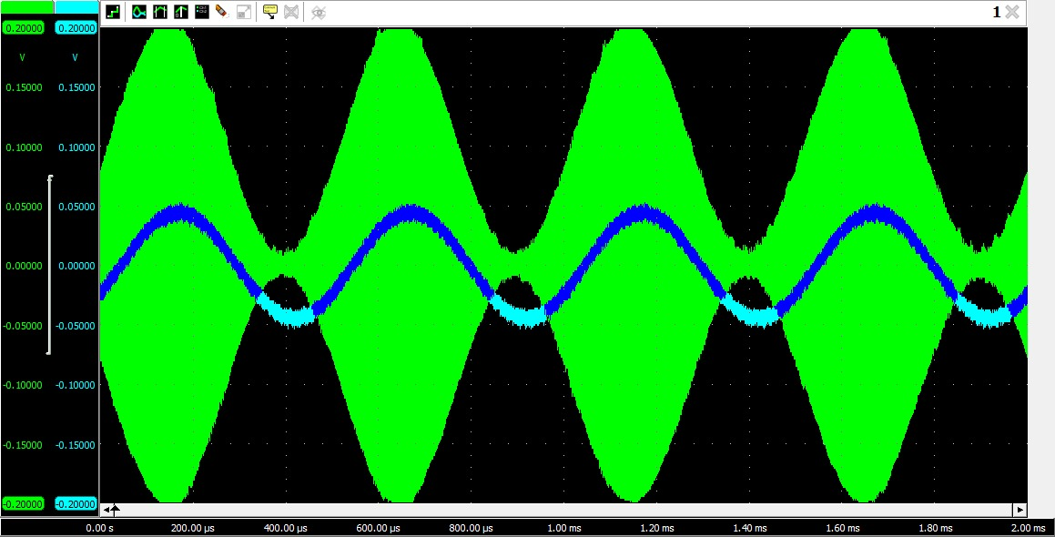

Figure : 100% Modulation AM Signal

* **Step 17**

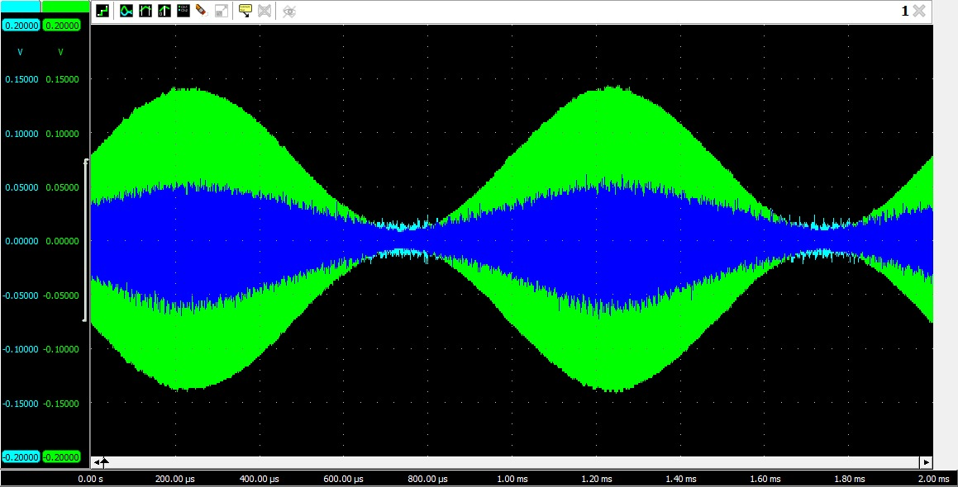

Figure : VCO-HI and AM signal

* **Step 18**

Yes, the presence of another modulation envelope is observed.

* **Step 19**

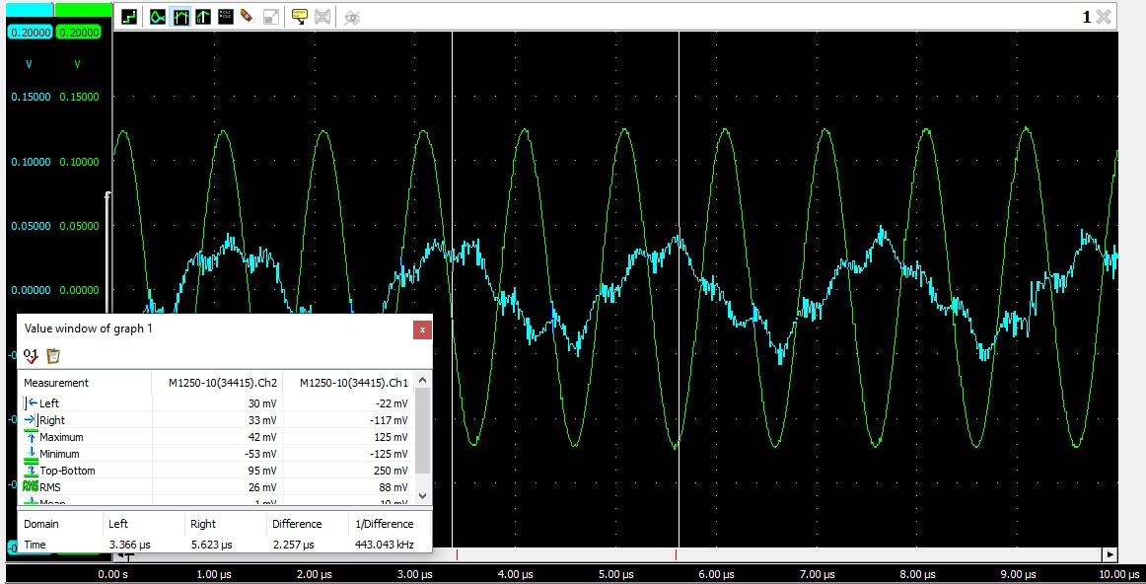

Figure : Period Calculation

T = 2.25

* **Step 20**

= 444.44

* **Step 21**

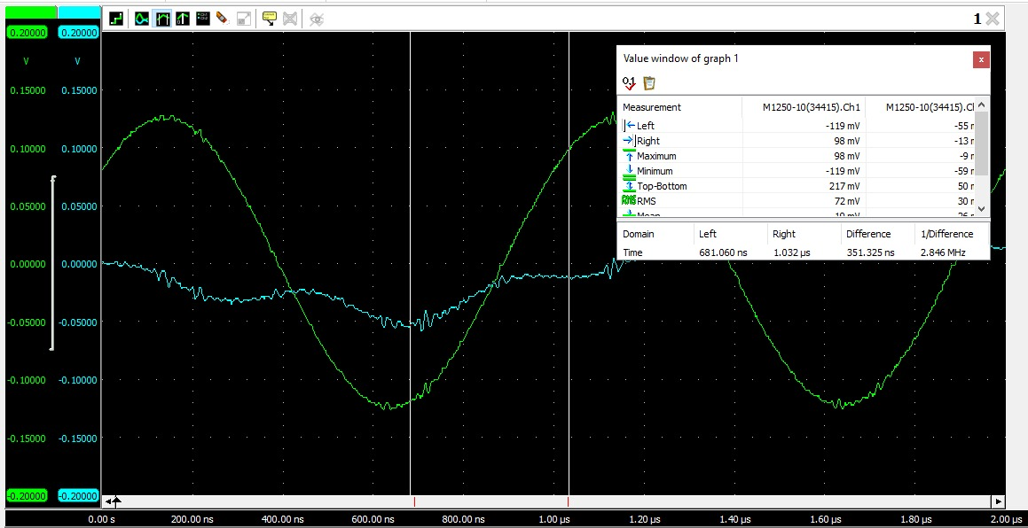

Figure : Period Calculation

T = 351

* **Step 22**

= 1/351

* **Step 24**

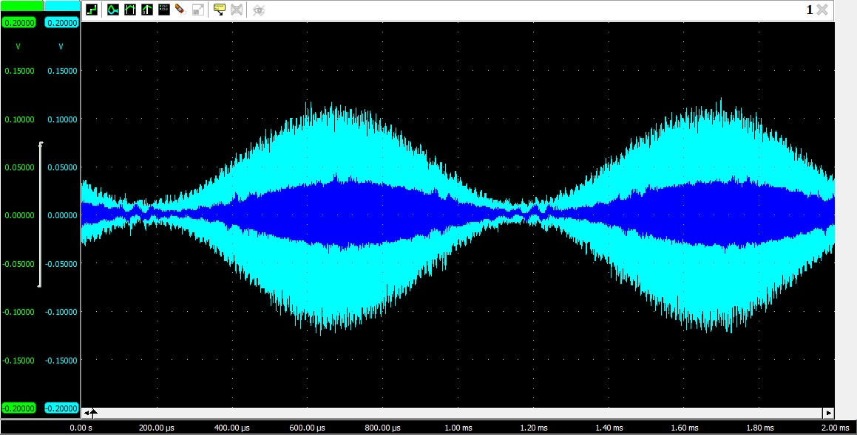

Figure : Presence of Modulation Envelope

* **Step 25**

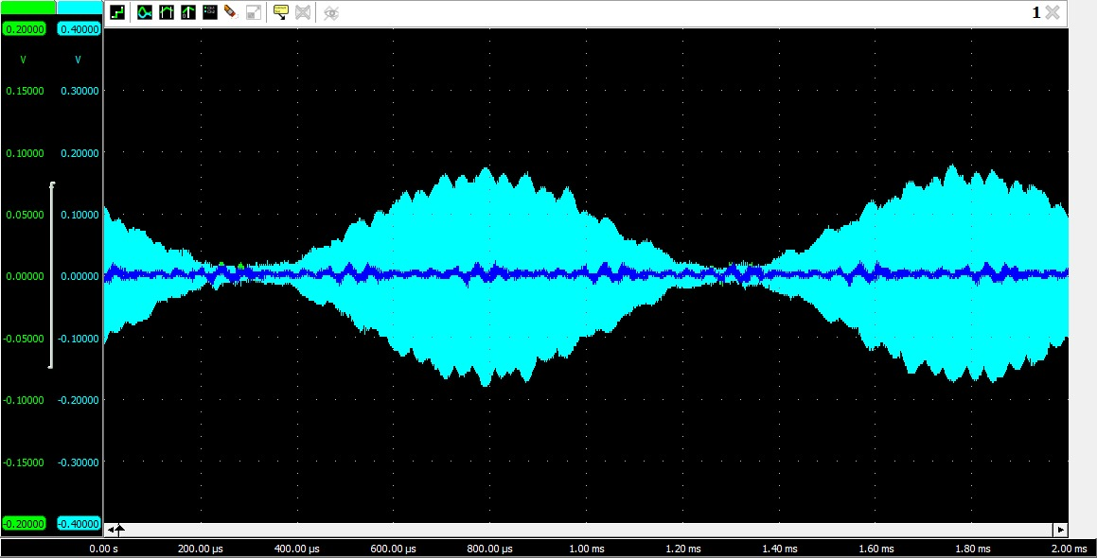

Figure : IF Filter Output

* **Step 28**

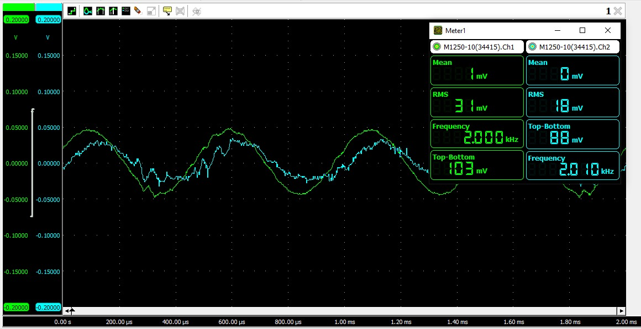

Figure : Envelope Detector Output

* **Step 29**

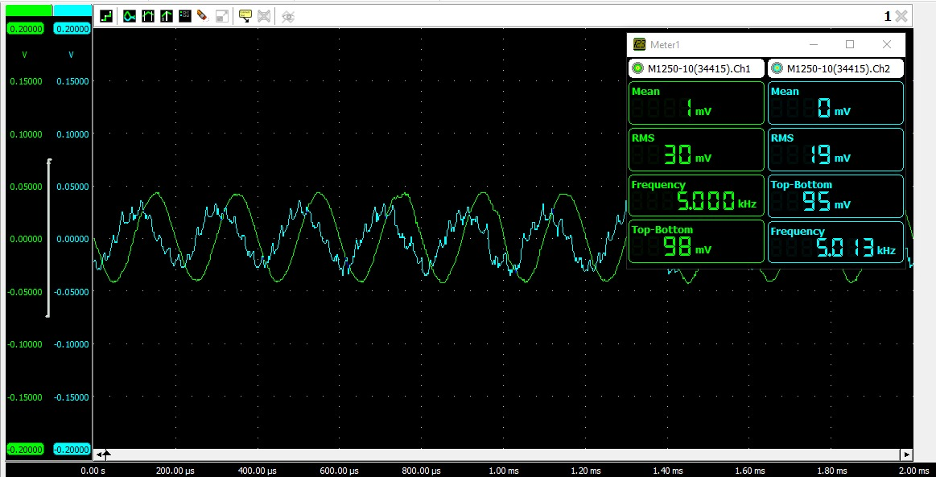

Figure : Frequency Variation

# Conclusion

We completed the lab exercise and gained practical knowledge and hands-on experience in understanding the fundamentals of communication systems. By the end of this lab, we had a better understanding of the mixer, IF filter, and envelope detector, as well as their individual functions in the context of modulation in a communication system.