**Department of Electrical Engineering and   
Computer Science**

**Faculty Member:** Dr. Huma Ghafoor  **Dated:** 09/04/2023

**Semester:** 6th **Section:** BEE 12C

**EE-351 Communication Systems**

Lab 8: SSB Reception

Group Members

|  |  |  |  |  |  |  |
| --- | --- | --- | --- | --- | --- | --- |
| **Name** | **Reg. No** | **Viva / Quiz / Lab Performance** | **Teamwork** | **Ethics** | **Software Tool Usage** | **Analysis of data in Lab Report** |
|  |  | **5 Marks** | **5 Marks** | **5 Marks** | **5 Marks** | **5 Marks** |
| Muhammad Ali Farooq | 331878 |  |  |  |  |  |
| Danial Ahmad | 331388 |  |  |  |  |  |
| Muhammad Umer | 345834 |  |  |  |  |  |
| Tariq Umar | 334943 |  |  |  |  |  |

**Table of Contents**

3 RF Power Amplifier 3

3.1 Objectives 3

3.2 Introduction 3

3.3 Lab Report Instructions 3

4 Lab Procedure 4

4.1 Introduction 4

4.2 Exercise 1 6

4.2.1 Procedure A: Connect the SSB Transmitter 6

4.2.2 Procedure B: RF Filter (Tune in the SSB Signal) 7

4.2.3 Procedure C: The RF Amplifier (Calculate Power Gain) 8

4.2.4 Procedure D: Mixer and IF Filter (produce a 455KHz SSB) 9

4.3 Exercise 2: Product Detector 10

4.3.1 Procedure A: Connect and Adjust SSB transmitter and Receiver if not done yet. 10

4.3.2 Procedure B: Product Detector and Audio Filter(Recover the message Signal) 11

4.4 Deliverables 13

5 Conclusion 16

**Table of Figures**

Figure 1: 100mV Peak to Peak Carrier Signal 13

Figure 2: LSB Filter Output 14

Figure 3: Signal across R5 14

Figure 4: SSB Output 14

Figure 5: Receiver Block's INPUT 15

Figure 6: MIXER's Output 16

# RF Power Amplifier

## Objectives

* At the competition of this lab, you will be able to describe SSB reception circuits and signals by using AM/SSB RECIEVER circuit BLOCK on the ANALOG COMMUNICATION CIRCUIT BOARD.

## Introduction

Analog communication systems have been widely used in the field of telecommunications for several decades. One of the important aspects of analog communication is the reception of Single Sideband (SSB) signals, which is the focus of this lab experiment. At the completion of this lab, the students are expected to have a comprehensive understanding of SSB reception circuits and signals using the AM/SSB receiver circuit block on the Analog Communication Circuit Board.

The AM/SSB receiver circuit block is a critical component in the analog communication system that is responsible for the reception and demodulation of SSB signals. The SSB signal is a complex waveform that contains both upper and lower sidebands, and it requires special circuits to extract the information from the carrier signal.

## Lab Report Instructions

All questions should be answered precisely to get maximum credit. Lab report must ensure following items:

* Lab objective
* Results (screen shots) duly commented and discussed.
* Conclusion

# Lab Procedure

## Introduction

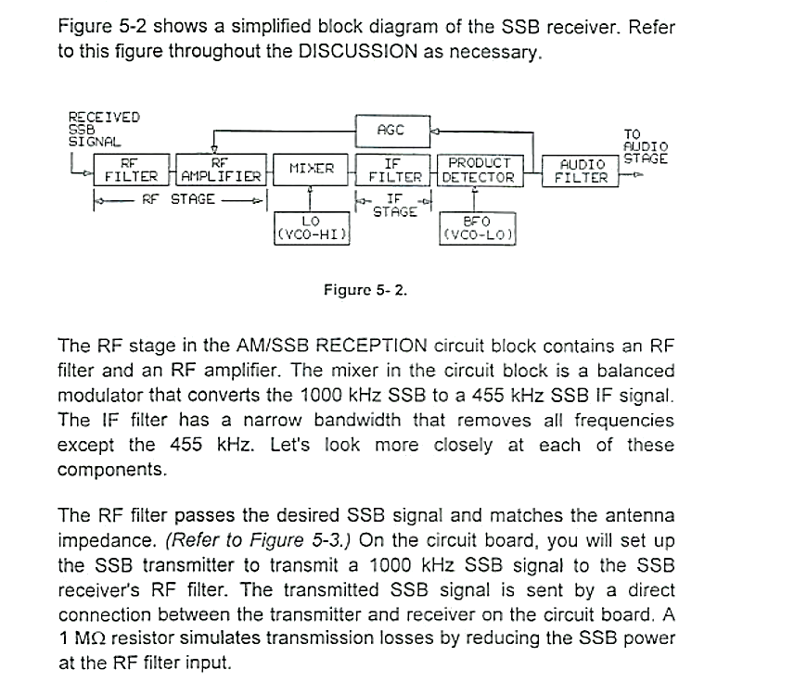

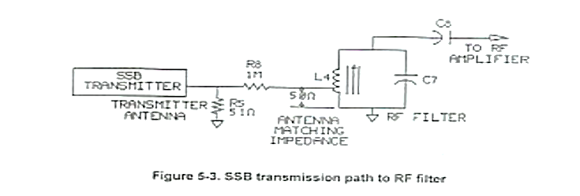

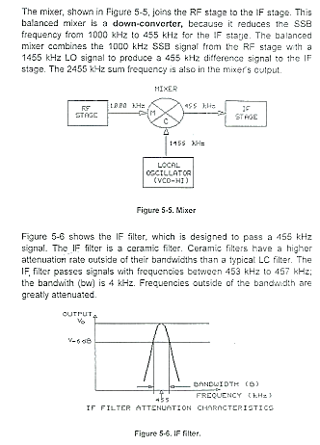

## Exercise 1

### Procedure A: Connect the SSB Transmitter

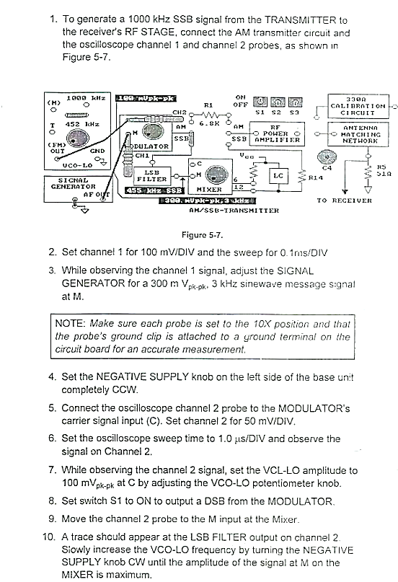

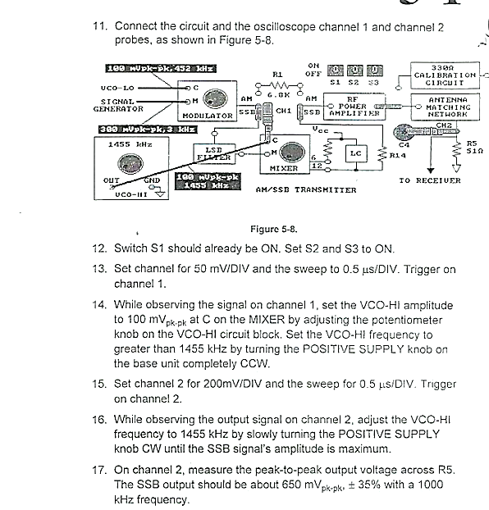

### Procedure B: RF Filter (Tune in the SSB Signal)

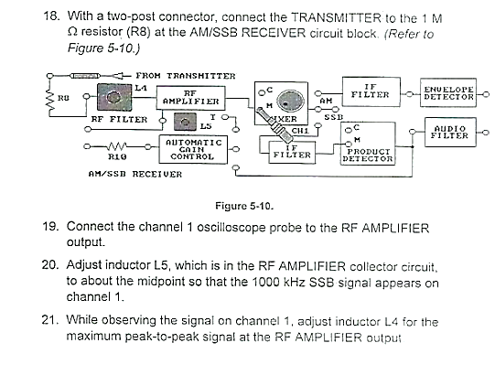

### Procedure C: The RF Amplifier (Calculate Power Gain)

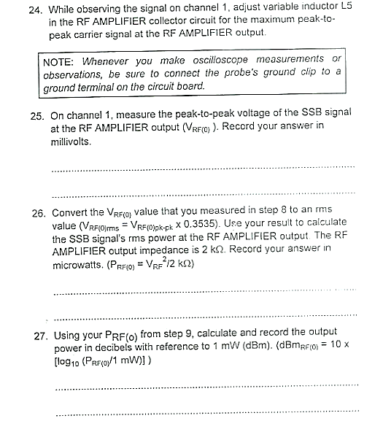

### Procedure D: Mixer and IF Filter (produce a 455KHz SSB)

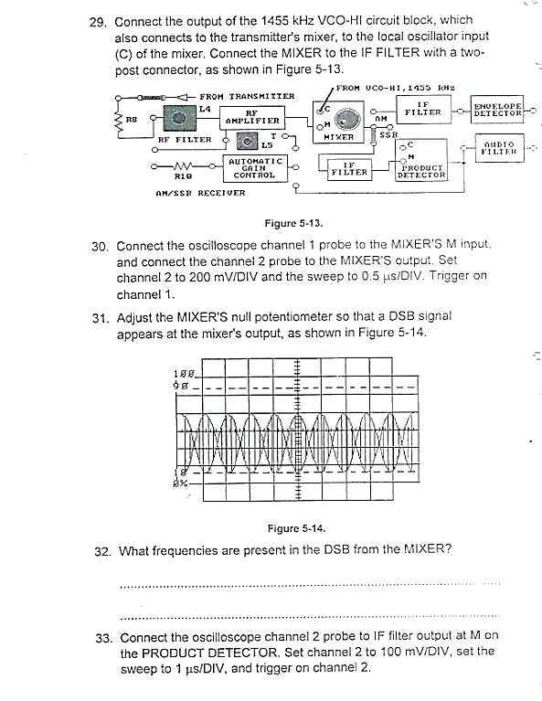

## Exercise 2: Product Detector

### Procedure A: Connect and Adjust SSB transmitter and Receiver if not done yet.

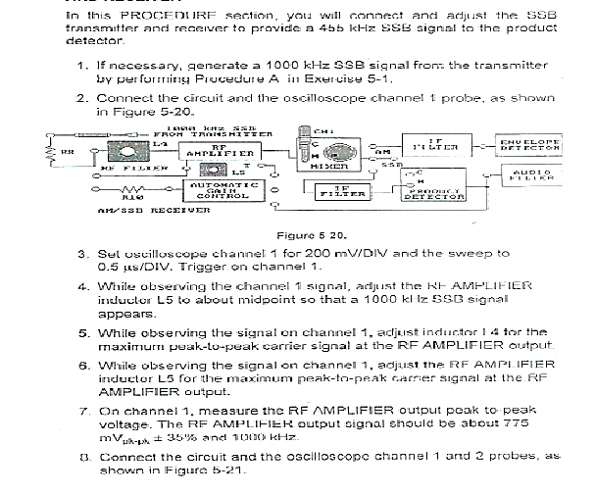

### Procedure B: Product Detector and Audio Filter(Recover the message Signal)

## Deliverables

* **Step 7**

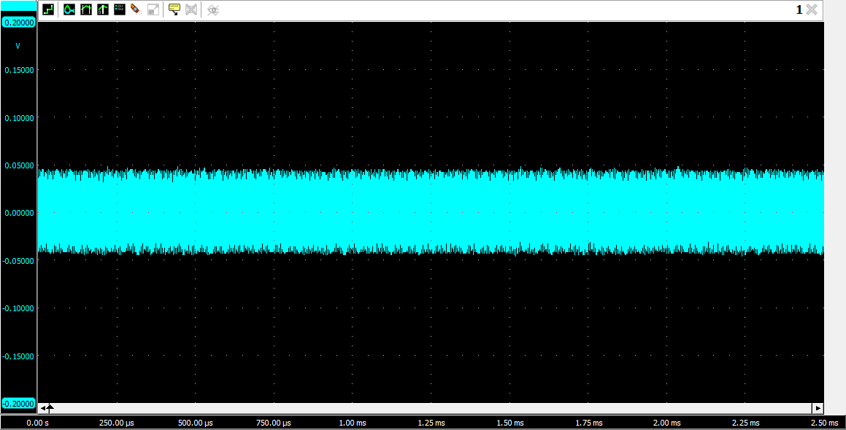

Figure 1: 100mV Peak to Peak Carrier Signal

* **Step 10**

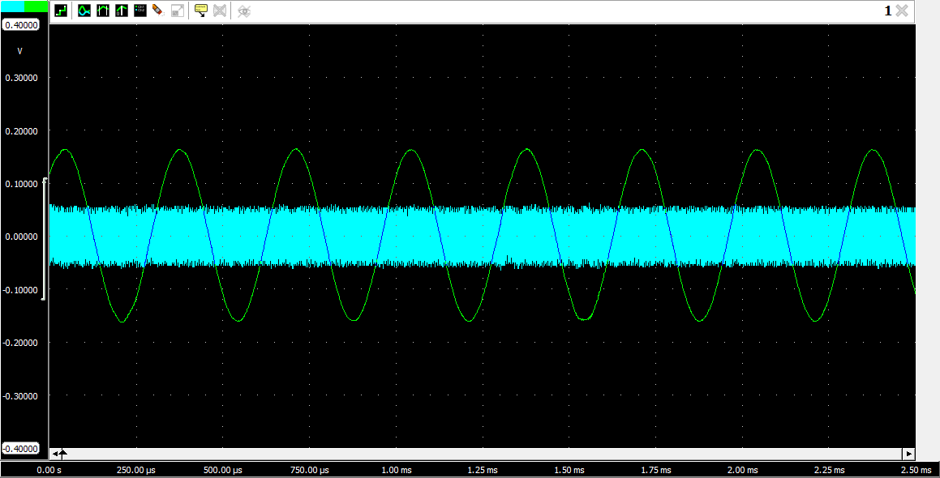

Figure 2: LSB Filter Output

* **Step 16**

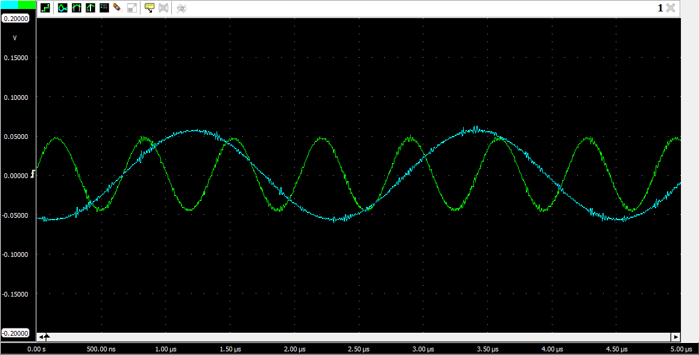

Figure 3: Signal across R5

* **Step 17**

Figure 4: SSB Output

* **Step 18**

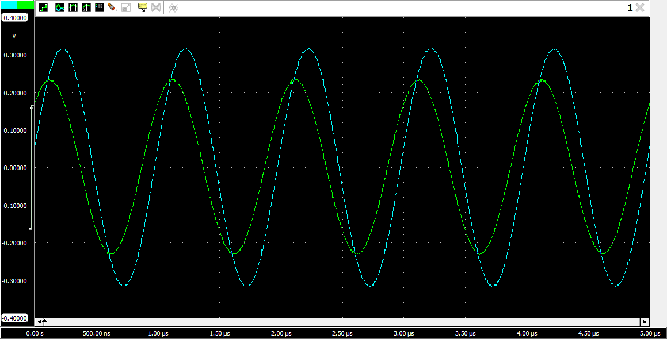

Figure 5: Receiver Block's INPUT

* **Step 25**

= 360 mV

* **Step 26**

= 127.26 mV

= 63.63 W

* **Step 27**

= -11.96 dBm

* **Step 28**

= 73 dBm

* **Step 31**

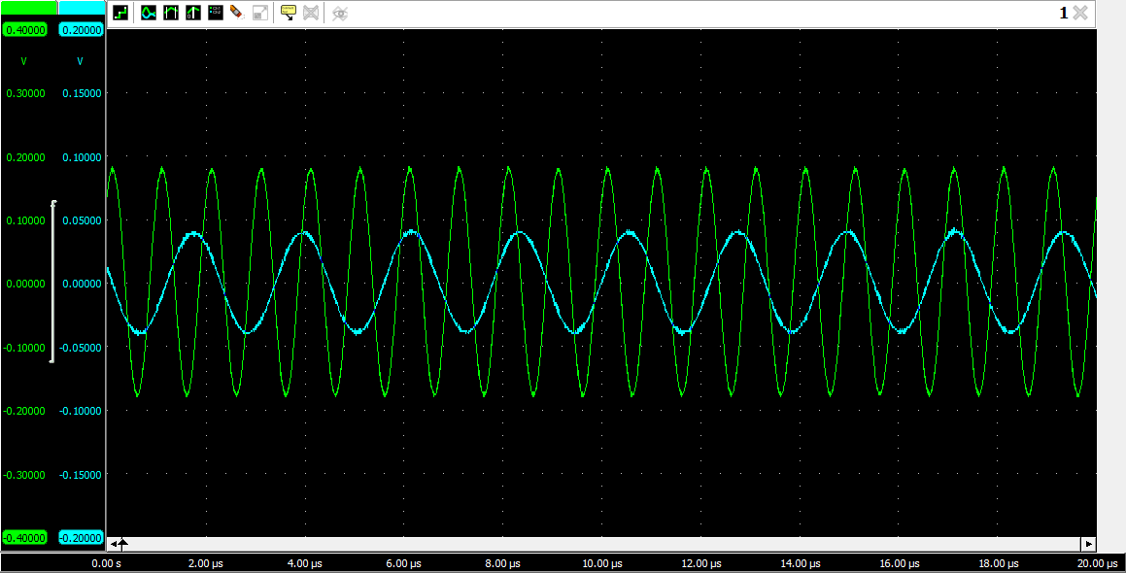

Figure 6: MIXER's Output

* **Step 34**

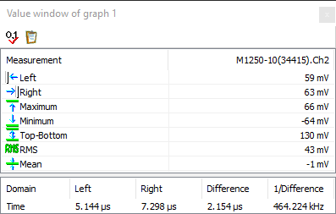

* **Step 35**

f = 464.3 kHz

# Conclusion

In conclusion, this helped us understand SSB reception circuits and signals by utilizing the AM/SSB RECEIVER circuit block present on the Analog Communication Circuit Board. By completing this lab, we attained knowledge about the different components of the SSB receiver circuit, such as the RF amplifier, mixer, local oscillator, IF amplifier, detector, and how they work together to extract the baseband signal from an SSB modulated RF signal. With this understanding, we will be able to apply this knowledge to design and implement SSB receiver circuits in various communication systems.