**Department of Electrical Engineering**

|  |  |
| --- | --- |
| **Faculty Member:____________________** | **Dated: ____________________** |
|  |  |
| **Course/Section:____________________** | **Semester: __________________** |
|  |  |

**EE-330 Digital Signal Processing**

**Lab 4 # Frequency Response and Pole Zero Plots**

(Taken from Signal processing first)

|  |  |  |  |  |  |  |
| --- | --- | --- | --- | --- | --- | --- |
|  |  | **PLO4-CLO4** | | **PLO5-CLO5** | **PLO8-CLO6** | **PLO9-CLO7** |
| **Name** | **Reg. No** | **Viva / Quiz / Lab Performance** | **Analysis of data in Lab Report** | **Modern Tool Usage** | **Ethics and Safety** | **Individual and Team Work** |
|  |  | **5 Marks** | **5 Marks** | **5 Marks** | **5 Marks** | **5 Marks** |
|  |  |  |  |  |  |  |
|  |  |  |  |  |  |  |
|  |  |  |  |  |  |  |
|  |  |  |  |  |  |  |

**Lab 4: Frequency Response and Pole Zero Plots of FIR/IIR Filters**

**Objectives**

In this lab, you will use PeZ to create filters with complex conjugate poles and zeros. These are called second-order filters because the denominator polynomial is a quadratic with two roots.

**Lab Instructions**

* The students should perform and demonstrate each lab task separately for step-wise evaluation
* Each group shall submit one lab report on LMS within 6 days after lab is conducted. Lab report submitted via email will not be graded.

. Students are however encouraged to practice on their own in spare time for enhancing their

**Lab Report Instructions**

All questions should be answered precisely to get maximum credit. Lab report must ensure following items:

* Lab objectives
* MATLAB codes
* Results (graphs/tables) duly commented and discussed
* Conclusion

# Introduction

In this part of the lab, you will use PeZto create filters with complex conjugate poles and zeros. These are called *second-order filters* because the denominator polynomial is a quadratic with two roots.

## PeZ: Introduction

In order to build an intuitive understanding of the relationship between the location of poles and zeros in the *z*-domain, the impulse response *h*[*n*] in the *n*-domain, and the frequency response $H(e^{jω})$ (the $ω$-domain), A graphical user interface (GUI) called **PeZ** was written in MATLAB for doing interactive explorations of the three domains[1]. **PeZ** is based on the system function, represented as a ratio of polynomials in *z*−1, which can be expressed in either factored or expanded form as:

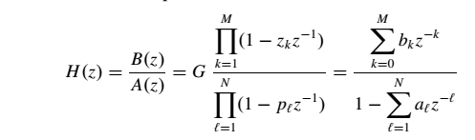

(1)

To run PeZ, type pezdemo at the command prompt and you will see the GUI shown in Fig. 1.

## Controls for PeZ using pezdemo

The PeZ GUI is controlled by the Pole-Zero Plot where the user can add (or delete) poles and zeros, as well as move them around with the pointing device. E.g., Fig. 1 shows a case where two (complex-conjugate) poles have been added, along with two (complex-conjugate) zeros on the unit circle.

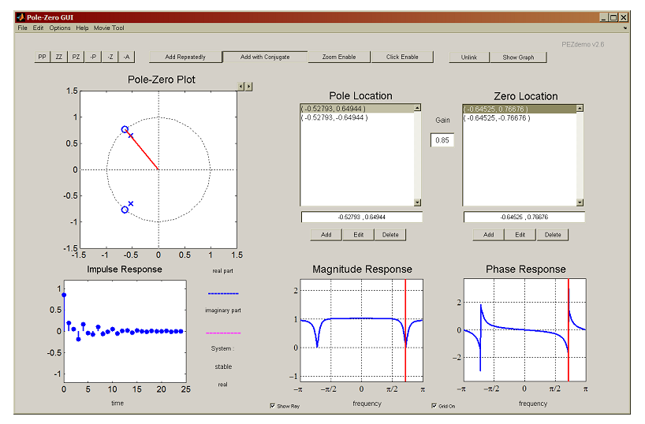

*Figure 1: GUI interface for pezdemo showing a second-order filter. Pole and zero locations are given in rectangular coordinates. The “Gain” was adjusted to G = 0.85 in order to make the frequency response equal to one in the passbands.*

The buttons named PP and ZZ were used to add these poles and zeros. By default, the “Add with Conjugate” property is turned on, so poles and zeros are typically added in pairs to satisfy the complex-conjugate property:

*A polynomial with real coefficients has roots that are real, or occur in complex-conjugate pairs.*

To learn about the other controls in pezdemo, access the menu item called “Help” for extensive information about all the PeZ controls and menus. Here are a few things to try. You can use the Pole-Zero Plot to selectively place poles and zeros in the z-plane, and then observe (in the other plots) how their placement affects the impulse- and frequency-responses. In PeZ an individual pole/zero pair can be moved around and the corresponding $H(e^{jω})$ and $h[n]$ plots will be updated as you drag the pole (or zero). The red ray in the z-domain window is tied to the red vertical lines on the frequency responses, and they move together. This helps identify frequency domain features that are caused by pole locations or zero locations, because the angle around the unit circle corresponds to frequency ω. Since exact placement of poles and zeros with the mouse is difficult, an Edit button is provided for numerical entry of the real and imaginary parts. Before you can edit a pole or zero, however, you must first select it in the list of Pole Locations or Zero Locations. Removal of individual poles or zeros can also be performed by using the -P or –Z buttons, or with the Delete button. Note that all poles and/or zeros can be easily cleared by clicking on the -A button.

## Create an IIR Filter with PeZ

### Lab Task 1

Use the PeZ interface to implement the following second-order system:

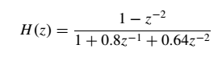

by determining where the two poles and two zeros are located and then placing the poles and zeros at the correct locations in the z -plane. First try placing the poles and zeros with the mouse, and then use the Edit feature to get exact locations. Since PeZ wants to add complex-conjugate pairs, you should only have to add one of the poles; for the zeros, the Add with Conjugate feature should be turned off because you will be adding two real-valued zeros. Look at the frequency response and determine what kind of filter you have?

**(BAND STOP)**

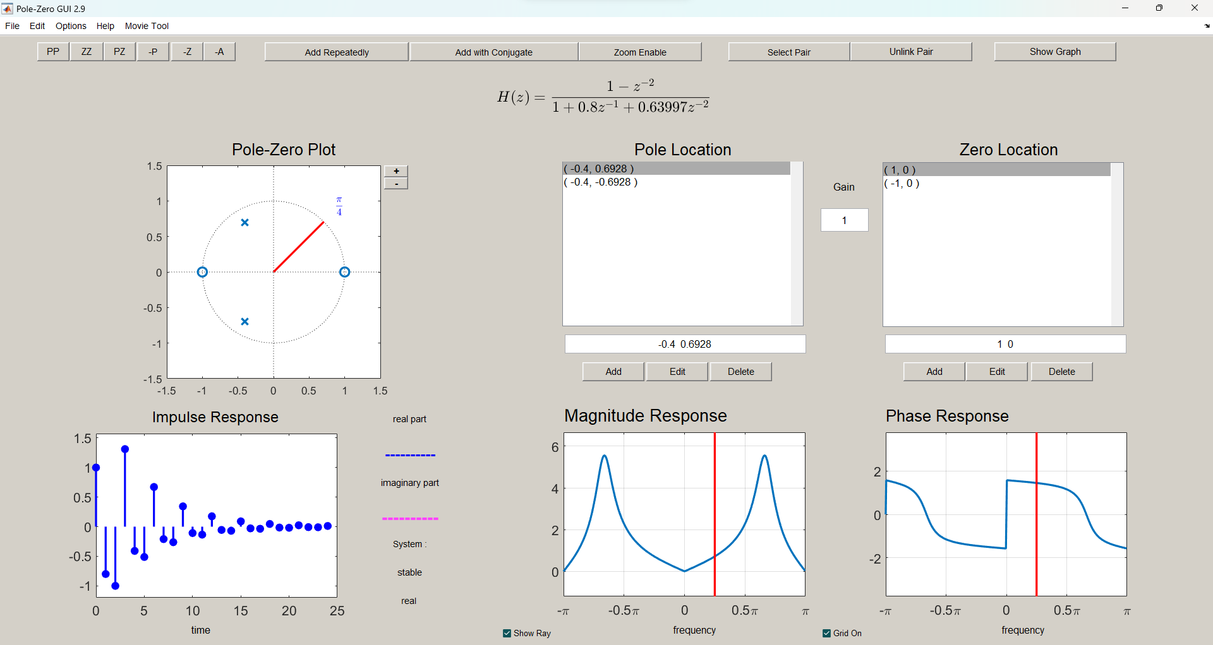

It is tempting to think that with two poles the frequency response ends up always having a peak, but there are two interesting cases where that doesn’t happen: (1) all-pass filters where ||= constant, and (2) IIR notch filters that null out one frequency, but are relatively flat across the rest of the frequency band.

• Implement the following second-order system:

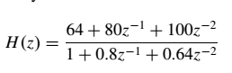

by determining where the two poles and two zeros are located and then placing the poles and zeros at the correct locations in the z -plane. Look at the frequency response and determine what kind of filter you have [3]. Now, use the mouse to “grab” the zero-pair and move the zeros to be exactly on the unit-circle at the same angle as the poles. Observe how the frequency response changes. In addition, determine the $H(z)$ for this filter.

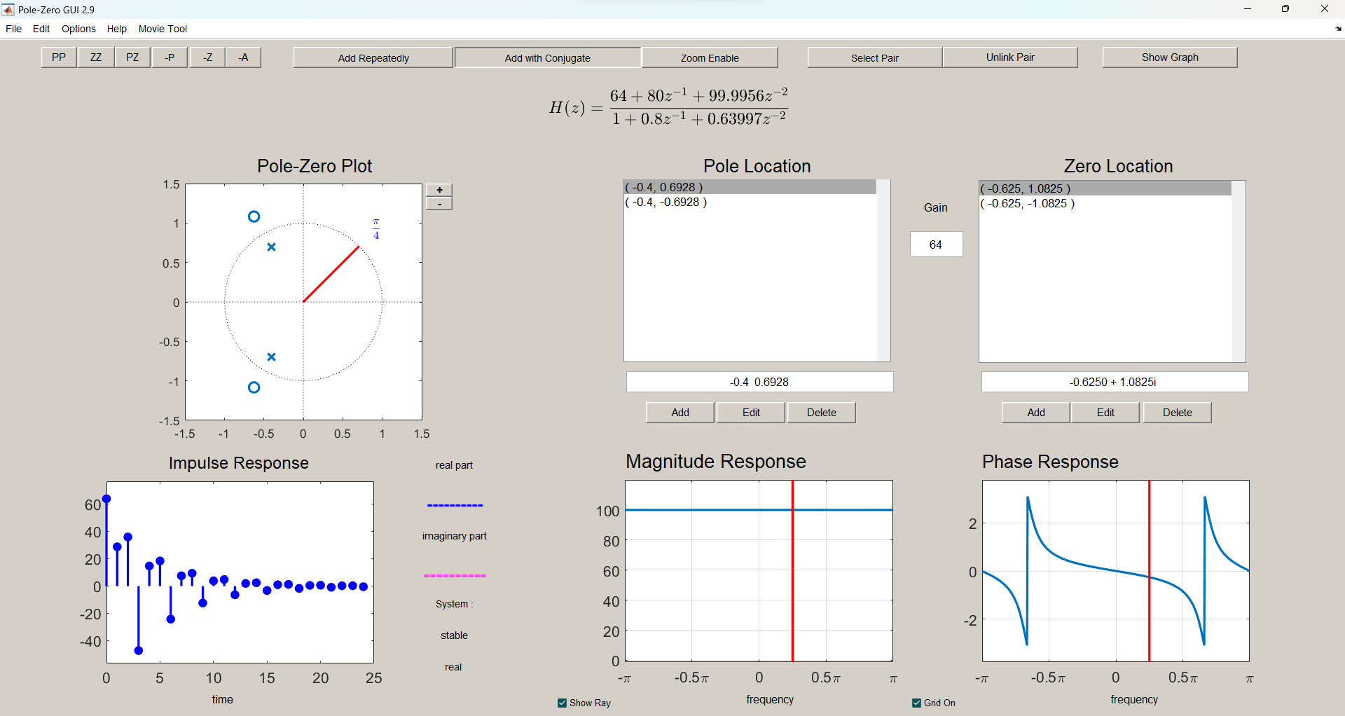

Describe the type of filter that you have now created.

**All pass filter**

## Bandpass Filter Design for IIR

It is easy to design a narrow passband IIR filter by putting a complex pole-pair near the unit circle.

### Lab Task 2

Complex Poles the first exercise is to move one pole-pair around and obtain formulas for how the frequency response changes as a function of the pole-pair radius and angle.

**(a)** Place following single pole-pairs



Then determine the coefficients of the numerator and denominator of the resulting $H(z)$.

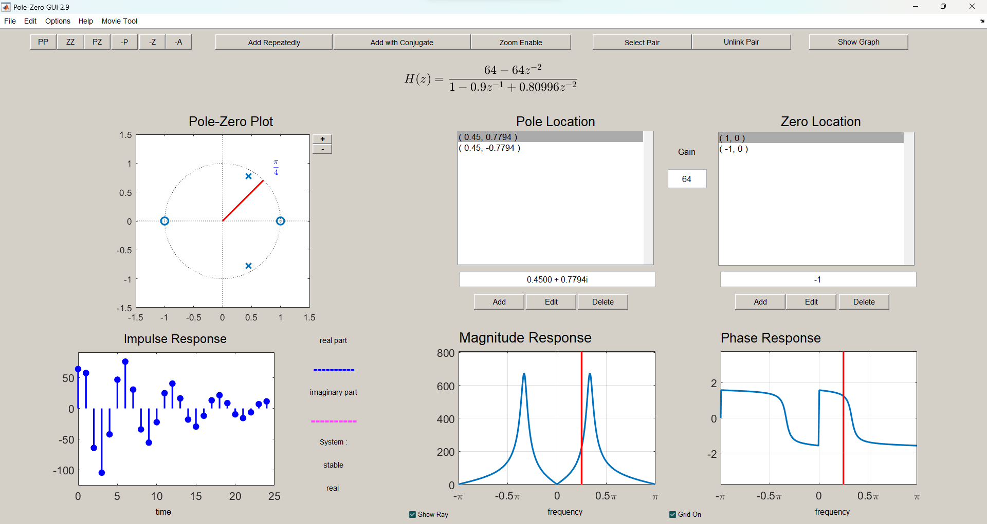

**(b)** Make a plot of the frequency response (magnitude only) with **freqz** and measure the width of the peak versus frequency. This presents a problem because we must define how to measure width. The usual definition is to measure the width at the “3-dB level.” In order to do this, the measurement must be made with respect to the peak value of the frequency response. If the peak value is $H_{max}$, then the “3-dB level” is at 0.707 $H_{max}$ [4].

Width = 0.207407



**(c)** Move the pole-pair so that the angles remain fixed at ±π/3, but the radius is r = 0.95 and r = 0.975. In each case, measure the 3-db width of the peak. Using these measured values, create a formula for the width that is proportional to (1 − r ), e.g., the following works quite well

PeakWidth ≈ K (1 − r )/√r where K is a constant of proportionality.

K = 1.967

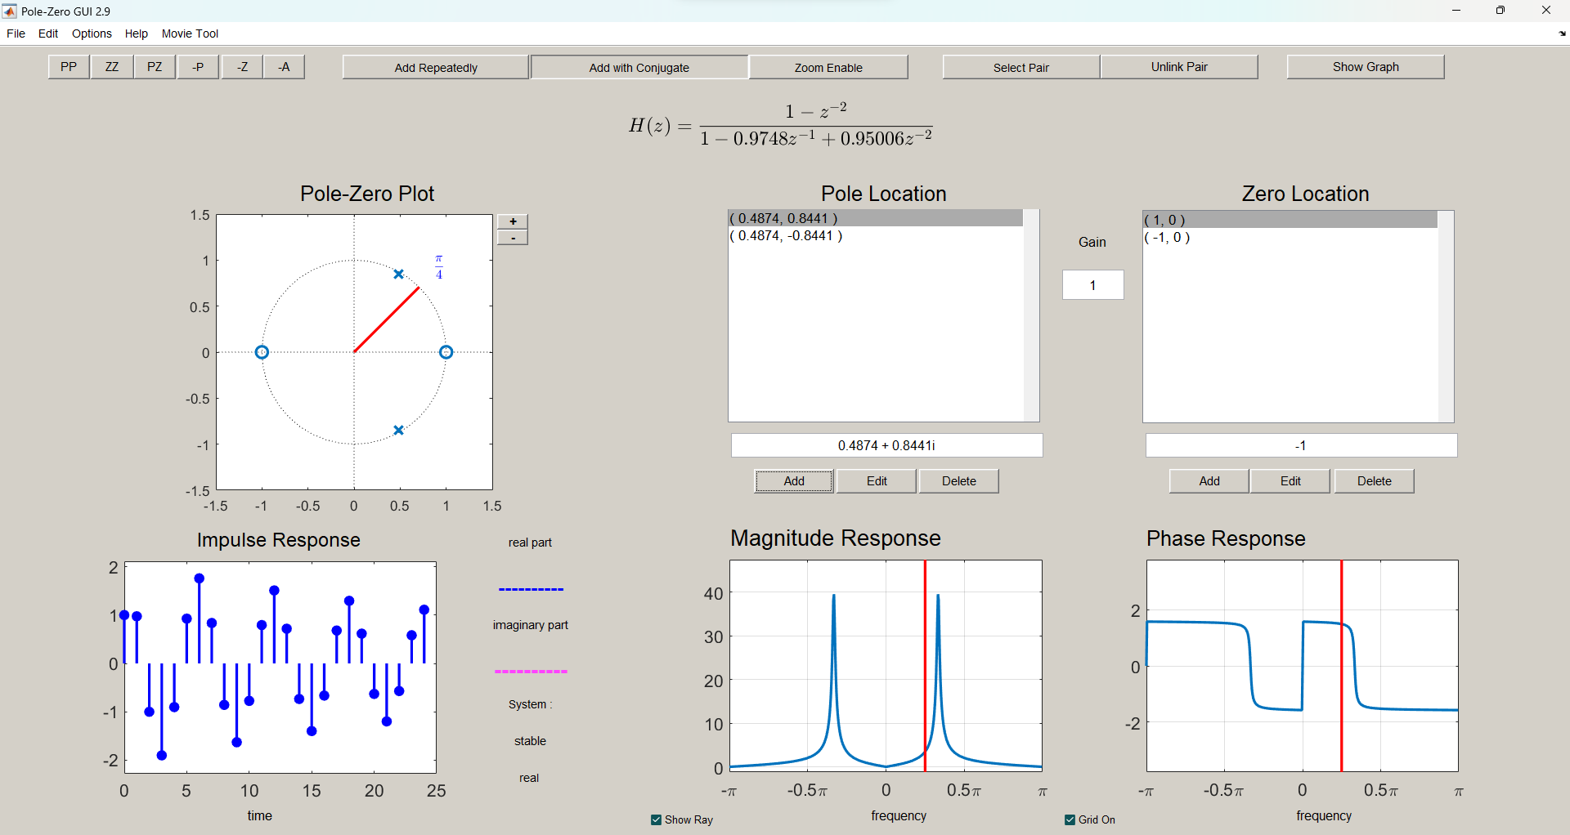



Width = 0.05161

PeakWidth ≈ K (1 − r )/√r where K is a constant of proportionality.

K = 1.967

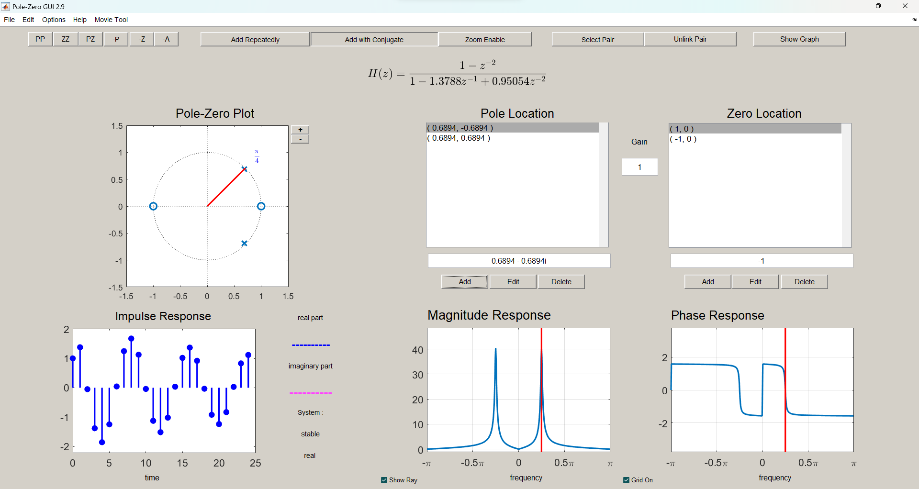**(d)** Move the pole-pair so that its radius remains fixed, and the angles change from ±π/3 to ±π/4 and then to ±π/2. State a formula for the peak location as a function of the pole location.

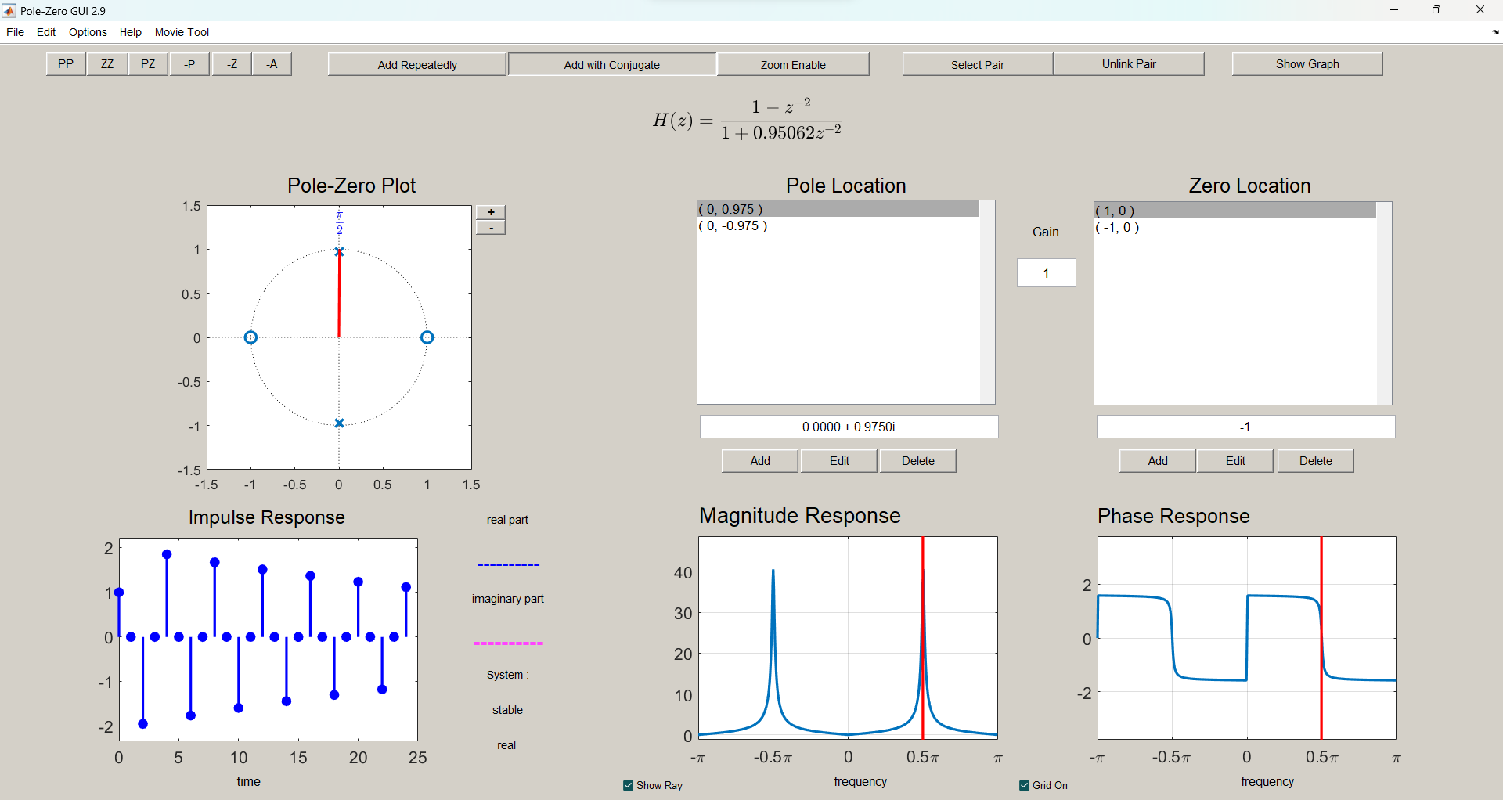Peak Location = $± \tan^{-1}{y/x }$

**Passband and Stopband**

We can characterize general bandpass filters if we define the passband width to be equal to the 3-dB width (as in the previous section). We also need a definition for the stopband, and we will arbitrarily define the stopbands of a BPF to be those regions where the frequency response (magnitude) is below −20 db, which is equivalent to 10% of the peak value.

Determine the stopband regions for three of the filters designed in the previous section. Use the cases where the pole angles are ±π/3 and the radii are r = 0.9, 0.95 and 0.975. In each case, measure the frequency regions of the two stopbands. There is one lower stopband for 0 ≤ ω ≤ ωs1 and one upper stopband for ωs2 ≤ ω ≤ π .







**(b)** For the same three filters, record the passband edges. The passband will be the peak width at the 3-dB level, so it will occupy a region such as ω1 ≤ ω ≤ ω 2 , where ω1 and ω2 are the band edges.

**(c)** Usually, filter design becomes difficult when we want the passband and stopband edges to be very close to one another. The difference between neighboring passband and stopband edges is called the Transition Width. Therefore, summarize the measurements of the previous two parts in a table that lists the two transition widths for each filter versus r. Does it depend on r?

Yes, it depends on r. More specifically, $r∝1/transition width$

**References**

[1]The original **PeZ** was written by Craig Ulmer; a later version by Koon Kong is the one that we will use in this lab. Recent modifications by Greg Krudysz have added new features such as movie-making capability.

[2]The command pez will invoke the older version of **PeZ** which is distinguished by a black background in all the plot regions.

[3]The relationship between the poles and zeros of an all-pass filter is zero = 1/(pole)*; this situation where two poles and two zeros are linked together can be done with the PZ option in PeZ.

[4] The frequency response is often plotted on a logarithmic scale using decibels, i.e.

20log10| *H (e j ω*ˆ *)* |. If you compute 20 log10(1/√2) you get −3.01 dB, and 1/√2 ≈ 0.707

**Note: download SPFIRST tool box form following link**

http://users.ece.gatech.edu/mcclella/SPFirst/Updates/SPFirstMATLAB.html