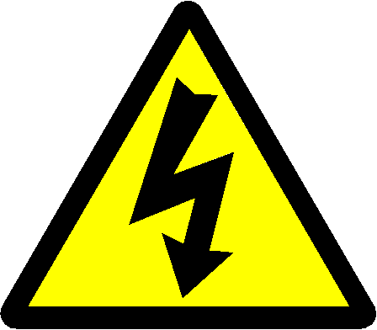

**ELECTRICAL SAFETY PRECAUTIONS**:

**The following general rules and precautions are to be observed at all times in the laboratory. These rules are for the benefit of the experimenter as well as those around him/her.**

* When making measurements, form the habit of using only one hand at a time. No part of a live circuit should be touched by the bare hand.
* Be as neat a possible. Keep the work area and workbench clear of items not used in the experiment.
* Always check to see that the power switch is OFF before plugging into the outlet. Also, turn instrument or equipment OFF before unplugging from the outlet.
* When unplugging a power cord, pull on the plug, not on the cable.
* When disassembling a circuit, first remove the source of power.
* No ungrounded electrical or electronic apparatus is to be used in the laboratory unless it is double insulated or battery operated.
* Keep fluids, chemicals, and beat away from instruments and circuits.
* Report any damages to equipment, hazards, and potential hazards to the laboratory instructor.
* If in doubt about electrical safety, call the laboratory instructor. Regarding specific equipment, consult the instruction manual provided by the manufacturer of the equipment. Information regarding safe use and possible- hazards should be studied carefully.



**ELECTRICAL SAFETY PRECAUTIONS**:

**The following general rules and precautions are to be observed at all times in the laboratory. These rules are for the benefit of the experimenter as well as those around him/her.**

* When making measurements, form the habit of using only one hand at a time. No part of a live circuit should be touched by the bare hand.
* Be as neat a possible. Keep the work area and workbench clear of items not used in the experiment.
* Always check to see that the power switch is OFF before plugging into the outlet. Also, turn instrument or equipment OFF before unplugging from the outlet.
* When unplugging a power cord, pull on the plug, not on the cable.
* When disassembling a circuit, first remove the source of power.
* No ungrounded electrical or electronic apparatus is to be used in the laboratory unless it is double insulated or battery operated.
* Keep fluids, chemicals, and beat away from instruments and circuits.
* Report any damages to equipment, hazards, and potential hazards to the laboratory instructor.
* If in doubt about electrical safety, call the laboratory instructor. Regarding specific equipment, consult the instruction manual provided by the manufacturer of the equipment. Information regarding safe use and possible- hazards should be studied carefully.